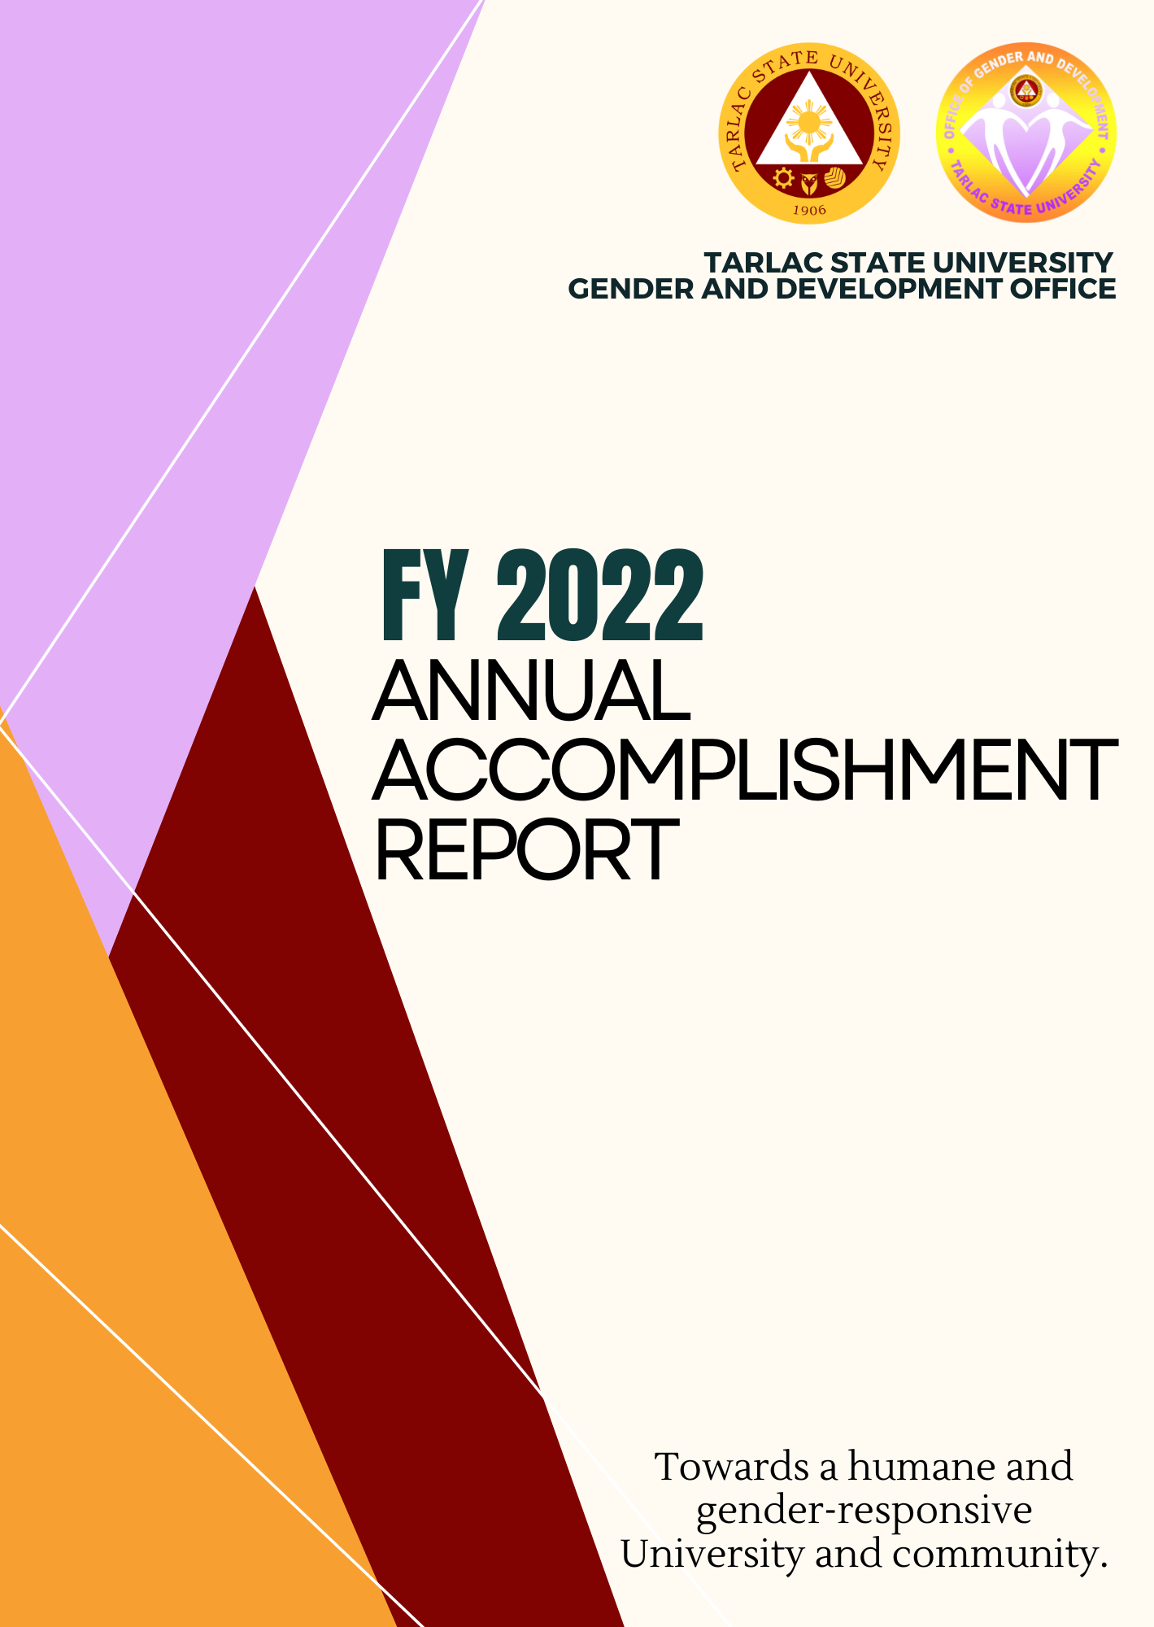
SUMMARY OF ACTIVITIES FOR 2022

Roadmap A – Resource Management Development Plan
A.1 Infrastructure, Facilities, and Equipment Development

KEY RESULT AREA  (ROADMAP) | DATE | ACTIVITY/VENUE | PERSONS/ OFFICE INVOLVED
Equipment Development | November 29, 2022 | Reproduction and distribution of IEC Materials on GAD Laws to Employees and Students | GAD Office

A.2 Executive, Faculty and Personnel Development

KEY RESULT AREA (ROADMAP) | DATE | ACTIVITY/ VENUE | PERSONS/ OFFICE INVOLVED
Executive Development | February 28, 2022 | Attendance to “RGADC III Technical Working Group (TWG) 1ST Quarter Meeting” via Zoom | Dr. Rita E. Pulmano
 | March 1, 2022 | Attendance to “1st Quarter RGADC III Meeting” via Zoom | Dr. Rita E. Pulmano  Assoc. Prof. Sheila Jane L. Gonzales
 | March 2, 2022 | Attendance to CHEDRO III SUCs Focal Person Meeting | Dr. Rita E. Pulmano
 | March 24, 2022 | Regional Hosting of the “RDC RGADC-III 2022 NWMC Women Empowerment Webinar” via ZOOM Meeting | Committee  Dr. Rita E. Pulmano  Ms. Christa Galle S. Aguas
 | May 30, 2022 | Attendance to “2nd Quarter RGADC III Meeting” via Zoom | Dr. Rita E. Pulmano  Ms. Rachel G. Ibale
 | June 7, 2022 | Attendance to the Regional Gender and Development Committee (RGADC) III Technical Working Group (TWG) on Planning via Zoom | Dr. Rita E. Pulmano
 | June 9, 2022 | Attendance to the 2nd Quarter GAD Focal Point System (GFPS) Meeting at the Provincial Capitol | Ms. Rachel G. Ibale  (TSU-GAD Representative)
 | September 9, 2022 | Attended the Joint GFPS-PCAT-VAWC 3rd Quarter Meeting @9:00AM to 12 NN at Provincial Capitol Building, Tarlac City | Ms. Rachel G. Ibale  (TSU-GAD Representative)
 | September 9, 2022 | Attendance to the 3rd Quarter RGADC III Meeting of Technical Working Group on Planning @10:00 AM via Zoom | Dr. Rita E. Pulmano
 | October 27-28, 2022 | TSU-GFPS Capacity Building Seminar cum Benchlearning Activity at Cavite State University and View Park Hotel, Tagaytay City | TSU-GFPS Officials  GAD Staff  GAD Student Interns  SSC Representatives
 | November 23, 2022 | Attendance to the 4th Quarter RGADC III TWG on Planning via Zoom @1PM | Dr. Rita E. Pulmano
 | December 6, 2022 | Attended the Joint GFPS-PCAT-VAWC 4th Quarter Meeting @9:00AM to 12 NN at Provincial Capitol Building, Tarlac City | Ms. Khyla Nicole R. Guevarra  (TSU-GAD Representative)
Faculty Competency Development  Faculty Competency Development | January 14, 2022 | Attendance to the “FLASHEIR3 Webinars on Proactive Strategies in Dealing with Student’s Mental Health and Development of School-based Mental Health Program | Dr. Rita E. Pulmano
 | January 27, 2022 | Attended the “Webinar on Women Entrepreneurs: Focusing at the Grassroots” via ZOOM meeting | Assoc.Prof. Sheila Jane L. Gonzales  Prof. Christine Janelle M. Santiago
 | February 24, 2022 | Attendance to PCW GAD Webinar Series “Introduction to GAD Concepts and SOGIESC” via ZOOM meeting | Prof. Juvy V. Galamay  Ms. Merlie Q. Espirutu  Ms. Christal Galle S. Aguas
 | March 8, 2023 | Attendance to “Gender in Research: Challenges and Opportunities towards Inclusion” via ZOOM Meeting | Ms. Christal Galle S. Aguas  GAD Coordinators:  Ms. Maria Tiara Fatima F. Galang  Mr. Bryan Jan S. Dizon  Prof. Juvy V. Galamay  Ms. Sheila Jane L. Gonzales  Ms. Merlie Q. Espiritu
 | March 9-11, 2022 | Attendance to the “35th AACUP Annual National Conference” | Dr. Rita E. Pulmano
 | March 11, 2022 | Go Negosyo “Women Summit 2022” | Dr. Rita E. Pulmano  Ms. Christal Galle S. Aguas  Ms. Maria Tiara Fatima F. Galang  Ms. Merlie Q. Espiritu  Prof. Sheila Jane L. Gonzales
 | March 24, 2022 | Regional Hosting of the “RDC RGADC-III 2022 NWMC Women Empowerment Webinar” via ZOOM Meeting | Committee  Dr. Rita E. Pulmano  Ms. Christa Galle S. Aguas
 | March 31, 2022 | Attendance to the NRCP’s Gender Sensitivity and Harmonized Gender and Development Guidelines via ZOOM | Ms. Christal Galle S. Aguas  Ms. Merlie Q. Espiritu  Prof. Juvy V. Galamay  Prof. Christine Janelle M. Santiago
 | May 19, 2022 | Attendance to CHEDRO III Webinar via Zoom:  Nourishing the Culture of Research Excellence in Higher Education | Dr. Rita E. Pulmano  Ms. Rachel G. Ibale
 | October 27-28, 2022 | TSU-GFPS Capacity Building Seminar cum Benchlearning Activity at Cavite State University and View Park Hotel, Tagaytay City | TSU-GFPS Officials  GAD Staff  GAD Student Interns  SSC Representatives
 | December 6, 2022 | 2022 RGADC Advocacy Forum to End Violence Against Women: “United for a VAW-free Philippines” via Zoom | Dr. Rita E. Pulmano  Ms. Maritess Timbol  Prof. Christine Janelle Santiago  Ms. Anna May Angeles  Ms. Rachel G. Ibale
Faculty Competency Development | December 16, 2022 | GAD-HRDMO Partnership in the “Webinar on RA 9262 or The Anti-Violence Against Women and Their Children Act of 2004” at 8:00AM to 5:00PM, via Zoom | Atty. Catherine Rose Diaz-Cunanan  (Speaker)  GAD Staff  TSU Employees
 | December 20, 2022 | GAD-HRDMO Partnership in the “Webinar on RA 11313 or The Safe Spaces Act” at 8:00AM to 5:00PM, via Zoom | Atty. Jewel Dela Cruz  (Speaker)  GAD Staff  TSU Employees
Personnel Competency Development (Non-Teaching)  Personnel Competency Development  (Non-Teaching)  Personnel Competency Development (Non-Teaching) | February 21, 2022 | GAD-NSTP’s “Basic First Aid and Basic Vital Signs: Strengthening Disaster Risk Reduction Skills” via ZOOM meeting | TSU Medical Services Office:  Ms. Cherryl M. Abila  Ms. Dana Marie O. Pagala  Mr. Edel Mark C. Capiendo  Ms. Danielle Anne D. Estrada  GAD – Dr. Rita E. Pulmano  Ms. Christal Galle S. Aguas  Prof. Louis Adonis G. Silvestre  NSTP faculty and student trainers
 | March 24, 2022 | Regional Hosting of the “RDC RGADC-III 2022 NWMC Women Empowerment Webinar” via ZOOM Meeting | Committee  Dr. Rita E. Pulmano  Ms. Christa Galle S. Aguas
 | June 30 – July 2, 2022 | Non-Academic Personnel Gender-Responsive Seminar/ Team Building | Dr. Rita E. Pulmano  NASA Officers and Members  Ms. Rachel G. Ibale
 | August 17, 2022 | GAD-HRDMO Partnership in the “Gender Sensitivity Orientation for Newly Hired Employees” at 8am to 5pm via Zoom | Dr. Rita E. Pulmano  Mr. Bryan Jan Dizon  Asst. Prof. Sheila Jane Gonzales  Ms. Rachel G. Ibale  Ms. Khyla Nicole R. Guevarra  Ms. Ma. Katrina Rivera  Newly-Hired Employees (January to August 2022)
 | August 26, 2022 | Served as Resource Speaker in TSU-ESMO’s “Appreciation Seminar-Workshop on the Requirements of SDG-Driven and Gender-Responsive Community Extension Projects” at View Park Hotel, Tagaytay City | Dr. Rita E. Pulmano
 | September 21, 2022 | GAD-HRDMO’s partnership in the “Safety in the Digital World: Cybercrime Awareness Webinar” at 9:00AM to 12NN at Engineering Building - AVR and Facebook Live | Dr. Rita E. Pulmano  HRDMO- Training & Organizational Development Unit  Ms. Rachel G. Ibale  Ms. Khyla Nicole R. Guevarra  Selected Employees  Student Leaders
 | October 1, 2022 | GAD-COESSE TSU Psychological Society partnership in the “Mindfulness Day 2022: Dance Your Stress Away (Morning Session) & YOGAwareness (Afternoon Session) @8:00 AM to 5:00 PM at the TSU Main Campus Gymnasium | Mr. Alberto L. Dimarucut (Speaker)  Ms. Priscilla S. Oro  (Speaker)  Ms. Khyla Nicole R. Guevarra  Ms. Rachel G. Ibale  TSU A.B. Psychology Students
 | December 1, 2022 | GAD-CBA-SC Partnership in the “HIV Awareness Seminar” at TSU Main Gymnasium @9:00AM to 12NN | Dr. Rita E. Pulmano  GAD Staff  CBA Student Council  TSU Employees  CBA Students
 | December 16, 2022 | GAD-HRDMO Partnership in the “Webinar on RA 9262 or The Anti-Violence Against Women and Their Children Act of 2004” at 8:00AM to 5:00PM, via Zoom | Atty. Catherine Rose Diaz-Cunanan  (Speaker)  GAD Staff  TSU Employees
 | December 20, 2022 | GAD-HRDMO Partnership in the “Webinar on RA 11313 or The Safe Spaces Act” at 8:00AM to 5:00PM, via Zoom | Atty. Jewel Dela Cruz  (Speaker)  GAD Staff  TSU Employees

Roadmap B – Instructional Quality and Relevance Development Plan

KEY RESULT AREA (ROADMAP) | DATE | ACTIVITY/ VENUE | PERSONS/ OFFICE INVOLVED
Student Support Services Development  Student Support Services Development  Student Support Services Development  Student Support Services Development  Student Support Services Development  Student Support Services Development | January 31, 2022 | GAD-SSC Partnership in the “Stress and Time Management Webinar” via ZOOM meeting | Ms. Igielene T. Torato-Sapuay (Speaker)  Dr. Rita E. Pulmano  Ms. Christal Galle S. Aguas  Ms. Mikaela B. Laxamana  SSC Officers  NSTP Students
 | February 5, 2022 | “GAD-SSC’s “Kaagapay: Mindfulness Exercise and Activity for Health and Well-being of TSUians” via ZOOM meeting | Ms. Jazmin Joy E. Dizon (CASS-Psych Dept.)  Dr. Rita E. Pulmano  Ms. Christal Galle S. Aguas  Ms. Mikaela B. Laxamana  Supreme Student Council  NSTP Students
 | February 18, 2022 | GAD-CEJPS’ “Work Ethics and Anti-Sexual Harassment (WEASH) Webinar” via ZOOM meeting | Prof. Gherold C. Benitez (CASS/SAS)  Mr. Jon-Ville M. Caliboso (HRDMO-TAOD)  Dr. Rita E. Pulmano  Ms. Niña C. Garcia  Ms. Christal Galle S. Aguas  Ms. Crisly Hannah D. Gueco
 | February 19, 2022 | GAD-SSC’s 3rd “Mx. Warrior 2022” via ZOOM Meeting and Facebook live | Dr. Rita E. Pulmano  Ms. Christal Galle S. Aguas  Ms. Mikaela B. Laxamana  GAD Coordinators  Supreme Student Council
 | February 21, 2022 | GAD-NSTP’s “Basic First Aid and Basic Vital Signs: Strengthening Disaster Risk Reduction Skills” via ZOOM meeting | TSU Medical Services Office:  Ms. Cherryl M. Abila  Ms. Dana Marie O. Pagala  Mr. Edel Mark C. Capiendo  Ms. Danielle Anne D. Estrada  GAD – Dr. Rita E. Pulmano  Ms. Christal Galle S. Aguas  Prof. Louis Adonis G. Silvestres  NSTP faculty and student trainers
 | March 5, 2022 | GAD-SSC’s “Women Empowerment Webinar” in line with the 2022 National Women’s Month Celebration | Dr. Victoria N. Apuan  Dr. Rita E. Pulmano  Ms. Sheila Jane L. Gonzales  Ms. Christal Galle S. Aguas  Ms. Mikaela B. Laxamana  Supreme Student Council
 | April 18, 2022 | GAD-SSC Partnership in the “Safe Spaces Act (Bawal Bastos Law) Webinar” via Zoom | Atty. Hendrix C. Bongalon  (Speaker)  Dr. Rita E. Pulmano  GAD Coordinators  Ms. Rachel G. Ibale  SSC Officers
 | April 23, 2022 | GAD- NSTP’s “Incident Command System Seminar, Training, and Workshop” @ TSU Gymnasium | FO1 Vien Michael Acosta  (Speaker)  NSTP Lecturers  TSU Students
 | May 31, 2022 | GAD-SSC Partnership in “Men and Women Empowerment Webinar” via Zoom | Dr. Rita E. Pulmano  Ms. Rachel G. Ibale  SSC Officers  TSU- CCJE First Year Students
 | July 21, 2022 | GAD-SSC Partnership “OUTSpoken: An Event that Celebrates Differences at Smith Hall, CASS Building, TSU Main | Vince Ren Carpio (Interviewee)  Reignchill A. Bactad (Interviewee)  Alvin N. Castillo (Host)  SSC Officers  Ms. Rachel G. Ibale
 | August 22, 2022 | GAD-CBA-CSC partnership in “Gender Sensitivity Orientation” at 1pm to 5pm via Zoom | Asst. Prof. Sheila Jane Gonzales (Speaker)  Ms. Rachel G. Ibale  Ms. Khyla Nicole R. Guevarra  CBA Students (1st year to 4th year)
 | September 5, 2022 | GAD-CEJPS Partnership in the “Work Ethics and safe Spaces Webinar” for CPAG Student Interns  @ 8:00 AM-12:00 NN via Zoom | Dr. Rita E. Pulmano  Ms. Khyla Nicole R. Guevarra  Ms. Rachel G. Ibale  CJEPS Unit  Ms. Niña C. Garcia  Ms. Crisly Hannah D. Gueco
 | September 17, 2022 | GAD-CEJPS Partnership in the “Work Ethics and safe Spaces Webinar” for Student Interns of the University  @ 8:00 AM-12:00 NN via Zoom | Dr. Rita E. Pulmano  Ms. Khyla Nicole R. Guevarra  Ms. Rachel G. Ibale  CJEPS Unit  Ms. Niña C. Garcia  Ms. Crisly Hannah D. Gueco
 | September 21, 2022 | GAD-HRDMO’s Partnership in the “Safety in the Digital World: Cybercrime Awareness Webinar” at 9:00AM to 12NN at Engineering Building - AVR and Facebook Live | Dr. Rita E. Pulmano  HRDMO- Training & Organizational Development Unit  Ms. Rachel G. Ibale  Ms. Khyla Nicole R. Guevarra  Selected Employees  Student Leaders
 | September 24, 2022 | GAD-JFINEX Partnership in Gender and Development National Webinar Series:  “Extroverts and Introverts among Gen Z: How the Pandemic Disrupted our Social Behavior” @8AM to 12NN via Zoom | Ms. Jazmin Dizon  (Speaker)  Ms. Khyla Nicole Guevarra  Ms. Rachel G. Ibale  Junior Financial Executives from universities nationwide
 | October 1, 2022 | GAD-COESSE TSU Psychological Society partnership in the “Mindfulness Day 2022: Dance Your Stress Away (Morning Session) & YOGAwareness (Afternoon Session) @8:00 AM to 5:00PM at the TSU Main Campus Gymnasium | Mr. Alberto L. Dimarucut (Speaker)  Ms. Priscilla S. Oro  (Speaker)  Ms. Khyla Nicole R. Guevarra  Ms. Rachel G. Ibale  TSU A.B. Psychology Students
 |  | GAD-SSC-COESSE partnership in the “PROJECT KAAGAPAY: All of Us Needs Saving: A Suicide Prevention and Awareness Webinar” @1:00PM via Zoom and Facebook Live | Ms. Jazmin Joy Dizon  (Speaker)  Ms. Khyla Nicole R. Guevarra  Ms. Rachel G. Ibale  COESSE & SSC Officers
 | October 3, 2022 | GAD-JFINEX Partnership in Gender and Development National Webinar Series:  2. “Fear of Missing Out (FOMO) among Gen Z: The Root of this Phenomenon & How to Avoid It” @8AM to 12NN via Zoom and Facebook Live | Assoc. Prof. Laarni Capinding  (Speaker)  GAD Staff  Junior Financial Executives from universities nationwide
 | October 18, 2022 | GAD-JPSPA partnership in the Debate Workshop themed “Safe and Sound: Safe behind Words, the Sound of your Voice is Heard” at 8:00AM to 12 NN | Mr. Masahiro Kobayashi  (Speaker)  Ms. Khyla Nicole R. Guevarra  CPAG and CET Students
 | November 8-11, 2022 | GAD-CBA Young Entrepreneurs’ Partnership in “BRIDGES: Better Roads in Developing Great Entrepreneurial Spirit” at TSU Main Campus | Dr. Rita E. Pulmano  Asst. Prof. Sheila Jane Gonzales (GAD Coordinator)  CBA Young Entrepreneurs Officers
 | November 19, 2022 | GAD-CBA-SC Partnership in the Webinar titled “Titindig Ako Kasama Mo: Webinar on Anti-Violence against Women and Children”  @ 9:00 AM-12:00 NN via Zoom and FB Live | Atty. Catherine Rose Diaz-Cunanan  (Speaker)  GAD Staff  CBA-SC Officers
 | November 21, 2022 | GAD-CBA-SC Partnership in the Webinar titled “Titindig Ako Kasama Mo: Breaking the Stigma and Overcoming Violence and Trauma”  @ 9:00 AM-12:00 NN via Zoom and FB Live | Mr. Jaymar Patana  (Speaker)  GAD Staff  CBA-SC Officers
 | November 28, 2022 | GAD-CAFA-SC Partnership in the “Umbrella Club: Bawal Bastos Webinar” | Dr. Rita E. Pulmano  Ms. Khyla Nicole R. Guevarra  CAFA-SC Officers
 |  | GAD-CTED Partnership in “Stress Management Webinar: Let Your Feelings Out” @1PM to 4PM via MS Teams | Dr. Erwin P. Lacanlale  (Speaker)  Dr. Rita E. Pulmano  Prof. Jovy P. Tomas  Ms. Rachel G. Ibale  TSU-GEMS Officers
 | November 29, 2022 | GAD-SSC Partnership in “Film Festival: Istorya ng Pagbangon” in line with the 18-Day Campaign to End VAWC 2022 | Dr. Rita E. Pulmano  GAD Staff  Student Interns  SSC Officers & Apprentice
 | December 1, 2022 | GAD-CBA-SC Partnership in the “HIV Awareness Seminar” at TSU Main Gymnasium @9:00AM to 12NN | Dr. Rita E. Pulmano  GAD Staff  CBA Student Council  TSU Employees  CBA Students
 | December 5, 2022 | GAD-CTED Partnership in the “Time Management Webinar: Get Organized” at 1:00 PM to 4:00PM via MS Teams | Ms. Shindy Abigael Morales  (Speaker)  Ms. Rachel G. Ibale  CTED Students
 | December 6, 2022 | GAD-CBA-SC Partnership in the “Campaign to End Violence Against Women and Children Art Competition” | Dr. Rita E. Pulmano  GAD Staff  CBA Student Council  TSU Students

Roadmap C – Research and Community Service Development
C.1 Research Development

KEY RESULT AREA (ROADMAP) | DATE | ACTIVITY/ VENUE | PERSONS/ OFFICE INVOLVED
Research Publication and Presentation Development Plan | November 18, 2022 | Served as a Paper Evaluator in the Central Luzon State University’s 4th National GAD Research Congress at CLSU, Science City of Muñoz, Nueva Ecija | Dr. Rita E. Pulmano
 | June 1, 2022 | Participated as Panelist in the TSU Research Bootcamp 2022 at TSU Lucinda Campus | Dr. Rita E. Pulmano
 | June 8, 2022 | Participated as Panelist in the TSU Research Bootcamp 2022 (Continuation) at TSU Lucinda Campus | Dr. Rita E. Pulmano
 | July 26, 2022 | UREC Meeting: Participated as Evaluator of 3 Finished Papers and 9 Research Proposals at TSU Lucinda Campus | Dr. Rita E. Pulmano
 | October 18-20, 2022 | Served as Panelist in the University-wide Research Proposal Colloquium held at TSU Lucinda Campus | Dr. Rita E. Pulmano
 | December 7, 2022 | Served as an Evaluator in the “University-wide Special Research Proposal Colloquium” at TSU Lucinda Campus, 8:00AM to 5:00PM | Dr. Rita E. Pulmano

C.2 Community Extension Services Development

KEY RESULT AREA (ROADMAP) | DATE | ACTIVITY/ VENUE | PERSONS/ OFFICE INVOLVED
Community Extension Services  /  Academe Government Agencies Linkages Development | March 18, 2022 | Short-term Extension Project “Gender-responsive Basic Education Policy” to Matatalaib High School, Tarlac City | Ms. Sheila Jane L. Gonzales  Ms. Christal Galle S. Aguas  Mr. Adrian A. Dizon  GAD Student Interns:  Ms. Khyla Nicole Guevarra  Ms. Faith Selah  Ms. Tryxia Guina  Ms. Roxanne Tinio
 | March 22, 2022 | Short-term Extension Project “Gender Sensitivity Orientation and High Risk of Cyber Bullying, Online Abuse and Exposure to Harmful Content and Online Threats during this time of covid-19 Situation” to Tibag Elementary School | Prof. Christine Janelle M. Santiago  Prof. Winifredo L. Luis  Ms. Christal Galle S. Aguas  Mr. Adrian A. Dizon  GAD Student Interns:  Ms. Khyla Nicole Guevarra  Ms. Faith Selah  Ms. Tryxia Guina  Ms. Roxanne Tinio
Community Extension Services  /  Academe Government Agencies Linkages Development | April 30, 2022 | TSU-GAD and USST Partnership in the “Gender Sensitivity Orientation in the Contemporary Context” via Google Meet | Mr. Bryan Jan Dizon (Speaker)  Ms. Rachel G. Ibale  USST - BSSW Students
 | June 8, 2022 | Lecture on “The Use of Gender Fair Language” via Zoom | Prof. Maria Teresa Agustin (Speaker)  Ms. Rachel G. Ibale  Armor (Pambato) Division Philippine Army Personnel
 | June 21, 2022 | Onsite Benchmarking with Gordon College | Dr. Rita E. Pulmano  Ms. Abegail G. Legaspi  (Gender and Development Director, Gordon College)
 | July 19, 2022 | Served as Resource Speaker in the PPDO-GAD Seminar titled  “Capacity Building Training on Gender Analysis, Gender Mainstreaming Evaluation Framework (GMEF),Gender Responsive LGU (GeRL) Assessment Tool, and other Succeeding Tools” at Diwa ng Tarlac, San Vicente, Tarlac City | Dr. Rita E. Pulmano  (Speaker)  PPDO-GAD Officials  LGU Officials
 | June 21, 2022 | Served as Resource Speaker in the Aranguren Integrated School High School Department Gender and Development Seminar titled “Addressing Sexual Orientation, Gender-based Violence in Capacitating Knowledge of AIS-HS Teachers amidst the New Normal” at VES Food House, Capas, Tarlac | Asst. Prof. Sheila Jane L. Gonzales  (Speaker)  AIS-HSD Faculty and Staff
Community Extension Services  /  Academe Government Agencies Linkages Development | August 3, 2022 | Served as Resource Speaker in the Marawi National High School GAD Seminar titled “Gender-Sensitive Language in Instruction and Communication” at Marawi National high School, Camiling, Tarlac | Ms. Rachel G. Ibale  (Speaker)  MNHS Faculty Staff
 | August 18, 2022 | Served as Resource Speakers in “Gender Sensitivity Orientation” and “Gender- Responsive Education” at San Manuel High School | Ms. Christine Janelle M. Santiago  Ms. Jovy P. Tomas  San Manuel High School Admin and Faculty Staff
 | September 12, 2022 | Served as the Resource Speaker in the “Gender Awareness and Development Seminar“ at San Juan de Valdez Integrated School, San Jose, Tarlac | Prof. Jovy P. Tomas (speaker)  San Juan de Valdez Integrated School Head and Faculty Staff
 | September 14, 2022 | Served as the Resource Speaker in the Seminar Workshop of the Municipality of Victoria titled “Preparation of Gender and Development Plan & Budget, and Annual Report Preparation” at Albergo Hotel, Baguio City | Dr. Rita E. Pulmano  (speaker)
 | September 22, 2022 | Served as Resource Speaker in the PPDO-GAD’s “Gender Sensitivity Training” @8:30 AM to 3:00 PM at Provincial Capitol Building, Tarlac City | Dr. Rita E. Pulmano  (speaker)  Ms. Khyla Nicole R. Guevarra
 | October 19, 1022 | Served as the Resource Speaker in the “Provincial Social Welfare and Development 2-Day Training/Seminar on Comprehensive Program for Out-of-school Youth and/or Street Children” @9:30 AM to 11:30 AM at DIWA ng Tarlac | Dr. Rita E. Pulmano  (speaker)  PSWDO Staff  Out-of-School Youth
 | November 15, 2022 | Served as the Resource Speaker in the “DEPED Regional Office III GFPS and Staff Training on the Good and the GAD: From GAD Plan Preparation to GAD Funds Audit” at Bakasyunan Resort and Conference Center, Iba, Zambales | Dr. Rita E. Pulmano  (speaker)  Ms. Khyla Nicole R. Guevarra  DepEd Region 3 GFPS and Staff
 | November 18, 2022 | Served as a Paper Evaluator in the Central Luzon State University’s 4th National GAD Research Congress at CLSU, Science City of Muñoz, Nueva Ecija | Dr. Rita E. Pulmano
 |  | Served as resource speakers in the GAD-AMA-ES webinar titled “Gender Sensitivity in the Workplace” at 1:00 pm to 5:00 pm via Zoom | Prof. Sheila Jane L. Gonzales  Prof. Jovy Tomas  Prof. Christine Janelle Santiago  (Speakers)
 | November 23, 2022 | AMA Onsite Benchmarking @10AM to 12NN | Dr. Rita E. Pulmano  Prof. Christine Janelle Santiago  Prof. Sheila Jane Gonzales  Prof. Jovy P. Tomas  GAD Staff  GAD Interns
Community Extension Services  /  Academe Government Agencies Linkages Development | December 1, 2022 | Served as the Resource Speakers in the “Department of Agriculture Region III Webinar on GAD Laws and Mandates” at 8:30AM to 4:00PM via Zoom. | Dr. Rita E. Pulmano  Mr. Bryan Jan Dizon  Ms. Rachel G. Ibale  DA Region 3-Integrated Laboratory Division Personnel
Community Extension Services  /  Academe Government Agencies Linkages Development | December 13, 2022 | Served as the Resource Speaker in the PPDO-GAD “Orientation Seminar on RA 9208 or the Anti-Trafficking in Persons Act and RA 8353 or the Anti-Rape Law” at Provincial Capitol Building, Tarlac City | Prof. Winifredo Luis  (Speaker)  PGT GFPS Officials
 | December 28, 2022 | Served as the Resource Speaker in the LGU-Moncada Gender and Development Focal Point System Committee & MSWDO “Gender and Development Seminar Using Harmonized Gender and Development Guidelines (HGDG) Tool & GAD Related Programs” in Moncada Public Auditorium | Dr. Rita E. Pulmano  Office Heads, Municipal Councilors, and Sectoral Groups

C.4 Gender and Development
Annual Campaign/Celebration

KEY RESULT AREA (ROADMAP) | DATE | ACTIVITY/ VENUE | PERSONS/ OFFICE INVOLVED
Annual Campaign/  Celebration | March 15, 2022 | TSU-GAD Hosting of the Flag Ceremony and Opening Program of the 2022 National Women’s Month Celebration | Dr. Rita E. Pulmano  Ms. Christal Galle S. Aguas  Ms. Rosita M. Ferrer  Ms. Maritess O. Timbol  Ms. Merlie Q. Espiritu  Prof. Christine Janelle M. Santiago  Ms. Mikaela B. Laxamana  Supreme Student Council
 | November 29, 2022 | TSU-GAD Hosting of the Flag Ceremony and Opening Program of the 2022 Campaign to End Violence Against Women and Children | Dr. Rita E. Pulmano  GAD Coordinators  GAD Staff  Student Interns
 | August 17, 2022 | GAD-HRDMO Partnership in the “Gender Sensitivity Orientation for Newly Hired Employees” at 8am to 5pm via Zoom | Dr. Rita E. Pulmano  Mr. Bryan Jan Dizon  Asst. Prof. Sheila Jane Gonzales  Ms. Rachel G. Ibale  Ms. Khyla Nicole R. Guevarra  Ms. Ma. Katrina Rivera  Newly-Hired Employees (January to August 2022)

Roadmap: D – Institutional Quality Assurance Development Plan
D.3 Quality Management System Development

KEY RESULT AREA (ROADMAP) | DATE | ACTIVITY/ VENUE | PERSONS/ OFFICE INVOLVED
Quality Management System Development | January 20, 2022 | Submitted the TSU GAD AR FY 2021 via GMMS | Dr. Rita E. Pulmano  Ms. Christal Galle S. Aguas
 | February 4, 2022 | Submitted the revised TSU GAD Plan and Budget F.Y. 2022 through GMMS | GAD Office
 | June 18, 2022 | Attendance to the Orientation and Workshop of Institutional Performance Information Management System (IPIMS) Ver.2 @ TSU San Isidro Campus | Dr. Rita E. Pulmano  Ms. Rachel G. Ibale
 | October 24, 2022 | Submitted the TSU-GAD Plan and Budget F.Y. 2023 via GMMS | Dr. Rita E. Pulmano  Ms. Rachel G. Ibale  Ms. Khyla Nicole R. Guevarra

Other Accomplishments

DATE | ACTIVITY/ VENUE | PERSONS/ OFFICE INVOLVED
January 5, 2022 | Attendance to the Special Academic Council Meeting 2022 via ZOOM | Dr. Rita E. Pulmano
January 26, 2022 | Attended the “Webinar on Basic Customer Service” via ZOOM | Ms. Christal Galle S. Aguas
March 3, 2022 | Meeting of GAD Coordinators, Staff, and Committee involved in the 2022 NWMC RGADC III Regional GAD Webinar | Dr. Rita E. Pulmano  All GAD Coordinators  Dir. Jazzel Llaneli M. Manabat  Dir. Lea B. Milan  Dir. Edjie M. Delos Reyes  Mr. Jon-Ville M. Caliboso  Ms. Maricor Cheska B. Santos
April 27, 2022 | Attendance to the Opening Meeting of Online Program Accreditation 3rd Survey Visit via Zoom | Dr. Rita E. Pulmano
April 29, 2022 | Attendance to the Closing Meeting of Online Program Accreditation 3rd Survey Visit via Zoom | Dr. Rita E. Pulmano
 | Attendance to the 1st Administrative Council Meeting 2022 @ TSU Main AVR | Dr. Rita E. Pulmano
May 4, 2022 | Release of  Gender and Development Survey | Dr. Rita E. Pulmano  Ms. Rachel G. Ibale  All Employees
May 20, 2022 | Attended the In-house Training for Values Restoration Program via Zoom | Ms. Rachel G. Ibale
June 10, 2022 | Submitted the TSU GFPS’ Top 2 GAD Best Practices to RGADCIII | GAD Office
June 16, 2022 | GAD Coordinators and Staff 2nd Quarter Meeting @ TSU Main AVR | Dr. Rita E. Pulmano  GAD Coordinators  GAD Staff  SSC Representatives  Ms. Rachel G. Ibale
July 3, 2022 | GAD and SSC Partnership Meeting at GAD Office, TSU Main | Dr. Rita E. Pulmano  Ms. Rachel G. Ibale  SSC Officers
August 4, 2022 | RES Directors’ Meeting at TSU Main AVR | RES Vice President and  RES Directors
August 10, 2022 | Academic Council Meeting @9am via Zoom | Academic Council
 | 2nd Administrative Council Meeting @2pm via Zoom | Administrative Council
August 26, 2022 | Served as Resource Speaker in TSU-ESMO’s “Appreciation Seminar-Workshop on the Requirements of SDG-Driven and Gender-Responsive Community Extension Projects” at View Park Hotel, Tagaytay City | Dr. Rita E. Pulmano
September 2, 2022 | Attendance to the IALO Exploratory and Consultative Meeting @9:00 AM via Zoom | Dr. Rita E. Pulmano  Directors  College Deans
September 6, 2022 | Attendance to the Directors’ Meeting under VPRES @9am at VPRES Office | Dr. Murphy P. Mohammed  Dr. Rita E. Pulmano  VPRES Directors
September 15, 2022 | GAD Coordinators and Staff Meeting @9:00 AM at AVR Business Center | Dr. Rita E. Pulmano  Ms. Rachel G. Ibale  Ms. Khyla Nicole R. Guevarra  GAD Coordinators  GAD Student Interns
October 21, 2022 | GAD Coordinators and Staff Meeting  @9:00 AM at AVR Business Center | Dr. Rita E. Pulmano  Ms. Rachel G.Ibale  Ms. Khyla Nicole R. Guevarra  GAD Coordinators  GAD Interns  SSC Representatives
November 17, 2022 | Served as one of resource speakers in the “Food Technology and Research Center Plotting and Benchmarking Activity” at Hidden Paradise, Bani, Pangasinan | Dr. Rita E. Pulmano  FTRC Director and Staff
December 12-15, 2022 | RES Strategic Planning for 2023 and 2024 @ Batis Aramin, Quezon Province | Offices under VPRES

GAD MILESTONE OF ACCOMPLISHMENTS
FY 2022

- GAD coordinators and staff attended an international free webinar on “Gender Research: Challenges and Opportunities towards Inclusion” held on March 8, 2022, via ZOOM meeting in line with the celebration of the International Women’s Day. The activity was part of the British Council’s webinar series on equality, diversity, and inclusion (EDI) in higher education. Likewise, it aimed at building awareness on EDI among SUCs in the country, promote gender equality in research, as well as discussion on ways to foster education in the field of research.

- The biggest Women Entrepreneurship Summit in the Philippines, the Go Negosyo Women Summit 2022 was attended by GAD coordinators and staff on March 11, 2022, via ZOOM and Facebook live which was intended to inspire and support the importance of women’s economic power by covering different entrepreneurship and empowerment topics which were highlighted by notable speakers followed by a forum featuring prominent female leaders and personalities.

- TSU-GAD spearheaded the program for the 2022 National Women’s Month Celebration held on March 15, 2022. Aside from the usual hosting of the flag-raising ceremony, the main highlight of the program was the recognition of remarkable contribution of women leaders of TSU who are prominent in implementing gender mainstreaming in the university. This year’s theme focused on “We Make Change Work for Women: Agenda ng Kababaihan tungo sa Kaunlaran”, a celebration of women exercising their choices, taking chances to make their voices heard, and benefitting from and trailblazing changes. It is a celebration of Filipino women’s power to take the narrative, raise priority issues that matter to them, and call for concrete actions.

- As part of the 2022 National Women’s Month Celebration, the Regional Gender and Development Committee (RGADC) III with the Tarlac State University led the “Women Empowerment Webinar” in line with the celebration of the National Women’s Month last March 24, 2022, via ZOOM and Facebook live. Highlighting the theme of the 2022 NWMC “We Make Change Work for Women: Agenda ng Kababaihan Tungo sa Kaunlaran”, the Women Empowerment webinar aimed at providing opportunity to establish an integrated scheme to ensure sustainable development goals and provide awareness in calibrating women’s work and empowerment. The webinar is accentuated with a notable resource speaker and empowered woman from the Philippine Commission on Women, Dr. Joyce Mandejar Dy who shared her expertise and experience in promoting the empowerment of women. She emphasized two important sources of information about women – 1) the nature of man and the nature specifically of a woman from a creationist perspective and 2) the neurophysiological realities and facts about a woman’s brain which are inevitable and persistent changes.

- The TSU – Non-Academic Staff Association (NASA) in partnership with the Gender and Development Office conducted a Gender-Responsive Seminar/ Team Building on June 30, 2022 to July 2, 2022 at Lago de Oro, Calatagan, Batangas. The first event on Day 1 (June 30) was a GAD-related seminar featuring TSU Executive Assistant to the President Dr. Brigido Corpuz as the guest speaker. Dr. Corpuz emphasized in his message the importance of synergy in a group by defining the 5Cs – Cooperation, Coordination, Care, Commitment, and Communication. which are all considered vital in achieving the common objective of a group. He was awarded with a Certificate of Appreciation by TSU-NASA Officials headed by Pres. Wima D. Salak.

- TSU-GAD in partnership with TSU-HRDMO conducted a seminar titled “Safety in the Digital World: Cybercrime Awareness” on September 21, 2022 at TSU Engineering Building – AVR and streamed via Facebook Live. This activity focused on the awareness of students/participants on the pre-emption, prevention, and prosecution of cybercrimes such as offenses against the confidentiality, integrity, and availability of computer data and systems, computer-related offenses, and content-related offenses. It also aimed to establish greater awareness and knowledge regarding illegal internet content and cybercrime among children, as well as parents and educators. Additionally, it aimed to equip participants with the appropriate information regarding issues affecting gender and development such as human trafficking and sexual exploitation, especially in the cyberspace. The office invited the PNP Regional Anti-Crime Unit as resource speakers for the said seminar which was attended by a total of 90 students and staff of the university.

- The TSU – Junior Financial Executives in partnership with the TSU - Gender and Development conducted and facilitated a gender and development national webinar series via Zoom and streamed on Facebook Live on September 24, 2022 (Session 1) and October 3, 2022 (Session 2). The webinar series was attended by Junior Financial Executives from different colleges nationwide. TSU-GAD invited TSU Psychology Instructor Ms. Jazmin Joy E. Dizon and Assoc. Prof. Laarni T. Capinding to be the resource speakers for the webinar series. Ms. Dizon introduced and furthered the knowledge of the attendees on the topic “Extroverts and Introverts among Gen Z: How the Pandemic Disrupted our Social Behavior”, while Assoc. Prof. Capinding discussed FOMO or the “Fear of Missing Out among Gen Z”. Overall, the webinar series was attended by 1,431 participants.

- On October 18, 2022, TSU- Junior Philippine Society of Public Administration in partnership with the Gender and Development Office held a DEBATE WORKSHOP themed “Safe and Sound: Safe behind Words, the Sound of Your Voice is Heard.” The program started at 9:00 AM at the CET AVR. The organization invited Mr. Masahiro Kobayashi of Bulacan State University as the speaker of the event. It was attended by 78 students from the College of Public Administration and Governance and College of Engineering.

- As part of its commitment in advancing GAD advocacy within the university and community, TSU-Gender and Development Office conducted its TSU-GFPS Capacity Building Seminar and Benchlearning Activity in Cavite on October 27-28, 2022. The two-day activity commenced with the benchmarking with Cavite State University- Gender and Development Resource Center in Indang, Cavite under the leadership of Dr. Susan G. Tan, CvSU-GADRC Director. In the afternoon, the capacity building was conducted at View Park Hotel, Tagaytay City. In this activity, CBA GAD Coordinator Ms. Christine Janelle Santiago presented the GAD Focal Point System Roles and Functions, while Ms. Tiara Fatima Galang, CPAG Coordinator, discussed the “Enhanced Gender Mainstreaming Evaluation Framework”. Afterward, Associate Professor Sheila Jane Gonzales presented the Proposed GAD Plan and Budget for F.Y. 2023. This capacity building and benchlearning activity was attended by the GFPS Officials, GAD Staff and Student Interns, and TDTCO Staff.

- The TSU – CBA Young Entrepreneurs’ Society in partnership with the Gender and Development Office conducted the very first Economic Enterprise Development Unit’s Entrepreneurial Skills Competition titled “BRIDGES: Better Roads in Developing Great Entrepreneurial Spirit” on November 7 to 11, 2022 at TSU Main Campus. This activity aimed to enhance entrepreneurial skills of all TSU students regardless of their course. This also provided students the venue to present their start-up businesses to the TSU community and entrepreneurial experts.

- In line with the Campaign to End Violence Against Women and Children 2022, the College of Business and Accountancy – Student Council in partnership with the TSU - Gender and Development conducted and facilitated a webinar series with a theme “Titindig Ako Kasama Mo” via Zoom and streamed on Facebook Live on November 19, 2022 (Session 1) and November 21, 2022 (Session 2). TSU-GAD invited TSU School of Law Instructor Atty. Catherine Rose Diaz-Cunanan and Program Development Officer at USAID Renew Health Project, Mr. Jaymar T. Patama as resource speakers for the series. Atty. Cunanan presented and explained the “Anti-Violence Against Women and Children Act of 2004”, while Mr. Patama focused on “Breaking the Stigma and Overcoming Violence and Trauma”.

- As they plan to establish their Gender and Development Unit, AMA Education System benchmarked TSU- GAD with its best practices in terms of program implementation, policy-making, planning, budgeting, and evaluation on November 23, 2022. Dr. Pulmano, together with GAD coordinators and staff, oriented AMA-ES representatives on the nature of office and quality policy, programs offered, mode of implementation, faculty and students involvement, and office certifications and achievements.

- TSU-GAD spearheaded a Kick-Off Activity in line with the annual observance of the 18-Day Campaign to End Violence Against Women on November 29, 2022 during the flag-raising ceremony at TSU Main Campus. This annual advocacy campaign runs from November 25 to December 12 as mandated by Proclamation 1172, s.2006. It aims to increase public awareness on the issue of violence against women and children, and to combat all forms of gender-based violence as enshrined in the 1987 Constitution. This year’s campaign highlights the accomplishments and milestones made in the country’s efforts to prevent and address VAW toward the assessment and strengthening of VAW-related laws’ implementation, in consonance with the new six-year (2022-2027) recurring theme “UNiTEd for a VAW-free Philippines”. GAD Director Dr. Rita E. Pulmano led the short program along with the GAD Staff and GAD Coordinators of different offices and colleges. Students also took part in the launch of the campaign by stating a commitment to pursue the common vision of a community that is free from violence against women and children. Furthermore, Vice President for Academic Affairs Dr. Agnes M. Macaraeg led the TSU Community in reciting the pledge to end any form of violence.

- TSU-Supreme Student Council took an active part in this year’s Campaign to End Violence Against Women by partnering with TSU-GAD in conducting a video-making competition titled “Istorya ng Pagbangon” on November 29, 2022. This activity aimed to bring awareness on the prevalent domestic violence in the community with the hope to demand change and enlightenment. Four short films were shown and evaluated by the board of judges headed by TSU President Arnold E. Velasco.

- As one of TSU-GAD’s major activities in observance to the annual Campaign to End Violence Against Women and Children, the office partnered with TSU-HRDMO in facilitating and conducting a webinar series on December 16, 2022 (Session 1) and December 20, 2022 (Session 2) via Zoom. The office invited Atty. Catherine Diaz-Cunanan to discuss the “Anti-Violence Against Women and Their Children Act”, and Atty. Jewel Dela Cruz intensively explained the coverage of R.A. 11313 or “The Safe Spaces Act”. This webinar series aimed to further educate the TSU community regarding these laws and to emphasize one’s role in diminishing and ending unlawful acts related to the subject matters.

Roadmap A – Resource Management Development Plan
A.1 Infrastructure, Facilities, and Equipment Development

Reproduction and distribution of IEC materials on GAD laws and mandates

TSU-GAD is committed to raising stakeholder awareness of children's and women's rights laws, as well as assisting in the reduction of workplace and other educational institution violence. Hence, TSU-GAD reproduced and distributed a total of 1,000 pieces of IEC materials on GAD specifically on R.A. 9262 (Anti-Violence Against Women and Children) in solidarity with the nation’s 18-Day Campaign to End Violence Against Women. Such IEC materials were hand-carried to Guidance Office, different campus libraries, and other student services on November 2022, and were to be distributed to students who have transactions with the said offices.
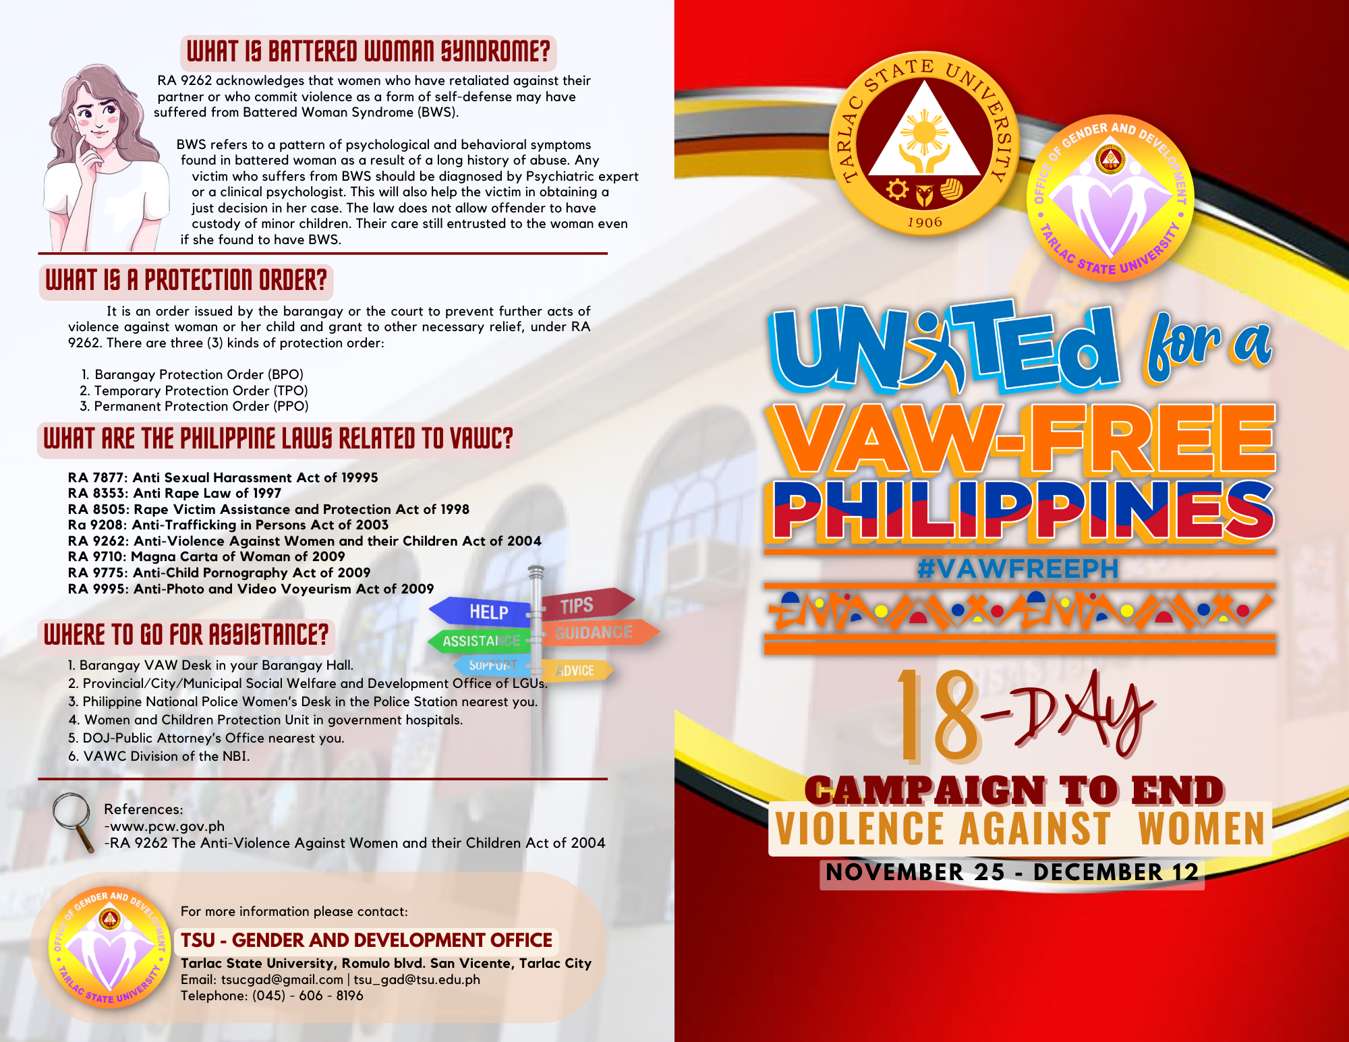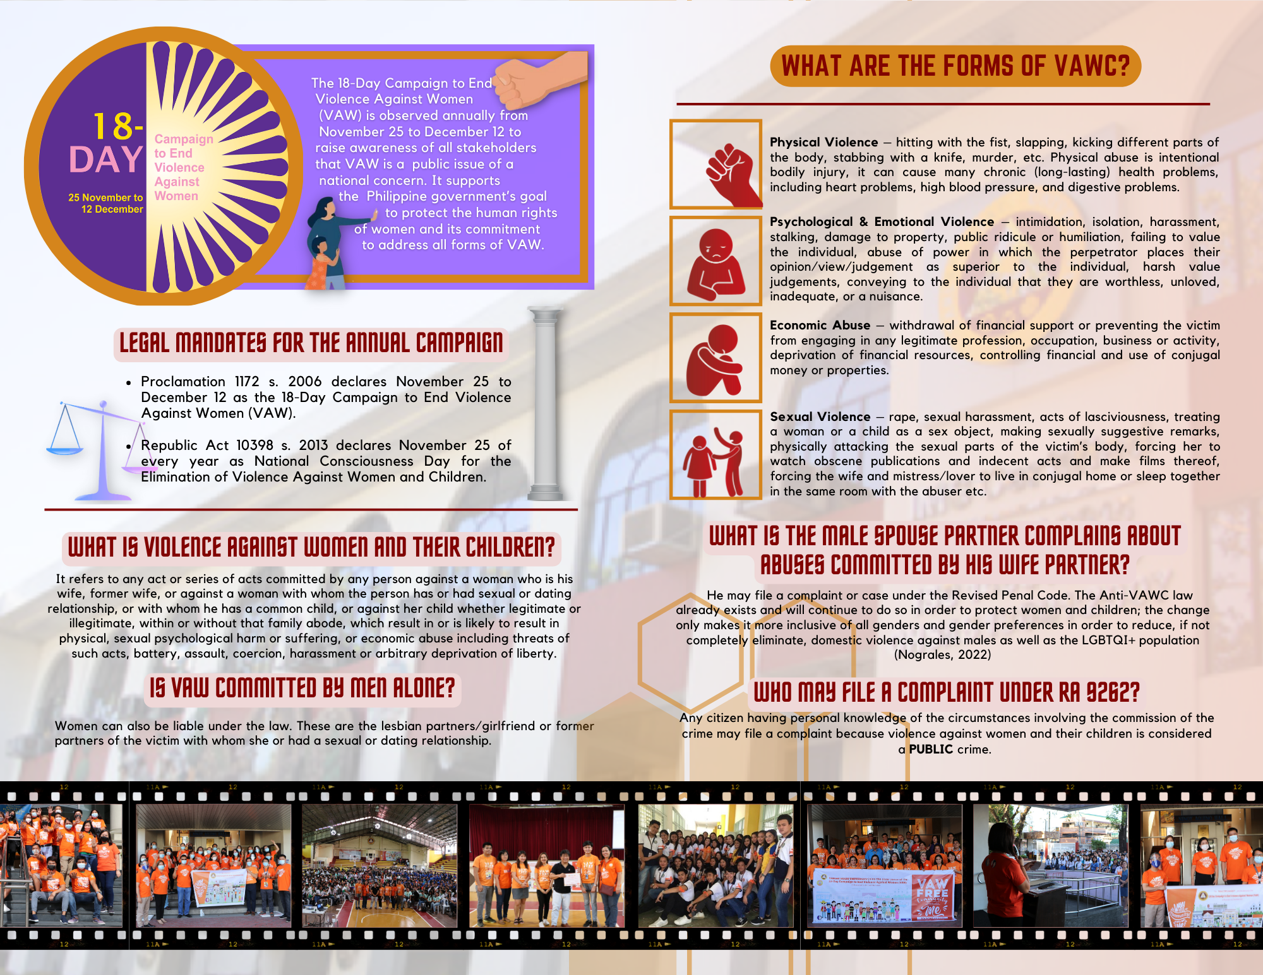

A.2 Executive, Faculty and Personnel Development
– Executive Development

Regional Hosting of the “RDC RGADC III Meeting”

As part of the 2022 National Women’s Month Celebration, the Regional Gender and Development Committee (RGADC) III with the Tarlac State University led the “Women Empowerment Webinar” in line with the celebration of the National Women’s Month last March 24, 2022, via ZOOM and Facebook live. Highlighting the theme of the 2022 NWMC “We Make Change Work for Women: Agenda ng Kababaihan Tungo sa Kaunlaran”, the Women Empowerment webinar aimed at providing opportunity to establish an integrated scheme to ensure sustainable development goals and provide awareness in calibrating women’s work and empowerment. The webinar is accentuated with a notable resource speaker and empowered woman from the Philippine Commission on Women, Dr. Joyce Mandejar Dy who shared her expertise and experience in promoting the empowerment of women. She emphasized two important sources of information about women – 1) the nature of man and the nature specifically of a woman from a creationist perspective and 2) the neurophysiological realities and facts about a woman’s brain which are inevitable and persistent changes.
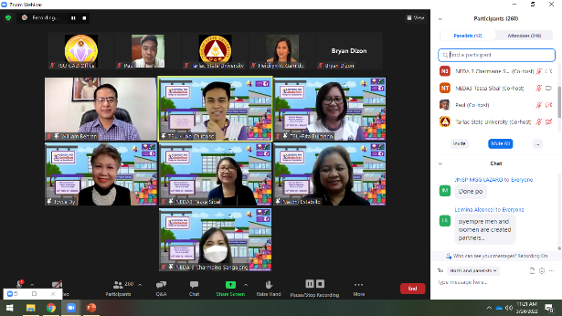
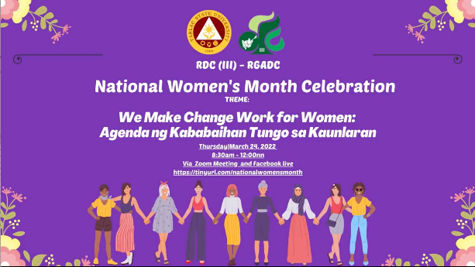

TSU-GFPS Capacity Building cum Benchlearning Activity at Cavite State University and View Park Hotel, Tagaytay City

As part of its commitment in advancing GAD advocacy within the university and community, TSU-Gender and Development Office conducted its TSU-GFPS Capacity Building Seminar and Benchlearning Activity in Cavite on October 27-28, 2022. The two-day activity commenced with the benchmarking with Cavite State University- Gender and Development Resource Center in Indang, Cavite under the leadership of Dr. Susan G. Tan, CvSU-GADRC Director.
Ms. Raechel A. Esteban, GADRC’s In-Charge of Planning, Monitoring, and Evaluation, shared an audio-visual presentation of the university’s best practice on GAD that publicized the GADRC’s services including budget allocation, mainstreaming of gender and development in instruction, research, and extension through the conduct of capability building such as trainings, seminars, workshops, and orientations among others. She also shared the establishment of Bookshare Corner and Lactation Station. Moreover, she also shared a synopsis on the establishment of MOVE (Men Opposed to Violence Everywhere) KATROPA (Kalalakihang Tapat sa Responsibilidad at Obligasyon sa Pamilya).

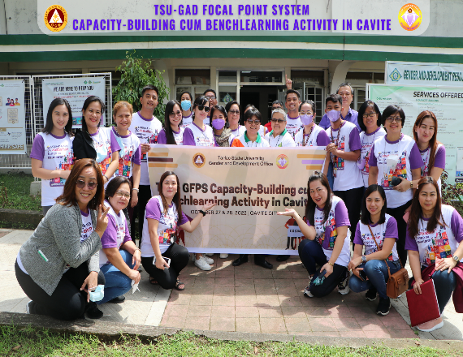
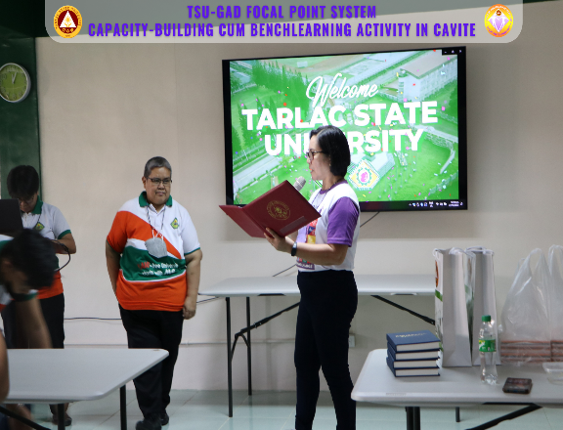
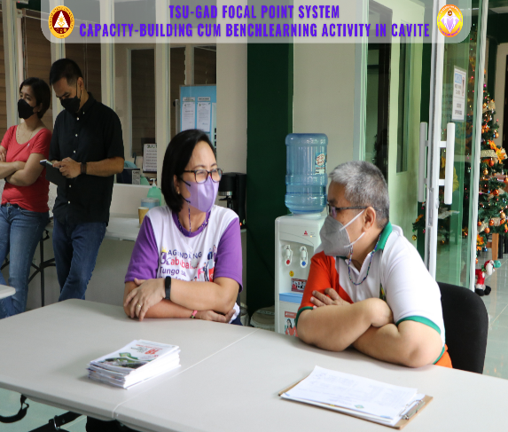
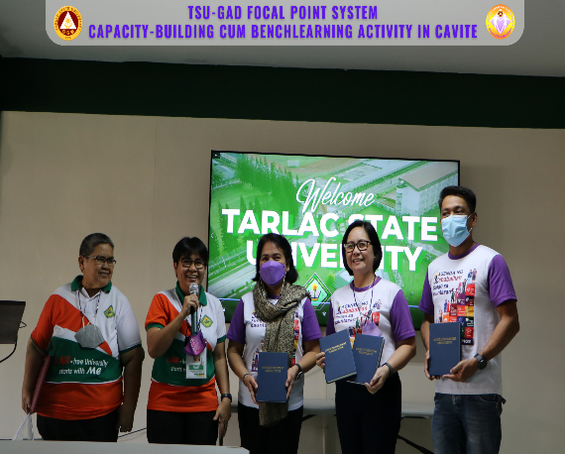

Gender in Research: Challenges and Opportunities towards Inclusion

GAD coordinators and staff attended an international free webinar on “Gender Research: Challenges and Opportunities towards Inclusion” held on March 8, 2022, via ZOOM meeting in line with the celebration of the International Women’s Day. The activity was part of the British Council’s webinar series on equality, diversity, and inclusion (EDI) in higher education. Likewise, it aimed at building awareness on EDI among SUCs in the country, promote gender equality in research, as well as discussion on ways to foster education in the field of research.

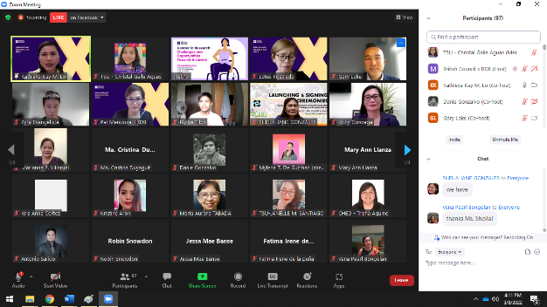
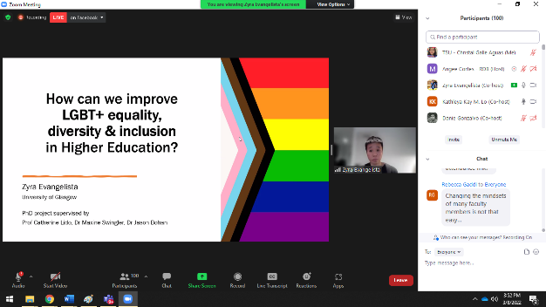

Go Negosyo Women Summit 2022

The biggest Women Entrepreneurship Summit in the Philippines, the Go Negosyo Women Summit 2022 was attended by GAD coordinators and staff on March 11, 2022, via ZOOM and Facebook live which was intended to inspire and support the importance of women’s economic power by covering different entrepreneurship and empowerment topics which were highlighted by notable speakers followed by a forum featuring prominent female leaders and personalities.
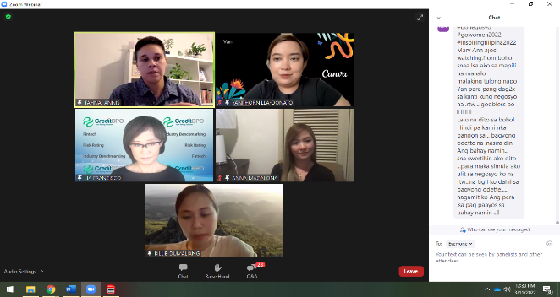
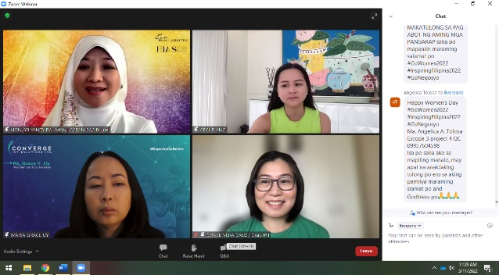

Basic First Aid and Basic Vital Signs: Strengthening Disaster Risk Reduction Skills

The National Service Training Program (NSTP) Office in partnership with the TSU – Gender and Development Office conducted and facilitated a webinar on “Basic First Aid and Basic Vital Signs with the theme: Strengthening Disaster Risk Reduction Skills” intended for NSTP trainers from lecturers and students in the university. The said webinar focused on 1) minimizing immediate risk to health and safety by controlling hazards following knowledge and skills required to perform basic first aid, 2) asses vital signs and physical condition by appropriate practice/procedure and available resources, and 3) monitor and record any accidents, injuries, or casualties under the proper procedures. In addition, the said webinar was held on February 21, 2022, Monday via ZOOM meeting.

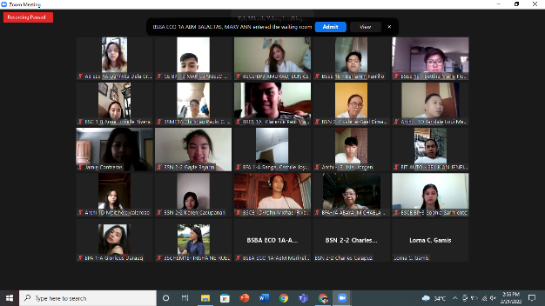
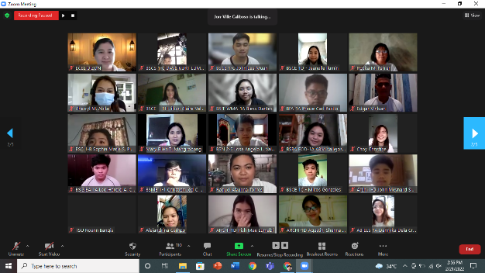
The NSTP and GAD Office invited resource speakers from the Medical Services Unit namely: Ms. Cherryl M. Abila, Ms. Dana Marie O. Pagala, Mr. Edel Mark C. Capiendo, and Ms. Danielle Anne D. Estrada who discussed an introduction to basic first aid and vital signs, heat-related emergency, airway obstructions, and bandaging techniques. The webinar was attended by a total of 60 participants among NSTP faculty and student trainers (18 male and 42 female). Furthermore, NSTP and TSU-GAD staff facilitated the activity.

Non-Academic Personnel Gender-Responsive Seminar/Team Building

The TSU – Non-Academic Staff Association (NASA) in partnership with the Gender and Development Office conducted a Gender-Responsive Seminar/Team Building on June 30, 2022 to July 2, 2022 at Lago de Oro, Calatagan, Batangas.

The first event on Day 1 (June 30) was a GAD-related seminar featuring TSU Executive Assistant to the President Dr. Brigido Corpuz as the guest speaker. Prior to Dr. Corpuz’s message, Ms. Cherry Lyn Onia, NASA Vice President and the activity host, honored previous NASA presidents, introduced the current NASA officers, and acknowledged the TSU officials who joined the teambuilding. Ms. Winniefe F. Gutierrez, Director of the Office of Administrative Service, delivered her opening remarks followed by messages from State Auditor Judy Cayabyab and GAD Director Rita E. Pulmano.

Dr. Corpuz emphasized in his message the importance of synergy in a group by defining the 5Cs – Cooperation, Coordination, Care, Commitment, and Communication. which are all considered vital in achieving the common objective of a group. He was awarded with a Certificate of Appreciation by TSU-NASA Officials headed by Pres. Wilma D. Salak.

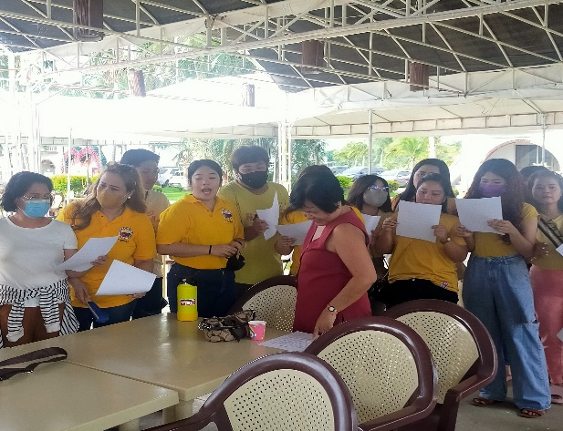
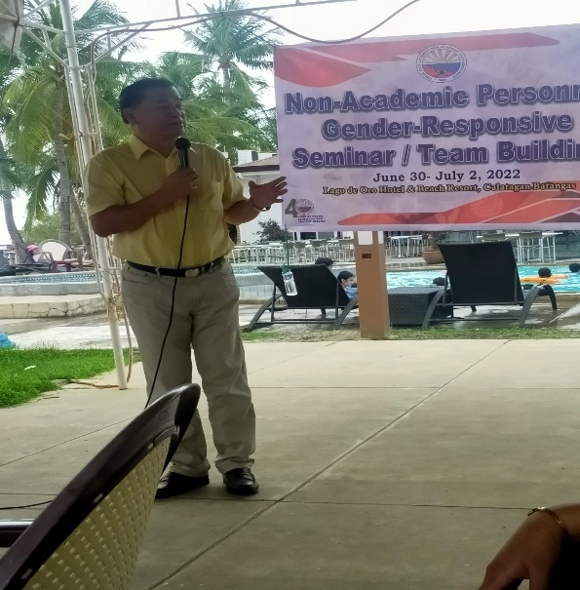
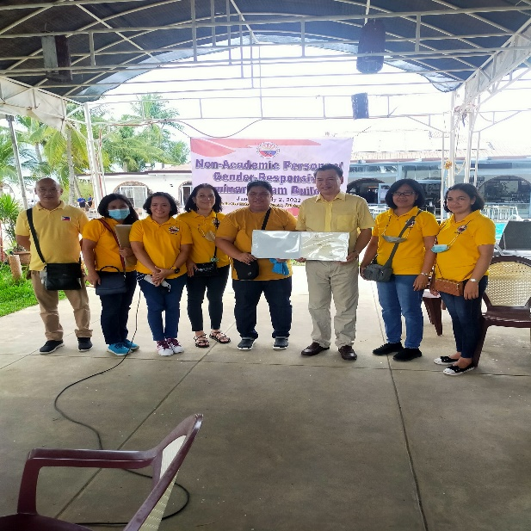
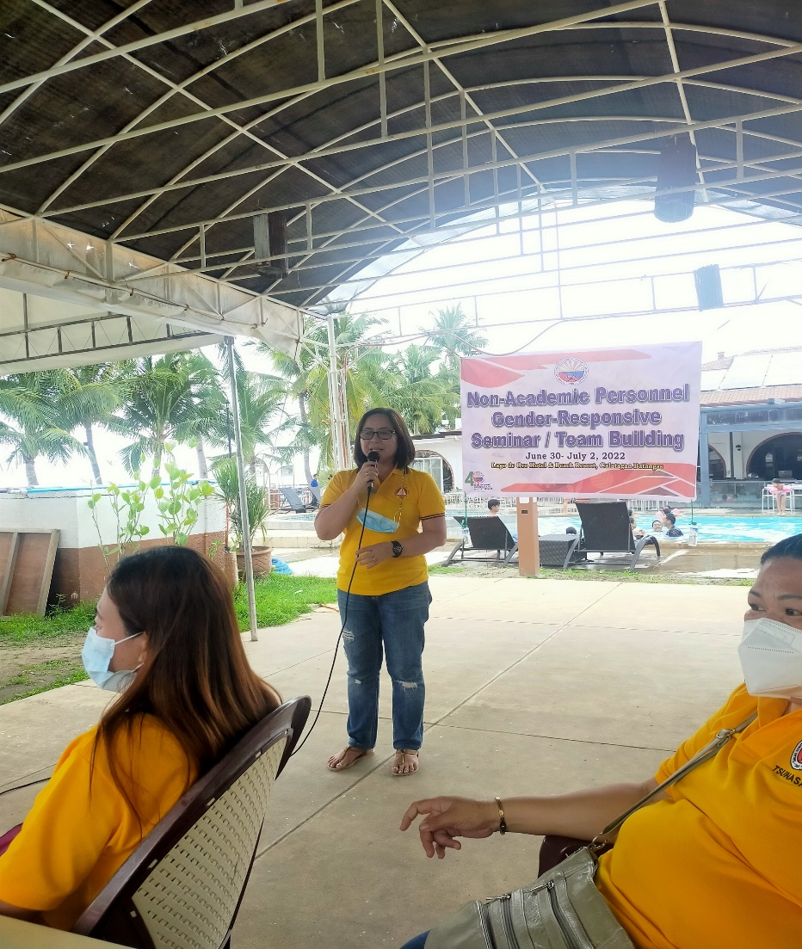

Gender Sensitivity Orientation for Newly Hired Employees

In consistent with the goal of the TSU - Gender and Development Office to promote gender-consciousness-raising, advocacy and affirmative action, and information dissemination, a gender sensitivity orientation for the newly hired employees of the institution took place in August 17, 2022 via Zoom. The purposeful event was initiated and led by the Gender and Development Office and the Human Resource Development and Management Office.

GAD Director Dr. Rita E. Pulmano officially started the program by delivering her opening remarks. In her message, she emphasized that the bottom line of conducting programs, such as GSO, is the respect that everyone must uphold regardless of position, gender, religion, etc. and develop sensitivity among others. .

The orientation had a morning and afternoon session. Ms. Rachel G. Ibale presented an overview of the Gender and Development Office and the Rationale of the Training in the morning, while Ms. Khyla Nicole Guevarra presented the overview and rationale in the afternoon. Moreover, Prof. Sheila Jane Gonzales (AM Session) and Mr. Bryan Jan S. Dizon (PM Session) led the discourse during the GSO proper. During the discussion, the differences between sex and gender were reiterated and social structures and social institutions were also explored.

Various audio and visual presentations were used to better delve into the concepts relating to gender sensitivity. Gender stereotypes were also debunked and ways to be more gender-sensitive and inclusive were cited. The orientation seminar, attended by 110 participants (58 female, 52 male), is one of the continuous efforts in the University in promoting gender equality and empowering the community to gain enough knowledge on gender sensitivity.

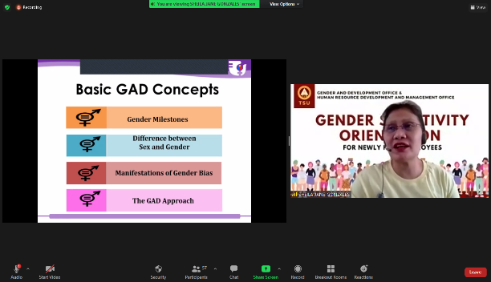
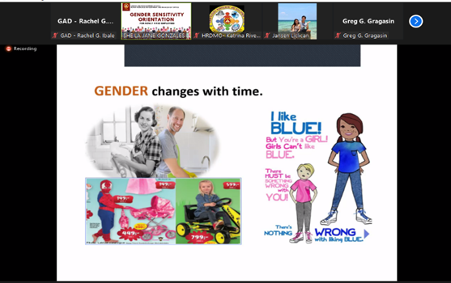
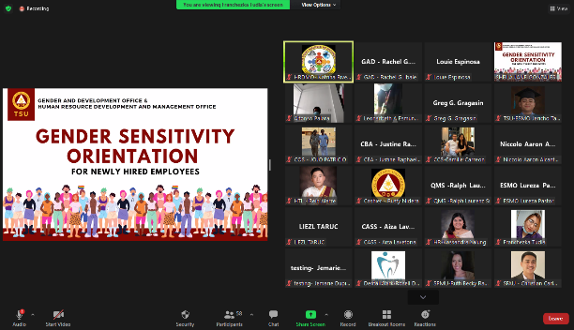
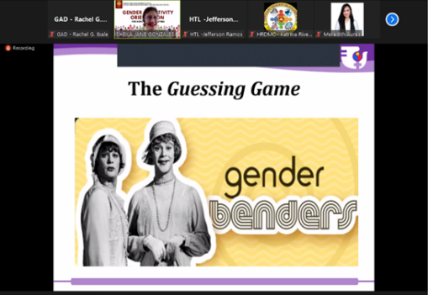

Safety in the Digital World: Cybercrime Awareness Seminar and Webinar

TSU-GAD in partnership with TSU-HRDMO conducted a seminar titled “Safety in the Digital World: Cybercrime Awareness” on September 21, 2022 at the Engineering Building – AVR and via Facebook Live.

This activity focused on the awareness of students/participants on the pre-emption, prevention, and prosecution of cybercrimes such as offenses against the confidentiality, integrity, and availability of computer data and systems, computer-related offenses, and content-related offenses. It also aimed to establish greater awareness and knowledge regarding illegal internet content and cybercrime among children, as well as parents and educators.

Additionally, it aimed to equip participants with the appropriate information regarding issues affecting gender and development such as human trafficking and sexual exploitation, especially in the cyberspace. The office invited the PNP Regional Anti-Crime Unit as resource speakers for the said seminar which was attended by a total of 90 students and staff of the university.
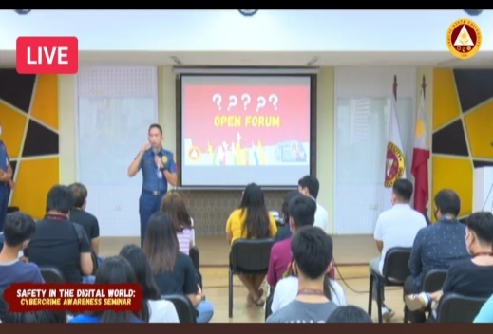
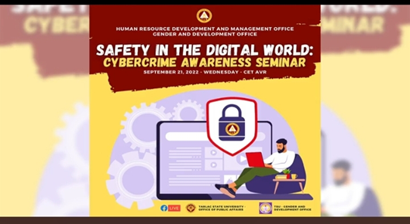
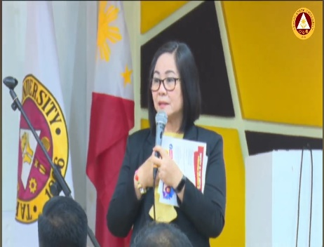

Mindfulness Day 2022: Dance Your Stress Away & YOGAwareness

The TSU – COESSE – The Psychological Society in partnership with the TSU - Gender and Development conducted and facilitated a two-session activity on October 1, 2022, at the TSU Gymnasium for the celebration of the Mindfulness Day 2022. The activity aims to introduce both dance and yoga as a way to distress in a fun, engaging way, and to connect with one’s inner self, respectively.

TSU-GAD invited Dr. Alberto L. Dimarucut and Ms. Priscilla S. Oro, currently an Assistant Professor at the University of the Philippines – College of Kinetics and a Yoga Teacher at the Yoga Playroom, Pampanga, respectively. Mr. Dimarucut facilitated the morning session where he highlighted the advantages of being physically active even indoors and demonstrated few basic movements that can help in improving balance, strength, endurance, and fitness.

In the afternoon, Ms. Oro facilitated the Yogawareness where she shared specific poses that help relieve stress and promote relaxation. She also emphasized that practicing yoga routinely could enhance concentration, improve memory, and exemplify mindfulness, especially to college students who battle the increasing stress on a daily basis. To conclude the event, the TSU-COESSE awarded a certificate of recognition to Dr. Dimarucut and Ms. Oro for their valuable insights and expertise. The successful activity was attended by 47 students.

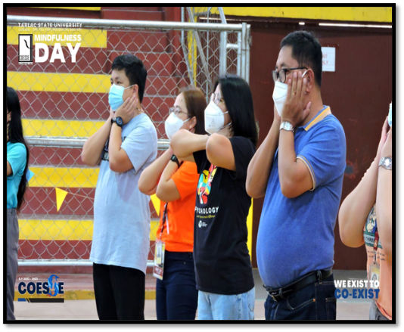
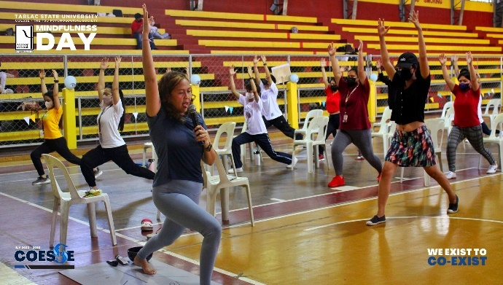
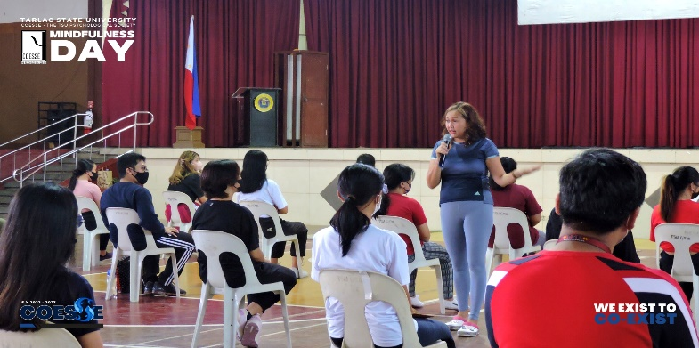
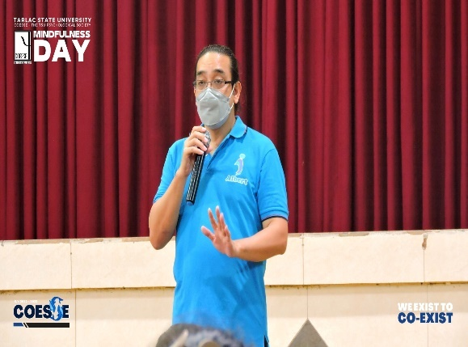
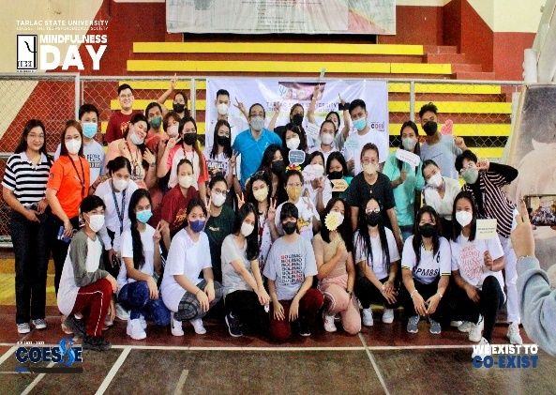
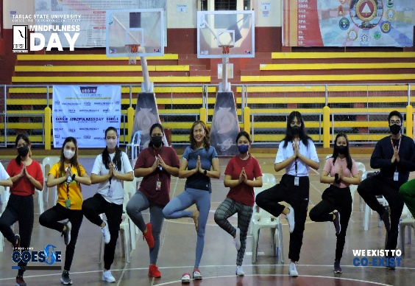

HIV Awareness Seminar

On December 1, 2022, the CBA – Student Council in partnership with the Gender and Development Office and the Kanlahi Community Center conducted an HIV Awareness Seminar with free testing at the TSU Gymnasium. The HIV Awareness Seminar is an activity to celebrate the HIV Awareness Day on December 1. This aims to increase knowledge and awareness in regards of HIV/Aids and debunk misconceptions and misinformation about the said virus. This will provide a safe space for discussions and queries about the impacts of the virus to individuals and to the society. A free HIV Testing will also be offered to the attendees of the event.

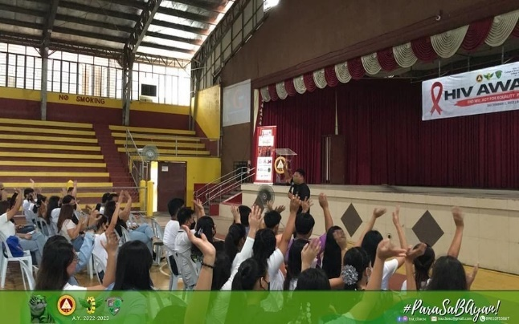
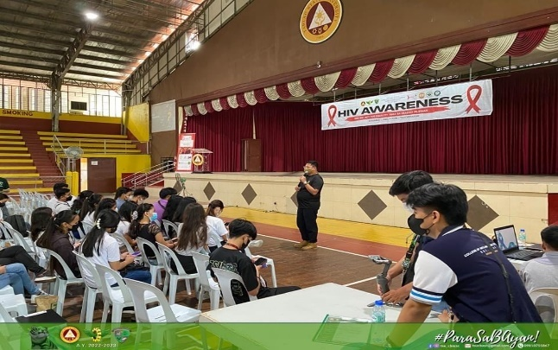

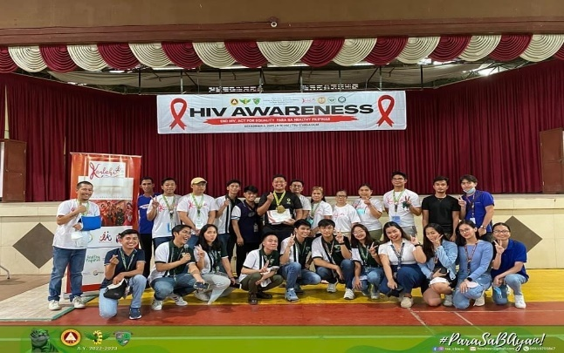
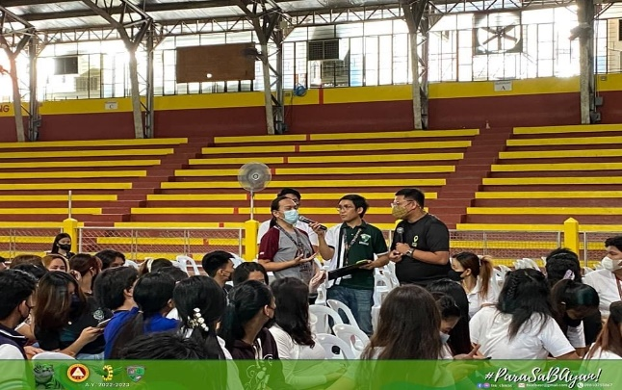

Roadmap B – Instructional Quality and Relevance Development Plan
Student Support Services Development

Stress and Time Management Webinar

The Supreme Student Council in partnership with the Gender and Development Office and National Training Program Office conducted and facilitated a webinar topic on “Stress and Time Management” on January 31, 2022, via ZOOM meeting. This webinar aimed at raising awareness and helping students to manage their time effectively and handling stress to improve student-life balance as it provides strategies for better time management. The TSU-GAD has invited Ms. Igielene T. Sapuay, resource pool from the Guidance and Counseling Unit and Associate Guidance Counselor of CASS & CBA. The activity was attended by a total of 393 (Male: 105; Female 288) participants coming from students from first-year students. Moreover, the TSU-GAD staff and SSC officers facilitated the activity.
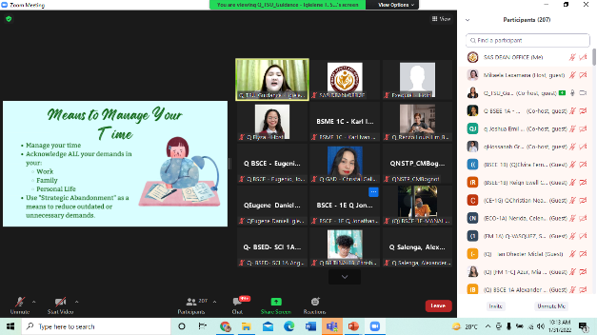
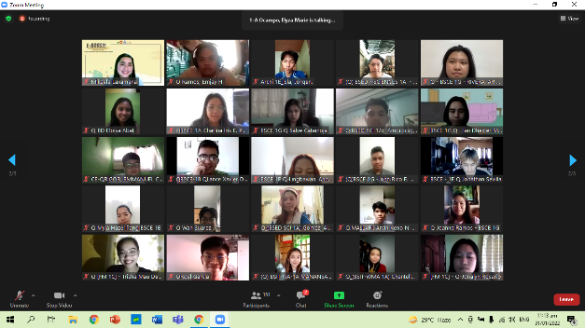

Kaagapay: Mindfulness Exercise and Activity for Health and Wellbeing of TSUians

The TSU – Supreme Student Council in partnership with the Gender and Development Office conducted and facilitated a timely webinar topic on Mental Health Awareness titled “Kaagapay: Mindfulness Exercise and Activity for Health Well-being of TSUians” on February 5, 2022, via ZOOM meeting. This webinar aimed at providing young people with a platform for genuine connection amid uncertainty and generate mental health awareness among young people and strengthen demand for integrated mental health and psychosocial interventions. The TSU-GAD has invited Ms. Jazmin Joy E. Dizon, a certified mental health first responder and a Psychology instructor in the university. Ms. Dizon emphasized the basic mindfulness meditation, formal and informal approaches, techniques, and benefits of mindfulness. The activity was attended by a total of 31 (Male: 6; Female 25) participants coming from NSTP students in the university. Moreover, the TSU-GAD and SSC officers facilitated the activity.
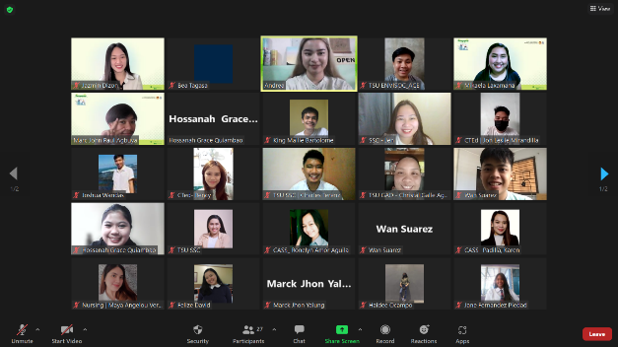
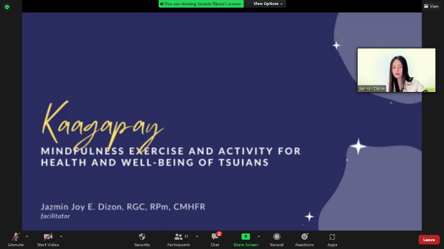

Work Ethics and Anti-Sexual Harassment (WEASH) Webinar

The Career Education and Job Placement Services (CEJPS) Unit in partnership with the TSU – Gender and Development Office conducted and facilitated the webinar series on “Work Ethics and Anti-Sexual Harassment (WEASH” intended for the upcoming student interns of the university. The activity was held on February 18, 2022, Friday via ZOOM. The purpose of the virtual activity was the understanding of the importance of developing a work ethic based on quality professionalism, and integrity, understanding the implications of proper ethics and social etiquette in a culturally diverse setting and environment, and (3) understanding and following the workplace policy regarding sexual harassment and it helps to promote and maintain a comfortable and safe work environment. The CEJPS and TSU-GAD have invited resource speakers for the activity. Prof. Gherold C. Benitez, from Student Affairs and Services served as resource speaker for Anti-Sexual Harassment-related discussion while Mr. Jon-Ville M. Caliboso, from the Training and Organizational Development Unit served as resource speaker for Work Ethics-related discussion. The webinar series was attended by CASS students from AB Psychology and AB Communication accumulating a total of 86 (58 female and 28 male) participants. Furthermore, CEJPS and TSU-GAD staff facilitated the activity.

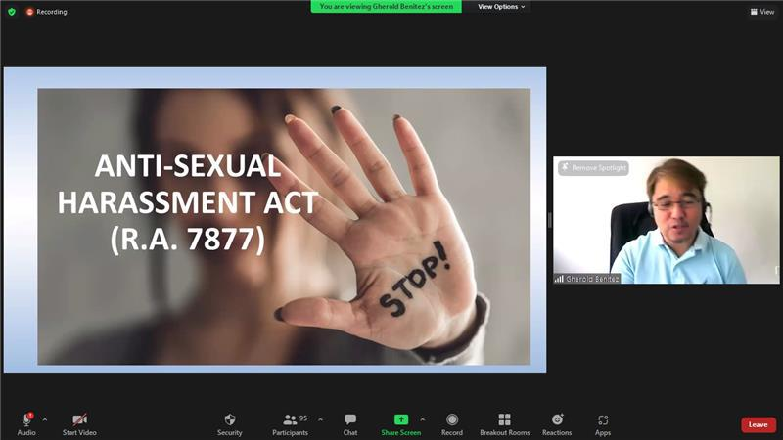
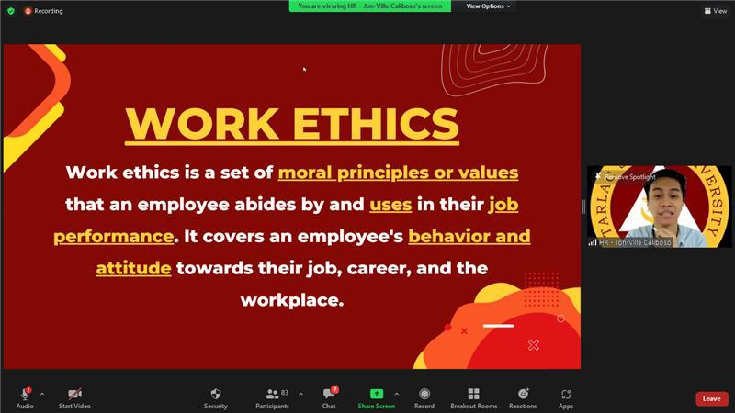

Mx. Warrior 2022

The Supreme Student Council in partnership with the TSU – Gender and Development Office conducted and facilitated the third search for the next “Mx. Warrior” of TSU which was held last February 19, 2022, via ZOOM and Facebook live through TSU – Supreme Student Council’s official page. It was participated by seven (7) lovely candidates representing their respective colleges. This activity is an annual pageant representing LGBTQIA++ community to strengthen the university’s advocacy in promoting gender equality and eco-friendly society. The newly crowned Mx. Warrior 2022 is Ms. Jelay Cruz from CPAG. Mx. Air, Xairhen Santos (CASS), Mx. Fire, Jeysn Martelino (CBA), Mx. Water, Mae Torres, COS, Mx. Land, Jessie Mercado (CTEd) were among other titles crowned in the said event. Meanwhile, various judges from different profession helped the organizers to choose among the candidates be crowned as Mx. Warrior.

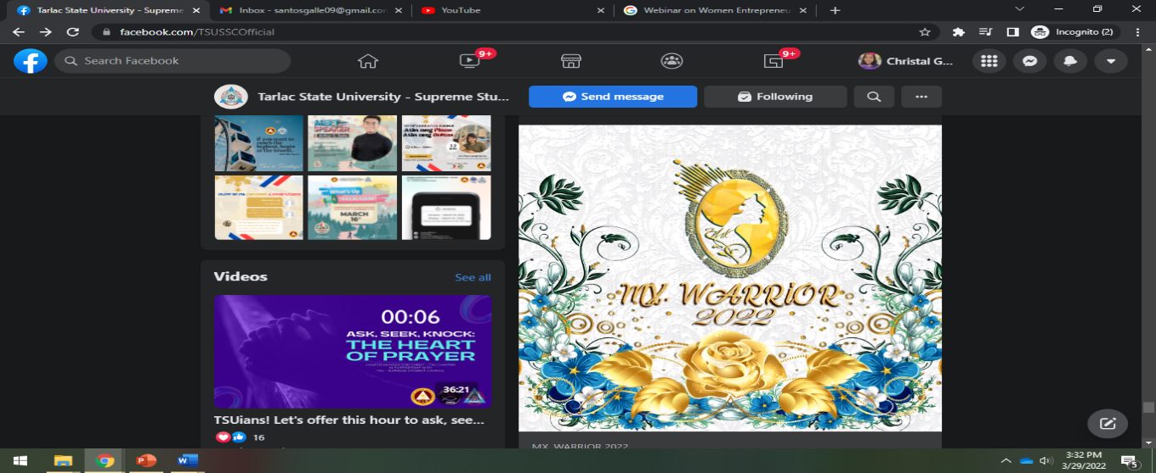
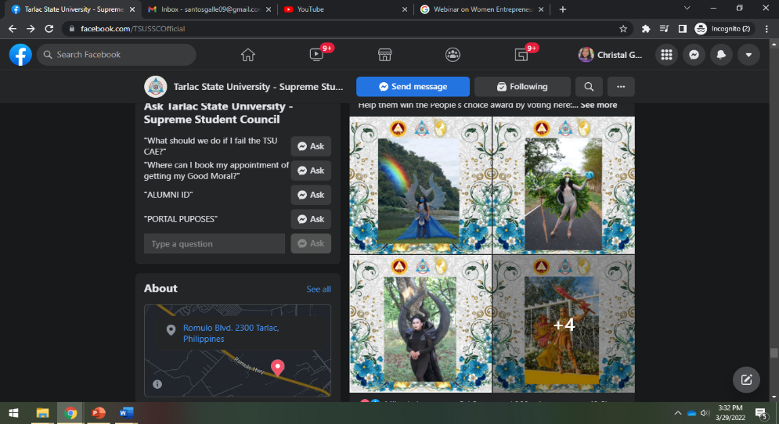
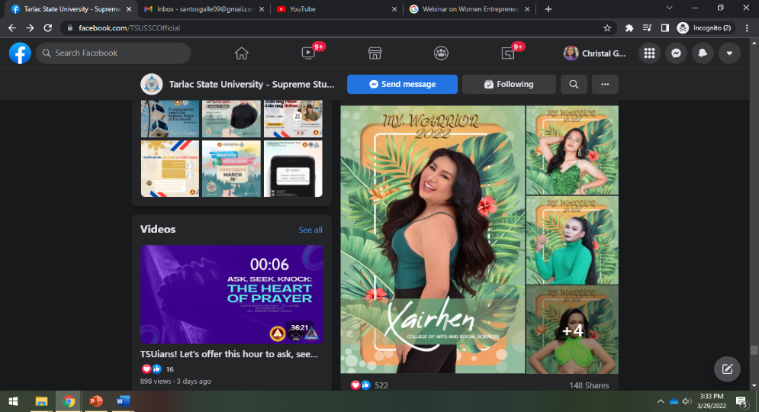
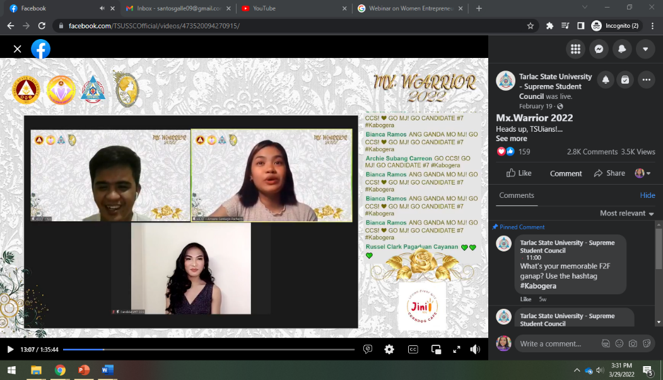

Women Empowerment Webinar

The Supreme Student Council in partnership with the Gender and Development Office organized a webinar on “Women Empowerment” in line with the 2022 National Women’s Month Celebration’s theme “We Make Change Work for Women: Agenda ng Kababaihan Tungo sa Kaunlaran” last March 5, 2022, via ZOOM meeting. The invited resource speaker for the said webinar is Dr. Victoria N. Apuan, a faculty member and women empowerment advocate from Miriam College. The webinar emphasized a coherent understanding of women’s empowerment and highlighted women’s achievements. Dr. Apuan also discussed continuing and emerging women’s empowerment and gender equality issues and concerns, challenges, and commitments.
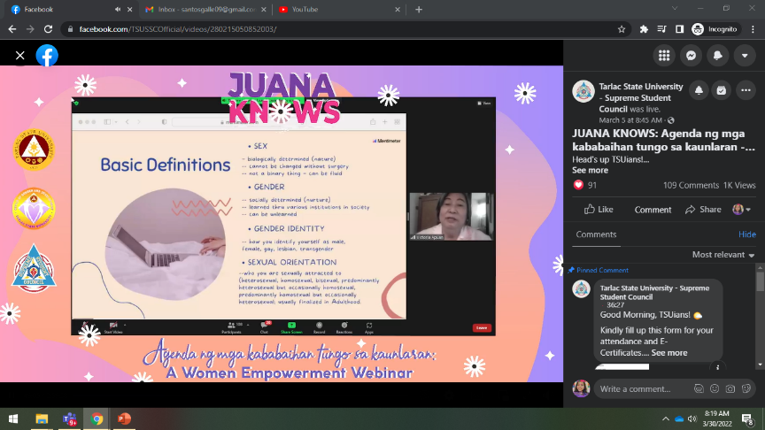
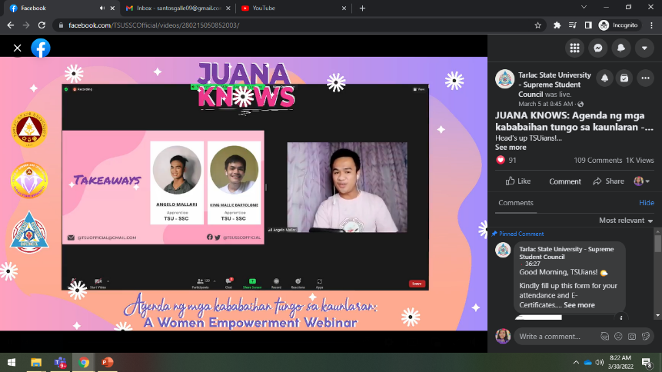

Safe Spaces Act (Bawal Bastos Law) Webinar

The TSU – Supreme Student Council in partnership with the Gender and Development Office conducted and facilitated a webinar titled “Safe Spaces Act (Bawal Bastos Law)” on April 18, 2022, via ZOOM meeting. The webinar focused on the important features of R.A. 11313, a law which covers all forms of gender-based sexual harassment committed in public spaces, educational or training institutions, workplace, and even online space.

The TSU-GAD invited Atty. Hendrix C. Bongalon, currently an attorney-at-law at Bongalon Law Office, Angeles City and a lecturer and Head of Labor Law and Social Legislation Department at Tarlac State University School of Law. Atty. Bongalon explained extensively the prohibited acts under R.A. 11313 and their corresponding penalties. It was also highlighted in the webinar that employers and school heads should ensure that sexual harassment in any form is not tolerated in the workplace/ institution. Otherwise, they can be held liable for not implementing the law or for not taking action on reported acts of gender-based sexual harassment committed in their institution.

Moreover, the speaker also emphasized the importance of creating internal mechanisms or grievance machineries in different institutions to encourage victims to speak up. These mechanisms will also provide an avenue for perpetrators to explain themselves and be afforded due process. In relation to this, TSU-GAD Director Rita E. Pulmano affirmed the students and even employees that GAD and other offices in TSU work together to assist them and to help them resolve their problems as much as they can. The activity, with a total of 110 attendees, was concluded by SSC President Mikaela Laxamana who emphasized the importance of respect and legal literacy in achieving safety and security.
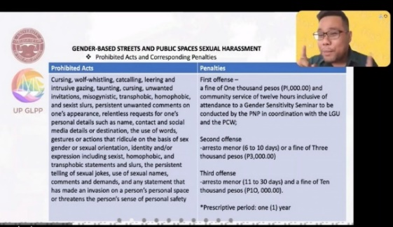
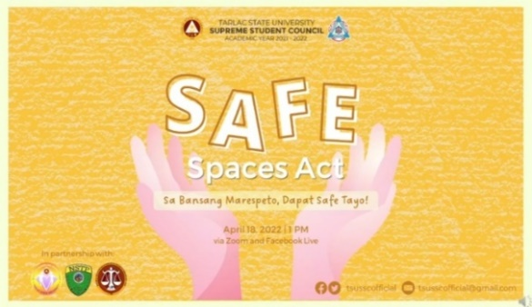
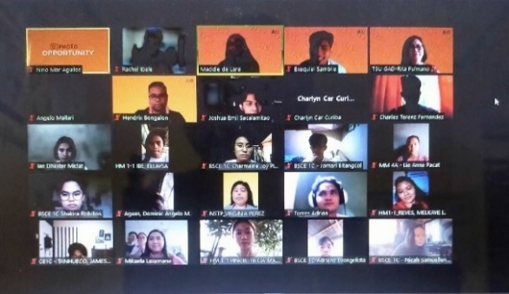

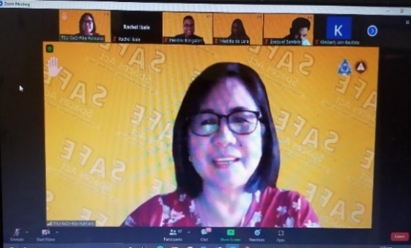

Men and Women Empowerment Webinar

The TSU – Supreme Student Council in partnership with the Gender and Development Office conducted a webinar titled “Men and Women Empowerment” on May 31, 2022 via Zoom. The webinar aimed to provide information on how the differences of nature of male and female influence the process of determining empowerment strategies. It also sought to recognize the significant roles and accomplishments of men and women in the community.

The TSU-GAD invited Dr. Joyce Mondejar-Dy, a counseling psychologist for organization and industry and a member of the Board of Trustees of the Philippine Adventist Counselor, Psychologists and Psychometricians Association, as resource speaker. Dr. Dy began her talk by explaining that empowerment is unique for each person because each person is unique. Aside from the biological differences between male and female, she also discussed the knowledge areas or disciplines that will help identify how empowerment process should be relative to the sex of the individual.

Moreover, the speaker also emphasized the importance of self-assessment to determine personal SWOC (strengths, weaknesses, opportunities, and challenge) and to identify the appropriate empowerment strategy that is appropriate for the person. Besides discussing the benefits of participating in Career Planning, Dr. Dy also encouraged the attendees to formulate their personal mission and vision statements. In addition, GAD Director Rita E. Pulmano suggested for a possible partnership with the Guidance Office in developing a regular program that will help assess the students’ needs in determining the empowerment or intervention strategies appropriate for each student.

This activity attended by a total of 167 students (89 female and 78 male) was concluded by the closing remarks of SSC President Mikaela Laxamana who encouraged the attendees to partake as agents of change and serve as catalysts of empowerment.
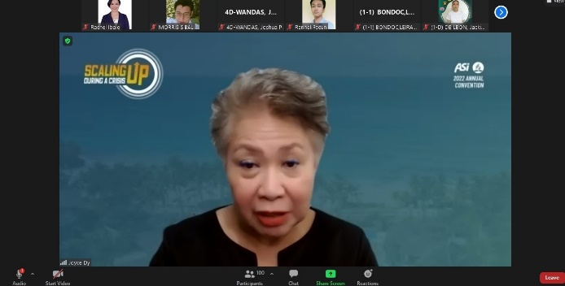
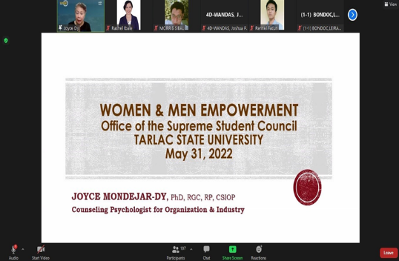
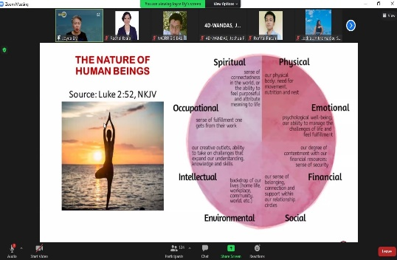
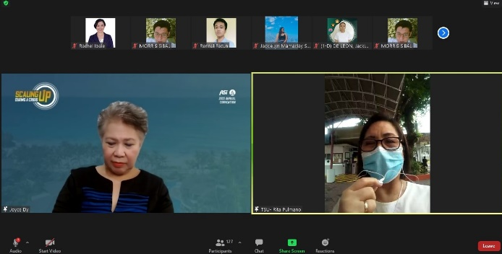

OUTSpoken: An Event that Celebrate Differences

On July 21, 2022, TSU-GAD in partnership with SSC conducted a talk show for the celebration of Pride Month with the theme “OUTSpoken: An Event that Celebrates Differences”. The talk show was aired on 87.9 Firefox Radio located at TSU College of Arts and Social Sciences Mini Theater Room, Smith Hall. It aimed to celebrate diversity among the LGBTQIAA+ community, as well as to share variegated stories and awareness in the society.

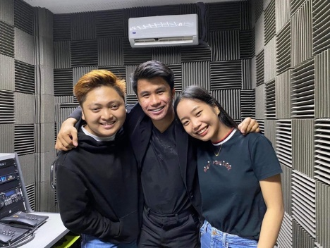

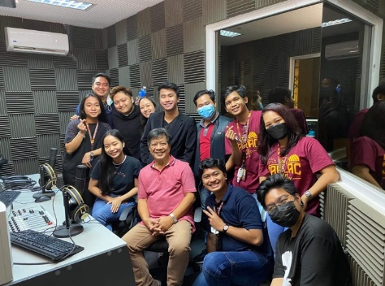
Gender Sensitivity Orientation

The College of Business and Accountancy – Student Council in partnership with the TSU - Gender and Development conducted and facilitated a gender sensitivity orientation via Zoom and streamed on Facebook Live on August 22, 2022. The orientation is a regular event done with different units and colleges by the GAD to ensure the attainment of the goal of conducting trainings and seminars on gender and development in order to elevate awareness on gender concerns and issues in the TSU community.

TSU-GAD invited Assistant Professor Shiela Jane L. Gonzales, currently a professor at Tarlac State University College of Business and Accountancy. Asst. Prof. Gonzales highlighted the difference between sex orientations and gender roles. The stereotypes and stigma within the community of people belonging to the LGBTQIA+ was also discussed. An audio and visual presentation showcasing how to break the gender code, illustrating, and reminding that men can be feminine and that women can be masculine were also part of her talk.
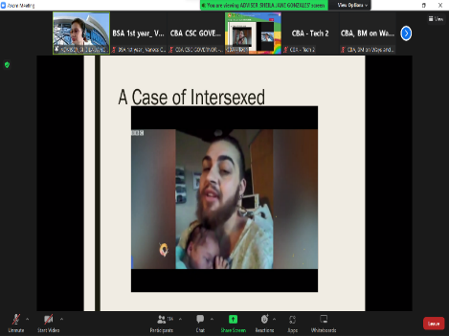
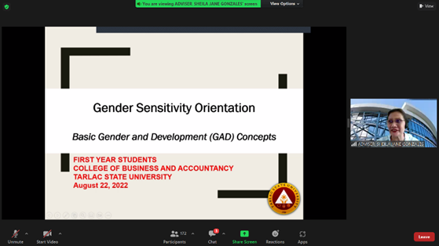
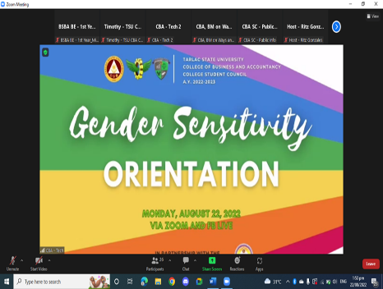

Work Ethics and Safe Spaces Act Webinar for CPAG Student Interns

The Career Education and Job Placement Services (CEJPS) Unit in partnership with the TSU – Gender and Development Office conducted and facilitated the webinar series on “Work Ethics and Safe Spaces Act (WESSA)” intended for the College of Public Administration and Governance (CPAG) student interns of the university. This activity is in compliance with the CMO No. 104 s. 2017 of the Revised Guidelines for Student Internship Program in the Philippines (SIPP) for all programs for all programs and the University’s On-The-Job Training Manual (TSU-VPA-01-02) or the guidelines for the implementation of Flexible Industry Immersion program.

The WESSA was held on September 5, 2022, Monday via ZOOM. The purpose of the virtual activity was to understand the importance of developing work ethics based on quality professionalism, and integrity, to understand the implications of proper ethics and social etiquette in a culturally diverse setting and environment, and to understand and follow the workplace policy regarding sexual harassment. It also helps to promote and maintain a comfortable and safe work environment.

The CEJPS and TSU-GAD invited Prof. Winifredo Luis as the resource speaker for Safe Spaces Act, while Mr. Jon-Ville Caliboso was invited to discuss the importance of Work Ethics. The webinar was attended by CPAG fourth-year students who are currently enrolled in the subject PAP 1- Practicum in any Government Organization accumulating a total of 155 (80 female and 75 male) participants.
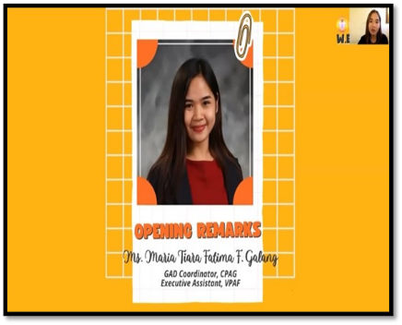
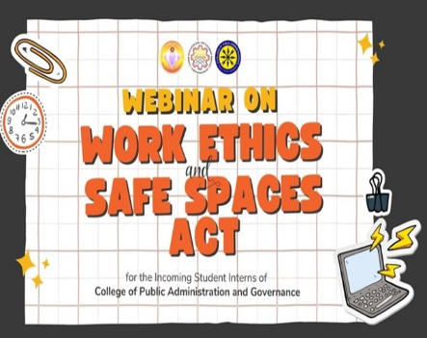
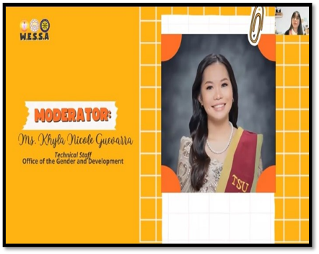
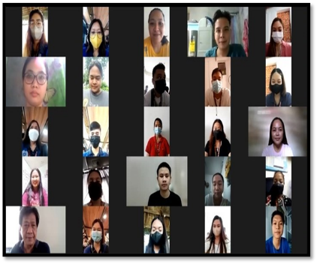
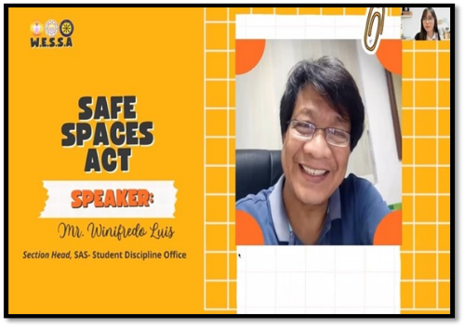
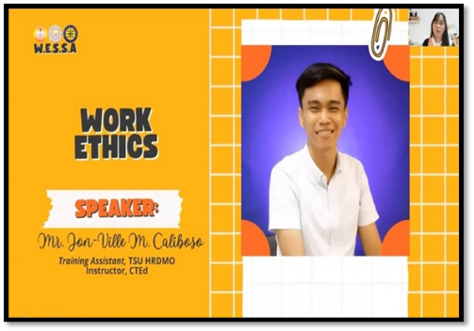

Work Ethics and Safe Spaces Act for Student Interns of the University

In compliance with the CMO No. 104 s.2017 of the revised Guidelines for Student Internship Program in the Philippines (SIPP) for all programs and the University’s On-The-Job Training Manual (TSU-VPA-01-02) or the guidelines for the implementation of Flexible Industry Immersion program, the Career Education and Job Placement Services (CEJPS) Unit in partnership with the TSU-Gender and Development Office conducted and facilitated the webinar titled “Work Ethics and Safe Spaces Act (WESSA)” intended for the student interns of the university.

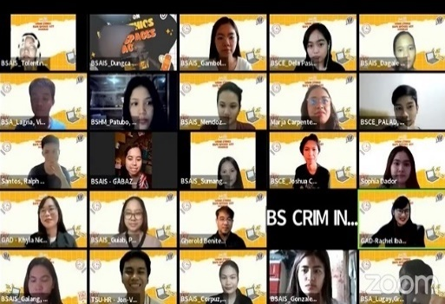
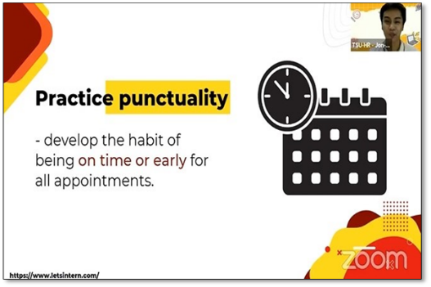
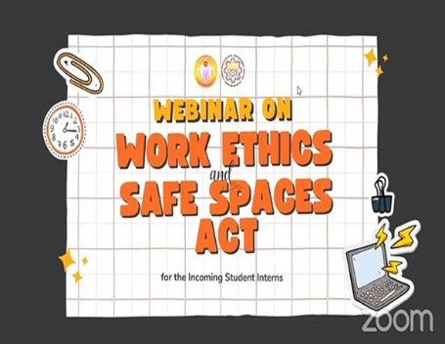
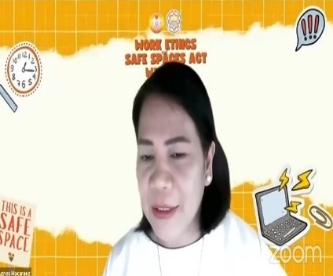
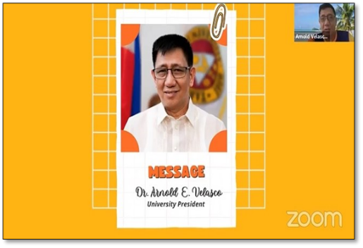
The WESSA was held on September 17, 2022, Saturday at 8:00 AM to 12 noon via ZOOM and FB Live. The webinar was facilitated by GAD technical staff, Ms. Khyla Nicole Guevarra and Ms. Rachel G. Ibale. The purpose of the virtual activity was to understand the importance of developing work ethics based on quality professionalism, and integrity, to understand the implications of proper ethics and social etiquette in a culturally diverse setting and environment, and to understand and follow the workplace policy regarding sexual harassment. It also helps to promote and maintain a comfortable and safe work environment. The CEJPS and TSU-GAD invited Prof. Gherold C. Benitez as the resource speaker for Safe Spaces Act, while Mr. Jon-Ville Caliboso was invited to discuss the importance of Work Ethics. The webinar was attended by fourth-year students who are currently student interns this First Semester accumulating a total of 854 (451 female, 403 male) participants.


Extroverts and Introverts among Gen Z: How the Pandemic Disrupted our Social Behavior

The TSU – Junior Financial Executives in partnership with the TSU - Gender and Development conducted and facilitated a gender and development webinar series via Zoom and streamed on Facebook Live on September 24, 2022, for its first day. The webinar series was attended by Junior Financial Executives from different college in Central Luzon.

TSU-GAD invited Ms. Jazmin Joy E. Dizon, currently an Instructor I at the Psychology Department of Tarlac State University – College of Arts and Social Sciences. Ms. Dizon introduced and furthered the knowledge of the attendees about introversion and extroversion. She also presented the effects of the pandemic to both introverts and extroverts, highlighted the key features of Gen Z in tackling different circumstances related to their emotional being, and reminded the attendees that it is okay not to be okay after citing few techniques that may help them in coping on adverse situation such as the pandemic. After Ms. Dizon’s talk, some attendees shared their thoughts and takeaways from the topic and discussion. The speaker willingly answered questions and actively responded to the clarification and sharing of the attendees.

To conclude the event, the TSU - JFINEX awarded a certificate of recognition to Ms. Jazmin Joy E. Dizon for her valuable insights and expertise about the subject matter. Through the words of the JFINEX and JCFAP Region 2 Adviser and TSU – JFINEX President, Prof. Christine Janelle Santiago and Ms. Ingrid Pobano, the organizers were able to express their gratitude to the 897 students who attended the event conducted by TSU - JFINEX and the TSU – Gender and Development Office.
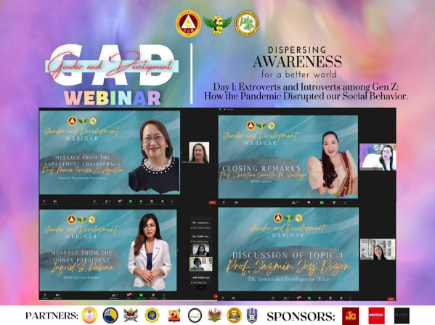
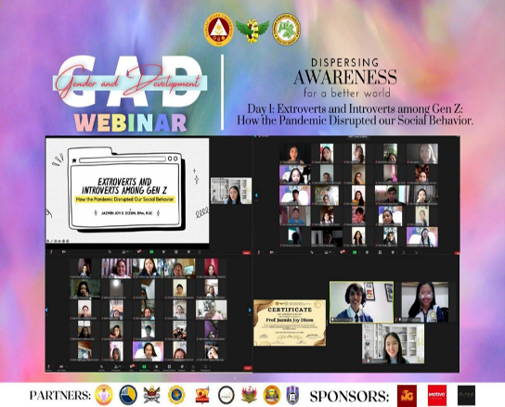

Project Kaagapay: All of Us Needs Saving – A Suicide Prevention Webinar

The TSU – Supreme Student Council in partnership with the TSU - Gender and Development conducted and facilitated a suicide prevention webinar entitled “All of Us Needs Saving: A Suicide Prevention and Awareness Webinar” via Zoom and streamed on Facebook Live on October 1, 2022. This activity aims to create an avenue for students to interact with fellow students and get inspired and raise awareness through the virtual talk of the resource speaker. In addition, it aspires for the students to feel valued, supported, and elevate awareness of measures that would prevent mental health issues and suicide.

TSU-GAD invited Ms. Jazmin Joy E. Dizon, RGC, RPm, currently an Instructor I at the Psychology Department of Tarlac State University – College of Arts and Social Sciences. Ms. Dizon initially debunked some myths about mental health concerns regarding suicide, and also elaborated the struggles one experiences during the challenging times of mental stability. Afterwards, the question-and-answer portion commenced where participants had their questions raised. In parallel with the vision of this webinar, the talk ended with an encouragement to be of help and be a provider of a shoulder to lean on to those who need one.

To conclude the event, the TSU – Supreme Student Council awarded a certificate of recognition to Ms. Jazmin Joy E. Dizon for her valuable insights and expertise about the subject matter. Through the words of the TSU – SSC President, Hon. Bea Claren Tagasa, the organizers were able to express their gratitude to the 108 students who attended the event conducted by TSU - SSC and the TSU – Gender and Development Office.
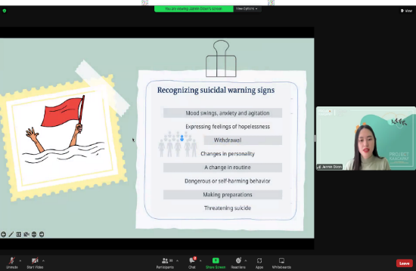
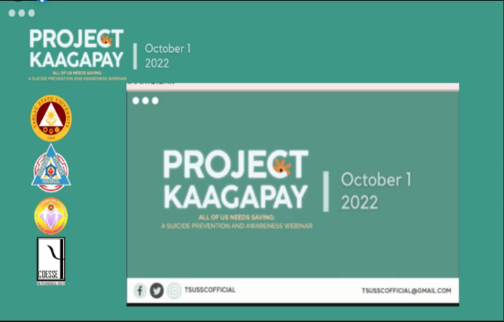

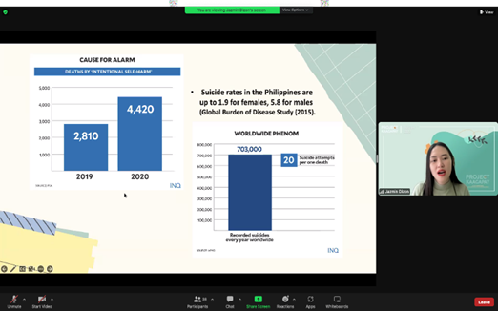
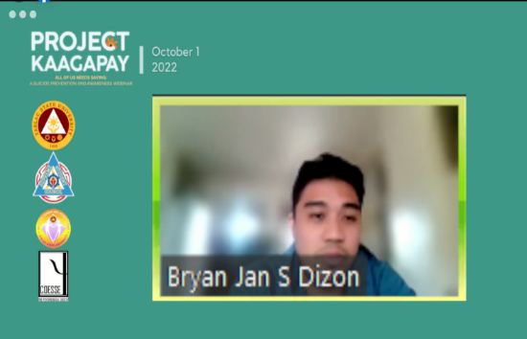

Fear of Missing Out (FOMO) among Gen Z: The Root of this Phenomenon and How to Avoid It

The TSU – Junior Financial Executives in partnership with the TSU - Gender and Development conducted and facilitated a gender and development webinar series via Zoom and streamed on Facebook Live on October 3, 2022, for its second day. The webinar series was attended by Junior Financial Executives from different college in Central Luzon.

TSU-GAD invited Assoc. Prof. Laarni T. Capinding, currently an Associate Professor I at the Psychology Department of Tarlac State University – College of Arts and Social Sciences. Ms. Capinding introduced and furthered the knowledge of the attendees of the phenomenon called fear of missing out or FOMO. She also started the conversation through asking questions using Mentimeter, exposed the root cause of FOMO and its interconnection with social media, encouraged self-assessment, and reminded the attendees that it is fine to miss some few things out after citing few pointers that may help them in coping whenever they experience this phenomenon. After Ms. Capinding’s talk, some attendees shared their thoughts and takeaways from the topic and discussion. The speaker willingly answered questions and actively responded to the clarification and sharing of the attendees.

To conclude the event, the TSU - JFINEX awarded a certificate of recognition to Assoc. Prof. Laarni T. Capinding for her valuable insights and expertise about the subject matter. Through the words of the JFINEX and JCFAP Region 2 Adviser and TSU – JFINEX President, Prof. Christine Janelle Santiago and Ms. Ingrid S. Pobano, the organizers were able to express their gratitude to the 534 students who attended the event conducted by TSU - JFINEX and the TSU – Gender and Development Office.
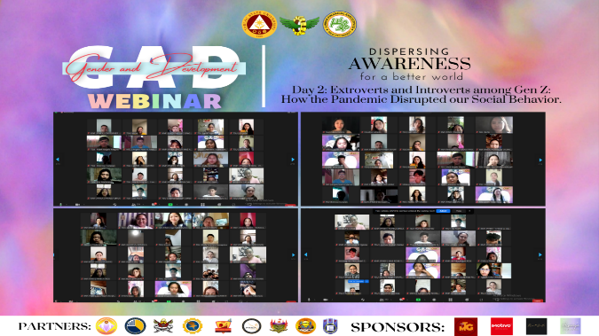
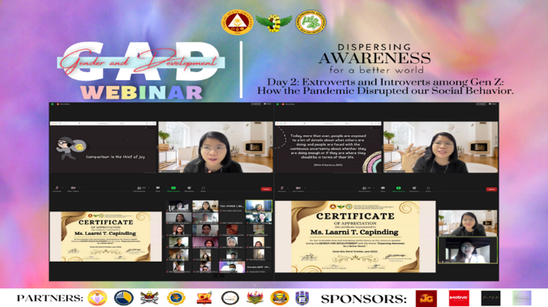

Safe and Sound: Safe behind Words, the Sound of your Voice is Heard

On October 18, 2022, TSU- Junior Philippine Society of Public Administration in partnership with the Gender and Development Office held a DEBATE WORKSHOP themed “Safe and Sound: Safe behind Words, the Sound of Your Voice is Heard.” The program started at 9:00 AM in the morning at the CET AVR.

The organization invited Mr. Masahiro Kobayashi of Bulacan State University as the speaker of the event. He demonstrated his expertise and field of work with his lecture on gender and debate. This face-to-face workshop would not have been possible without his enthusiastic support. As the venerable Sir Kobayashi said: "There are no losers in debate. If you win--you win. If you lose, you learn something new." This activity was attended by 78 students from the College of Public Administration and Governance and College of Engineering.
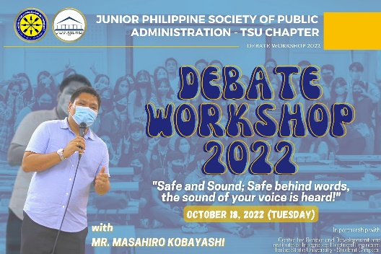
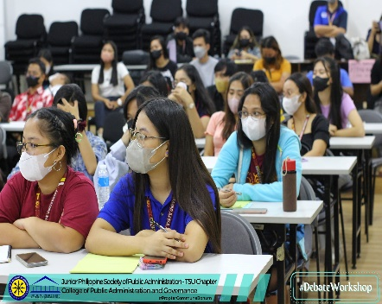
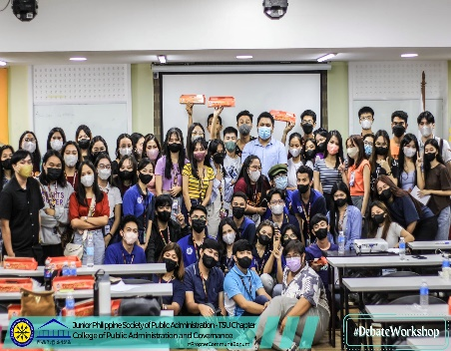

BRIDGES: Better Roads in Developing Great Entrepreneurial Spirit

The TSU – CBA Young Entrepreneurs’ Society in partnership with the Gender and Development Office conducted the very first Economic Enterprise Development Unit’s Entrepreneurial Skills Competition titled “BRIDGES: Better Roads in Developing Great Entrepreneurial Spirit” on November 7 to 11, 2022 at TSU Main Campus. This activity aimed to enhance entrepreneurial skills of all TSU students regardless of their course. This also provided students the venue to present their start-up businesses to the TSU community and entrepreneurial experts.

By showcasing their leadership, camaraderie, social responsibility, and most especially, their entrepreneurial skills, the following teams aced the competition. Team OUI, under the leadership of Mr. Allen Dale O. Embesan, garnered 1st Place in the competition; Team PIIE, headed by Ms. Jolina P. Sumat won 2nd Place; 3rd Place goes to Team PICE, led by Ms. Joi Alliah P. Pangilinan; and Team IDIMSS, under the leadership of Ms. Aira Lyn Rivera, won 4th Place (Consolation Prize)..
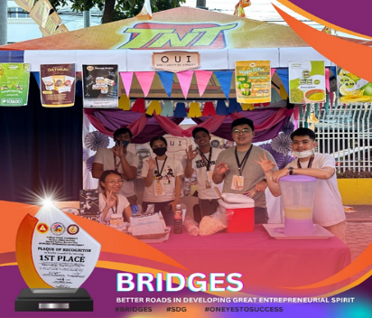
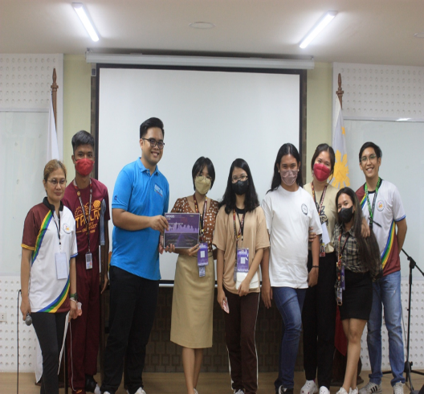
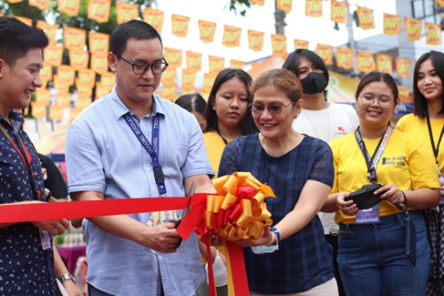

Titindig Ako Kasama Mo: Webinar on Anti-Violence Against Women and Children Act

The College of Business and Accountancy – Student Council in partnership with the TSU - Gender and Development conducted and facilitated a webinar regarding the Republic Act 9262 entitled “Titindig Ako Kasama Mo” via Zoom and streamed on Facebook Live on November 19, 2022. The webinar about the said law is a regular event conducted by GAD to ensure the attainment of the goal of conducting trainings and seminars on gender and development in order to elevate awareness on gender concerns and issues in the TSU community.

TSU-GAD invited Attorney Catherine Rose G. Diaz-Cunanan, currently an instructor at Tarlac State University – School of Law. Atty. Diaz-Cunanan defined the vital terms related to the RA 9262 such as victim, dating relationship, sexual relations, and such. The gender biases and prejudices were also discussed. Atty. Diaz-Cunanan also cited ways how to help and what to do during cases of unlawful events and she discussed the potential psychological damage the violence can do to the victims or the Battered Woman Syndrome. Atty. Diaz-Cunanan wrapped up her presentation by reminding everyone that we cannot succeed when half of us is held back. Some questions and clarifications were answered by Atty. Diaz-Cunanan regarding her discussion.
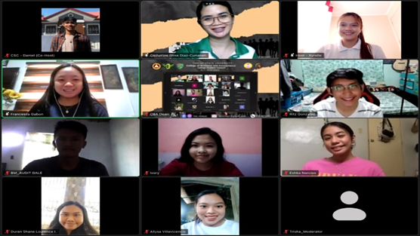
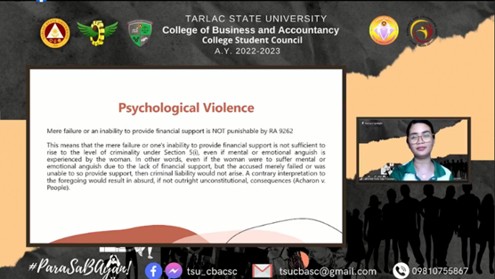
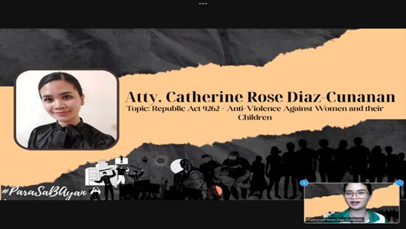

Titindig Ako Kasama Mo: Breaking the Stigma and Overcoming Violence and Trauma

The College of Business and Accountancy – Student Council in partnership with the TSU - Gender and Development conducted and facilitated a webinar regarding the Republic Act 9262 entitled “Titindig Ako Kasama Mo” via Zoom and streamed on Facebook Live on November 21, 2022. The webinar about the said law is a regular event conducted by GAD to ensure the attainment of the goal of conducting trainings and seminars on gender and development in order to elevate awareness on gender concerns and issues in the TSU community.

TSU-GAD invited Mr. Jaymar T. Patana, currently a Program Development Officer at USAID Renew Health Project. Mr. Patana started his presentation by an emotion check and then established the learning goals for the webinar. He later defined the key terms such as ‘trauma’ through the lens of a psychological perspective and differentiated its different types. Mr. Patana also discussed the biological aspects of trauma and cited healthy coping mechanisms. He ended his presentation by reminding everyone that it is important to know how to battle stress and other negative emotions. A question-and-answer segment followed his presentation to clarify and answer queries related to the psychological matters of the law.

To conclude the event, the CBA – Student Council awarded a certificate of recognition to Mr. Jaymar T. Patana for his valuable effort in sharing his expertise and draw raffle winners. Through the words of the governor of the student council, Mr. Timothy Julian L. Bote, the student leaders were able to express their gratitude to the 16 students, 14 females and 2 males, in the Zoom call and to those who are watching via Facebook Live for the event conducted by their council and the TSU – Gender and Development Office.
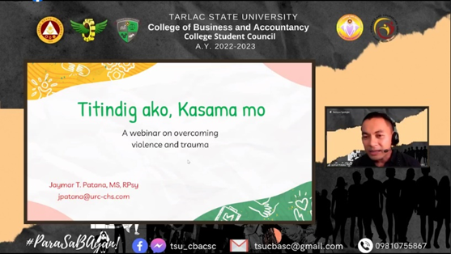
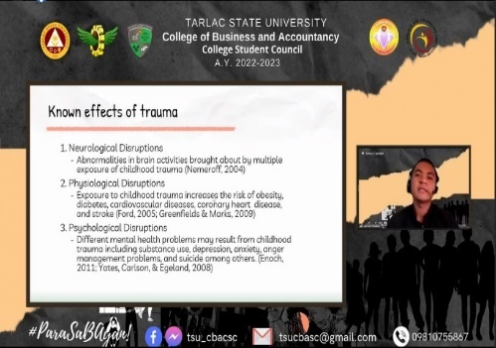
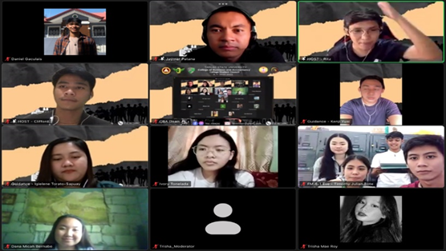

Stress Management Webinar: Let Your Feelings Out

The TSU – College of Teacher Education Student Council in partnership with the Gender and Development Office conducted a webinar titled “Stress Management Webinar: Let Your Feelings Out” on November 28, 2022 via MS Teams. The webinar aimed to help the students breathe and be reminded of the importance of stress management. It was also intended to help participants gain the necessary skills that they need in order to cope with the demands and pressures of daily living. The program formally started with GAD Coordinator, Prof. Jovy P. Tomas, introducing Dr. Erwin P. Lacanlale, currently a professor at TSU- College of Teacher Education, as the resource speaker. GAD Director Dr. Rita E. Pulmano also delivered her opening remarks.

Dr. Lacanlale began his discussion by defining the word “stress” and emphasizing the different types of stress, such as eustress and distress. He presented a list of unhealthy ways of coping with stress like smoking, drinking too much, procrastinating, and using pills or drugs to relax. Furthermore, the speaker shared some strategies on how to deal with stress. He highlighted the importance of a stress journal which can help in identifying regular stressors and usual and helpful ways to deal with them.

At the end of the webinar, Dr. Lacanlale emphasized that there is no single method that works for everyone or in every situation. However, one must focus on what makes he/she feel calm and in control. This activity was attended by a total of 143 participants and was concluded by the closing remarks of Ms. Chastine Parazo.
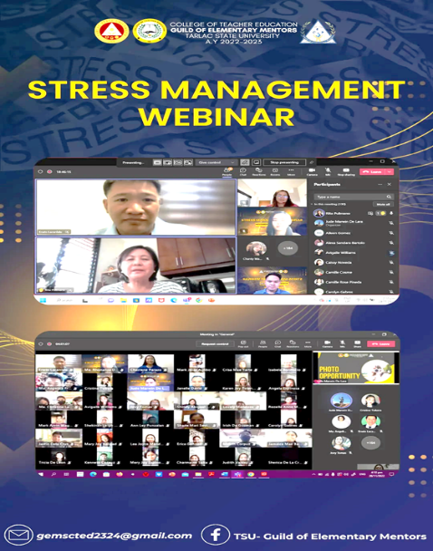
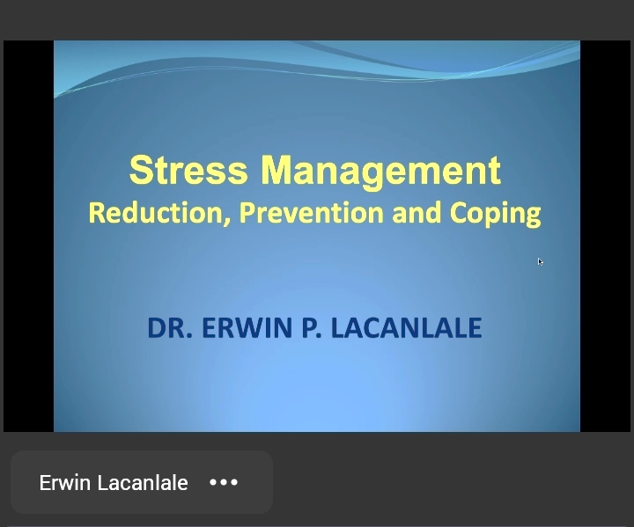
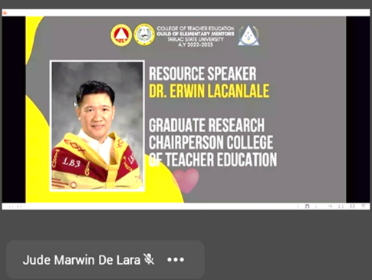

Film Festival: Istorya ng Pagbangon

TSU-Supreme Student Council took an active part in this year’s Campaign to End Violence Against Women by partnering with TSU-GAD in conducting a video-making competition titled “Istorya ng Pagbangon” on November 29, 2022. This activity aimed to bring awareness on the prevalent domestic violence in the community with the hope to demand change and enlightenment. Four short films were shown and evaluated by the board of judges headed by TSU President Arnold E. Velasco.
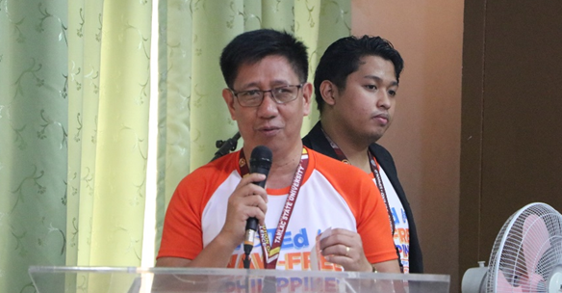
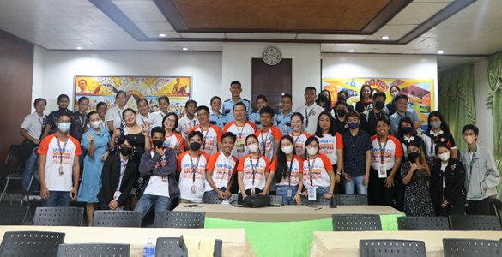

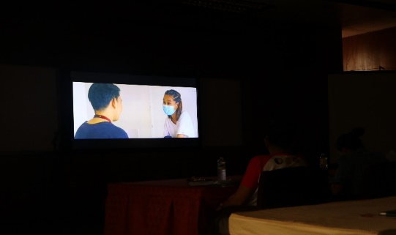
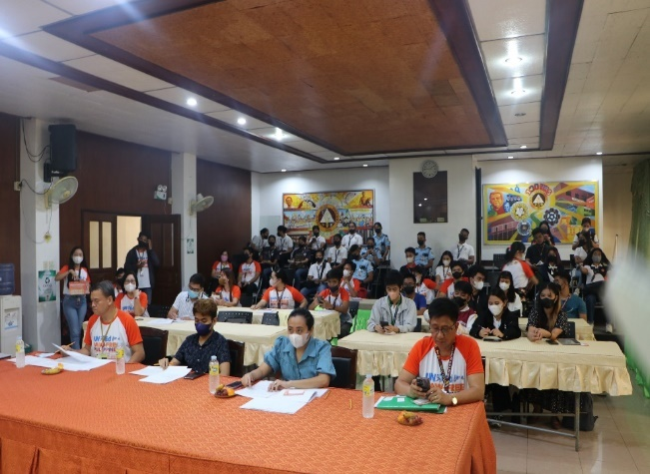

Time Management Webinar: Get Organized

The TSU – College of Teacher Education in partnership with the Gender and Development Office conducted a webinar titled “Time Management Webinar: Get Organized” on December 5, 2022 via MS Teams. The webinar aimed to provide knowledge to the students on how to set personal goals and directions, needs, and development. This activity was also intended for students to learn and practice the skills needed to manage time, maximize effectiveness, and gain a renewed sense of control over their tasks.

The GAD office invited Ms. Shindy Abegail Morales, CTED Student Council Financial Adviser, as the resource speaker for the webinar. Ms. Morales began her discussion by explaining the definition of time and the significant of time management. The speaker also enumerated and expounded the most important time management skills, the strategies on how to effectively and efficiently manage one’s time, and lastly the benefits of good time management.

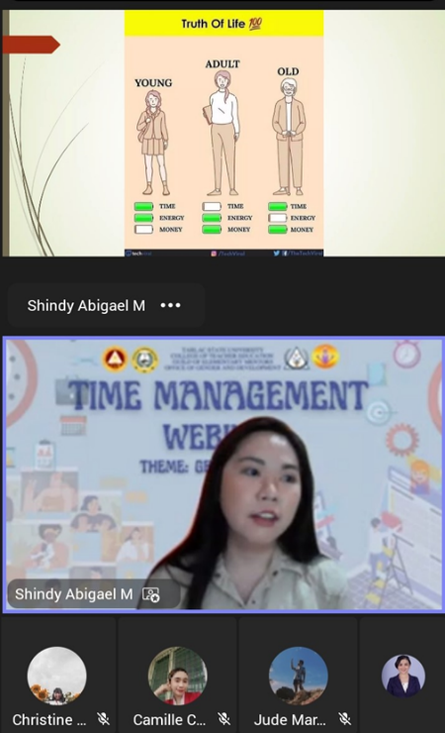
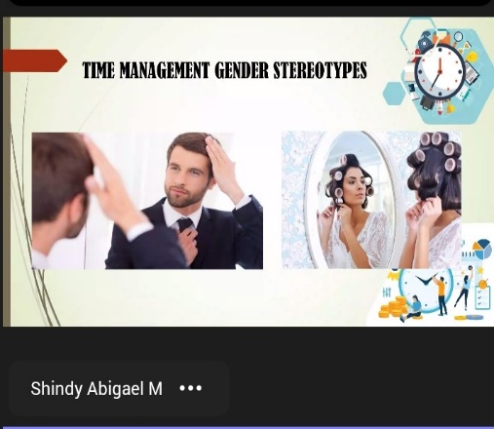
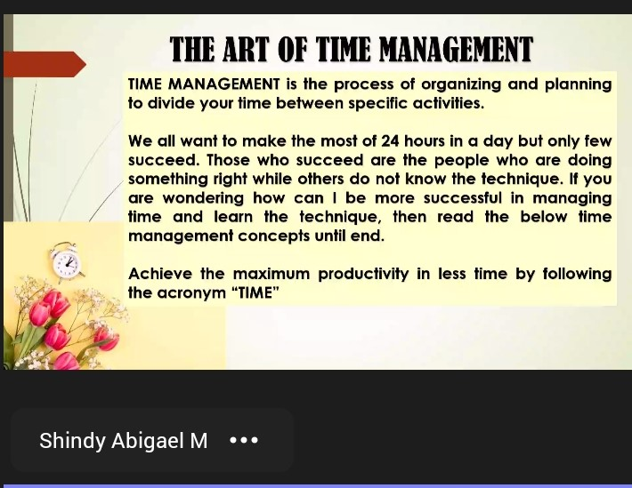
At the end of the webinar, Ms. Morales emphasized a quote saying that life and time are the best two teachers; life teaches us to make good use of time and time teaches us the value of life. This activity was attended by a total of 155 participants and was concluded by the closing remarks of Ms. Esther Soriano, Assistant on Records of CTED-GEMS.

Campaign to End Violence Against Women and Children Art Competition

In collaboration with TSU-GAD, the College of Business and Accountancy Student Council spearheaded the 2022 Campaign to End Violence Against Women and Children Art Competition. This includes Poster-making Contest, Slogan making Contest, Digital Poster-making Contest, Infographics Design Contest, and Infomercial Video Contest.
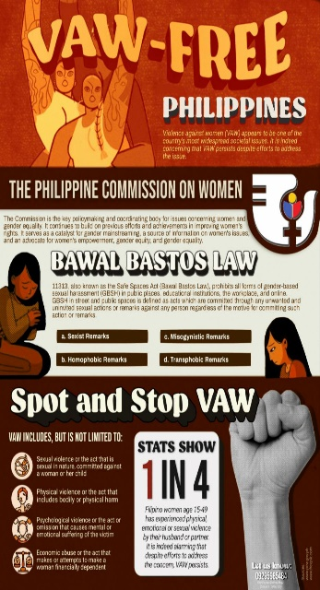
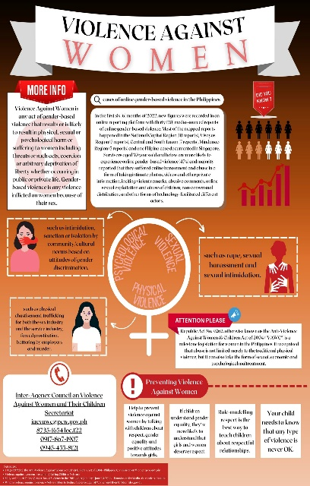

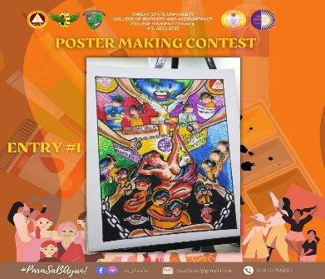


Roadmap C – Research and Community Service Development
C.1 Research Development
Research Presentation and Publication Development

“TSU Research Bootcamp 2022”

On June 2022, the First TSU Research Bootcamp is organized by the University Research Office with the theme “Sama-Sama tungo sa isang Maginhawa at Matatag na Komunidad”. The bootcamp occurred on May 5, 6, 12, and 13 at the Alumni Center, Lucinda Campus. A total of 54 teaching personnel from different colleges participated in the bootcamp. This activity “aims to provide an intensive training for the faculty members and encourage them to engage in multidisciplinary research that are aligned to the least prioritized research agenda in the university.” As a member of the University Research Evaluation Committee (UREC), Dr. Rita E. Pulmano served as an evaluator of the research outputs on June 1, 2022. Below are the photos from the University Research Office during the event:
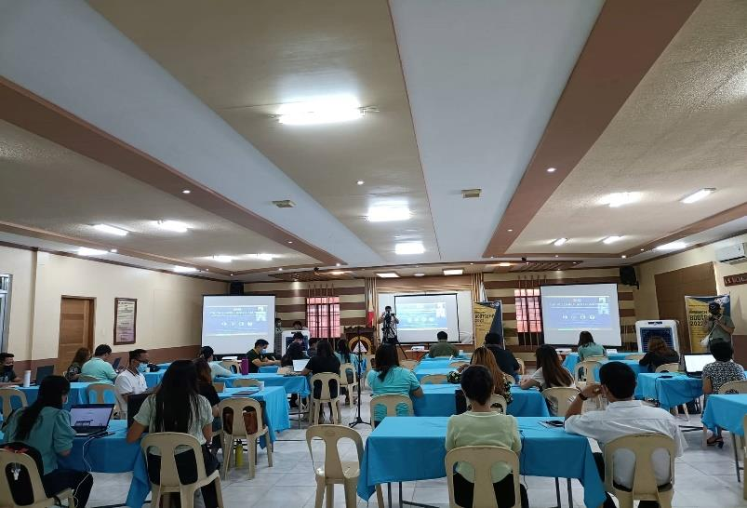
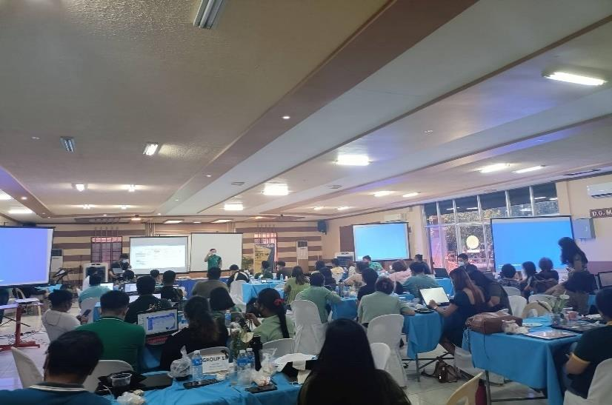

“University-Wide Research Proposal Colloquium”

The University Research Office organized a university-wide Research Proposal Colloquium with the theme, “Towards the Mission: Strengthening TSU’s Stature as a Research Institution through Innovative and Collaborative Researches” on October 18-20, 2022 at the Academic Building, TSU Lucinda Campus. A total of 81 research proposals were presented by the faculty members from different colleges and offices. As a member of the University Research Evaluation Committee (UREC), Dr. Rita E. Pulmano served as an evaluator during the colloquium to ensure and probe the gender-sensitivity of the proposed research. Below are the photos from the University Research Office during the event:
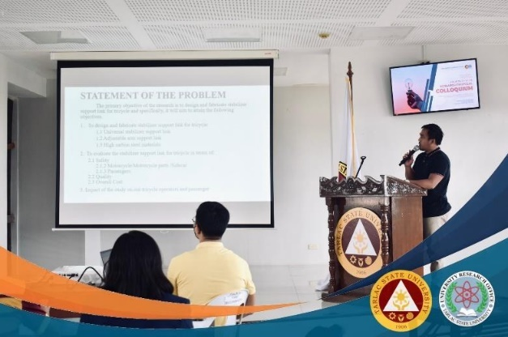
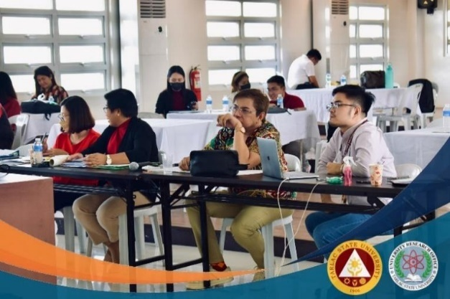

“Special Research Proposal Colloquium”

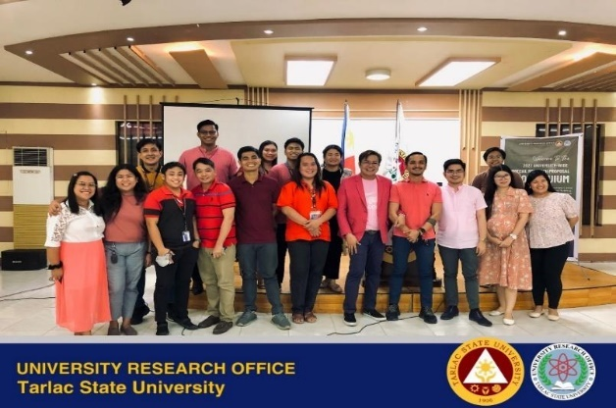
To accommodate more research proposals that were not presented during the first colloquium, the University Research Office organized a Special Research Proposal Colloquium on December 7, 2022, at the Alumni Center, Lucinda Campus. During the colloquium, 26 research proposals were presented by the teaching and non-teaching personnel of the university. As a member of the University Research Evaluation Committee (UREC), Dr. Rita E. Pulmano served as an evaluator during the colloquium to ensure and probe the gender-sensitivity of the proposed research. Below are the photos from the University Research Office during the event:
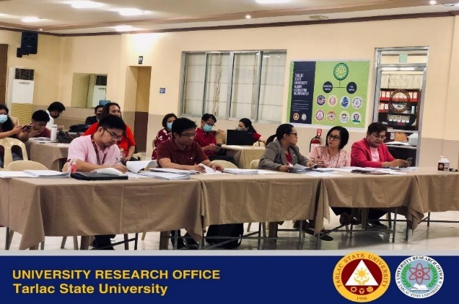

“4th National GAD Research Congress” at Central Luzon State University

Dr. Rita E. Pulmano served as one of the paper evaluators in the Central Luzon State University’s 4th National GAD Research Congress at CLSU, Science City of Muñoz, Nueva Ecija on November 18, 2022.
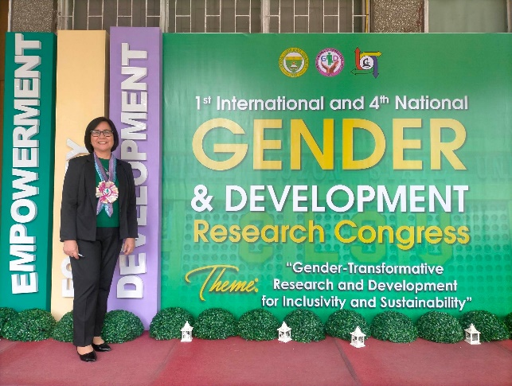
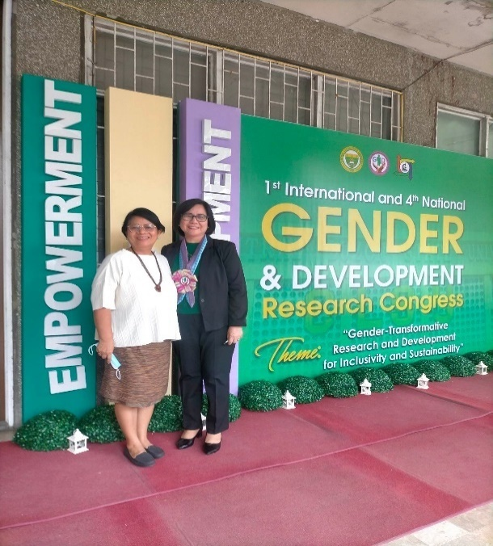

C.2 Community Extension Services Development
Academe-Government Agencies Linkages Development

“Gender-Responsive Basic Education Policy” to Matatalaib High School, Tarlac City

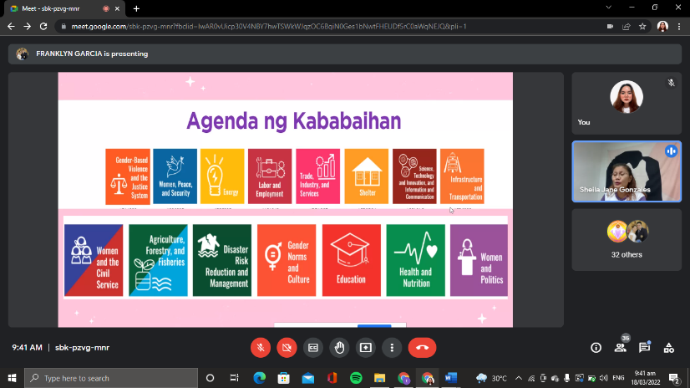
Two (2) short-term extension programs were facilitated by TSU-GAD on March 2022. The first activity was in partnership with Matatalaib High School held on March 18, 2022, via Google Meet is the “Gender-responsive Basic Education Policy” which focused on strengthening the importance of gender equality as the core of education through gender-responsive plans and policies. Ms. Sheila Jane L. Gonzales, CBA GAD coordinator and a certified GAD Resource Pool served as resource speaker in the said activity. She highlighted the topic with the discussion on gender issues related to basic education in the Philippines as well as enumerate ways to address such gender issues and concerns as well as gender barriers in education and find solutions on how to address such through programs and policies in the context of the pandemic. The activity was facilitated by GAD staff and student interns, and ESMO representative. Likewise, the activity was attended by a total thirty (30) participants.
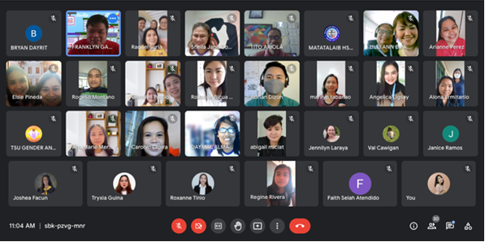
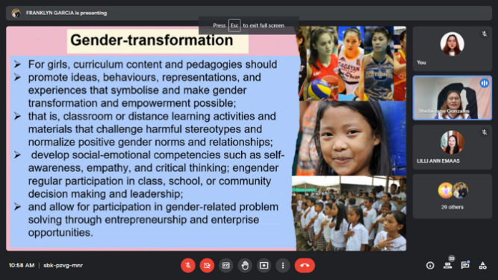

“Gender Sensitivity Orientation and High Risk of Cyber Bullying, Online Abuse, and Exposure to Harmful Content and Online Threats during the COVID-19 Situation” at Tibag Elementary School

On March 22, 2022, a short-term extension activity was also carried out in collaboration with Tibag Elementary School titled “GAD Webinar on Gender Sensitivity Orientation and topic on High Risk of Cyber Bullying, Online Sexual Abuse and Exposure to Harmful Content and Online Threats during this time of COVID-19 Situation“ which aimed to focus on important concepts regarding gender sensitivity, as well as debunking stigmas against gender roles and attributes. The forum also ought to increase knowledge and awareness about cyberbullying, sexual abuse, and online harassment. It aimed to educate children, parents, and teachers about their critical role in preventing and combating cybercrime. GAD resource pool namely: Prof. Christine Janelle M. Santiago and Prof. Winifredo L. Luis discussed respectively discussed concepts on differences between sex and gender along with gender roles and attributes, gender stereotypes, and the importance of gender equality to our society and discussion on differentiating normal online conversations and gestures from sexual abuse, as well as differences between cyberbullying, online harassment, and online libel. The webinar was attended by a total of seventy-seven (77) participants on Google Meet and it was also livestreamed through official Facebook page of Tibag Elementary School.

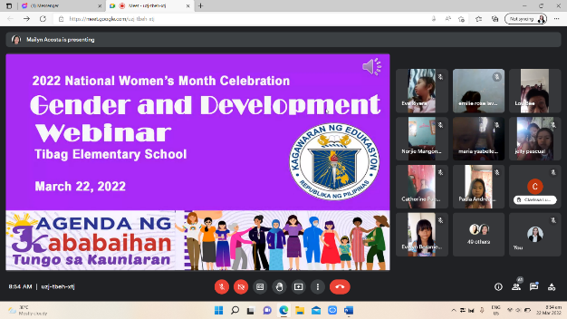
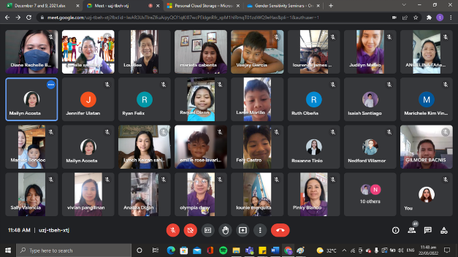
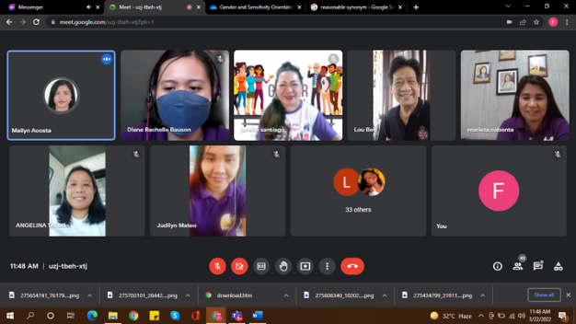
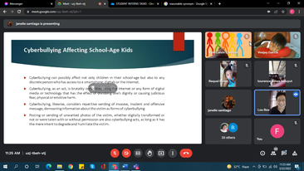

“Gender Sensitivity Orientation in the Contemporary Context” at USST

The TSU-GAD invited one of the adept GAD Resource Pool, a GAD Coordinator from the College of Arts and Social Sciences (CASS), and currently, the Unit Head of the International Protocol Affairs Program in the International Affairs and Linkages Office – Mr. Bryan Jan S. Dizon. In the said webinar, Mr. Dizon emphasized the importance of enriching one’s ideas and awareness on gender sensitivity and equality. He also introduced the mandates for a gender-fair society. Furthermore, Mr. Dizon addressed how rampant gender stereotyping in the present society, that even emotions are being categorized based on gender. He ended his presentation with the poem “For Every Woman” by Nancy Smith which implies that gender stereotyping limits all of humanity from exploring their full potential.

This webinar was attended by a total of forty-seven (47) attendees. It was concluded by the closing remarks of Ms. Tanya Louise Tanhueco, USST Instructor, who encouraged all the participants to advocate for the vulnerable sectors and continue addressing social oppression.

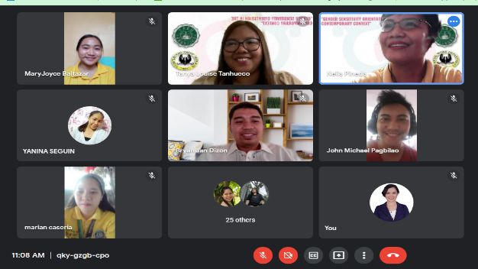
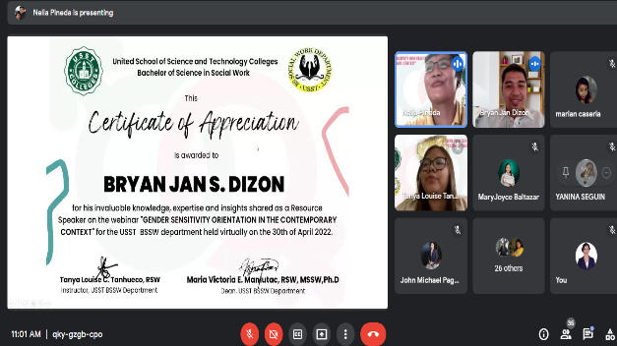

“The Use of Gender-Fair Language” via Zoom to Division Philippine Army Personnel

One of the objectives of the TSU Office of the Gender and Development is to strengthen partnerships with line agencies, both public and private, by extending services such as providing professional expertise through gender-responsive seminars and trainings. In line with this, TSU-GAD was requested by Armor (Pambato) Division, Philippine Army to provide a lecture on “The Use of Gender-fair Language.” This activity was conducted via Zoom on June 8, 2022 at 2PM to 5PM.

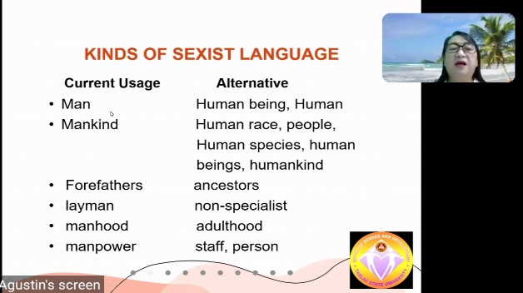
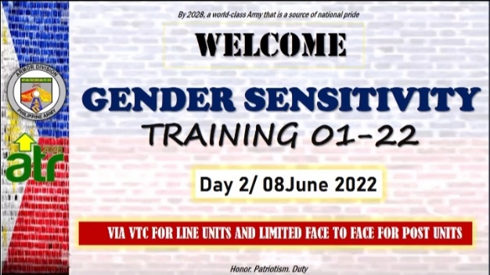
As TSU representative, an active GAD Advocate and faculty of College of Business and Accountancy, Professor Maria Teresa C. Agustin, conducted the lecture to approximately 200 personnel who are newly-designated GAD officers in their respective battalions and companies of the Division. In the said webinar, Prof. Agustin emphasized the importance of language and words. She also presented several kinds of sexist language that people commonly use and the alternatives which are more appropriate and gender-fair.

Moreover, Prof. Agustin also highlighted the gender polarization of meanings in using of adjectives which reflects biases toward genders. As application of learning, she provided an activity where the attendees identified the sexist word/ language used in a sentence and replaced it with a more gender-fair alternative. Prof. Agustin also requested the attendees to assess their office memorandums and identify the statements that are not gender-fair.

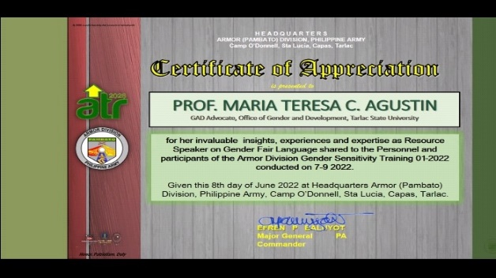
As closing, Prof. Agustin explained that gender and development issues are everybody’s concern, so it is essential for everyone to help one another to promote and protect the well-being of each gender.
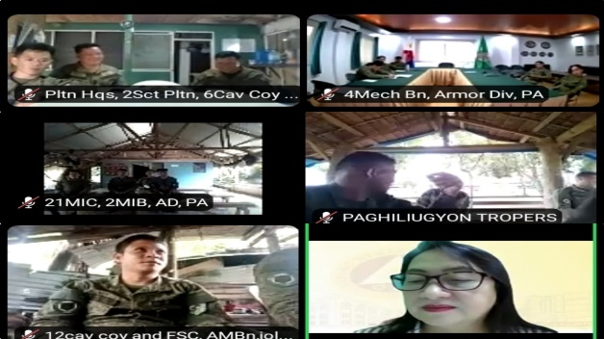
“Capacity Building Training on Gender Analysis, Gender Mainstreaming Evaluation Framework (GMEF), Gender Responsive LGU (GeRL) Assessment Tool and other Succeeding Tools” at Diwa ng Tarlac, San Vicente, Tarlac City

On July 19, 2022, Dr. Rita E. Pulmano served as a resource speaker in the PPDO-GAD Seminar titled “Capacity Building Training on Gender Analysis, Gender Mainstreaming Evaluation Framework (GMEF),Gender Responsive LGU (GeRL) Assessment Tool, and other Succeeding Tools”. The seminar was conducted at Diwa ng Tarlac, San Vicente, Tarlac City with 44 employees (M:10, F:34) as participants.
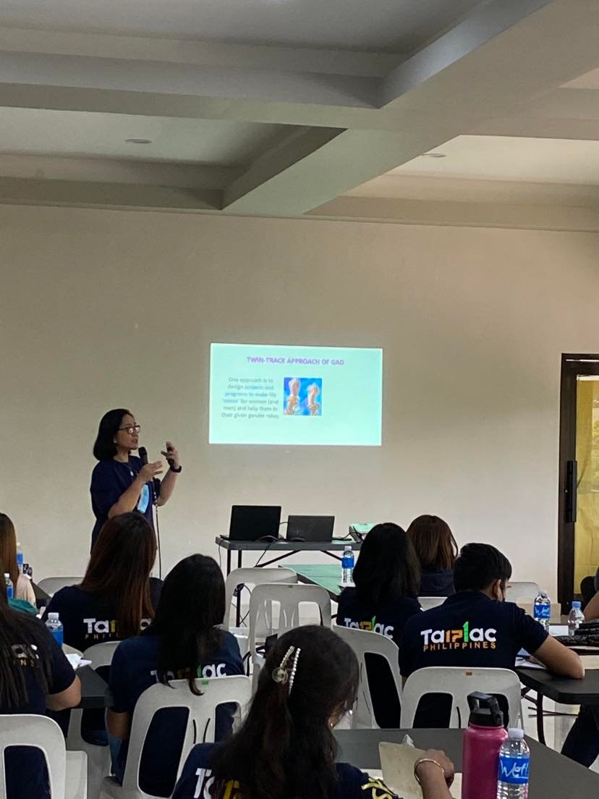
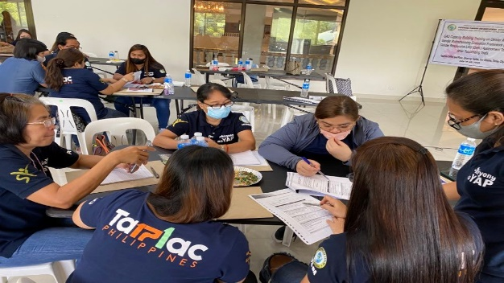

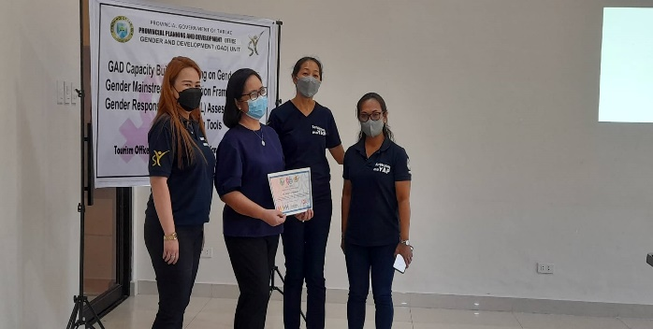

“Addressing Sexual Orientation, Gender-Based Violence in Capacitating Knowledge of AIS-HS Teachers amidst the New Normal” at VES Food House, Capas, Tarlac

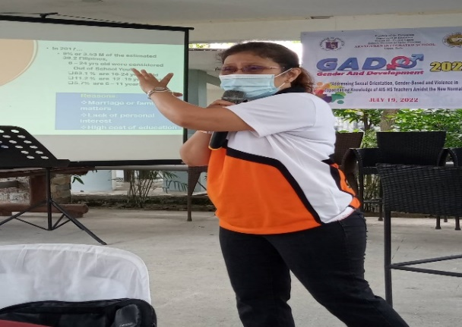
Assoc. Professor Shiela Jane L. Gonzales served as the resource speaker in Aranguren Integrated School High School Department Gender and Development Seminar titled “Addressing Sexual Orientation, Gender-based and Violence in Capacitating Knowledge of AIS-HS Teachers amidst the New Normal” held on July 19, 2022 at VES Food House, Capas, Tarlac.
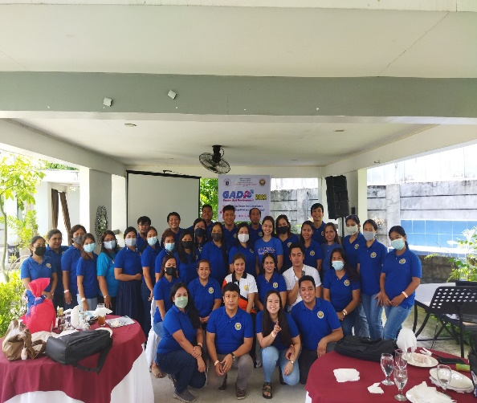
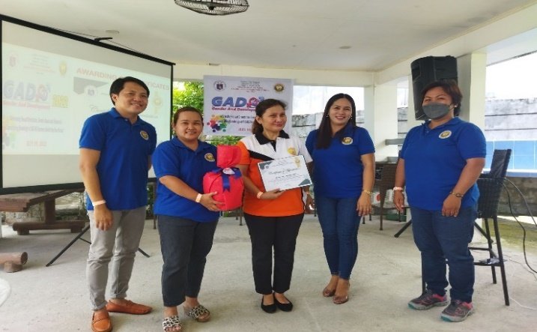

“Gender-Sensitive Language in Instruction and Communication” at Marawi National High School, Camiling, Tarlac

TSU-Gender and Development has consistently been committed to its goal in establishing and strengthening partnerships with line agencies, both public and private, by offering professional expertise through gender-responsive seminars/ workshops. In line with this, TSU-GAD, as requested by Marawi National High School, provided a webinar titled “Gender-Sensitive Language in Instruction and Communication” on August 3, 2022 at MNHS grounds.

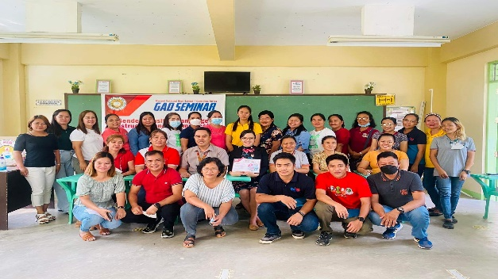
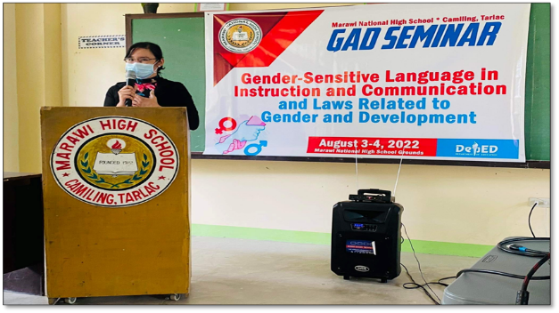
TSU-GAD Technical Staff Ms. Rachel G. Ibale served as the resource speaker in the said webinar. It started with a warm-up activity that highlights the importance of asking to avoid false assumptions about others, particularly about their gender identity. She also discussed the presence of sexism in language and communication, gender-fair language in instruction, and ways in promoting gender equality in the classroom which she deemed fitting since the attendees were administrative and academic professionals. Ms. Ibale also addressed the manifestations of sexism not only toward women, but also toward men, as they have been under constant pressure to uphold conventional ideas of masculinity gender-based sexual harassment committed in their institution.

Furthermore, she showed several sexist terms that are currently being used up to this day and presented alternatives which are more appropriate and gender-fair. As application of learning, Ms. Ibale provided a group activity in which the attendees had to identify the sexist terms used in different school learning materials and propose ways on how to make these terms gender-neutral.

This webinar was attended by a total of forty-three (43) attendees. To give the attendees something to reflect on, the speaker concluded the activity with a quote, “We have a lot of work to do, but we can get there if we work together.”
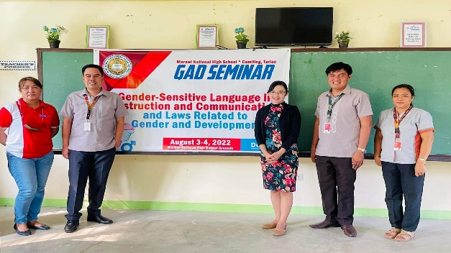
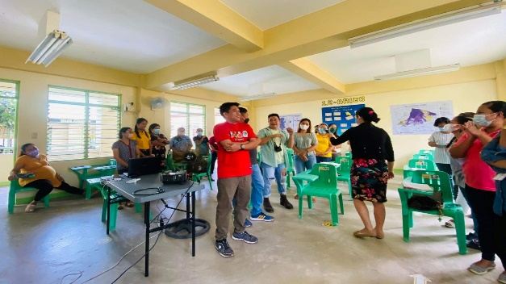

“Gender Sensitivity Orientation” and “Gender-Responsive Education” at San Manuel High School

In partnership with the Extension Services Management Office, GAD Coordinators Ms. Christine Janelle Santiago and Ms. Jovy P. Tomas served as resource speakers in San Manuel High School’s “Gender Sensitivity Orientation” and “Gender-Responsive Education” on August 18, 2022 held at SMHS Covered Court.
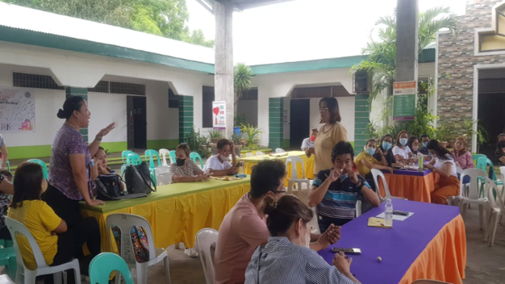
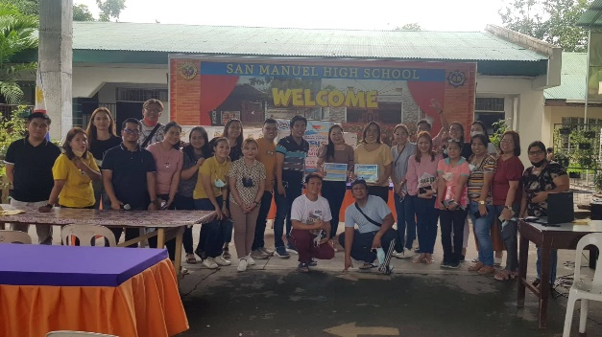

“Preparation of Gender and Development Plan and Budget, and Annual Report Preparation” to the Municipality of Victoria Personnel at Albergo Hotel, Baguio City

On September 14, 2022, the Municipality of Victoria, Tarlac, requested the assistance of Tarlac State University-Gender and Development for the creation of their GAD Plan and Budget (GPB) and Annual Report.

The seminar-workshop was conducted at Albergo Hotel, Baguio City, with TSU-GAD Director Rita Pulmano as the resource speaker. The GAD Workshop is one of the components of the 3-day training on creating its municipal and barangay development plans.
In her presentation, Dr. Pulmano emphasized the need to do GAD planning and budgeting. She also highlighted the elements, processes, and procedures for submission, review, and endorsement.
More than 300 participants, led by Victoria, Tarlac Mayor Rex C. Villa Agustin, including representatives from various barangays, department heads, Sangguniang Bayan members, and executive officials.

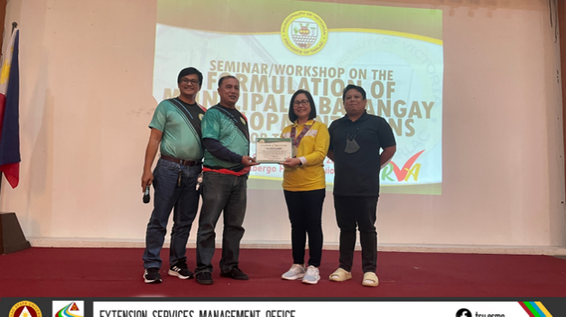
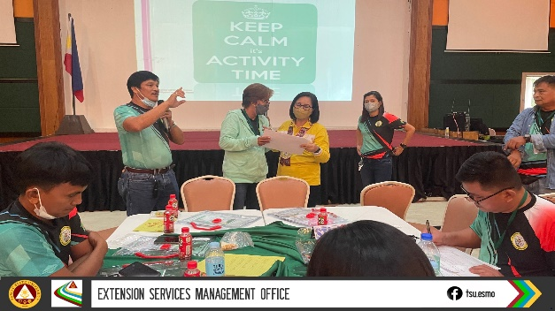
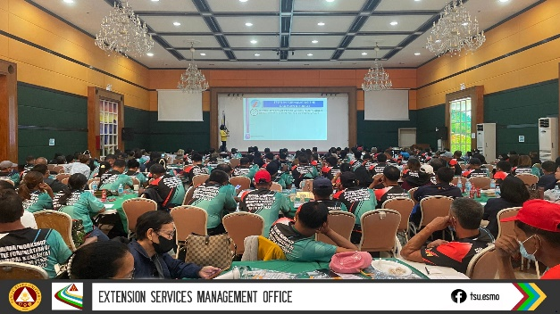
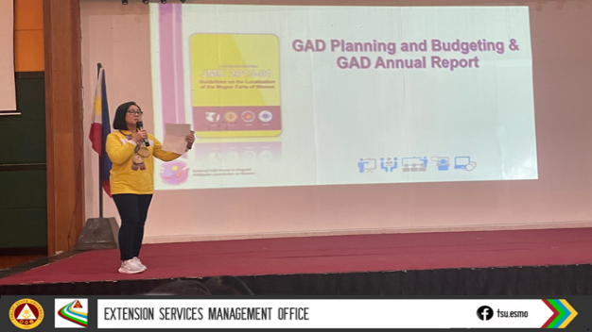

“Gender Sensitivity Training” to Tarlac Provincial Staff and Personnel at Provincial Capitol Building, Tarlac City

On September 22, 2022, Dr. Rita E. Pulmano served as the resource speaker in the PPDO-GAD’s “Gender Sensitivity Training”. Held at the Provincial Capitol Building, Tarlac City, the webinar was participated by a total of 54 attendees (21 male, 33 female).
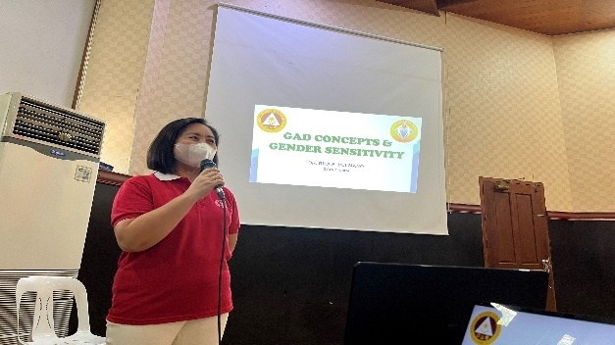

“Good and the GAD: From GAD Plan Preparation and GAD Funds Audit” to DepEd Regional Office III GFPS and Staff at Bakasyunan Resort and Conference Center, Iba, Zambales

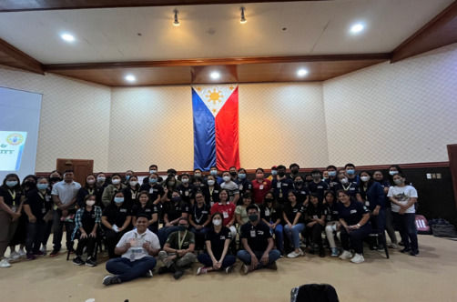
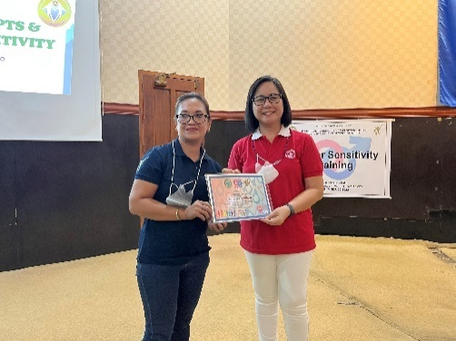
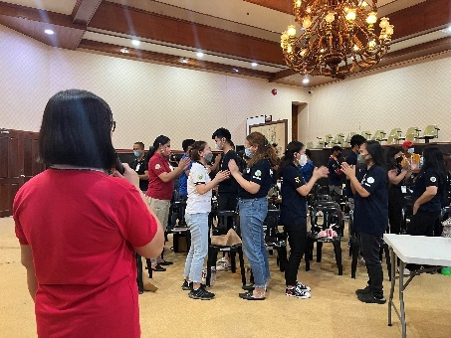
On November 15, 2022, Dr. Rita E. Pulmano served as the resource speaker in the “DEPED Regional Office III GFPS and Staff Training on the Good and the GAD: From GAD Plan Preparation to GAD Funds Audit” at Bakasyunan Resort and Conference Center, Iba, Zambales.

In this training, Dr. Pulmano discussed significant procedures in GAD Planning and Budgeting and in accomplishing GAD Annual Report.
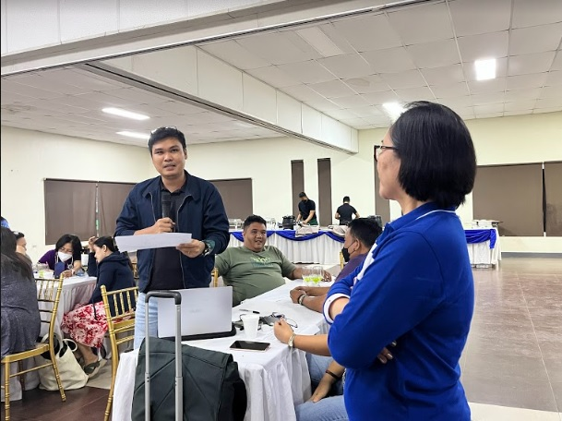
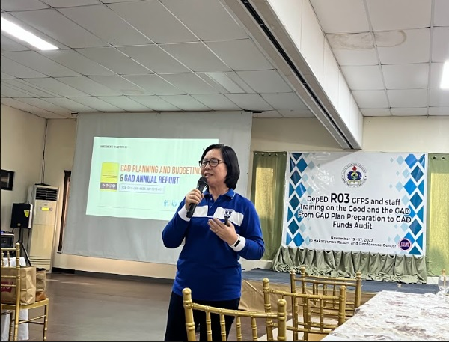

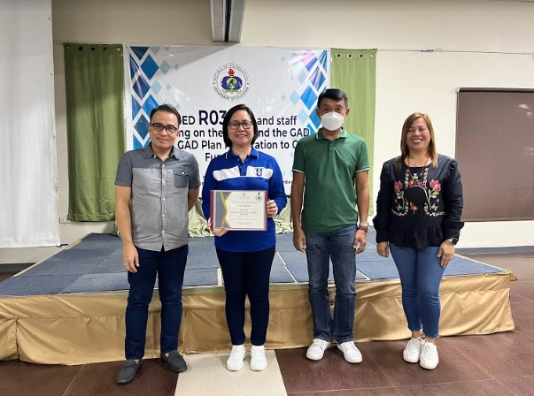
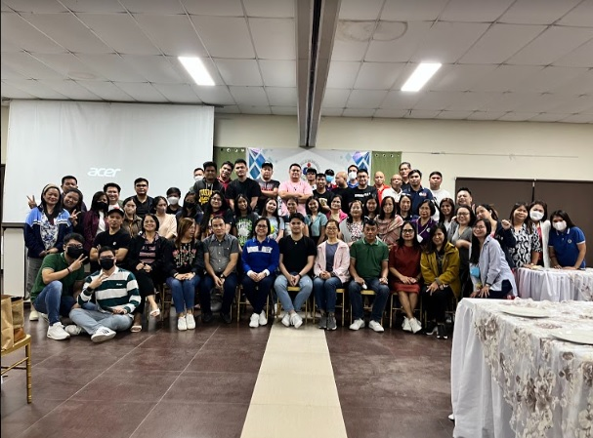

AMA Onsite Benchmarking

As they plan to establish their Gender and Development Unit, AMA Education System benchmarked TSU- GAD with its best practices in terms of program implementation, policy-making, planning, budgeting, and evaluation on November 23, 2022.

Dr. Pulmano, together with the coordinators and staff, oriented AMA-ES representatives on the nature of office and quality policy, programs offered, mode of implementation, faculty and students’ involvement, and office certifications and achievements.

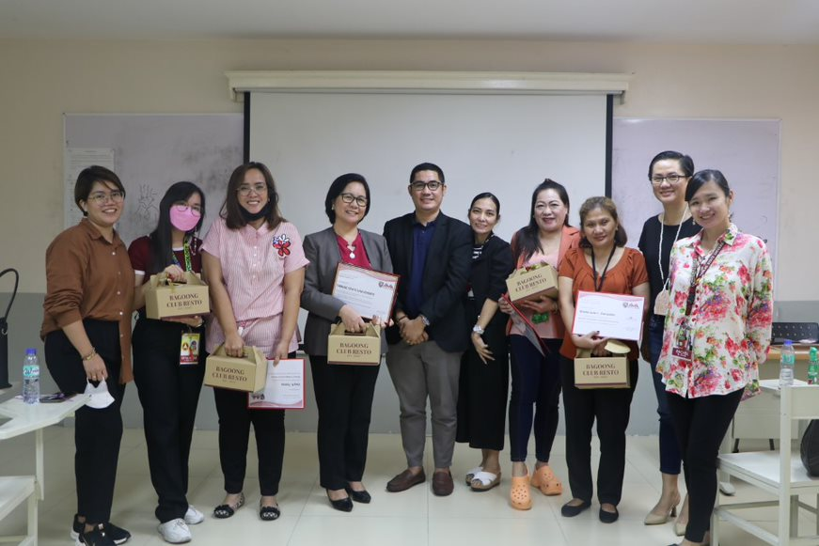
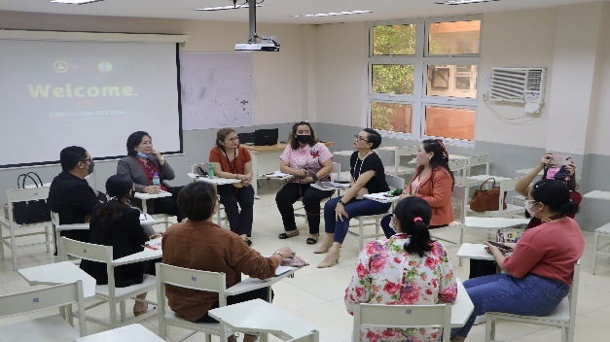

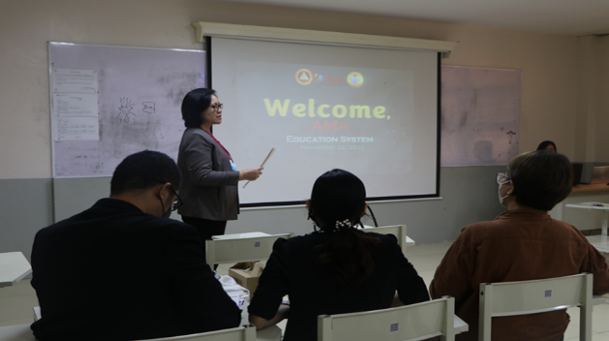

“Department of Agriculture Region III Webinar on GAD Laws and Mandates” via Zoom

On December 1, 2022, Dr. Rita E. Pulmano and GAD Coordinator Mr. Bryan Jan Dizon served as the resource speakers in the Department of Agriculture Region III Webinar on GAD Laws and Mandates at 8:00AM to 5:00 PM via Zoom.

Dr. Pulmano specifically discussed the Magna Carta of Women where she emphasized the rights of women including the protection from all forms of violence, participation and representation, and equal treatment before the law, among others.

Meanwhile, Mr. Dizon intensively explained the Republic Act 9262 or the Anti-Violence against Women and Children, highlighting the acts of violence which are covered under R.A. 9262.
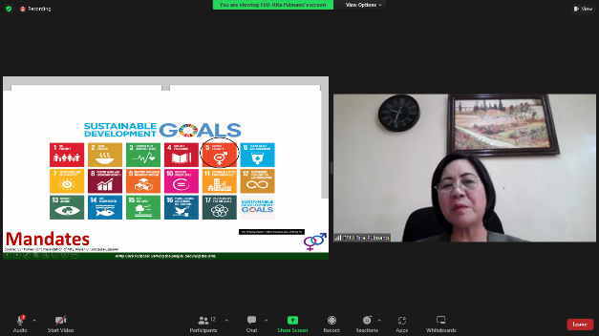
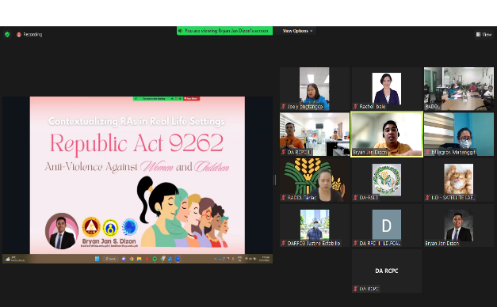
This webinar was participated by DA Region 3-Integrated Laboratory Division Personnel.

C.4 Gender and Development
Annual Campaign/Celebration

In support of the nationwide celebration, the TSU – Gender and Development Office (GAD) in coordination with various offices and units of the university, initiated the conduct of the month-long celebration of the 2022 National Women’s Month in the following activities:

2022 NATIONAL WOMEN’S MONTH CELEBRATION
MARCH 1-31, 2022

LIST OF ACTIVITIES

Activity | Tentative Date | Description | Persons/Office Involved
Printing and Posting/Display of the Banner/Streamer | March 1 to 31, 2022 | Four (4) advocacy banners/streamers will be posted in the university premises and uploaded to the TSU website and all online platforms. This is to highlight the gains achieved for women and girls, assess actions towards gender equality and look forward to steps that must be taken to ensure progress in empowering women | GAD Staff and Coordinators  TSU-OPA
#Purple Tuesdays | March 1, 8, 15, 22 and 29, 2022 | The TSU Community is encouraged to wear anything purple on all the Tuesdays of March to signify support for NWMC. | All Offices/  Units, and  Colleges
GAD Survey Questionnaire | March 1-31, 2022 | This activity is an online participation of TSU stakeholders to the “Gender and Development (GAD) Survey Questionnaire”. This will help us generate gender disaggregated data that will serve as our baseline data in understanding the situation of men and women with the goal to develop better approaches and programs in the implementation of GAD PAPs in the university. | GAD Office  HRDMO
#GADtoKnow! | March 1-31, 2022 | This will feature online IEC materials pursuant to the National Women’s Month Celebration and laws on women, particularly the Magna Carta of Women | GAD Staff and Coordinators
Musika ng Kababaihan Fridays (#MNKFridays) | March 4, 11, 18, & 25, 2022 | This will highlight the advocacy of the 2022 NWMC through music. The 87.5 Firefox Radio Station will be utilized to play songs from PCW’s MusikJuana Songwriting Contests 2021 and other PCW advocacy songs which aims to share music as an advocacy tool for gender equality and women’s empowerment. | GAD Coordinators
#PurpleYourIcon  Online Advocacy | March 1-31, 2022 | To make the advocacy take over the online realm, the TSU Community is encouraged to post about the celebration/campaign and sharing posts from PCW’s official social media accounts regarding 2022 NWMC.  The TSU community can also use the NWMC Advocacy Profile Photo Frame and other online materials (Instagram Story/Facebook My Day Frames, Viber stickers). They can also showcase their activities online and join the online thread using #WomenMakeChange. Follow and share PCW’s official social media accounts to help us reach more Juanas. | GAD Coordinators
#SerbisyoParaKay  Juana Online Consultation | March 21, 2022 | It is the season to make “everyJuana” feel appreciated. Hence, TSU-GAD in coordination with the Medical Unit, College of Science – Nursing Department, and Guidance and Counseling Unit will be offering free online consultation via MS Teams for women and girls which may help address issues/concerns and queries of “everyJuana” regarding teenage pregnancy, reproductive health, mental health, and other health related matters. All consultations are 100% free and confidential. For a one-on-one consultation, participants may send or call through MS Teams. | GAD Office  Nursing Department -COS  Medical Services Unit  Guidance and Counseling Unit
Virtual Program for the 2022 National Women’s Month Celebration | March 8, 2022 | A university-wide hosting of the Gender and Development Office of the Flag-Raising Ceremony in support to the National Women’s Month celebration. This activity is a venue not only to commemorate women but also it will be a celebration of women exercising their choices, taking chances to make their voices heard, and benefitting from and trailblazing changes. It is a celebration of Filipino women’s power to take the narrative, raise priority issues that matter to them, and call for concrete actions. | GAD  GAD Coordinators  Supreme Student Council
Supreme Student Council (SSC)-Organized Activities for 2022 NWMC  - Women Empowerment Webinar  - 2022 NWMC Online Contests | March 5, 2022  9:00 AM to 12:00 NN via ZOOM Meeting  March 1-31, 2022 | To involve the participation of TSU students, the Supreme Student Council will organize and facilitate programs and activities in line with the celebration of the women’s month which will feature women’s contribution in standing up for their rights, challenging stereotypes, breaking barriers, and serving as pioneers of change. This year, the nation recognizes women’s valuable role in society and proves that inclusive and sustainable development is only possible when gender equality becomes obtainable. | Supreme Student Council

Gender Sensitivity Orientation for Newly Hired Employees

In consistent with the goal of the TSU - Gender and Development Office to promote gender-consciousness-raising, advocacy and affirmative action, and information dissemination, a gender sensitivity orientation for the newly hired employees of the institution took place in August 17, 2022 via Zoom. The purposeful event was initiated and led by the Gender and Development Office and the Human Resource Development and Management Office.

GAD Director Dr. Rita E. Pulmano officially started the program by delivering her opening remarks. In her message, she emphasized that the bottom line of conducting programs, such as GSO, is the respect that everyone must uphold regardless of position, gender, religion, etc. and develop sensitivity among others.

The orientation had a morning and afternoon session. Ms. Rachel G. Ibale presented an overview of the Gender and Development Office and the Rationale of the Training in the morning, while Ms. Khyla Nicole Guevarra presented the overview and rationale in the afternoon. Moreover, Prof. Sheila Jane Gonzales (AM Session) and Mr. Bryan Jan S. Dizon (PM Session) led the discourse during the GSO proper. During the discussion, the differences between sex and gender were reiterated and social structures and social institutions were also explored.

Various audio and visual presentations were used to better delve into the concepts relating to gender sensitivity. Gender stereotypes were also debunked and ways to be more gender-sensitive and inclusive were cited. The orientation seminar, attended by 110 participants (58 female, 52 male), is one of the continuous efforts in the University in promoting gender equality and empowering the community to gain enough knowledge on gender sensitivity.
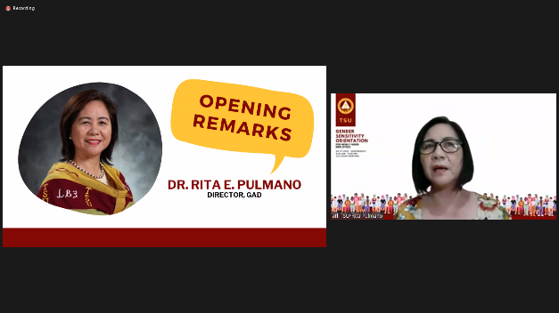
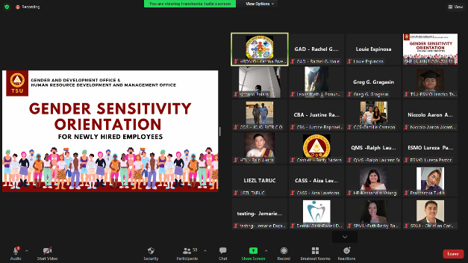

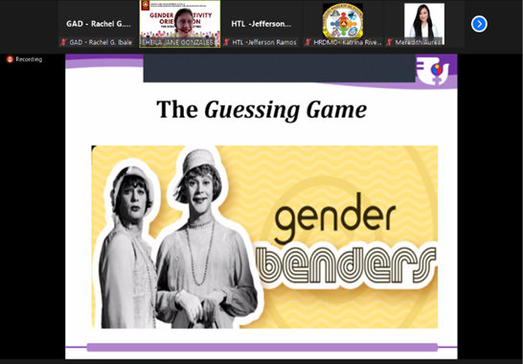

2022 NWMC Kick-Off Activity

TSU-GAD spearheaded the program for the 2022 National Women’s Month Celebration held on March 15, 2022. Aside from the usual hosting of the flag-raising ceremony, the main highlight of the program was the recognition of remarkable contribution of women leaders of TSU who are prominent in implementing gender mainstreaming in the university. This year’s theme focused on “We Make Change Work for Women: Agenda ng Kababaihan tungo sa Kaunlaran”, a celebration of women exercising their choices, taking chances to make their voices heard, and benefitting from and trailblazing changes. It is a celebration of Filipino women’s power to take the narrative, raise priority issues that matter to them, and call for concrete actions.
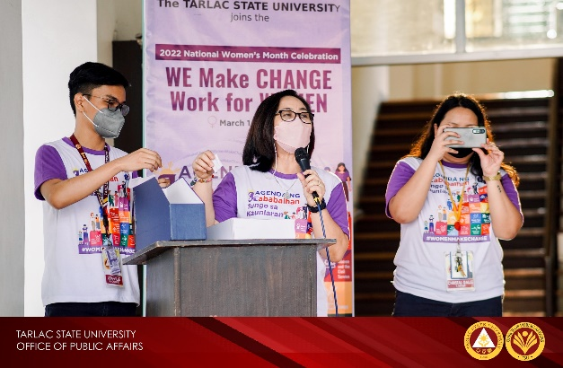
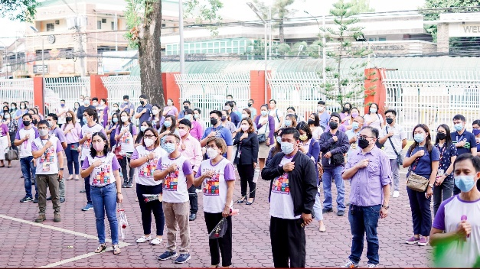

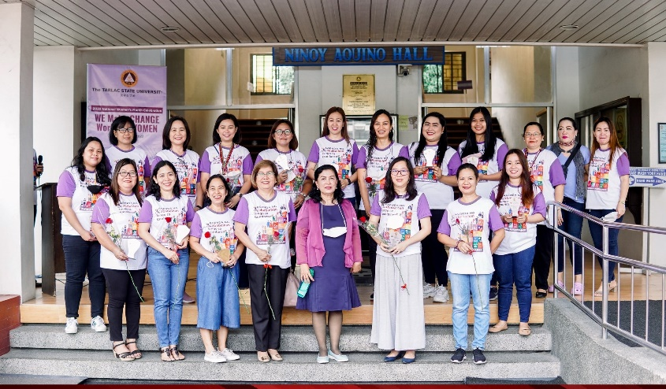

2022 18-Day Campaign to End Violence Against Women (VAW) Highlight of Activities

TSU-GAD Office spearheaded the annual observation of the 18-Day Campaign to End Violence Against Women from November 25 to December 12, 2021, to support the Philippine government’s goal of protecting the human rights of women and girls by upholding its commitment to address all forms of gender-based violence and to raise awareness on the problem of violence and the elimination of all forms of violence against women and girls. The theme “VAW-Free Starts with Me”, elevates the campaign to positive advocacy as it enjoins everyone to pursue the common vision of a community free from violence against women and girls, and highlights what can be done to achieve such. In addition, this year’s campaign focuses on featuring RA No. 11313 known as the Safe Spaces Act to intensify awareness-raising on the core provisions of the law, the penalties, and mechanisms in place as the country continue to fight the COVID-19 pandemic which breeds various forms of VAW, especially online with many spending their time in the digital realm. Therefore, the campaign also emphasizes the theme “Filipino Marespeto: Safe Spaces, KasaliTayo”.

In addition, TSU-GAD had conducted and facilitated the following activities:

Activity | Schedule | Description
Kick-off Activity for the 18-day Campaign to End Violence Against Women | November 22, 2022  8:00 AM onwards | A kick-off activity will be held in support of the campaign against VAW. The rationale behind this activity is to disseminate and raise awareness against VAW within the university.  The activity envisions to wheedle not just women, children, and people in the vulnerable sectors, but also men to campaign against VAW and to end the impunity, discrimination, and violence against women.
Supreme Student Council’s Campaign to End VAWC (Istorya ng Pagbangon) | November 25 to November 29, 2022 | This initially approved activity aims to defy the Violence Against Women & their children (VAWC), the TSU-SSC will be mobilizing the online platform for series of posting that contains safety guidelines, raise awareness of what and how to claim rights, and educating where to seek help in cases of violence.  Moreover, a Video-making competition will be administered where interviewees and/or participants can bring awareness to their own experiences of VAWC, with the hope to galvanize the community to demand change and enlightenment.
GAD-CBA Student Council’s Anti-Violence Against Women Campaign | November 26, 2022 | This activity aims to raise awareness against VAWC and to further the knowledge of students about the rights and protection of women and children through competitions which will encourage the students to express their creativity and talent.
Safe Spaces Pledge | November 25 to December 12, 2022 | Towards the goal of building a VAW-free community, this encourages everyone to commit to ensuring safe spaces for all in any way possible. Officials of agencies, implementers, service providers, establishment owners, educators, employers, influencers, and ordinary people can share their #SafeSpacesPledge vowing to do their part in making all spaces safe through actions as public servants, private institutions, or as individuals.
#VAWFreePH Online Campaign | November 25 to December 12, 2022 | The online advocacy campaign will be strengthened through different social media cards on VAW, use of official hashtag: #VAWFreePH, use of 18-Day Campaign to End VAW Facebook Profile Frame available through the PCW FB page, encouraging agencies to feature the 18-Day Campaign to End VAW on their websites and social media accounts. Viber stickers bearing messages on the Safe Spaces Act and VAW in general will be up for download.
Orange Your Icon Advocacy Initiative | November 25 to December 12, 2022 | This initiative enjoins government offices and private organizations nationwide to color its major landmarks or icons with orange from November 25 to December 12 this year in line with the 18-Day Campaign to End VAW. Launched in 2015, this initiative aims to attract and spark the public’s curiosity which provides opportunities for advocates to explain and declare their support to the Anti-VAW advocacy. This will serve as a springboard for public discourse and for disseminating the message of zero-tolerance for VAW.
Campaign to End Violence Against Women and Children | November 29, 2022 | This activity aims to raise awareness against VAWC and to further the knowledge of students about the rights and protection of women and children through competitions which will encourage the students to express their creativity and talent.
HIV Awareness | December 1, 2022 | The HIV Awareness Seminar is an activity to celebrate the HIV Awareness Day on December 1. This aims to increase knowledge and awareness in regards of HIV/Aids and debunk misconceptions and misinformation about the said virus. This will provide a safe space for discussions and queries about the impacts of the virus to individuals and to the society. A free HIV Testing will also be offered to the attendees of the event.

Kick-off Activity for the 18-day Campaign to End Violence Against Women

TSU-GAD spearheaded a Kick-Off Activity in line with the annual observance of the 18-Day Campaign to End Violence Against Women on November 29, 2022 during the flag-raising ceremony at TSU Main Campus. This annual advocacy campaign runs from November 25 to December 12 as mandated by Proclamation 1172, s.2006. It aims to increase public awareness on the issue of violence against women and children, and to combat all forms of gender-based violence as enshrined in the 1987 Constitution.
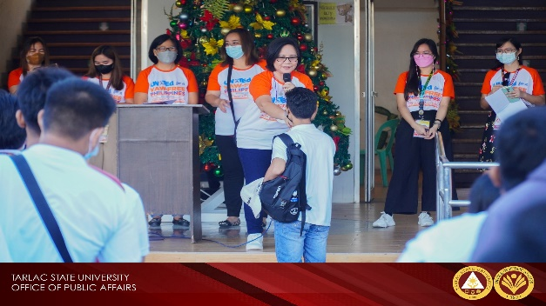
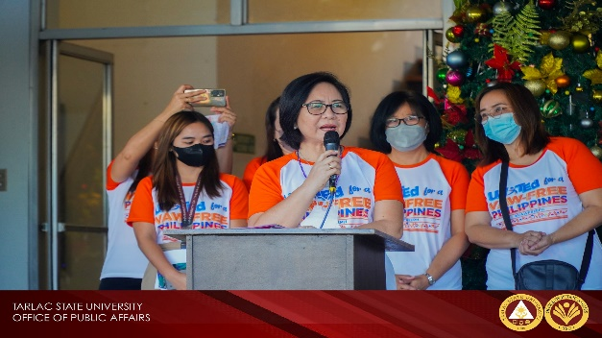
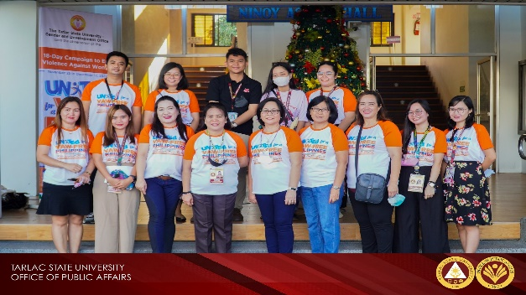
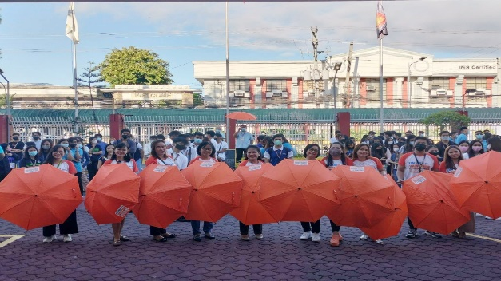
This year’s campaign highlights the accomplishments and milestones made in the country’s efforts to prevent and address VAW toward the assessment and strengthening of VAW-related laws’ implementation, in consonance with the new six-year (2022-2027) recurring theme “UNiTEd for a VAW-free Philippines”.

Roadmap: D – Institutional Quality Assurance Development Plan
D.3 Quality Management System Development

TSU GAD Accomplishment Report FY 2021

On January 20, 2022, the Office of Gender and Development submitted the GAD Accomplishment Report F.Y. 2021 through the Gender Mainstreaming Monitoring System of the Philippine Commission on Women. The AR has a total of 13.55% of GAD Allocation.
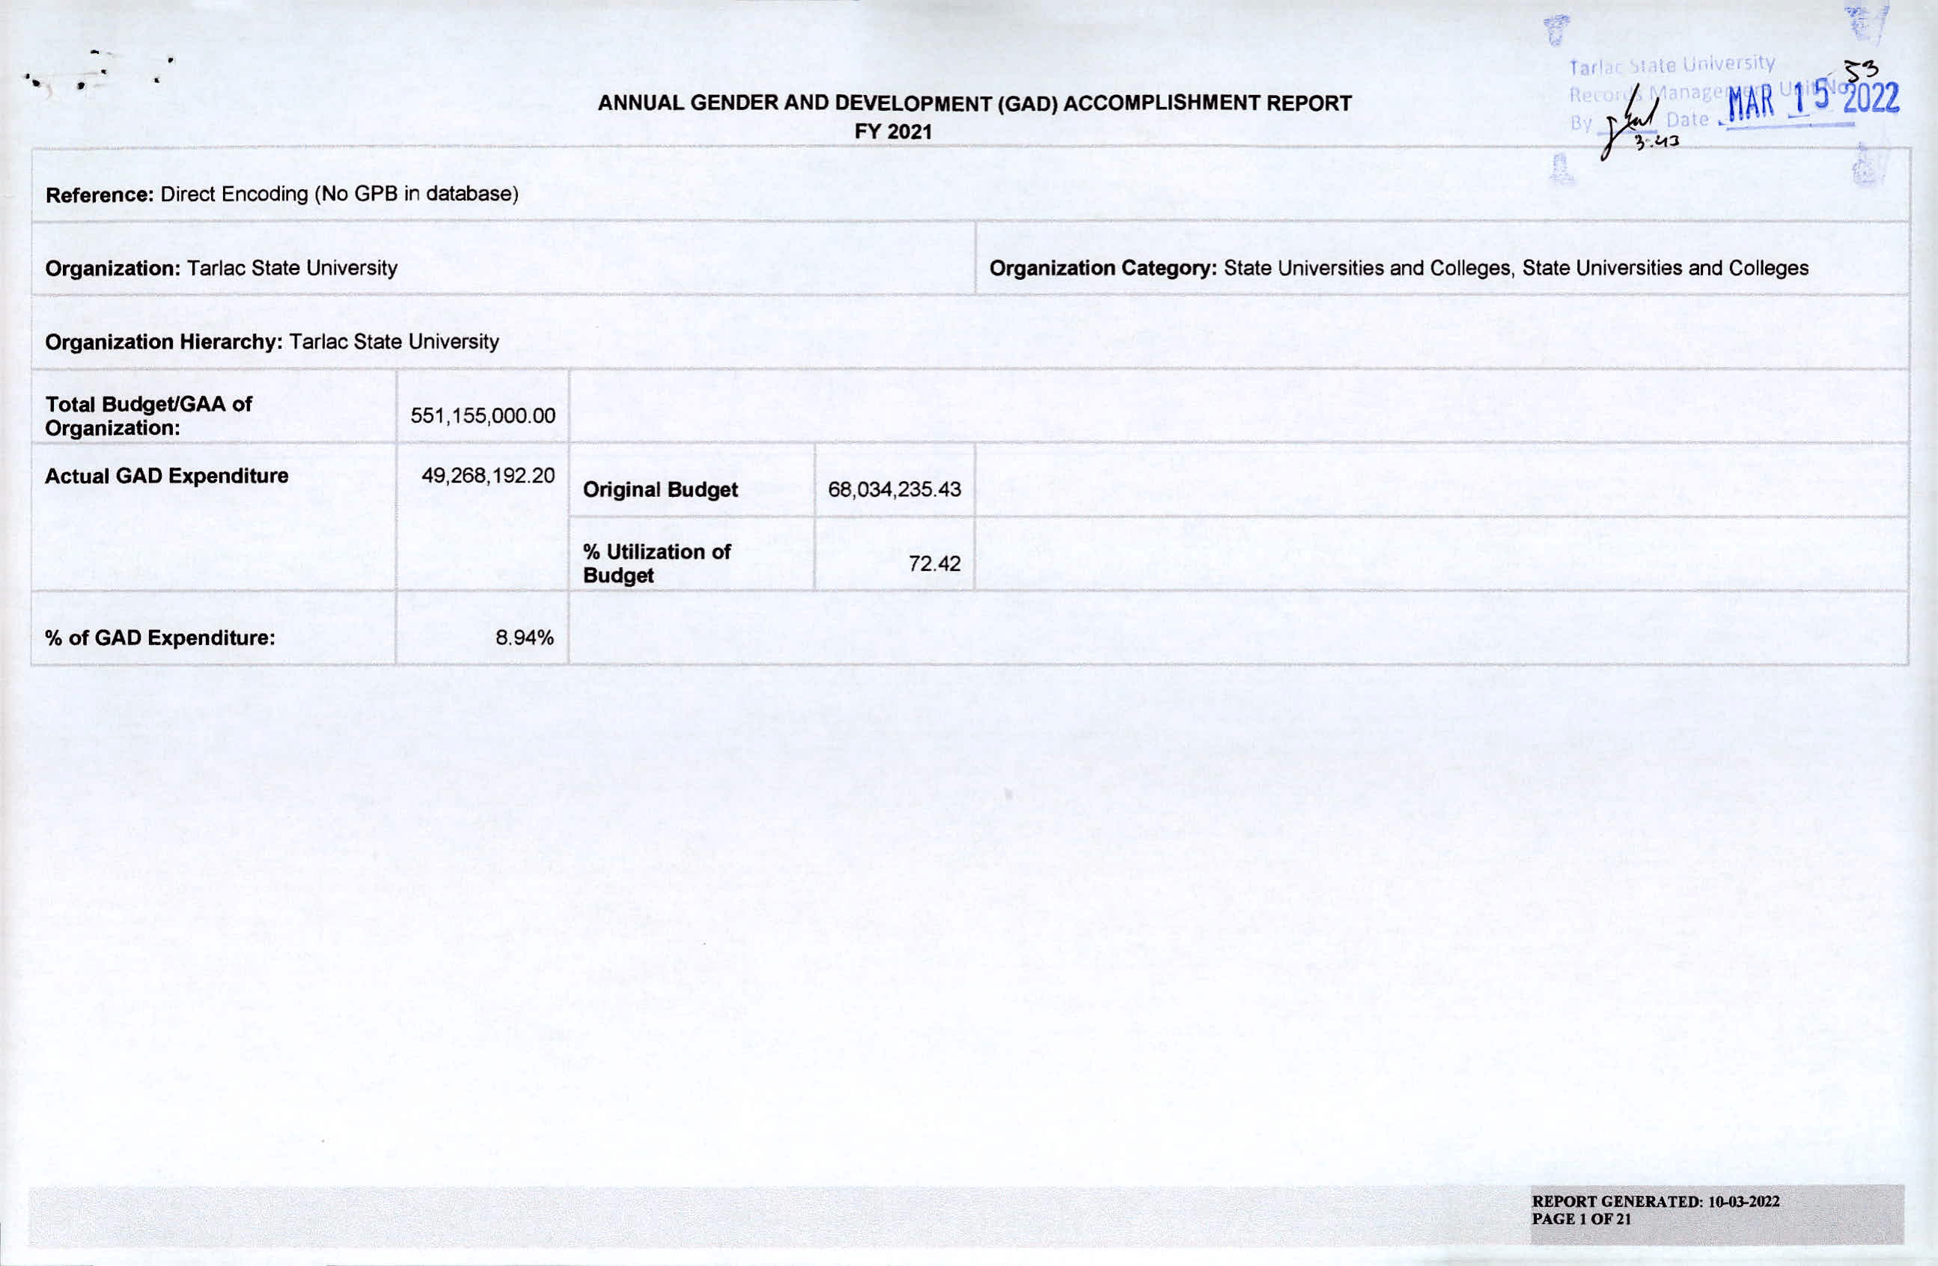

Revised TSU GAD Plan and Budget FY 2022

On February 4, 2022, the Office of Gender and Development submitted the GAD Plan and Budget F.Y. 2022 through the Gender Mainstreaming Monitoring System of the Philippine Commission on Women. The revised GPB has a total of 13.55% of GAD Allocation.
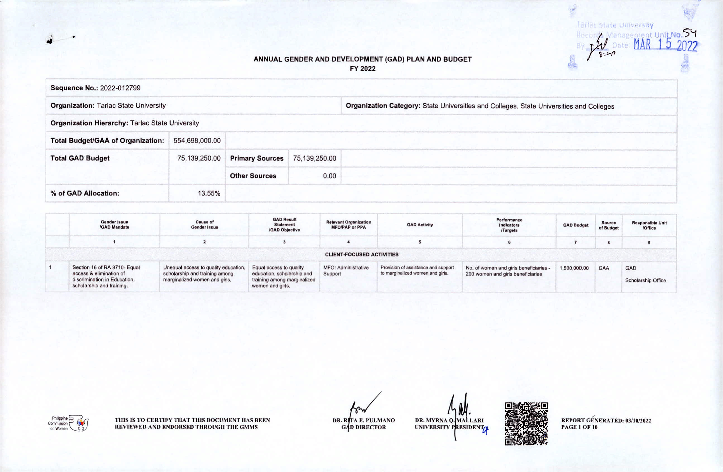

TSU GAD Plan and Budget F.Y. 2023

On October 24, 2022, the Office of Gender and Development submitted the GAD Plan and Budget F.Y. 2023 through the Gender Mainstreaming Monitoring System of the Philippine Commission on Women. The revised GPB has a total of 7.40% of GAD Allocation.



Prepared by: Attested by:

MS. KHYLA NICOLE R. GUEVARRA DR. RITA E. PULMANO
Technical Staff, Gender and Development Office Director, Office of Gender and Development Office

