**COLLEGE OF PUBLIC ADMINISTRATION AND GOVERNANCE**

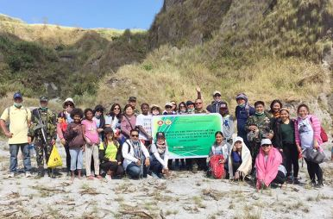

**CPAG extends Malasakit para sa Aeta Community in Barangay Sta. Juliana**

Dr. Alfred Nonnatus V. Rigor, CPAG

As part of the extension services of the University, the College of Public Administration and Governance held an extension project entitled Malasakit Para sa Aeta Community for far-flung Aeta communities in partnership with the Department of Environment and Natural Resources CENRO office at Sito Sitler, Barangay Sta. Juliana, Capas, Tarlac for Aeta Abellen and Hungèy tribes in which visits were held from February to June of the year 2018.

Spearheaded by CPAG Dean Dr. Ma. June S. Carlos along with her co-leaders Dr. Alfred Nonnatus V. Rigor; Ms. Maria Tiara Fatima F. Galang; Ms. Patricia Ann D. Estrada; Dr. Edwin T. Caoleng; and Mr. Roswald Fermin, the first visit was initiated on February 12 and services from gift giving, meeting with community leaders, project orientation and education on human development agenda were extended to the Aeta Community.

Presently representing the DENR-CENRO on the visit was Emmanuel T. Razalan, MPA, focal person of the National Greening Program, who is currently enrolled as a student in the College DPA program and also Vice President of CPAG Graduate School Student Organization and also present was Chairman Armando Ocampo who is the leader of the Lupaing Ninuno Aeta Association who served as facilitator, caretaker and spokesperson of the Aeta community.

After a month from the first visit, the second visit was held on March 12 where food donations, medical check-up with free medicines and vitamins, and a needs assessment were the services extended. The activity was supported by the students enrolled in the Master of Public Administration major in Health Management who shared their expertise and resources for the medical mission and students of the Master of Public Administration, Doctor of Public Administration, and Bachelor of Public Administration programs of the college donated various goods and facilitated its packaging for the success of the mission.

With the second visit, Sitio Duray, a nearby tribe was added and though not in the original plan, they witnessed the medical service and distribution of goods that prompted them, if possible, to be also included in the extension services. Since there were surplus goods and medicines, the team successfully assisted them and from 32 households living in Sitio Sitler, another 21 families were added. Those families are residents of Sitio Duray. And with the addition, the total number of family beneficiaries rose to 53 households.

On June 4, Dr. Alfred NonnatusV. Rigor, went to the community and conducted a dialogue with the tribe officials of Sito Duray and Sito Sitler in which a Translated Memorandum of Agreement was formally signed, and a focal group discussion was held to identify priority needs for socio economic development. On June 23, the college extended its third-round humanitarian mission which involved MPA students, CPAG Faculty, Training and Doctrine Command’s medical personnel who went up to the community and delivered humanitarian aid from operation-tuli (circumcision) to giving of 6 packs of assorted high value vegetable seeds courtesy of Governor Susan Yap through the Provincial Agriculture Office. As of October, the plantation of high value vegetable seeds was already implemented. On November 20, Chairman Jover Ocampo reported with documentation, the successful harvest of vegetables that was distributed for planting from the June visit. A female carabao worth PHP 35,000.00 was also donated as an incentive for the successful harvest realized in the community.

Sitio Sitler can be reached by taking a 4X4 vehicle with one hour estimated travel time to reach the nearest accessible road at the foot of the mountain. Another 40 minute-walk is needed in order to reach the tribal community. The provincial government of Tarlac and the Training and Doctrine Command provided 4X4 vehicles on the duration of the visits.

Chairman Jover was thankful for the assistance of the university that instilled the true meaning of empowerment which can be achieved if the Aeta community can gain the power to control their ancestral land and to define their own path to development. And on the question of sustainability, the proponent reported that the project will be sustained through collaborative efforts.

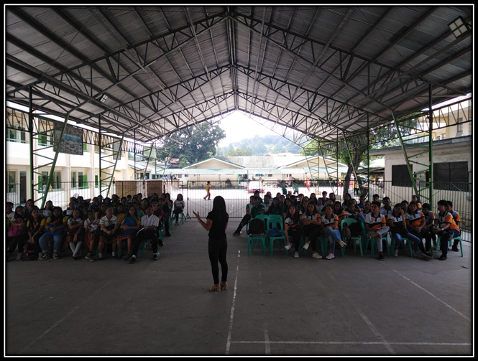

**Project Student Leader: Capacity Building Training for Young Leaders**

DepEd High School, Bamban, Tarlac

September 27, 2019

|  |  |
| --- | --- |
| Beneficiary | Dapdap Highschool Bamban Tarlac |
| Type of Service | Knowledge Transfer |
| Extension Service Providers | Maria Fatima F. Galang (Resource Speaker)  Patricia Ann D. Estrada (Resource Speaker)  Jeremiah P. Silvestre (Resource Speaker)  Grace T. Lim (Resource Speaker)  Izelle C. Francisco (Facilitator)  Roswald G. Fermin (Facilitator) |
| Participants | 74 |
| Hours | 8 |

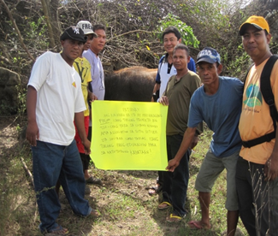

**COMDEV Project Planning for 2019, Research and Gift Giving and**

**Awarding Ceremony of the donated Carabao Project**

Capas, Tarlac

March 2, 2019

|  |  |
| --- | --- |
| Beneficiary | Lupaing Ninuno Aeta Association Incorporated |
| Type of Service | Knowledge Transfer |
| Extension Service Providers | Dr. Alfred V. Rigor (Facilitator)  Maria Fatima F. Galang (Facilitator)  Patricia Ann D. Estrada (Facilitator) |
| Hours | 8 |