**COLLEGE OF COMPUTER STUDIES**

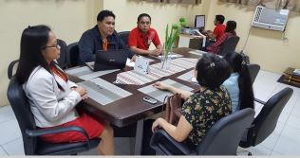

**CCS introduces Industry 4.0 for selected Micro Food Processor of Tarlac**

Carlos P. Flores, CCS

Danica B. Reyes, CCS

The College of Computer Studies (CCS) continuously extends their help to the community with the use of information and communications technologies. ICT simplify and boost development for all kinds of enterprises, yet in case of small and medium enterprises, the influence is far better visible. Activities such as searching for new markets become easy, companies find various economical barriers reduced, which in turn decreases costs of international operations. It is a subject of vital importance for both companies that can increase their competitive ability, as well as for the consumers, who gain access to wider array of products, services and information – all due to Internet access.

Micro Food Processor like Potter’s Hand Processed Food is driven to enhance the senses of its consumers, especially their palate with the new taste that they can provide. They want their customers to express their feelings to their loved ones by the taste of the food they make. Their mission is to produce and supply high quality and safe traditional sauces and condiments with good taste and value to the market so that their customers can consume it with confidence and trust.

Stakeholders for this project met initially through the endorsement of University Extension Services Office (UESO) with a Service Request Form to the College of Computer Studies (CCS). The initial meeting was held at the CCS building and attended by Ms. Susana Dy, owner of Potter’s Hand Processed Food, Engr. Marlon V. Gamido, Dean CCS, Ms. Valarie D. Simbol, Associate Dean, Mr. Carlos P. Flores, Jr., BSIT Program Extension Chairperson, Mr. Ronnie B. Mercado, BSCS Chairperson and Mr. Abegail L. Madayag, Faculty. The purpose of the meeting was to discuss the needs of the micro food processor, current technologies used and terms of the project.

After analyzing the requirements of the Potter’s Hand Processed Food, the team planned and identified each requirement and categorized them, group them per sprint, which serve as a guide throughout the development of the website. This process allows the team to check the progress of the project and match it, where each member carries a task and need to produce a deliverable. Upon completing the task, a meeting with the stakeholders was held to discuss if the requirements were met, feedbacks and suggestions were considered during the product increment to satisfy the beneficiary. This process also included the review of the sprint to check the target completion. In this stage also, the product release can also happen, once all the sprints are met and the client is satisfied with the output.

In general, the website developed is concluded and ready to be used to improve the marketing strategy of the Potter’s Hand Processed Food. More so, this project introduced the Industry 4.0 which is a name given to the current trend of automation and data exchange in manufacturing technologies and identified the need and enablers which were applied in Potter’s Hand Processed Food. The collaboration with Industry 4.0 test environments increasingly essential to allow Small and medium-sized enterprises (SMEs) to reach and address the inquiries of their demanding customers. The developed website enabled the customer to view the product and its details, be updated about the selected micro food processor of Tarlac, and send feedback whenever needed.

**BACHELOR OF SCIENCE IN INFORMATION SYSTEMS**

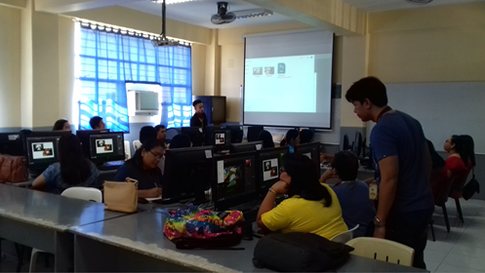

**Series of Photoshop Training**

CCS Building, TSU San Isidro Extension Campus, Tarlac

March 1-April 30, 2018

|  |  |
| --- | --- |
| Beneficiary | Department of Education (Tarlac) |
| Participants | 31 |
| Type of Service | Continuing Education |
| Extension Service Providers | Patima Susanne C. Pingol (Resource Speaker)  Abegail L. Madayag (Resource Speaker)  Lito Alexis M. Tolentino (Facilitator) |
| Hours | 16 |

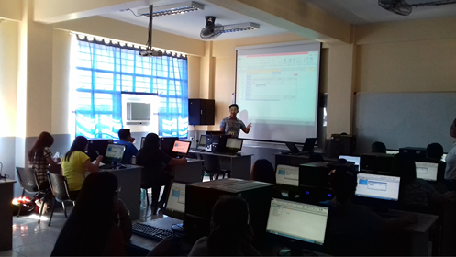

**Series of Microsoft Excel Training**

CCS Building, TSU San Isidro Extension Campus, Tarlac

March 1 - April 30, 2018

|  |  |
| --- | --- |
| Beneficiary | Department of Education (Tarlac) |
| Participants | 10 |
| Type of Service | Continuing Education |
| Extension Service Providers | Mark B. Manalang (Resource Speaker)  Gilbert G. Gonzales (Resource Speaker)  Nicolas Z. Diaz Jr. (Facilitator)  Jo Anne G. Cura (Facilitator)  Gloria L. Prellejera (Facilitator)  Michelle E. Subiate (Facilitator)  Lito Alexis M. Tolentino (Facilitator)  Erwin L. Sibal (Facilitator) |
| Hours | 16 |

**BACHELOR OF SCIENCE IN COMPUTER SCIENCE**

**Technical Consultancy on Design and Development of Promotional Materials**

Brgy. Poblacion I, Camiling, Tarlac

March 20 – April 30, 2019

|  |  |
| --- | --- |
| Beneficiary | Gamia Beyoutify Enterprises |
| Type of Service | Technical Consultancy |
| Extension Service Providers | Mark B. Manalang (Technical Consultant and Speaker)  Gilbert G. Gonzales (Consultant and Speaker) |
| Hours | 160 |

**BACHELOR OF SCIENCE IN INFORMATION TECHNOLOGY**

**Technical Consultancy on Computer Aided Product Label Design**

Brgy. Lalapac, Victoria, Tarlac

July 1- November 30, 2019

|  |  |
| --- | --- |
| Beneficiary | Lalapac Agri Products |
| Type of Service | Technical Consultancy |
| Extension Service Providers | Gilbert. G. Gonzales (Technical Consultant)  Patima Susanne C. Pingol (Technical Consultant)  Heidlyn T. Gamido (Technical Consultant) |
| Hours | 90 |