**COLLEGE OF ARCHITECTURE AND FINE ARTS**

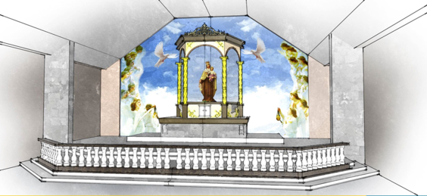

**CAFA, CET lift the hearts of worshippers through church building and altar design**Jay Ann L. Pablo, UESO

Christian believes that art and design matter to the Church because it matters to God. It is a house of prayer and a place that becomes hallowed with prayer. Through visual improvements, the heart of worshipper lifts even the hardest heart to prayer. Rev. Cielo M. Villanueva, Senior Pastor of Jesus Touch Ministry Incorporated, a religious organization in Concepcion, Tarlac sought assistance from the university particularly the faculty experts of College of Architecture and Fine Arts (CAFA) to develop a building design for worship center with a lot area of 240 square meters. Arch. Marco F. Bildan, Arch. Paul E. Villegas and Arch. Jerimiah A. Bildan of Architecture Department, Dr. Wilfredo G. Dungca of Fine Arts Department were tapped to provide professional assistance from February to April. The building design also served as a reference guide to the client in constructing the worship center showing the floor plan, site plan, elevation, cross-section, and projections. Through Atty. Godofredo Sabado, Council President of Our Lady of Fatima Parish, a non-profit and religious organization in San Vicente, Tarlac City asked technical assistance in designing the altar church. The faculty from the College of Engineering and Technology (CET) initiated the project and collaborated with the faculty experts of CAFA Arch. Paul E. Villegas, Arch. Gabriel Angelo E. Bucad and Arch. Ethelbert A. Escoto of Architecture Department and Mr. Judeo R. Herrera of Fine Arts Department provided extension services from the month of September to October.

CAFA also has a joint undertaking with the College of Engineering and Technology (CET) particularly with the Bachelor of Industrial Technology under the management of PEC Christine Janella M. Santiago and Bachelor of Science in Industrial Technology under the management of PEC Jovy P. Tomas. The joint undertaking aimed to provide technical assistance at Our Lady of Fatima Parish in San Vicente, Tarlac City. The project was requested by Atty. Godofredo Sabado, Council President of Our Lady of Fatima Parish. Faculty experts from the Architecture Department namely, Arch. Paul E. Villegas, Arch. Gabriel Angelo E. Bucad and Arch. Ethelbert A. Escoto and Fine Arts Department, Mr. Judeo R. Herrera were tapped to design the altar church.

**ARCHITECTURE DEPARTMENT**

**Renovation Design of Barangay Hall**

Gate III Calle Fausta, Brgy. San Sebastian, Tarlac City

February 1 – April 30, 2019

|  |  |
| --- | --- |
| Beneficiary | Barangay San Sebastian, Tarlac City |
| Type of Service | Professional Assistance |
| Extension Service Providers | Arch. Paul E. Villegas (Consultant, Artist)  Arch. Garry M. Advento (Consultant, Artist)  Arch. Marco F. Bildan (Consultant, Artist)  Arch. Jermiah Marco A. Bildan (Consultant, Artist)  Arch. Cesar M. Bartolo (Consultant, Artist)  Arch. Leonardo S. Hirang (Consultant, Artist) |
| Hours | 30 |

**Design of Multi-Purpose 3-Storey Building**

Pada-Pada, Sta. Ignacia, Tarlac

February 1- April 30, 2019

|  |  |
| --- | --- |
| Beneficiary | United Methodist Church |
| Type of Service | Professional Assistance |
| Extension Service Providers | Arch. Paul E. Villegas (Consultant, Artist)  Arch. Garry M. Advento (Consultant, Artist)  Arch. Marco F. Bildan (Consultant, Artist)  Arch. Jermiah Marco A. Bildan (Consultant, Artist)  Arch. Cesar M. Bartolo (Consultant, Artist)  Arch. Jumar M. Valdez (Consultant, Arist)  Arch. Leonardo S. Hirang (Consultant, Artist) |
| Hours | 32 |

**FINE ARTS DEPARTMENT**

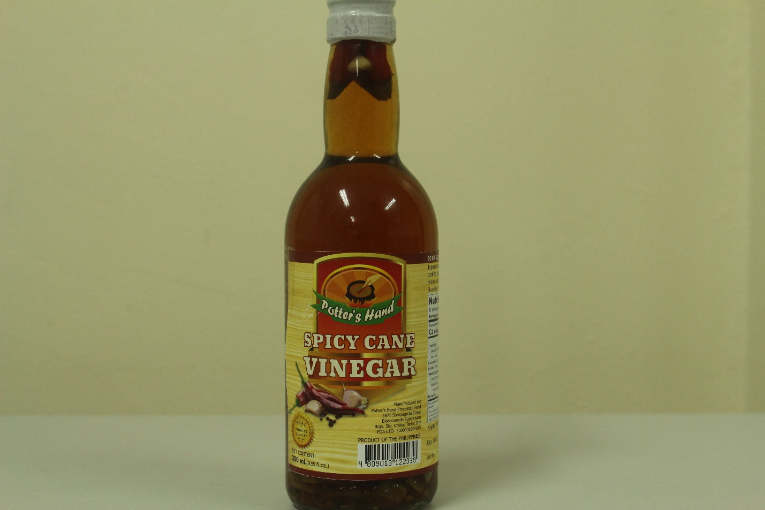

**Technical Assistance in the Design and Development of Promotional Label**

**requested by Potters Hand Processed Foods**

Brgy. Sto. Cristo, Tarlac City

February 20 – April 15, 2018

|  |  |
| --- | --- |
| Beneficiary | Potters Hand Processed Foods |
| Type of Service | Technical Consultancy |
| Extension Service Providers | Judeo R. Herrera (Consultant, Artist) |
| Hours | 48 |