University Research Office
The University Research Office (URO) highlights of accomplishments for 2018 involves the BOR approval of the University Research Statistical Center establishment of the Food Technology and Research Center building. The successful Regional Research Conference held on October 4-5, 2018 at TSU Lucinda Campus and the launching of the E-vehicle on July 3, 2018 were also some major achievements of the University Research Office.
With respect of its core function which is to oversee the conduct of research activities as to consolidate, coordinate and operationalize research activities, the URO was able to obtain 33 completed researches; 13 published researches, 35 paper presented (International fora- 9 and Regional Presentation- 26) as of December, 2018. In addition, the Office conducted 2 In-House Reviews for Completed Researches and 5 Capability Building Seminars as of December, 2018 as well.
Completed Researches
The figure and table below shows the distribution of the completed researches in 2018 as to Information Dissemination - 9 researches, Social Sciences, (SOCSCI) - 16 researches, and Technology Generated- 8:

Name of Faculty/ies | College | Title Of Paper
Social Science
Laarni T. Capinding, Daniel T. Dizon, Editha Q. Villavicencio | CASS | Exploring Mental Health Stigma and its Relationship to College Student’s Help Seeking Behavior
Douglas C. Ferrer | COED | Emergence of New Family Structure: House-Husbands Managing the Home
Wilmark Ramos | CBA | Segmenting Tarlaqueño Consumer: An Analysis
Rosario C. Salas | COED | Qualifications and Competencies of the Technology and Livelihood Education (TLE) Faculty in Region 3: Basis for Faculty Development Plan
Franchete Caingat | CASS | Multiple Intelligence and the Learning Styles of English Language Learners: Implications to Teachers’ Teaching Strategies
Mellany Masangkay | COED | Talent Engagement and Leadership Abilities of College of Education Faculty Members in State Universities and Colleges of Region III: basis of a Teacher management Program
Jay R. Pabustan | CCS | Quality Dimensions of Online Services of Philippines Higher Education Institutions
Nelvin Nool and Jessie B. Aquino | COED | The Use of Edmodo with Journal Writing in Teaching Mathematics
Ma. Agnes P. Ladia, Elizabeth P. balanquit, Niño Corpuz and Nelvin Nool | COED | Accreditation Status Does Matter: Evidence on the LET Performance of State Universities and Colleges
Nelvin R. Nool, Ma. Agnes P. Ladia and Elizabeth P. Balanquit | COED | Influence of Faculty Members’ Educational Attainment on Graduates’ LET Performance among State Universities and Colleges
Theodore Timpac, Roel Alviar, Lylani Claro and Jayson Felix | CCJE | A Study on the Awareness of Katarungang Pambarangay in the Different Barangays of San Clemente, Tarlac
Rebecca Mercado | COED | Instructional Materials on Poetry as Springboard in OBTL in Professional Courses
Marie Paz H. Angeles | CASS | Achievement Motivation vis- a vis personality Type: Implications for Academic Success
Lea B. Milan, Abegail F. Feliciano and Aljon N. Lusong | COS/UESO/URO | Participatory Diagnostic Study on Food and Drug Administration—License to Operate (FDA-LTO) Food Safety Requirements for Selected Micro Food Processors of Tarlac: An Action Research for the Identification of Needed Extension Intervention under TSU Academe- Industry Partnership Program
Jeanette P. Mendoza | COED | Ethnic and National Stereotypes and Self- Stereotypes of the Kapampangan, Ilocano and tagalog Students of Tarlac State University
Technology Generated
Marie Wendy J. Frany, Edwin L. Dela Vega | CET | GIS-Based Liquefaction Potential Analysis: A Seismic Hazard Mapping of Tarlac Province
Murphy Mohammed | CET | Flood Hazard Modeling of Tarlac River
Heidilyn Gamido and Marlon V. Gamido | CCS | Development of Integrated Administrative Management System: Procurement Module for Tarlac State University
Angelo Garcia and Carlos Flores | CCS | An Integrated System for Red Cross: Blood Service
Carlos Flores | CCS | Attendance Monitoring System; College of Computer Studies Computerized Key Logger, Consultation and Attendance Monitoring
Ronnie Mercado, Dennis Virtudazo and Valerie Simbol | CCS | WebApp for Energy Management System
Leo Piao, Raul Canlas, Adam Rombaoa, Arnel Punla, Bernardino Nalipay and Jessie Domingo | CET | Electric Vehicle with Backup Solar Charger Research Project
Lea Milan and Abegail Feliciano | COS/UESO/URO | Composition and process of Improving the Stability of Non- Carbonated Calamondin (Citrofortunella Microcarpa) Ready to Drink Juice
Information Dissemination
Dexter L. Manzano | CASS | Ang Programang Filipino ng Pang-Estadong Unibersidad at Kolehiyo sa Rehiyon III: Batayang Pag-aaral tungo sa isang Akademikong Modelong Pangwika
Joanna Marie I. Escalona | COED | Leadership Framework in Kindergarten Education
Jasper Jay N. Mendoza | COED | Analysis of MAPEH Pre-Service Teachers’ Reflection Logs using Butin’s Model
Jessica Marie I. Dela Peña, Daisy T. Inalvez, Juvy V. Galamay | COED  CASS | Integrasyon ng Edukasyong Gender sa Pagtuturo ng Filipino
Myrna Q. Mallari | CBA | The Practices on Quality Assurance Among State Universities and Colleges in the Philippines
Nelvin R. Nool | COED | Analysis of the LET Performance of BEEd Graduates: Basis for Enhancement in Curriculum and Instruction
Nelvin R. Nool | COED | Development and Validation of Worktext
Rebecca M. Mercado | COED | Mga Gabay sa Pang-Akademikong Pagsasalin
Rebecca M. Mercado | COED | Wika ng Kababaihan sa Biblia: Tungo sa pagbuo ng Glosaryo ng Terminolohiya ng Kababaihan
Alma M. Corpuz, Cynthia G. Quiambao, Julius S. Ganapin, Marivic D. Payang | COED | Evaluation of School-Based Feeding Program: Towards the Development of the TRAC Feeding Program

Published Researches
The table below shows the list of 11 internationally-published researches

Journal Title | Title of Paper | Author/s
Scopus Indexed
Revista Kasmera | Evaluation On The Functionality Of The Barangay Violence Against Women (Vaw) Desks: Basis For Intervention | Rita Pulmano
3L: Language, Linguistics, Literature | Examining The Oral Communication Strategies Used By A Group Of Nepalese Adult Learners In An ESLContext | Brendalyn Manzano
3L: Language, Linguistics, Literature | Development And Validation Of A Monolungual Glossary Of Terms Used By Cockfighters | Dexter Manzano
Iranian Journal Of Language Teaching Research | Researcher And Non- Researcher Teachers' Evaluation Of ELT Materials: Converging Or Diverging? | Brendalyn Manzano
Google Scholar
Review Of Integrative Business And Economics Research | Cases Of Micro Enterprises On The Incentives Asnd Benefits Of The Barangay Micro Enterprises Act Of 2002 | Derick Figueroa
Review Of Integrative Business And Economics Research | Competency Requirements For Professional Accountanting Curriculum Enhancement | Henry Rufino
Review Of Integrative Business And Economics Research | The Employability Skills Of BSBA- Marketing Management Students | Wilmark Ramos
Review Of Integrative Business And Economics Research | Organizational Change And Dimensions Of Learning Organization In Manufacturing Firms | Wilmark Ramos
Review Of Integrative Business And Economics Research | Internal Marketing (IM) Dimensions And Organizational Commitment (OC) Of Universal Banks' Employees | Wilmark Ramos
Review Of Integrative Business And Economics Research | Entrepreneurial Orientation Among TSU BS- Entrepreneurship Students and Graduates | Limuel Pavico
International Journal Of Management And Applied Science | Women School Leaders: Striking The Balance Between Career And Family Life | Alma Corpuz
ISI Indexed
International Review Of Humanities And Scientific Research | Implementation Of TB-DOTS In Rural Health Units Of Tarlac City: An Assessment | Alma Corpuz
Asia Life Sciences | Influence of Mathematics Engagement on the Performing of Secondary Students in a Classroom Setting Employing Understanding by Design Framework | Nelvin Nool

Presented Researches

The table below shows the distribution of 35 presented researches in 26 regional, and 9 international conferences.
Name of Presenter | Title of Paper | Title of Conference
International Fora
Wilmark Ramos | Organizational Change And Dimensions Of Learning Organizations In Manufacturing Firms | SIBR Seoul Conference On Interdisciplinary Business And Economics Research
Wilmark Ramos | The Employability Skills of the BSBA-Marketing Management Students | SIBR Seoul Conference On Interdisciplinary Business And Economics Research
Limuel Pavico | Entrepreneurial Orientation among Tarlac State University BS-Entrepreneurship Students and Graduates | SIBR Seoul Conference On Interdisciplinary Business And Economics Research
Derick Figueroa | Cases of Micro Enterprises on the Incentives and Benefits of the Barangay Micro Business Enterprises Act of 2002 | SIBR Seoul Conference On Interdisciplinary Business And Economics Research
Henry Rufino | Competency Requirements for Professional Accountants: Basis for Accounting Curriculum Enhancement | SIBR Seoul Conference On Interdisciplinary Business And Economics Research
Lolita V. Sicat | Indicators of Indigenous students’ school engagement: basis for plan of action | First International Forum On Empowerment And Social Transformation
Sheila Marie David | Oral Corrective Feedback In A Tertiary L2 Classroom: A Metalinguistic Analysis | 2018 4th International Conference On Culture, Languages And Literature (ICCL 2018)
Nelvin Nool | Exploring The Validity Of TSU College Admission Test In Predicting Graduates' Let Performance | International Conference On Educational Measurement And Evaluation Association
Cecilia Calub | Listening Comprehension Difficulties Of College Students: Basis For Remediation Strategies In The Classroom | Cher- Hongkong 2018 The Iafor Conference For Higher Education Research
Marie Paz Angeles | An Assessment of Intrapersonal and Interpersonal Skills of Non-Teaching Employees: Towards an Effective Wellness Program | Human Rights, Dignity And Justice Icp 76th Annual Conference
Jeanette Mendoza | Inter-Ethnolinguistics Group Stereotypes At Tarlac State University | Second International Conference On Philippine And Asian Studies
Regional Conference
Leo P. Piao | Computing And Interpreting Reliability Indices Of An Electric Distribution Circuit | 1st Regional Research Conference
Rita Esteban-Pulmano | Evaluation On The Functionality Of Barangay Violence Against Women (Vaw) Desks: Basis For Intervention | 1st Regional Research Conference
Murphy P. Mohammed | Flood Hazard Zoning Of Tarlac City: Towards The Development Of Flood Overlay Zones And Provision | 1st Regional Research Conference
Mervin P. Mohammed | Licensure Examination Performance Evaluation Of The Candidate Engineers As Basis For A Proposed Action Plan | 1st Regional Research Conference
Alma M. Corpuz | Types Of Household Waste And Disposal Practices Of Residents In A Selected Barangay In Tarlac | 1st Regional Research Conference
Ma. Theresa A. Acosta | Women School Leaders: Striking A Balance Between Career And Family Life | 1st Regional Research Conference
Cynthia G. Quiambao | Evaluation Of A Feeding Program In I Public Elementary Shool In Tarlac And The Development Of The Trac Feeding Program Model | 1st Regional Research Conference
Dexter L. Manzano | Ang Programang Filipino Ng Mga Pang-Estadong Unibersidad At Kolehiyo Sa Rehiyon III: Batayang Pag-Aaral Tungo Sa Isang Akademikong Modelong Pangwika | 1st Regional Research Conference
Jessica Marie I. Dela Peña | Integrasyon Ng Edukasyong Gender Sa Pagtuturo Ng Filipino | 1st Regional Research Conference
Arlyn C. Cura | Ebalwasyon Ng Kapampangan Mother Tongue-Based Education: Batayan Ng Isang Kagamitang Pampagtuturo | 1st Regional Research Conference
Laarni T. Capinding | Exploring Mental Health Stigma And Its Relationship To College Student’s Help Seeking Behavior | 1st Regional Research Conference
Douglas C. Ferrer | Emergence Of New Family Structure: House-Husbands Managing The Home | 1st Regional Research Conference
Wilmark Ramos | Segmenting Tarlaqueño Consumer: An Analysis | 1st Regional Research Conference
Marie Wendy Frany | Gis-Based Liquefaction Potential Analysis: A Seismic Hazard Mapping Of Tarlac Province | 1st Regional Research Conference
Joanna Marie I. Escalona | Leadership Framework In Kindergarten Education | 1st Regional Research Conference
Jasper Jay N. Mendoza | Analysis Of Mapeh Pre-Service Teachers’ Reflection Logs Using Butin’s Model | 1st Regional Research Conference
Nelvin R. Nool | Development And Validation Of Worktext | 1st Regional Research Conference
Rebecca M. Mercado | Mga Gabay Sa Pang-Akademikong Pagsasalin | 1st Regional Research Conference
Jayson Y. Punzalan | Development And Validation Of Infographics Based On The Least Mastered Competencies In Physics | 1st Regional Research Conference
Rowena Ramos | Performance Of Multi-Purpose Cooperatives In The City Of Tarlac | 1st Regional Research Conference
 | Personal Finance Practices of TSU Faculty And Personnel | 1st Regional Research Conference
 | The Bachelor Of Science In Business Administration Major In Financial Management Graduates Of Tarlac State University | 1st Regional Research Conference
Criselda Alamo | Sanitary Conditions Of Food Vending Sites Research Abstract Submission | 1st Regional Research Conference
Marlon Gamido | Comparative Review Of The Features Of Automated Software Testing Tools | 1st Regional Research Conference
Angelo Garcia | An Integrated System For Red Cross: Donors’ Profiling | 1st Regional Research Conference
Ma. Agnes Ladia | Community Extension In Laungcupang, La Paz, Tarlac, Central Luzon, Philippines: Best Practices And Lessons Learned | 1st Regional Research Conference

Researches Cited
The table below shows the distribution of 8 researches cited in international journals.

Name Of Researcher | Title Of Research | Title Of The Citing Article/Book | Citing Journal/Book
Google Scholar
Jhonel C. Panlilio | Needs Assessment Of Women Entrepreneurs In The Province Of Tarlac, Phil: Basis For The Creation Of A Business Development Center | Strategies To Sustain Small Businesses Beyond 5 Years | Walden University Scholarworks
Wilmark Ramos | Internal Marketing (IM) Dimensions And Organizational Commitment (OC) Of Universal Banks' Employees | The Effect Of Internal Marketing Dimensions On Organizational Commitment Of Employees: An Investigation Among Private Banks In Falsalabad, Pakistan (A Study Based On Different Dimensions Of Internal Marketing) | European Online Journal Of Natural And Social Sciences 2018
Claire C. Lagrana | Chironomids As Biological Indicator Of Metal Contamination In Aquatic Environment | Response Of Chironomus Striatapennis Larvae Exposed To Three Heavy Metals | Asian Journal Of Biology
Claire Lagrana | Toxicity Of Cu2+, Cd2+ And Pb 2+ Metal Ions In Chironomids And Factors That Affect Metal Accumulating | Toxicity Of Nerium Oleander Extracts Against Pectinophora Gossypiella (Saunders) (Lepidoptera: Gelechiidae) | International Journal Of Advanced Research In Biological Science
Erwin P. Lacanlale | Development And Validation Of A Solid Intelligence Inventory | A Qualitative Case Study Of Engagement In Higher Education: The Influence Of Teacher's Experiences On Classroom Engagement At A Southern State | Northcentral University, Proquest Dissertations Publishing, 2018
Murphy Mohammed | Flood Hazard Zoning In Tarlac City: Towards The Development Of Flood Overlay Zones And Provision |  | International Journal Of Civil Engineering And Technology(Flood Mitigation Management In Tidal Water Areas)
Elizabeth Amurao | Marketing Strategies Of Selected Business Establishments In The City Of Tarlac | An Examination Of Marketing Mix Elements And Customer Retention In Malaysian Retail Market | Internation Journal Of Trade And Global Markets (Analysis Of Marketing Strategies And Competitive Advantages Of Two Producers Special Foods In Garut)
Limuel Pavico | The Relationship Of Supply Chain Management Practices Of Micro Enterprises To Competetitive Advantage | Supply Chain Modelling In The Ceramic Industry Center In Purwakarta, Indonesia | Review Of Integrative Business And Economic Research

Capacity Building
Below is the table showing the seminars/trainings conducted by the University Research Office in 2018
TITLE OF TRAINING | DATE | NO OF TRAINED FACULTY/STAFF
TRAINING ON THE USE OF TURNITIN SOFTWARE | NOV 8, 2018 | 50
SEMINAR ON RESEARCH WRITING | JANUARY 24, 2018 | 41

IN-HOUSE REVIEWS OF COMPLETED RESEARCHES

The Midyear In-House review was held at the Training Room RED Building, TSU Lucinda Campus on August 30, 2018 with 14 research entries and the Yearend In-House review of completed researches was conducted on December 14, 2018 with 19 research entries.
2018 Mid-Year In-House Review of Completed Researches

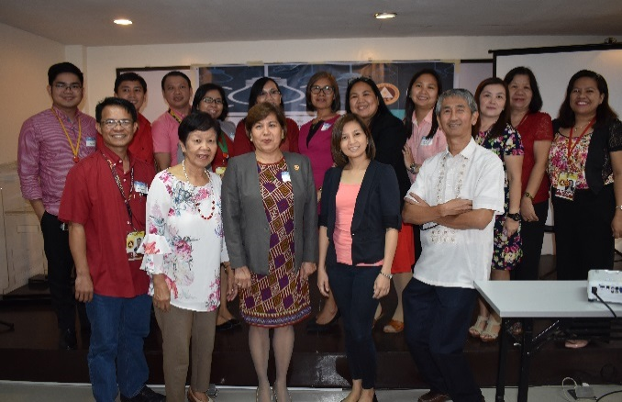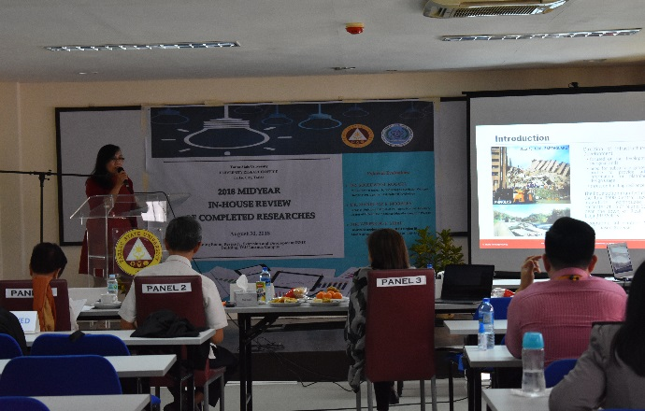
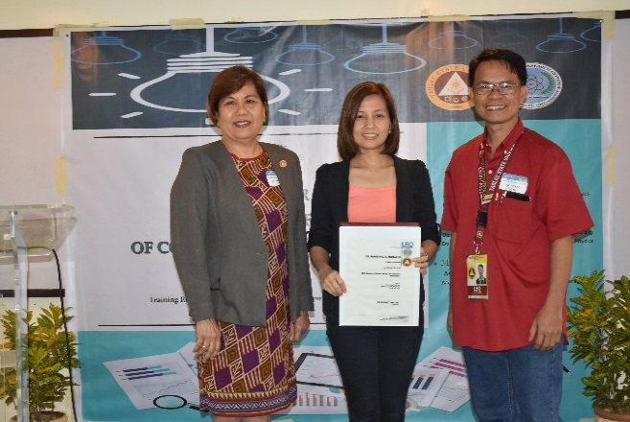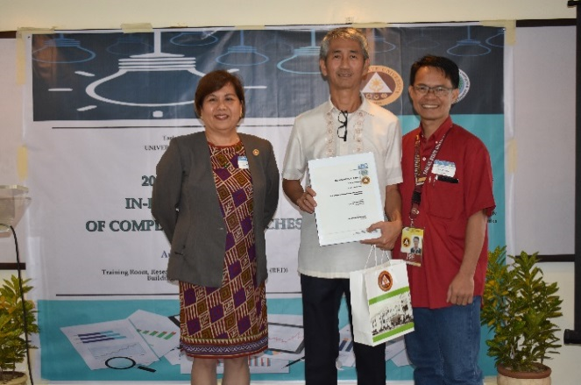

2018 Year- End In-House Review of Completed Researches
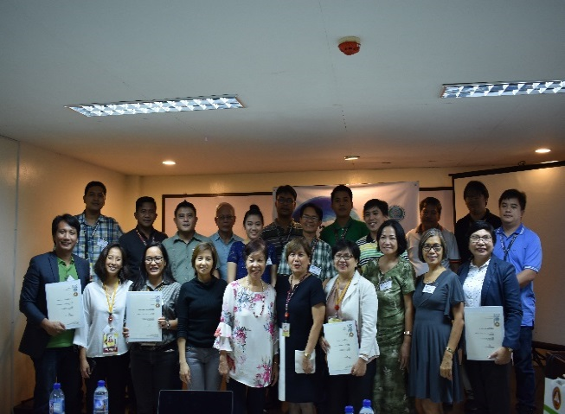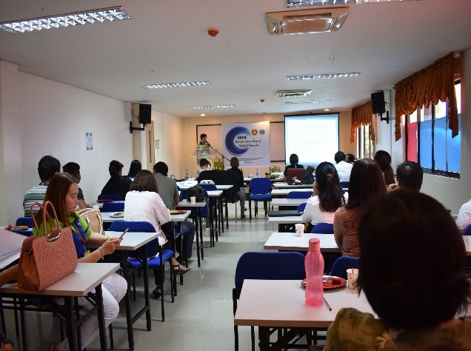

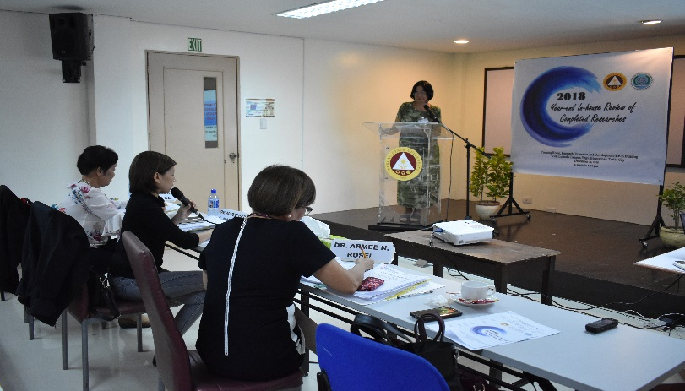

CAPABILITY BUILDING
SEMINAR ON RESEARCH WRITING
(JANUARY 24, 2018)

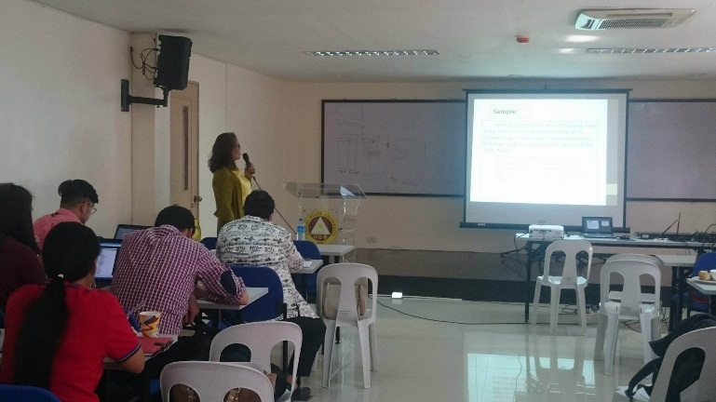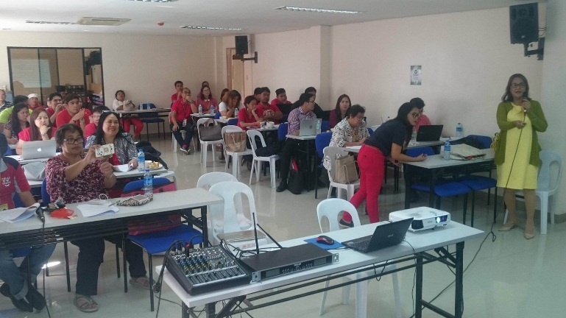

A seminar on Research Writing was held on January 24, 2018 at the Training Room, RED Building, Lucinda Campus. The invited speaker was Dr. Cecilia L. Calub from the College of Education, TSU. A total of 41 faculty members attended the said seminar which aimed to equip more knowledge on research writing.
Seminar on Turnitin Software
(November 8, 2018)

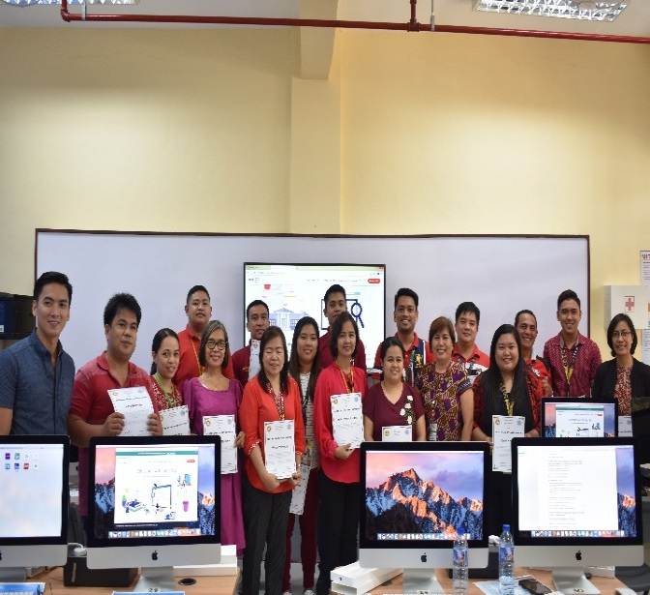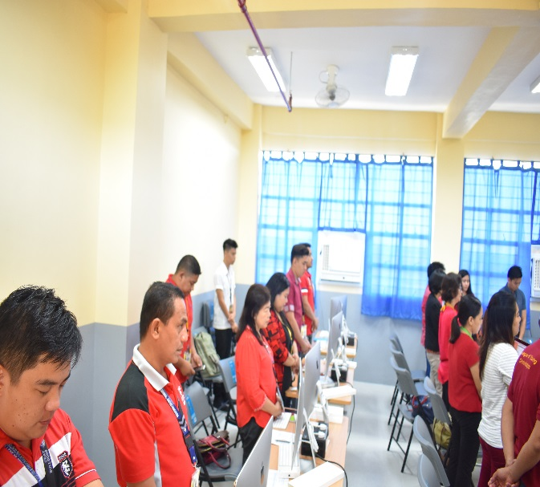
To further capacitate the faculty researchers, the URO conducted a Seminar on Turnitin Software on November 8, 2018 at the Computer Laboratory, CCS, TSU San Isidro wherin a total of 50 faculty mebers attended the said seminar.
OTHER ACTIVITIES
1st Regional Research Conference
(October 4-5, 2018)
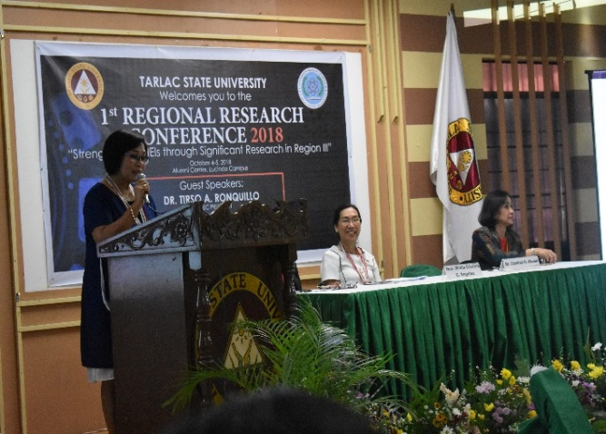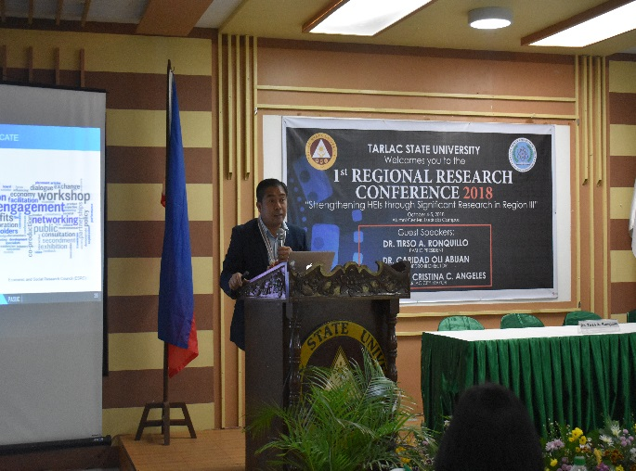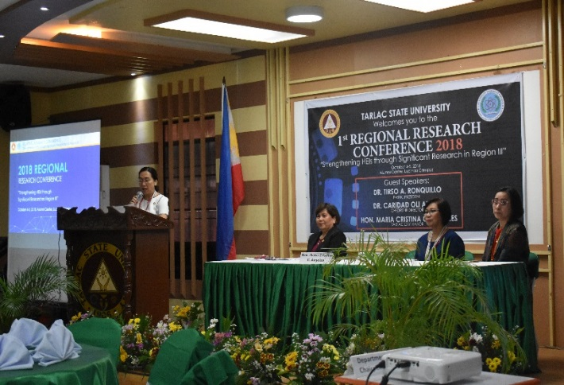

3-in-1 Event
(July 4, 2018)
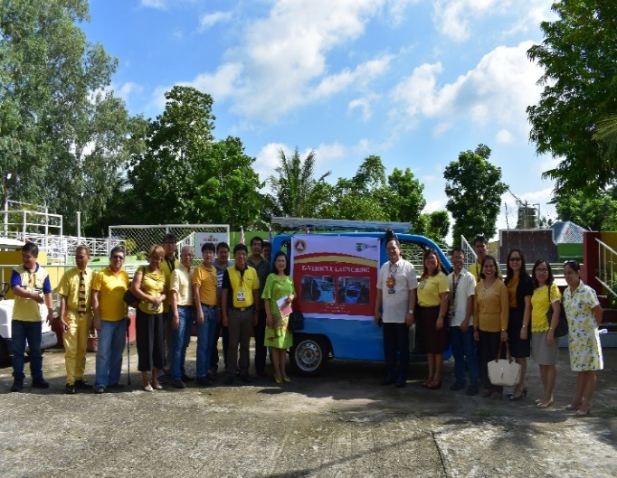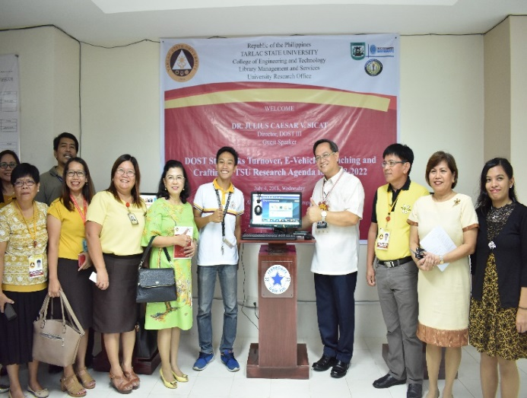

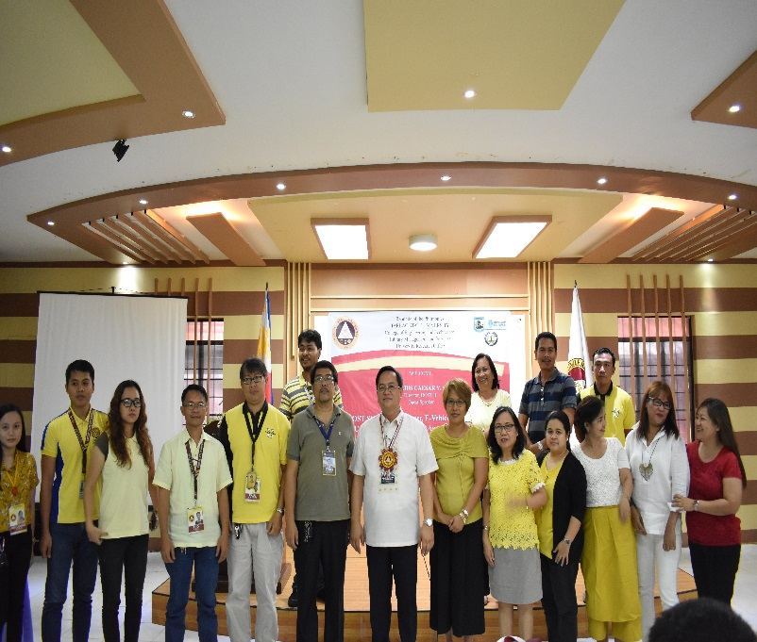
IMS AUDIT
(October 9 and 11, 2018)
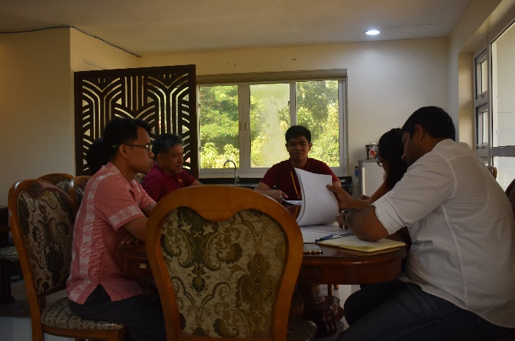

Photos of Research Proposal Colloquim

COLLEGE OF BUSINESS AND ACCOUNTANCY
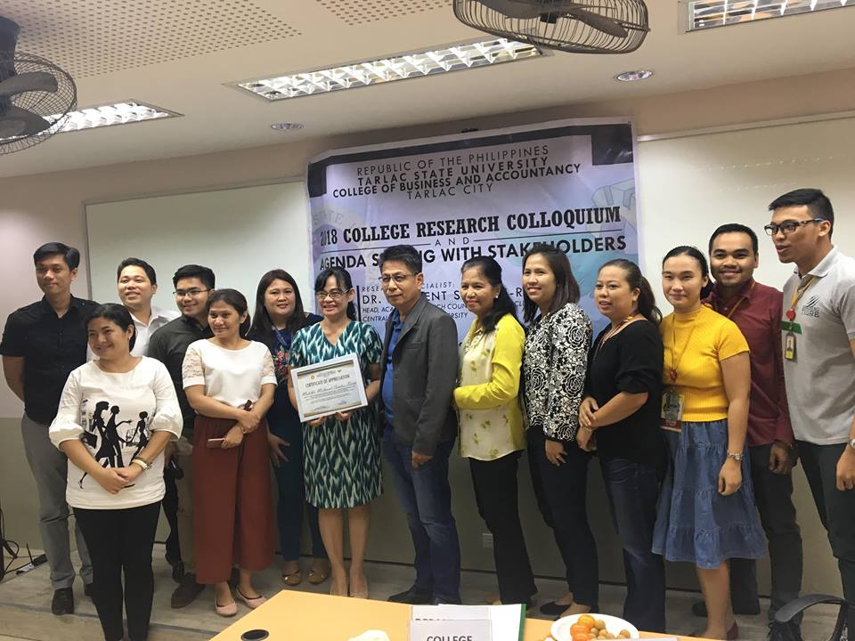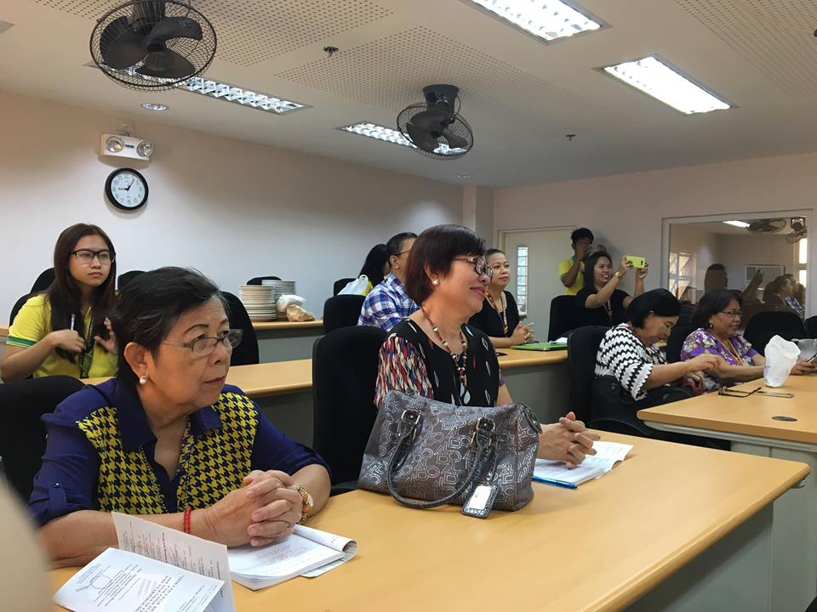
COLLEGE OF COMPUTER STUDIES
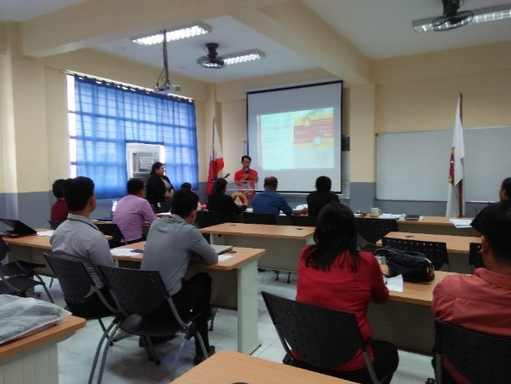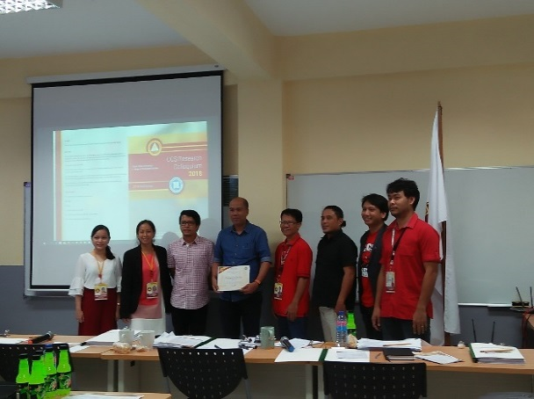
COLLEGE OF SCIENCE
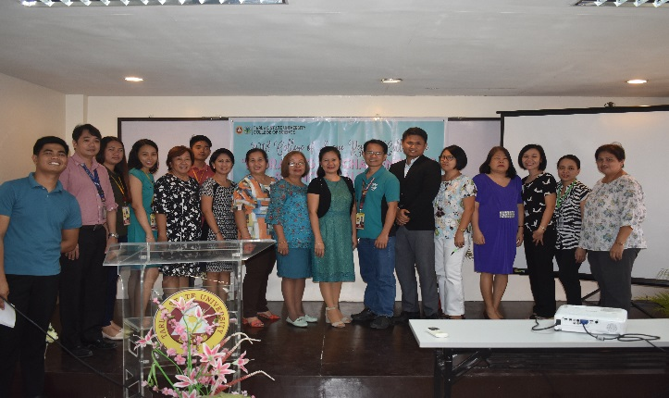
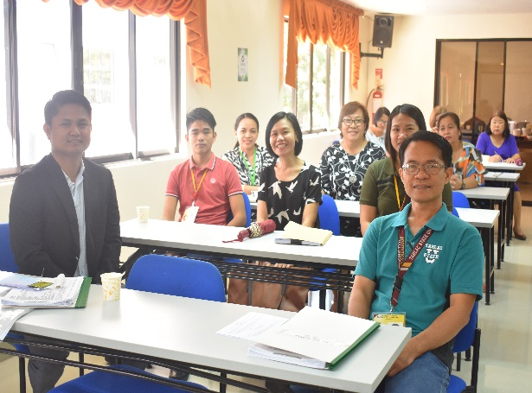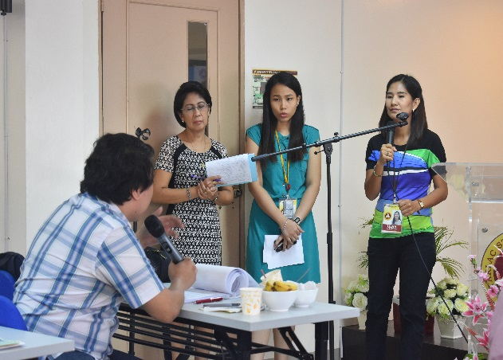

PAMANTASANG SENTRO NG WIKANG FILIPINO

- Prepared documents needed as member of Area III (Curriculum and Instruction) for MAED-Filipino Program Level II Accreditation held last 17-19 April 2018
- Submitted research proposal to the Office of Regional Center for Resources and Development of Indigenous People which is entitled “Lingguwistikong Etnograpiya ng Ayta Mag-antsi sa Lalawigang Tarlac”.
- Translated two (2) documents of the UESO in Filipino, which are entitled:
- Non-exclusive License Agreement
- Mutual Confidential Disclosure Agreement
- Sought the approval to conduct National Seminar-Workshop in Filipino from the TSU President, its proposed scheduled budget and letter of invitation to speakers.
- On the process of gathering data for the research commissioned by KWF for the “Linguistic Ethnography of Aeta Mag-antsi” in Barangay Sapang Bato, Angeles City, Pampanga.
- Attended the following activities:
- RRC meeting on 26 June 2018.
- COED and CASS graduation ceremonies held on 19-20 June 2018.
- VP RES Pre-Panning on 20 June 2018 (PM)
- COED faculty meeting on 21 June 2018
- Organized University Program for Buwan ng Wika 2018 on 23 August 2018 at the Gymnasium.
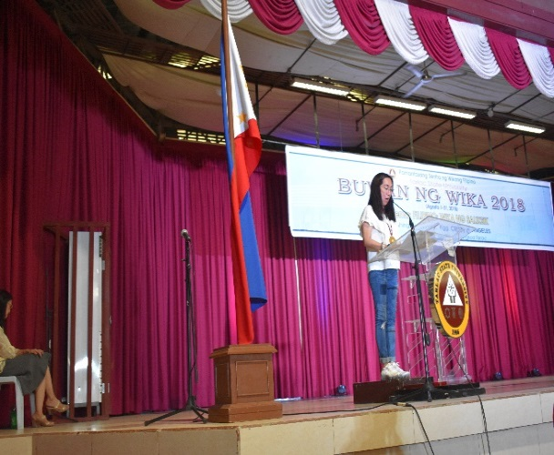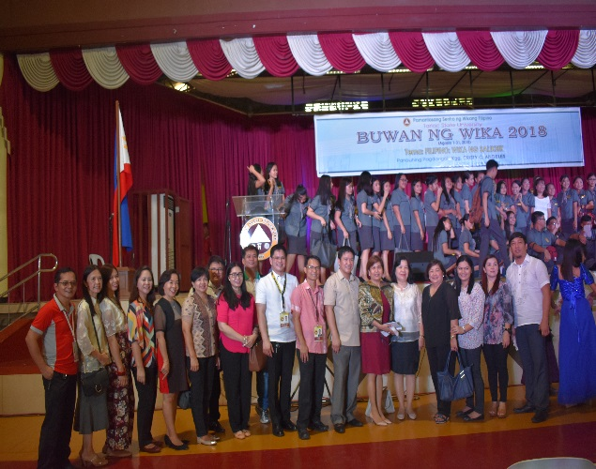
- Conducted 4 literary contest in Filipino which were held on the following dates at the Amphitheater:
August 24, 2018 - Malikhaing Pagkukwento
- Dagliang Talumpati
- Pagsulat ng Sanaysay
August 30, 2018 - Sabayang Pagbigkas
- Submitted the edited book titled:”Kontekstwalisadong Komunikasyon sa Filipino” to the TSU Book Committee for the review and evaluation
- Conducted Pambansang Seminar-Workshop in Filipino with the theme: “Pagsulat ng Pananaliksik, Modyul at ang Publikasyon Nito” on October 19-21, 2018 at Alumni Center, Lucinda Campus, Tarlac State University.
Pagpapakilala sa mga Delegado
DR. DAISY T. INALVEZ
Tagapangulo, PSWF

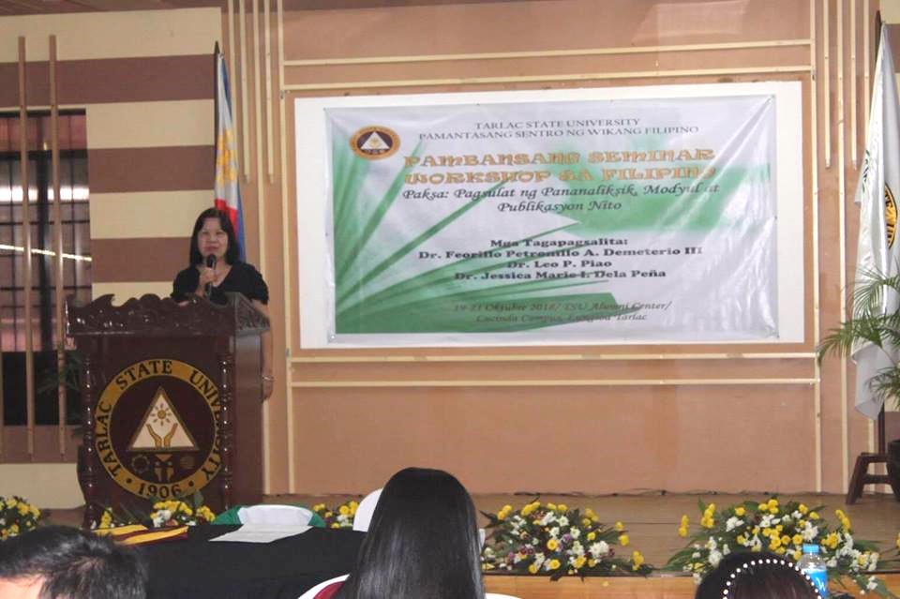

Tagapanayam 1

DR. FEORILLO PETRONILLO A. DEMETERIO
Director, University Research Coordination Office
De La Salle University, Manila
Paksa: Publikasyon ng Pananaliksik

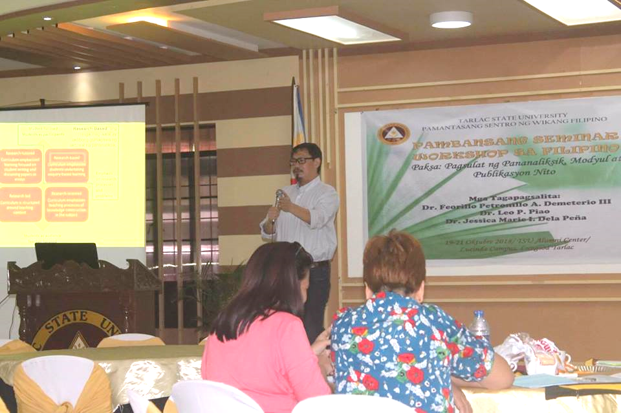

Tagapanayam 2

DR. LEO P. PIAO
Director, Tanggapan ng Pananaliksik ng TSU
Paksa: “Pagsulat ng Pananaliksik”
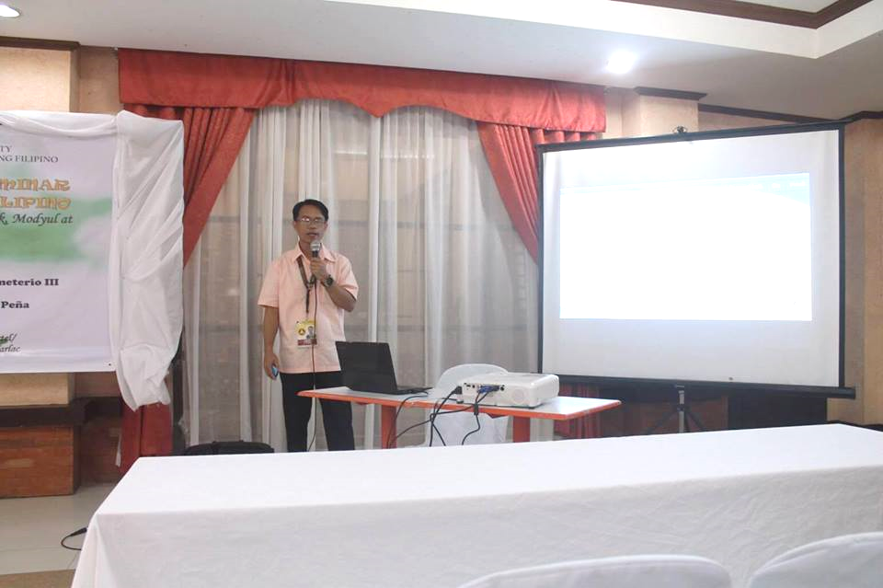

Tagapanayam 3:
DR. JESSICA MARIE I. DELA PEÑA
Asst. Professor, Kolehiyo ng Edukasyon
Paksa: “Pagsulat ng Modyul”
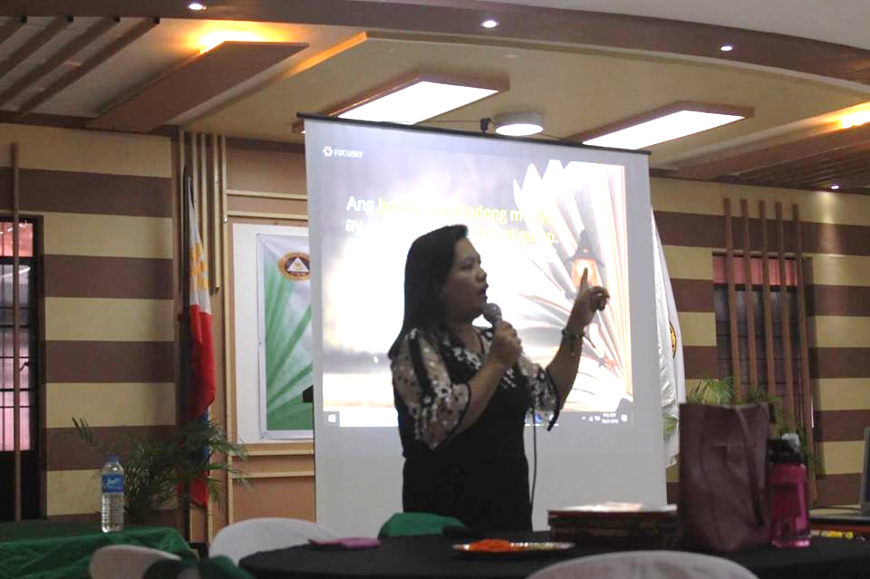

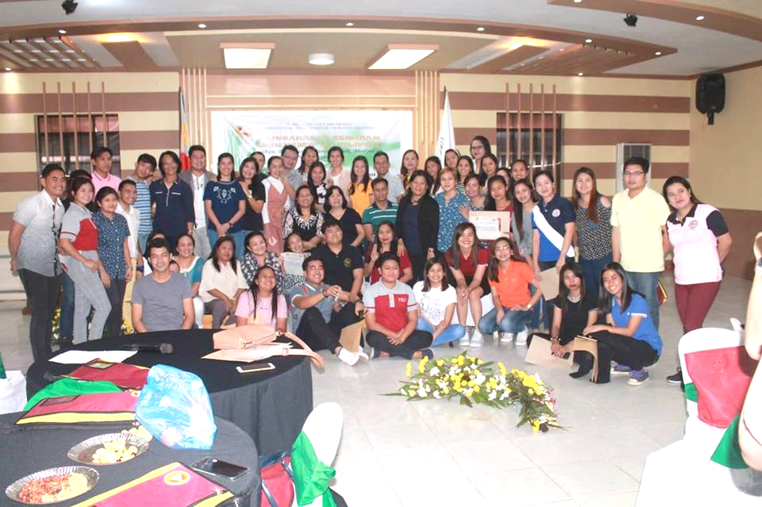
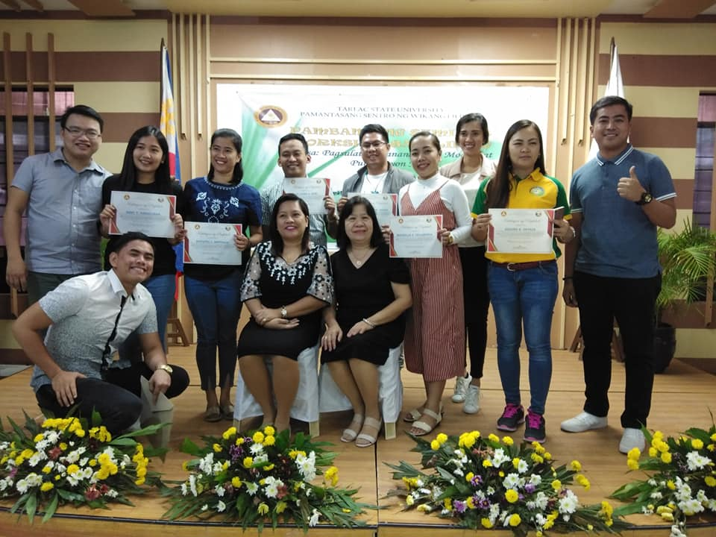

- Translation – English to Kapampangan
- Research Questionnaire of Ms. Michelle Larin - Research Assistant of National Health Literacy Survey, College of Public Health,
- University of the Philippines, Manila.

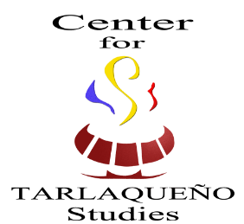
Center for Tarlaqueño Studies

- Conversion of Old CCS Room 8 and 9 into University Musem
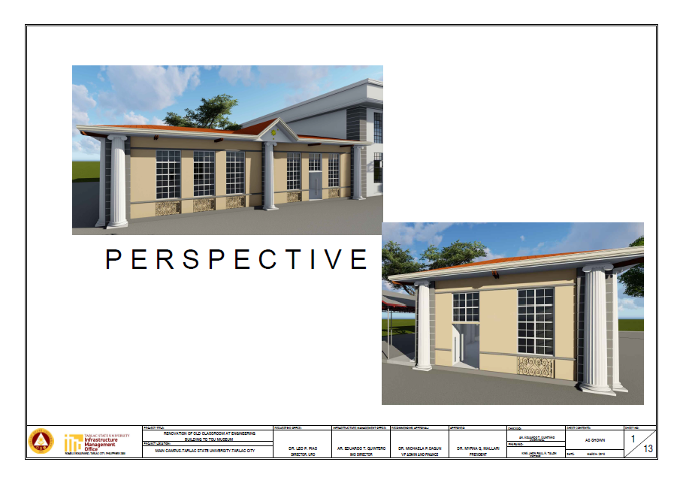
- Memorandum of Agreement with the Municipality of Concepcion, Tarlac for the adoption of the CTS publication KASALESAYAN as the official reference of the Municipal Local History Quiz every foundation day. June 27, 2018
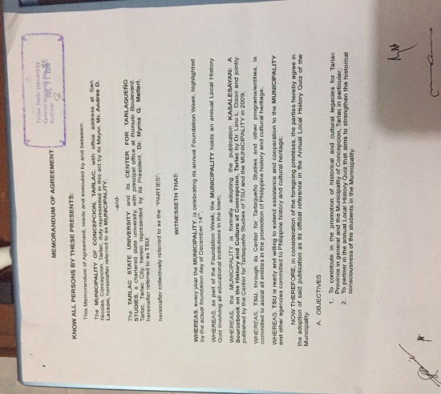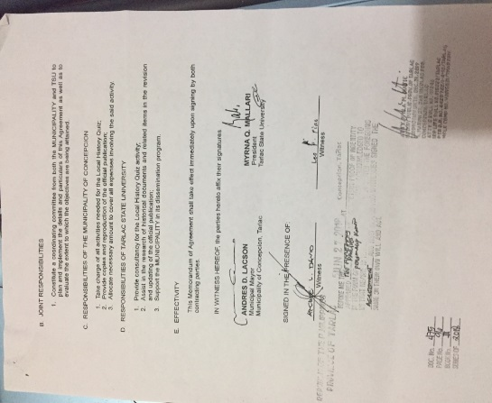
- Memorandum of Agreement with the Municipality of Concepcion, Tarlac for the adoption of the CTS publication KASALESAYAN as the official reference of the Municipal Local History Quiz every foundation day. June 27, 2018

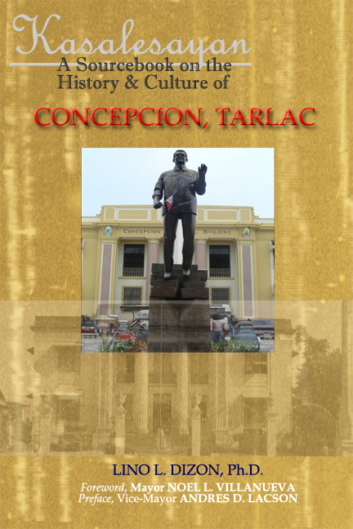
- Presented in the International Conference: TAIWAN and the ASIA-PACIFIC Emerging Trends and Opportunities, Asian Center, University of the Philippines-Diliman, April 20, 2018

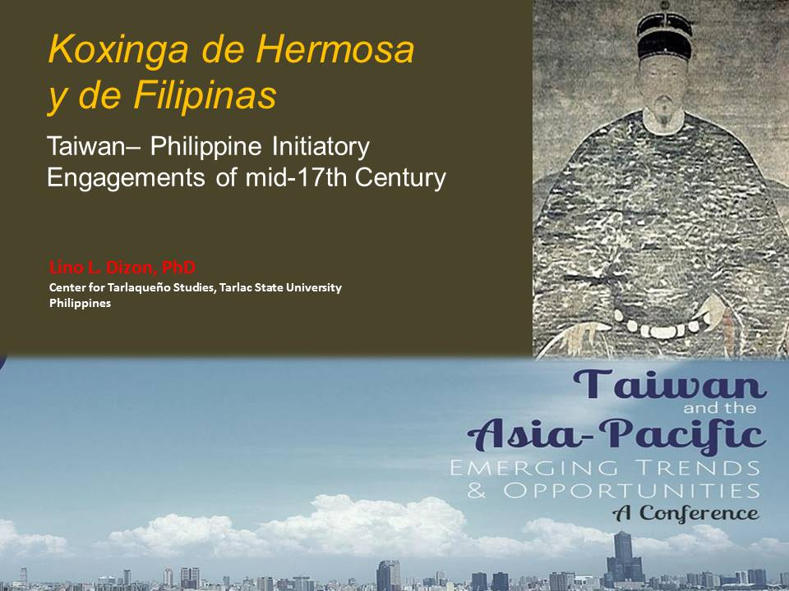
- As Guest of Honor and Speaker during the 145th Foundation Day of Tarlac Province, May 28, 2018.
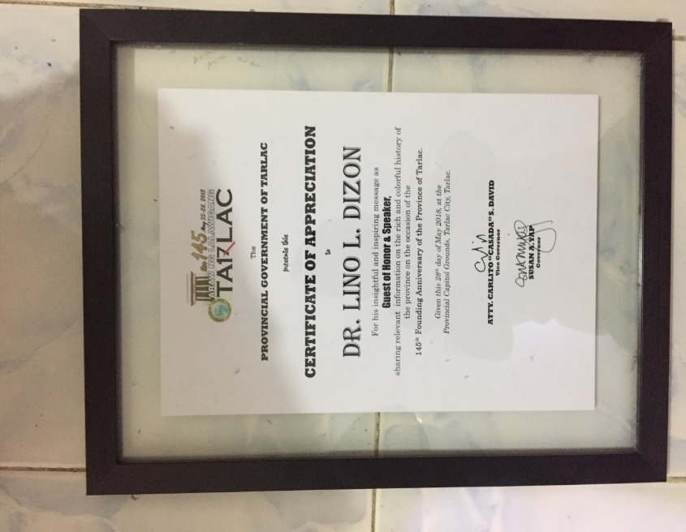
- Member of the Tarlac City Council for Culture and the Arts
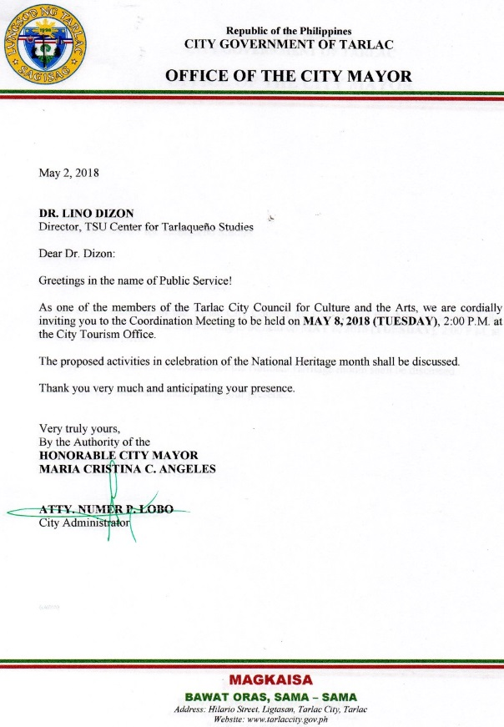
- Served as Translator and Member of the FGD (Focal Group Discussant) in the preparation of the Kapampangan Survey Questions targeted for Tarlac Province (Capital City and Third District) in the National Health Literacy Survey of the UP Health Institute, Manila.
- Submitted research proposal entitled “CULTURAL INDEXING TARLAQUENO COMMUNITIES (TCS) THROUGH PLACE-BASED EDUCATION AND CRITICAL PEDAGOGY OF PLACE:” In the National Commission for the Culture and the Arts Call for Research Proposals 2019.

TSU-Analytical Testing Laboratory & Natural Products Research Center
- Audit was conducted by Department of Health on October 9, 2018 with some recommendations.
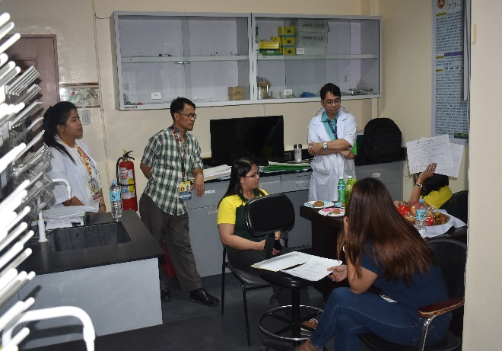
- Sampling and testing of water supply in 3 campuses finished by end of December 2018.
- Completion and submission of Documents of the TSU-Analytical Testing Laboratory in preparation for DOH registration finished by end of December 2018.
- Submission of monthly (notarized) consumption reports of TSU-ATL-NPRC to PNP.
- Permit to Purchase and Moved Chemicals successfully submitted and approved by PNP Camp Crame by December 2018.
- Renewal for PNP License and submission of new set of documents with license renewed by October 2018.
- Renewal for PDEA License and submission of new set of documents with license renewed by December 2018.
- Submission of semi-annual consumption report of TSU-ATL-NPRC for January to June 2018 to PDEA on or before July 15, 2018.
- Participation in the Regional Research Conference last October 4-5, 2018 held at TSU Lucinda Campus.
- Submission of proposal entitled, “Status of Ground Water And Waste Water Management In Tarlac State University: Compliance To The Dao 2016-08 On Water Quality Guidelines And Integrated Management Systems (IMS)” presented at the COS Colloquium on October 26, 2018.
- Active participation in all meetings and activities of DENR-Manila Bay Rehabilitation for 3rd and 4th quarter of 2018 and 6th manila Bay Day Celebration (September 18, 2018 and TO# 12-070 s. 2018)
- Catered 15 clients from TSU and other agencies and universities

Food Technology and Research Center
- Completed and presented research entitled “Composition and Process of Improving the Stability of Non-Carbonated Calamondin (Citrfortunella microcarpa) Ready to Drink Juice” and “Participatory Diagnostic Study on Food and Drug Administration—License to Operate (FDA-LTO) Food Safety Requirements for Selected Micro Food Processors of Tarlac: An Action Research for the Identification of Needed Extension Intervention under TSU Academe- Industry Partnership Program” during the 2018 Year- end In- House Review of Completed Researches
- Submitted a research proposal entitled “Development of Composition and Process of Ready-to-Eat Canned Rice Meals and Snacks” to Department of Agriculture on December 27, 2018
- Attended the following capacity building activities:
Statistical Process Control Seminar-Workshop | July 24-26, 2018
Webinar on Overview of the New ISO 22000: 2018 (Food Safety Management System) Standards | Dec. 7, 2018
Webinar on How to Select a GFSI (Global Food Safety Initiative) Certification Scheme that is Best for my Company | Dec. 21, 2018

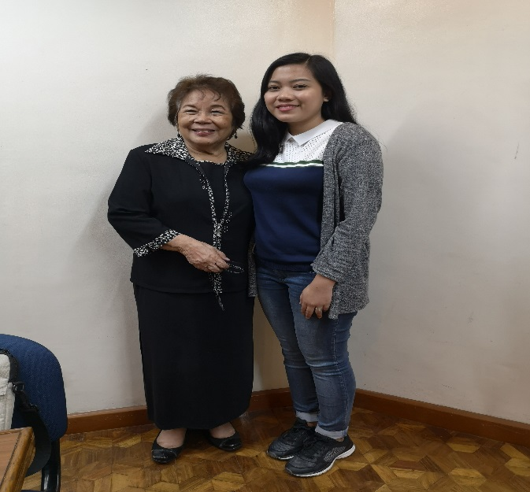
STATISTICAL PROCESS CONTROL SEMINAR-WORKSHOP
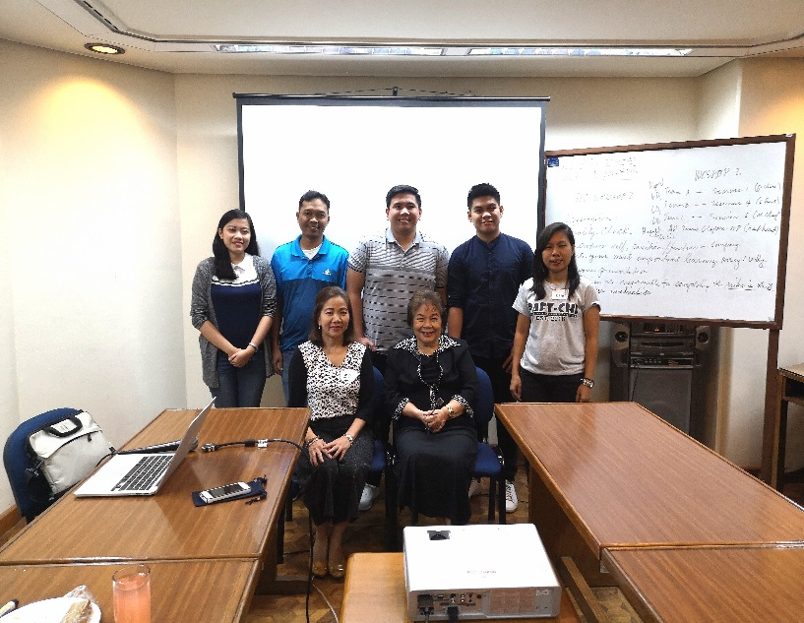

- Review of the FTRC Operations Manual FTRCOM Review Committee on Dec. 19, 2018
- Assisted in the following activities spearheaded by URO:
- 2018 Mid-Year In-House Review of Completed Researches, Aug. 30, 2018
- 1st Regional Research Conference on Oct. 4-5, 2018
- 2018 Year-End In-House Review of Completed Researches on Dec. 14, 2018

University Research Statistical Center
- Increased number of recognized statisticians by the university
- Conducted 2 capability buildings last March 26, 2018 and November 12, 2018 respectively
TEST OF DIFFERENCE USING SPSS | NOV 12, 2018 | 12
SEMINAR WORKSHOP ON THE USE OF IBM- SPSS | MAR 26, 2018 | 14

SEMINAR WORKSHOP ON THE USE OF IBM- SPSS
(MAR 26, 2018)
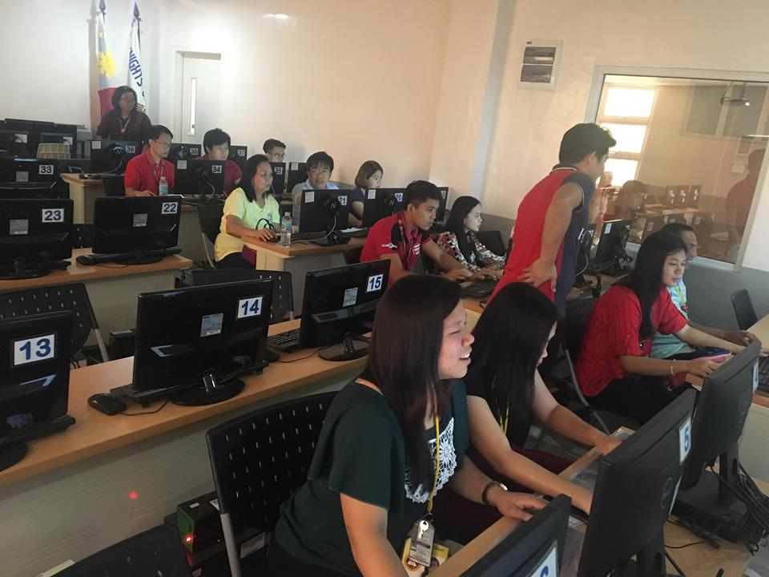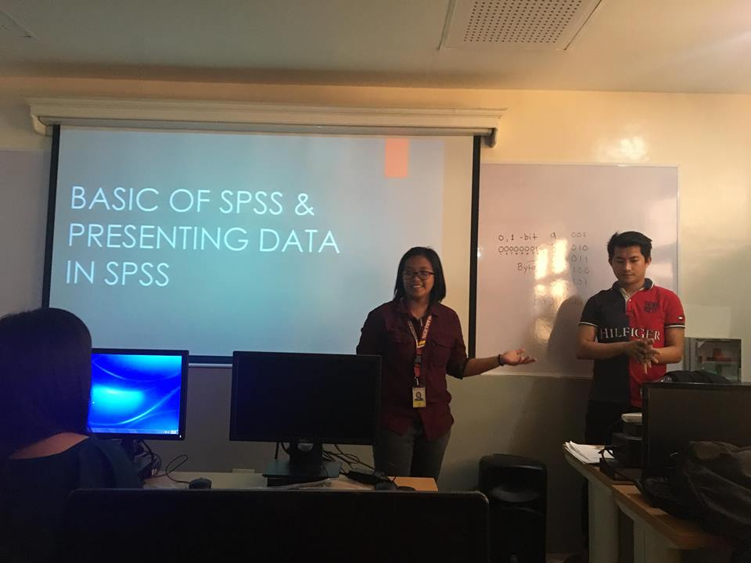
In the pursuit of knowledge in research writing, data gathering interpretation of data, the URSC conducted a Seminar Workshop on the Use of IBM- SPSS in which Mr. Jersey Pangilinan shared his expertise on the use of SPSS.

Test of Difference using SPSS
(November 12, 2018)

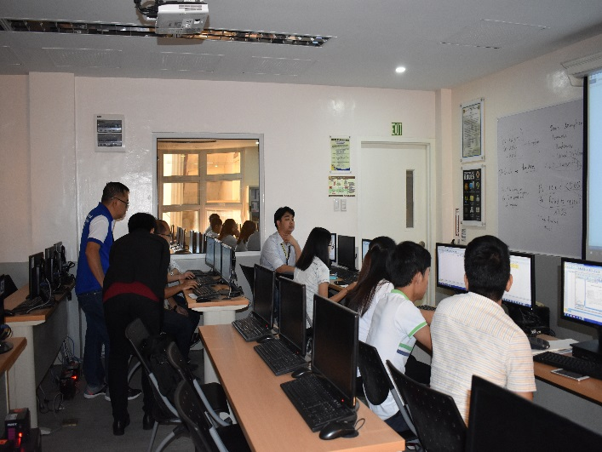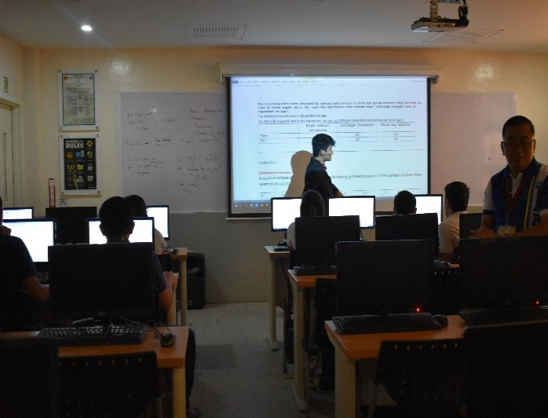
After the Seminar on the Basics of IBM- SPSS held earlier this year, another seminar was conducted by the URSC on Nov. 12, 2018 to further capacitate the faculty researchers’ basic knowledge on SPSS.

- Conducted consultation to graduate students as part of the suggestions of the Review Committee of the URSC Research Operations Manual.
- Approval of the URSC Research Operations Manual during the 4th Admin Council held at TSU Cristo Rey Campus on November 14, 2018.
- Catered 12 clients--- undergraduate and graduate students from January to December

