ANNUAL REPORT 2019
One of the major accomplishments of the University Research Office is the inauguration of the Museo- Archivo Tarlaqueno, initiated by Dr. Lino Dizon. Also, the 1st National Research Conference was held this year participated by delegates from different provinces in the Philippines.
In terms of its core function, to oversee, coordinate, consolidate, and operationalize the conduct of research activities of the university, a total of 39 completed research papers (ABLESS-17 and STEM- 22), 15 published researches (Scopus- 13, ISI- 1 and other international peer reviewed journal- 1), 13 research papers presented in national research conferences and 134research- based citations were recorded.
RESEARCH SERVICES
Completed Research
A total number of 39 research papers (17- ABLESS and 22- STEM). The figure and table below show the completed researches in 2019 and the awards/ recognitions received:

No. | Research Title | Author/s | College | Awards/ Recognition
1 | Exploring the Experiences of Men as Early Childhood Educators | Niño Corpuz | CTE | - 1st place- In- House Review of Completed Researches (Social Science category)  - Best Paper- 2019 GAD National Congress
2 | Sediment Characterization and Heavy Metal Pollution Assessment in Laguna de Bay, Philippines | Bertrand Aldous Santillan | COS | - 1st place- In- House Review of Completed Researches (STEM category)  - Best Paper- 1st Annual National PCSMT Research Congress
3 | GIS Based Analysis of Urbanization and Water Quality Trends in Laguna de Bay, Philippines | Bertrand Aldous Santillan | COS | - 2nd place- In- House Review of Completed Researches (STEM category)  - Presented in the 1st Annual National PCSMT Research Congress
4 | Delivery of Health Services in an Adopted Community: Positive Outcomes and Areas for Refinement | Alma M. Corpuz, Adora Obregon, Mary Jane N. Rigor, Lorna C. Gamis, Ma. Susan Z. Maglaqui, Lucila O. Sunga, and Estrella B. Pagco | COS | - Presented in the 1st National Research Conference
5 | Web-based Faculty Promotion Evaluation System Using NBC 461 CCE/QCE | Heidilyn Gamido | CCS
6 | Developing a Secured Image File Management System Using Modified Advanced Encryption Standard | Marlon Gamido | CCS
7 | Disaster Risk Reduction and Management of Tarlac City | Murphy Mohammed | CET
8 | Local Public Enterprise: Its Impact in the Local Economic Development in the Province of Tarlac | Maria Tiara Fatima F. Galang | CPAG | - 2nd place- In- House Review of Completed Researches (Social Science category)  - Best Paper- 1st National Research Conference
9 | Level of Competitiveness on Resiliency in the 3rd District of Tarlac an Analysis | Patricia Estrada | CPAG | - 3rd place- In- House Review of Completed Researches (Social Science category)
10 | Modified SHA-1 Algorithm | Rogel Quilala | CCS
11 | QR Code Integrity Verification Based on Modified SHA-1 Algorithm | Rogel Quilala | CCS
12 | Improved MSHA-1 Algorithm with Mixing Method | Rogel Quilala | CCS | - 3rd place- In- House Review of Completed Researches (STEM Category)
13 | Modified AES for text and image encryption | Heidilyn Gamido | CCS
14 | Implementation of a Bit-Permutation-based Advanced Encryption Standard for Securing Text and Image Files | Heidilyn Gamido | CCS | - 2nd place In- House Review of Completed Researches (STEM Category)
15 | The Development and Fabrication of the Automated Machine for Smoked Fish System | Aldrin Joar Taduran | CET
16 | An Improved Overlapping Clustering Algorithm to Detect Outliers | Alvincent Danganan | CCS
17 | OCA: Overlapping Clustering Application Unsupervised Approach for Data Analysis | Alvincent Danganan | CCS
18 | An Enhanced Overlapping Clustering for Data Analysis Approach | Alvincent Danganan | CCS
19 | Development of Molding Machine for Petal-Shape Gum Paste | Adam Rombaoa | CET
20 | 9 -Element Electronically Steerable Parasitic Array Radiator Antenna for Ultra High Frequency Band | Don Louie Sanvictores | CET
21 | Modified Blowfish Algorithm | Theda Flare Quilala | CCS
22 | Securing Electronic Medical Records using Modified Blowfish Algorithm | Theda Flare Quilala | CCS
23 | Optimization of Traditional Muscovado Cook Stove in Gerona Tarlac | Larry Suboc | CET | - 3rd place In- House Review of Completed Researches (STEM Category
24 | Energy Consumption Analysis in a Computer Laboratory | Dennis Virtudazo | CCS
25 | Composition and Process of Producing Sweet Potato- Based Desserts | Lea Milan | COS
26 | Career Success and Acquired Competency Skills of the Graduates of the Bachelor of Secondary Education- Physical Science of the College of Education, Tarlac State University | Jayson Punzalan | CTE
27 | Amidst Difficulties: Challenges and Coping Mechanisms of Farmers in a Flood-Prone Community | Jersey Pangilinan | CASS
28 | Continuing Professional Development of the Teacher Education Faculty among State Universities and Colleges in Region III | Ninez Tulo | CTE
29 | Victim Survivor of Forced Labor Among Aetas: A Case Study in Tarlac | Ramil Las Igan | CCJE
30 | Employability Self-Efficacy Scale for Technical-Vocational Senior High School Students | Rosana Pablico | CTE
31 | Assessment of Extension Support Services to Micro-Food Processors’ Compliance to RA 10611 or Food Safety Act Of 2013 | Vien Jamaica Samson | CPAG
32 | The Role of Authentic Leadership and Authentic Followership to Self – Efficacy, Work Engagement and Organizational Commitment Among Nurses | Lucila Sunga | COS | - 3rd place In- House Review of Completed Researches (ABLESS Category
33 | An Ergonomic Risk Assessment in Relation to Productivity in an Aerospace Components Manufacturing Company | Anna Angeles | CET
34 | Student Publications Management Practices and Challenges in State Universities in Region III: Basis for a Proposed Management Framework | Gladie Natherine Cabanizas | CASS
35 | Citizen Satisfaction on Governance and Response in the Municipality of Concepcion, Tarlac: An Evaluation | Patricia Ann Estrada | CPAG
36 | Optimal Control on a Discrete Time Model for Tuberculosis | Nancy Mati and John Sebastian Simon | COS
37 | Praxis of Organizational Development in the National Government Agencies: Towards a Proposed Innovative Model | Ma. June S. Carlos | CPAG
38 | Gauging Sustainable Competitiveness in the Philippines: An Analysis of the Cities and Municipalities Competitiveness Index (CMCI) | Ma. Tiara Fatima Galang | CPAG
39 | Lingguwistikong Etnograpiya ng Filipinas | Arlyn Cura, Daisy Inalvez, Raffy Aganon | CTE | - 2nd place In- House Review of Completed Researches (ABLESS Category

Research Publications
The University Research Office has recorded a total number of 15 publications for this year. The table and below shows the list of publications produced.

No | Research Title | Author/s | College | Name of Journal | Indexing
1 | Development and Validation of Infographics Based on the Least Mastered Competencies in Physics | Cynthia Quiambao and Jayson Punzalan | CTE | International Journal of Recent Technology and Engineering | Scopus
2 | Comparative Review of the Features of Automated Sotware Testing Tools | Heidilyn Gamido | CCS | International Journal of Electrical Computer Engineering | Scopus
3 | Achievement Motivation vis- a- vis Personality Type: Implications for Academic Success | Marie Paz Angeles | CASS | International Journal of Social Sciences and Humanities | Other refereed journal
4 | River Flood Hazard Modelling: Forecasting Flood Hazard for Disaster Risk Reduction | Murphy Mohammed | CET | Civil Engineering Journal | ISI
5 | Analysis of the Licensure Examination for Teachers LET) performance of Bachelor of Elementary Education Graduates: Basis for Enhancement in Curriculum and Instruction | Nelvin Nool | CTE | Asia Life Science | Scopus
6 | Development and Validation of Worktext in Fundamentals of Mathematics | Nelvin Nool | CTE | Asia Life Sciences | Scopus
7 | Exploring the Potentials of Edmodo with Journal Writing in Learning Mathematics | Nelvin Nool | CTE | Asia Life Sciences | Scopus
8 | OCA: Overlapping Clustering Application Unsupervised Approach for Data Analysis | Alvincent Danganan | CCS | Indonesian Journal of Electrical Engineering and Computer Science | Scopus
9 | Developing a Secured Image File Management System using Modified Advanced Encryption Standard | Heidilyn Gamido | CCS | Bulletin of Electrical Engineering and Informatics | Scopus
10 | Modified AES Cipher Round and Key Schedule | Edjie De Los Reyes | CCS | Indonesian Journal of Electrical Engineering and Informatics | Scopus
11 | File Encryption Based on Reduced-round AES with Revised Round Keys and Key Schedule | Edjie De Los Reyes | CCS | Indonesian Journal of Electrical Engineering and Computer Science | Scopus
12 | Praxis of Organizational Development in the National Government Agencies: Towards a Proposed Innovative Model | Ma. June S. Carlos | CPAG | International Journal of Public Administration | Scopus
13 | Optimal Control on a Discrete Time Model for Tuberculosis | Nancy L. Mati and John Sebastian Simon | COS | Thai Journal of Mathematics | Scopus
14 | Influence of Faculty Members' Educational Attainment on Graduates' LET Performance among State Universities and Colleges | Nelvin R. Nool, Maria Agnes P. Ladia, & Elizabeth P. Balanquit | CTE | Revista Kasmera | Scopus
15 | Assessment of the Qualifications and Competencies of the Technology and Livelihood Education Faculty in Teacher Education Institutions | Rosario C. Salas | CTE | Revista Kasmera | Scopus

Research Presentation
The Research Office has recorded a total number of 13 research presentations. The table and below shows the list of the research presentations.

No | Research Title | Presenter | College | Conference Title | Date and Venue | Type of Conference
1 | The Entrepreneurs in Tarlac Province: An Analysis | Joseph M. Melegrito | CTE | 1st National Research Conference | October 3-5, 2019 | National
2 | Utilization of Taro for Innovative Flavored Chips Product | Limuel Pavico | CBA | Entrepreneurs' National Educators Association, Inc. National Conference | February 7-9, 2019 | National
3 | Achievement Motivation vis- a- vis Personality Type: Implications for Academic Success | Marie Paz Angles | CASS | 1st National Research Conference | October 3-5, 2019 | National
4 | Electric Vehicle with Backup Solar Charger Research Project | Leo Piao | CTE | 6th National Technology Festival 2019 | April 10-12, 2019 | National
5 | Development of Integrated Administrative Management System: Procurement Module for Tarlac State University | Heidilyn Gamido | CCS | 1st National Research Conference | October 3-5, 2019 | National
6 | WebApp for Energy Management System | Dennis Virtudazo | CCS | 1st National Research Conference | October 3-5, 2019 | National
7 | Energy Audit of Engineering Building of Tarlac: Input to Energy Efficiency Sustainability | Ferdinand Marcos | CET | 1st National Research Conference | October 3-5, 2019 | National
8 | Exploring the Experiences of Men as Early Childhood Educators | Nino Corpuz | CTE | 1st National Research Conference | October 3-5, 2019 | National
9 | Level of Competitiveness on Resiliency in the 3rd District of Tarlac: An Analysis | Patricia Ann Estrada | CPAG | Cities and Municipalities Competitiveness Index Academic Symposium 2019 | October 15, 2019 | National
10 | Local Public Enterprise: Its Impact in the Local Economic Development | Ma. Fatima Tiara Galang | CPAG | 1st National Research Conference | October 3-5, 2019 | National
11 | Sediment Characterization and Heavy Metal Pollution Assessment in Laguna de bay, Philippines | Bertrand Aldous Santillan | COS | 1st Annual National PCSMT Research Congress | August 28-30, 2019 | National
12 | GIS-based Analysis of Urbanization and Water Quality Trends in Laguna de Bay | Bertrand Aldous Santillan | COS | 1st Annual National PCSMT Research Congress | August 28-30, 2019 | National
13 | Delivery Health Services in an Adopted Community: Positive Outcomes and Areas for Refinement | Adora Obregon | COS | 1st National Research Conference | October 3-5, 2019 | National

Research- based Citations
The University Research Office has recorded a total number of 14 research- based citations. The table below shows the complete list of research- based citations in different journals:

No | Research Title | Author/s | College | Citing Journal | Indexing
1 | Researcher and Non- Researcher Teachers' Evaluation of ELT Materials: Converging or Diverging? | Brendalyn Manzano | CASS | Iraninan Journal of Language Teaching Research | Scopus
2 | Sanitary Conditions of Food Vending Sites and Food Handling Practices of Street Food Vendors along the Peripheral Area of Tarlac State University, Main Campus: Implication for Food Hygiene and Safety | Criselda Alamo-Tonelada, Ferdinand Y. Silaran, Maria Cristina A. Bildan | CBA | Journal of Economics and Finance | Other Refereed Journal
3 | Implementation of Modified AES as Image Encryption Scheme | Heidilyn Gamido | CCS | Telkomnika | Scopus
4 | Implementation of Modified AES as Image Encryption Scheme | Heidilyn Gamido | CCS | International Journal of Advanced Trends in Computer Science and Engineering | Scopus
5 | Disaster Risk Reduction and Management of Tarlac City | Murphy Mohammed | CET | Bulletin of Mathematics | Other Refereed Journal
6 | Disaster Risk Reduction and Management of Tarlac City | Murphy Mohammed | CET | Journal of Environmental Engineering and Landscape Management | Other Refereed Journal
7 | An Improved Overlapping Clustering Algorithm to Detect Outlier | Alvincent Danganan | CCS | International Journal of Innovative Technology and Exploring Engineering | Scopus
8 | An Improved Overlapping Clustering Algorithm to Detect Outlier | Alvincent Danganan | CCS | International Journal of Innovative Technology and Exploring Engineering | Scopus
9 | Modified AES for Text and Image Encryption | Heidilyn Gamido | CCS | International Journal of Supply Chain Management | Scopus
10 | Modified AES for Text and Image Encryption | Heidilyn Gamido | CCS | International Journal of Electrical and Computer Engineering | Scopus
11 | Modified AES for Text and Image Encryption | Heidilyn Gamido | CCS | Indonesian Journal of Electrical Engineering and Computer Science | Scopus
12 | Modified SHA-1 Algorithm | Rogel Quilala | CCS | Indonesian Journal of Electrical Engineering and Computer Science | Scopus
13 | Modified Blowfish Algorithm | Theda Flare Quilala | CCS | Journal of Baghdad College of Economic Sciences University | Scopus
14 | Modified Blowfish Algorithm | Theda Flare Quilala | CCS | International Journal of Scientific and Technology Research | Scopus

Capacity Building
Below is the table showing the seminars/trainings conducted by the University Research Office in 2019:
TITLE OF TRAINING | DATE | NO OF TRAINED FACULTY/STAFF
Seminar Workshop on Basic Patent Search and Patent Drafting | February 19-21, 2019 | 25
Seminar- Echo on Impact Assessment | March 22, 2019 | 20
Seminar Workshop on Research Writing for External Funding | October 25, 2019 | 25
1st National Research Conference | October 3-5, 2019 | 9
Seminar Workshop on Basic Patent Search and Patent Drafting
A Seminar Workshop on Basic Patent Search and Patent Drafting was held on February 19-21, 2019 at TSU Alumni Center, Lucinda Campus, Tarlac City in collaboration with the TDTCO.
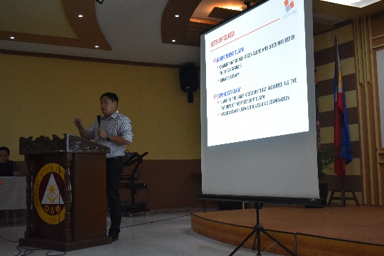
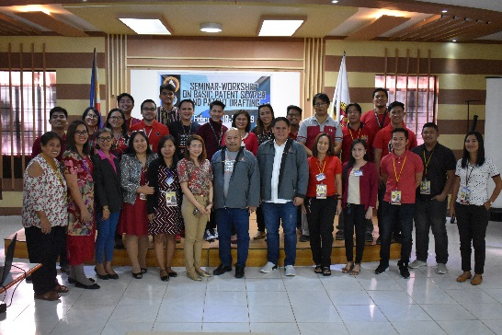

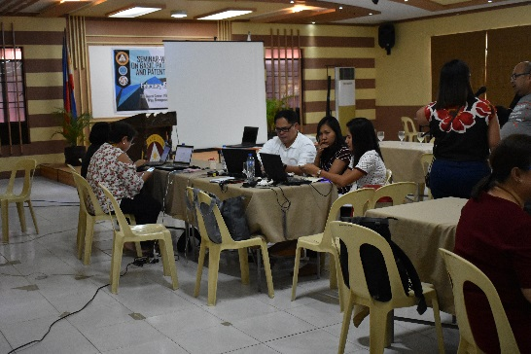
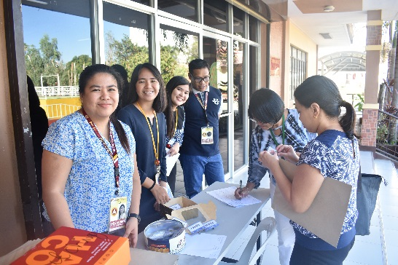

Sample Photos during the event
Seminar- Echo on Impact Assessment
For the trainings attended by faculty members be beneficial to the University, an echo seminar/ training should be conducted. Last March 22, 2019, Mr. Wesley S. Gagarin, the Head of the research Services Unit, conducted an Echo- Seminar on Impact Evaluation attended by chosen faculty members and staff from different colleges and office 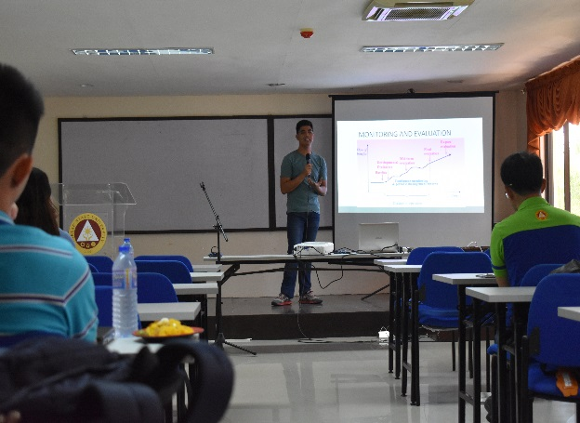 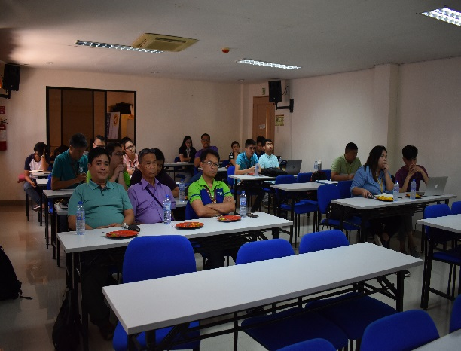
Sample Photos during the event
Seminar Workshop on Research Writing for External Funding
Part of the mandate of the office is to capacitate the faculty researchers with the knowledge needed in research writing. Last October 25, 2019, the URO organized a seminar workshop on Research Writing for External Funding participated by 25 faculty researchers with existing research proposals from the College of Engineering and Technology and College of Science. The Assistant Regional Director of DOST 3, Mr. Wilfredo Sibal, was invited to be the resource speaker.
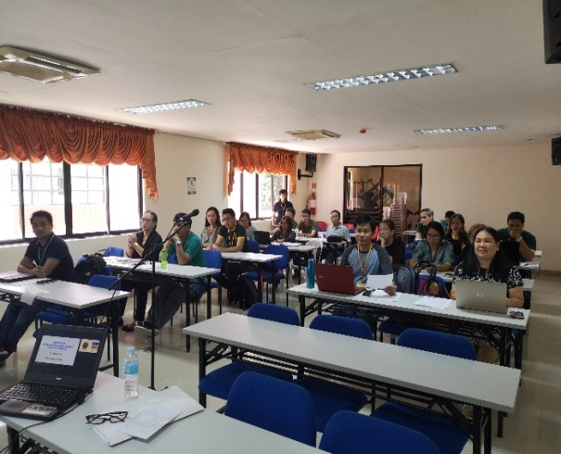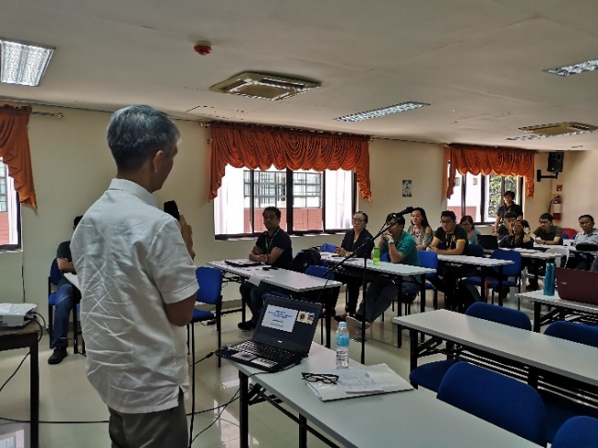
Sample Photos during the event

1st National Research Conference
The TSU, initiated by the University Research Office organized the 1st National Research Conference held on October 3-5, 2019 at the TSU Lucinda Extension Campus. The Department Research Chairpersons were invited to attend and participate to capacitate them with research skills.
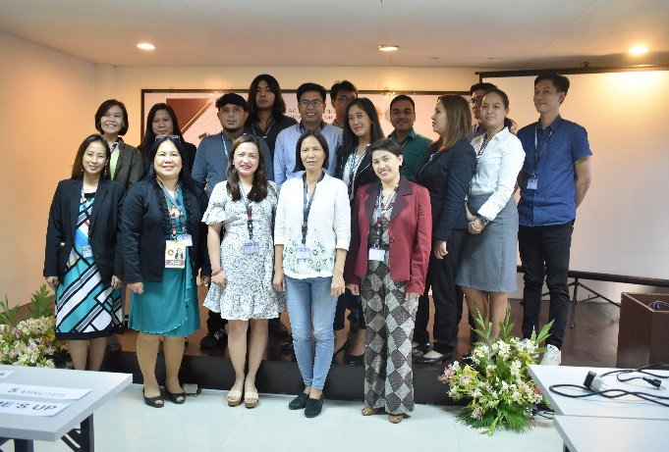
Sample Photo during the event
In- House reviews of Completed Researches
The University Research Office conducted 2 In- House Reviews of Completed Researches (Mid- year and In- House). During the Mid- year In- House Review, a total of 12 completed researches were presented while there are 36 completed researches were presented during the Year- end In- House Review.
Mid- Year In- House Review of Completed Researches
The University Research Office held the 2019 Mid- Year In- House Review of Completed Researches on June 14, 2019 at the Training Room, RED Bldng., TSU Lucinda Campus. A total of 12 completed researches were presented adjudged by a set of intelligent external panels from different field of expertise. At the end, COS faculty member, Mr. Aldous Bertrand Santillan bagged the 1st and 2nd awards for the STEM category while Dr. Niño Corpuz of COEd won 1st place in the SSBEd category.
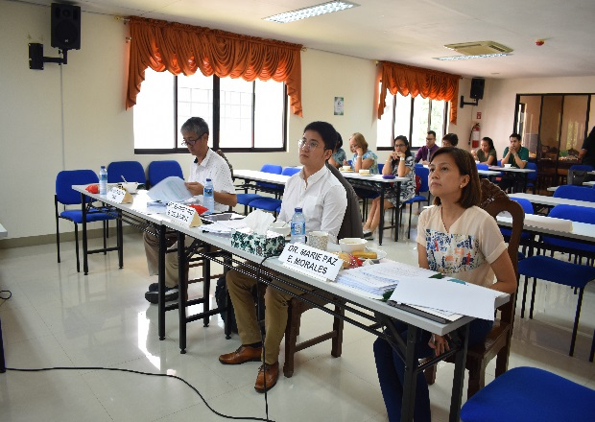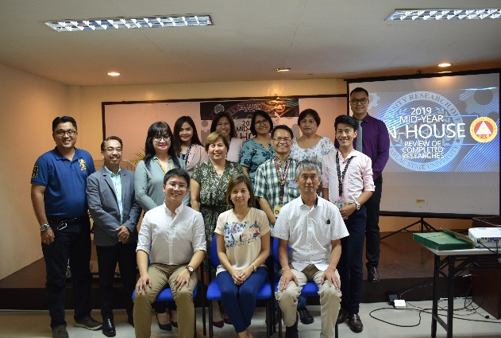
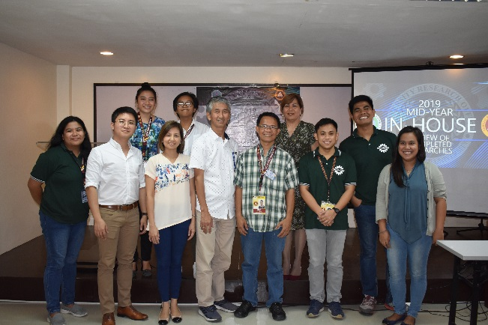
Sample Photos during the event

Year- end In- House Review of Completed Researches
The 2019 Year- end In- House Review of Completed Researches was held on December 6, 2019 at the TSU Lucinda Extension Campus. This year, the In- House Review was divided into parallel sessions. A set of external evaluators for each session were also invited to judge the research papers. Also, stakeholders from LGUs and other government agencies like DOST attended and witnessed the said event. This year, there is a total of 39 researches presented by faculty researchers from the different colleges.
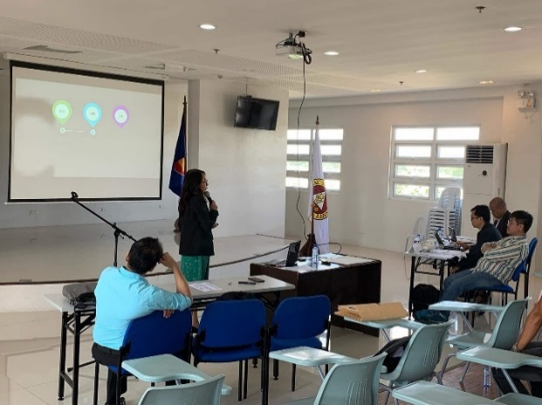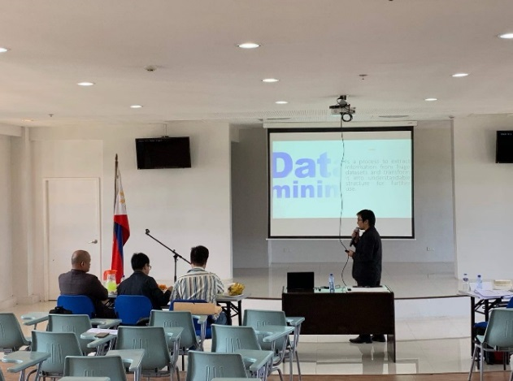
Sample Photos during the event
Other Activities
1st National Research Conference
The TSU, initiated by the University Research Office organized the 1st National Research Conference held on October 3-5, 2019 at the TSU Lucinda Extension Campus. The said conference was attended by 34 research presenters from different institutions like Catanduanes State University, Central Luzon State University, Don Honorio Ventura State University, Philippine Atmospheric, Geophysical and Astronomical Services Administration (PAGASA), Department of Interior and Local Governance, Bukidnon State University, Bulacan State University, Palawan State University and Tarlac State University. Also, Dr. Custer Deocaris from CHED, Dr. Rowena Cristina Guevara from DOST and DOST 3 Regional Director Dr. Julius Caesar Sicat attended the event as keynote speakers.
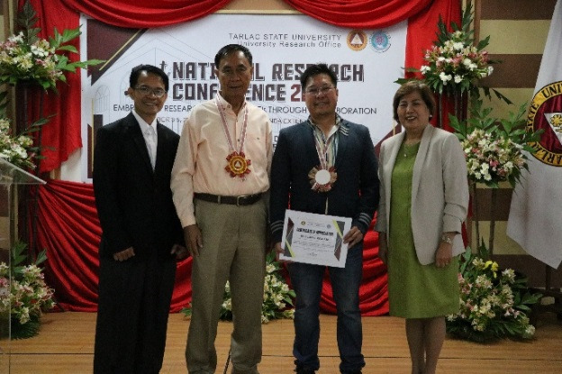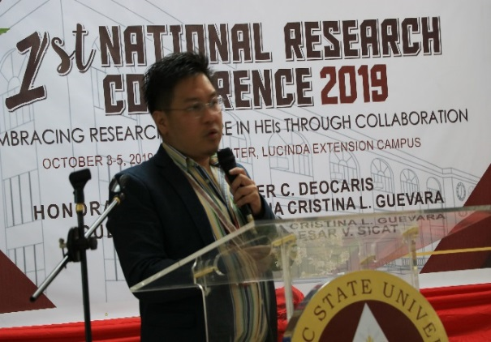
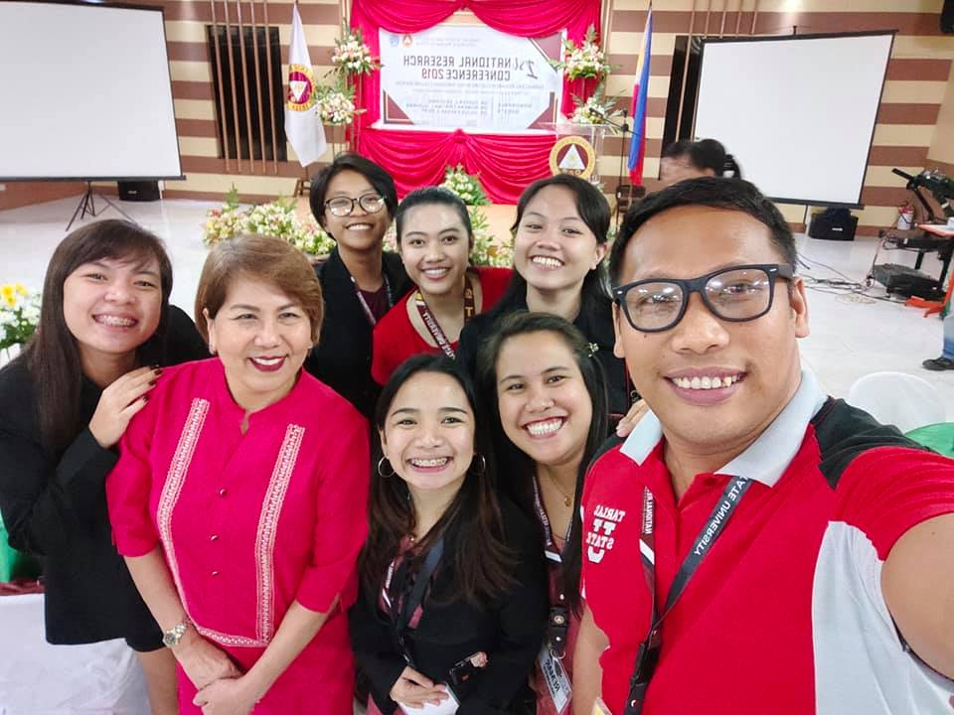
Sample Photos during the event
Panrehiyong Seminar sa Filipino
The annual seminar for teachers with CPD units organized by the Pamantasang Sentro ng Wikang Filipino was held on October 25-27, 2019 entitled “Panrehiyong Seminar sa Filipino”. The seminar was attended by teachers in the DepEd Tarlac Province.
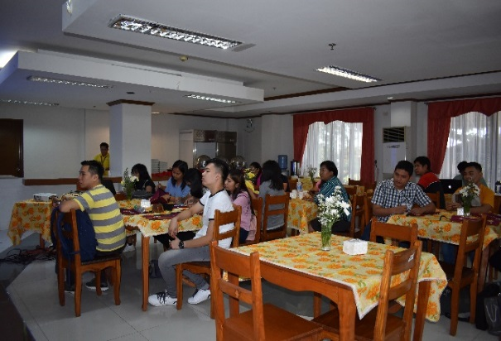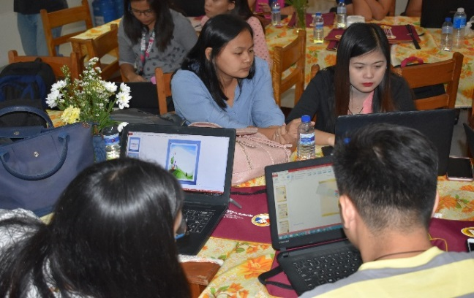
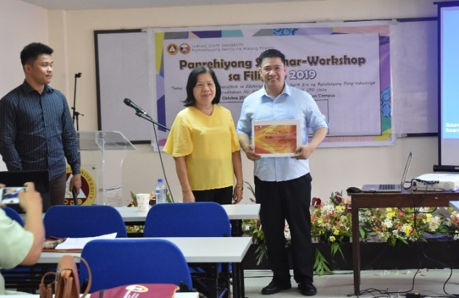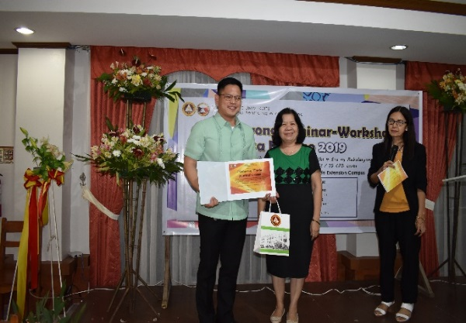
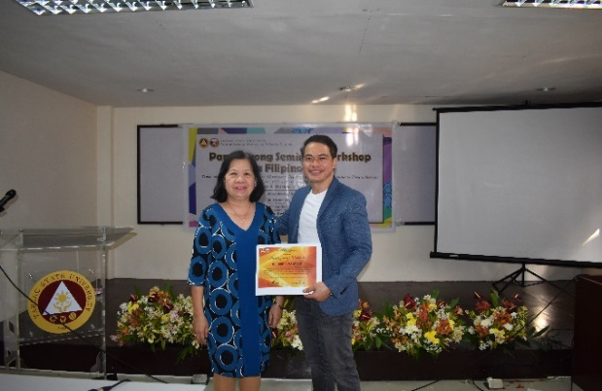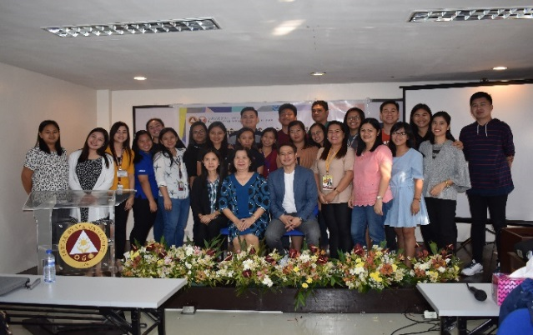
Sample Photos during the event
Aguinaldo @ 150 National Forum on Tarlac as the Last Capital of Aguinaldo Republic
The Center for Tarlaqueno Studied successfully conducted a forum on Tarlac as the Last Capital of Aguinaldo Republic as part of the celebration of Aguinaldo @ 150 on November 8, 2019. The event was conducted in partnership with the Local Government Unit of Tarlac. This forum was funded by the National Historical Commission of the Philippines through a research proposal submitted by Dr. Lino Dizon.
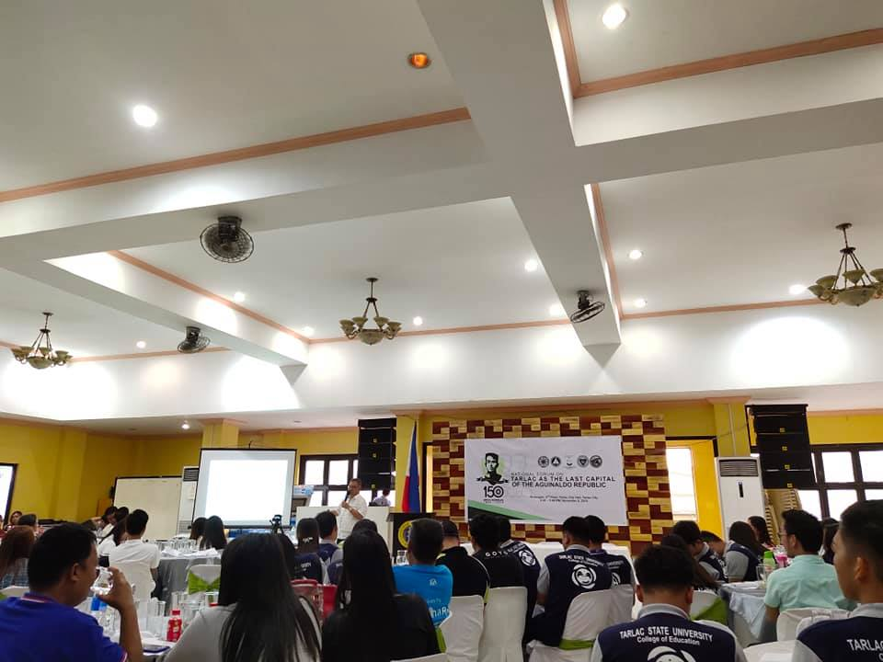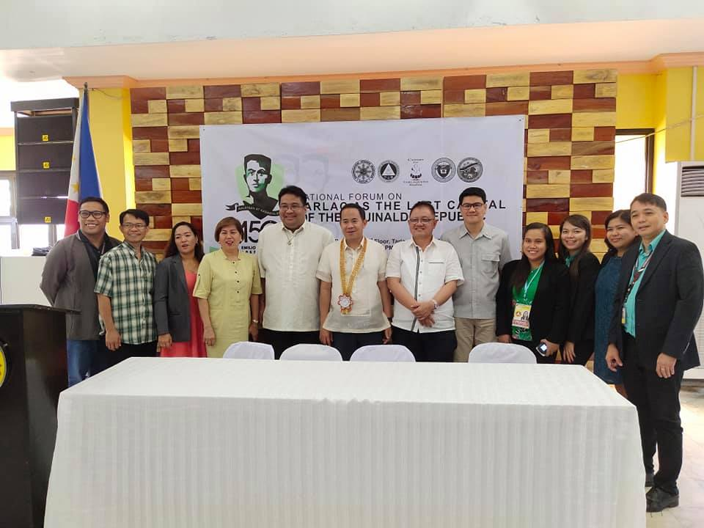
Sample Photos during the event
Inauguration and Blessing of the Museo- Archivo Tarlaqueño
With the initiative of Dr. Lino Dizon, Head of the Center for Tarlaqueño Studies, old CCS rooms at the Engineering Building was converted into a university museum which will be called the Museo- Archivo Tarlaqueño. The museum was inaugurated on July 12, 2019 which was witnessed by the University Administrative Council led by Dr. Myrna Mallari and representatives from the Provincial Governor and City Mayor.
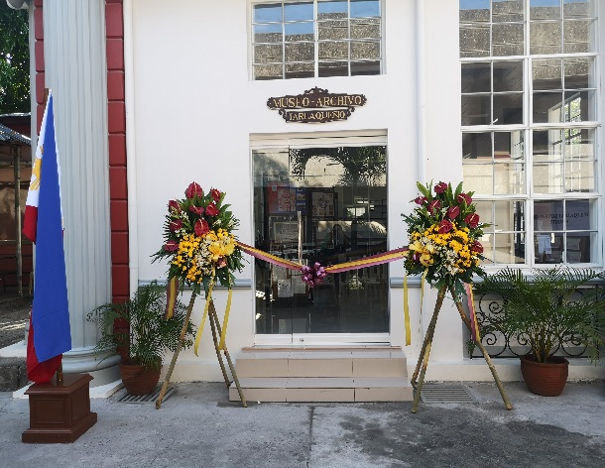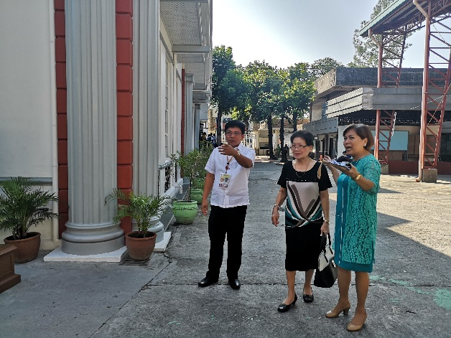
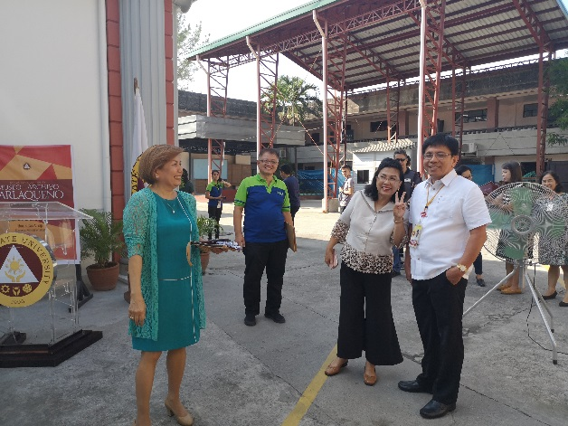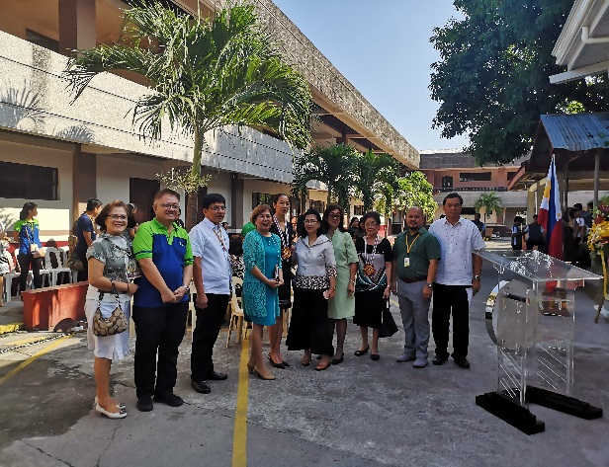
Food Technology Project Consultation with Dr. Azanza and Benchmarking at UP Diliman
With the initiative of Dr. Lea Milan of COS- FT, a research project was submitted to DOST for possible funding. Last, November 20, 2019, a group of faculty researchers from College of Science together with the URO Director and staff went to the UP Diliman and conducted a benchmarking activity and consultation with one of the professors in the Department of Science and Nutrition.
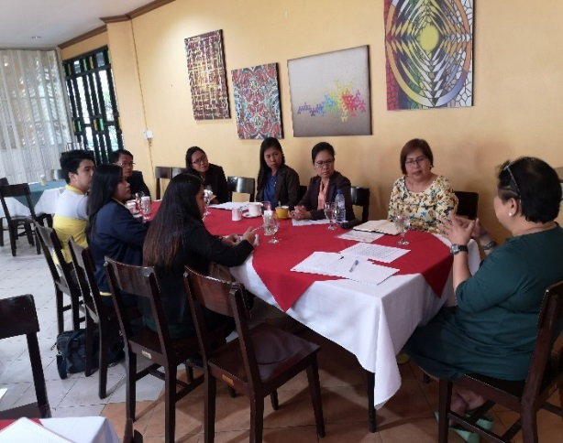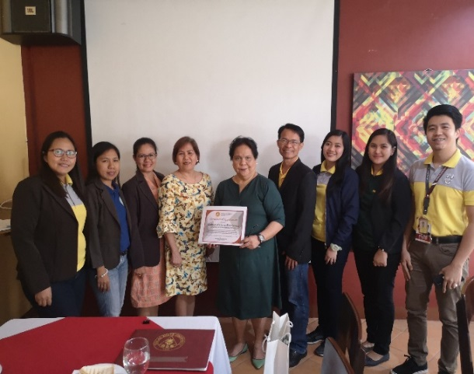
Sample Photos during the event

STRDC Project Proposal Presentation
Last November 27, 2019, an STRDC Project Proposal Presentation was presented on to DOST – PCIEERD, Bicutan, Taguig. The said presentation was led by the URO Director and the rest of the team.
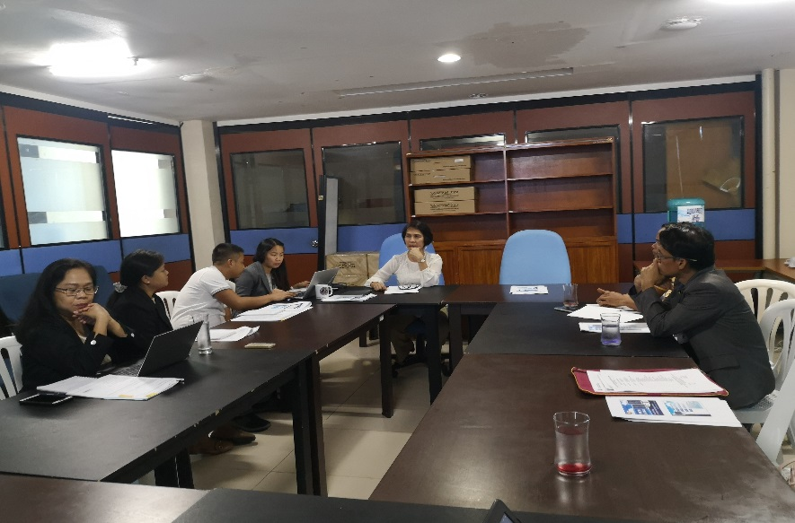
Sample Photo during the event
RES Strategic Planning
The RES Strategic Planning was held on December 2-3, 2019 at the Venus Parkview Hotel, Baguio City. Highlight of the activity is the presentation of plans for 2020. Major accomplishments per office for 2019 were also presented.
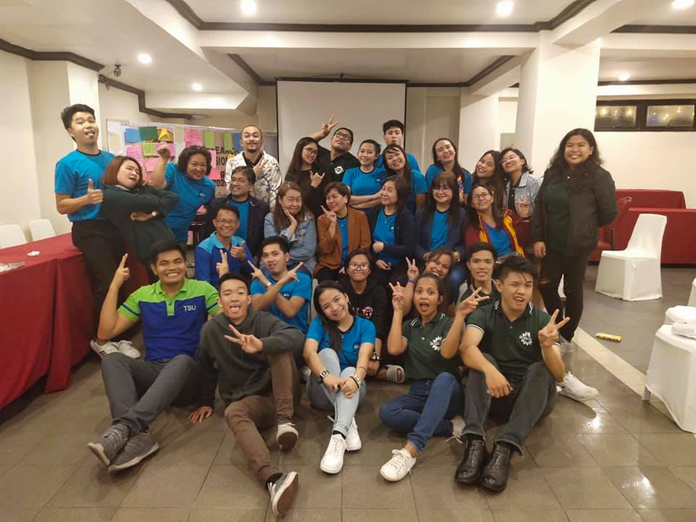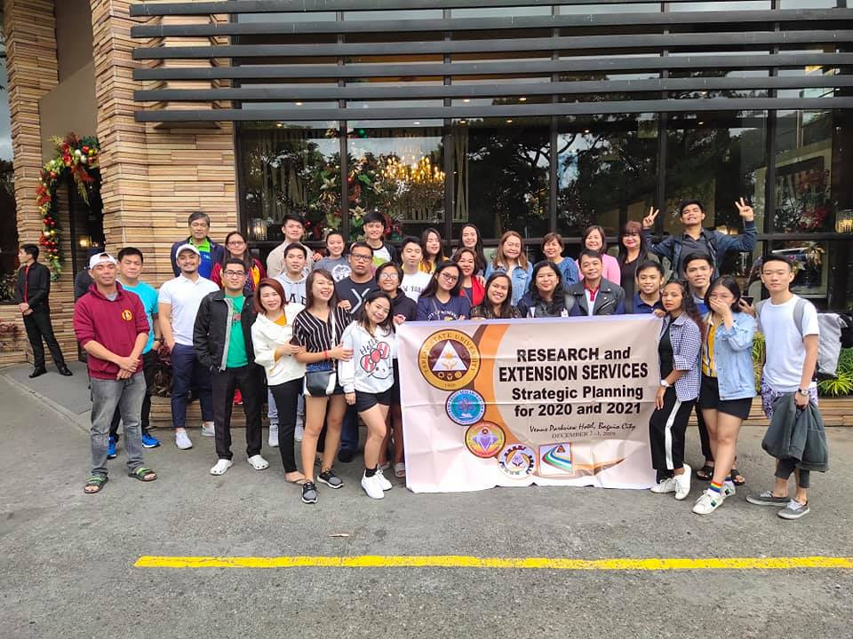
Sample Photos during the event

College Research Colloquium
College of Teacher Education
The College of Education, through the initiative of the college dean, Dr. Erwin Lacanlale and the DRCs held their College Colloquium on February 28, 2019 wherein 25 quality research proposals were presented. A very competitive and passionate external panel was also invited to help improve the presented research proposals.
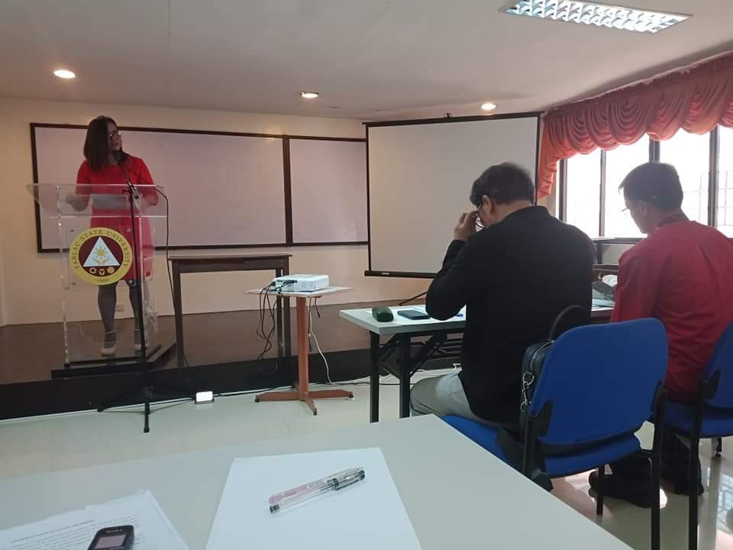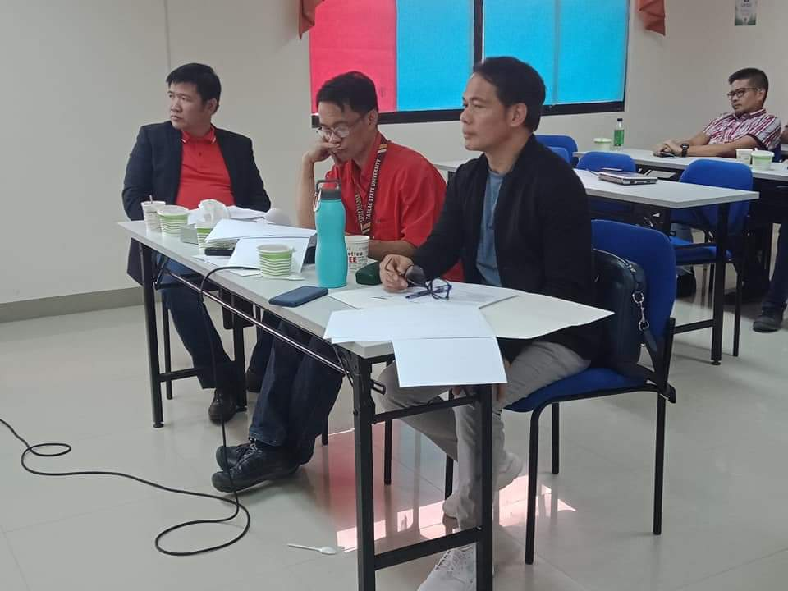
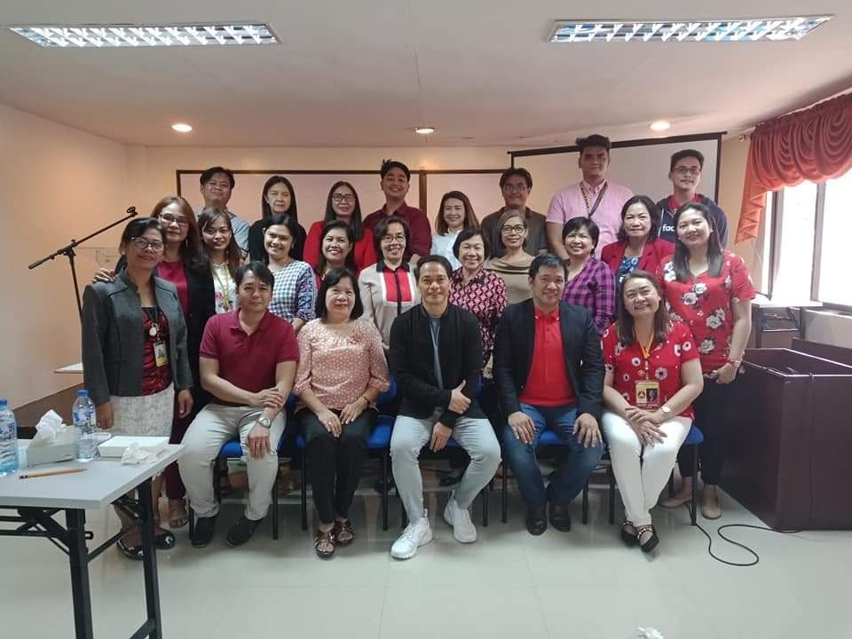
Sample Photos during the event
College of Computer Studies
A total of 9 researches were presented during the College of Computer Studies 2019 Research Colloquium on March 6, 2019. The colloquium was made possible through the very active college dean assisted by the Department Research Chairpersons.
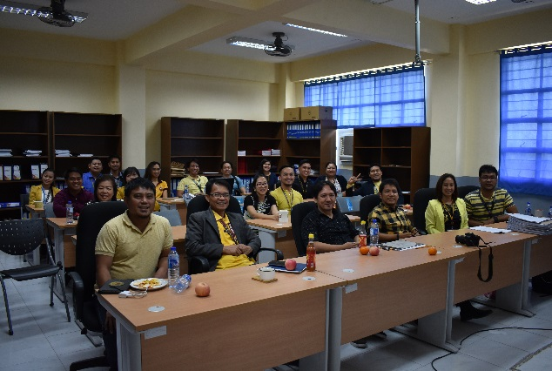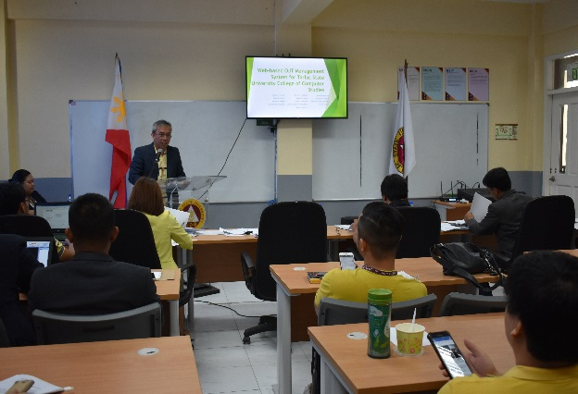
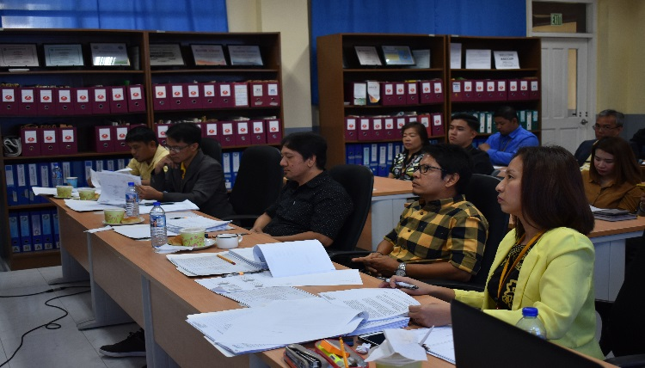
Sample Photos during the event
College of Science
The College of Science held their 2019 College Colloquia on March 27, 2019 wherein 16 research proposals were presented. A set of external panels were also invited to give inputs on improving the presented research proposals.
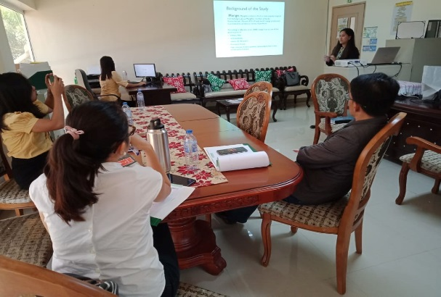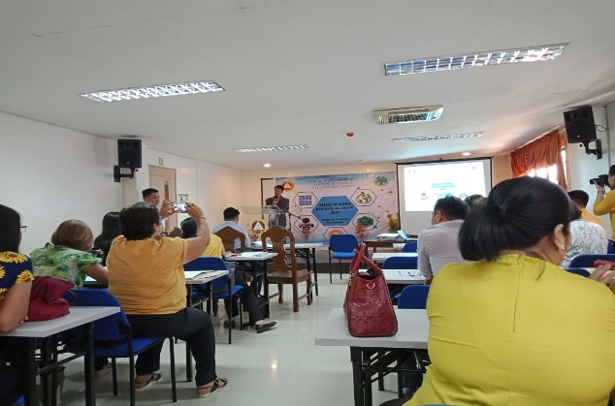
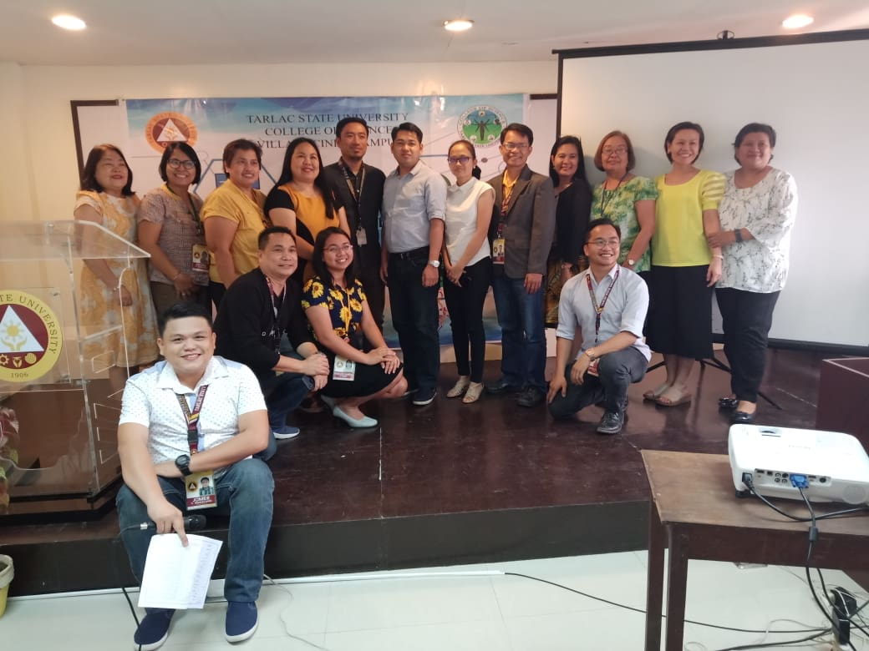
Sample Photos during the event
College of Engineering and Technology
A total of 17 research proposals were presented during the College of Engineering and Technology Colloquia held on March 29, 2019 at the Engineering Building. The ARD for Technical Operations of DOST was invited to witness the research presentations.
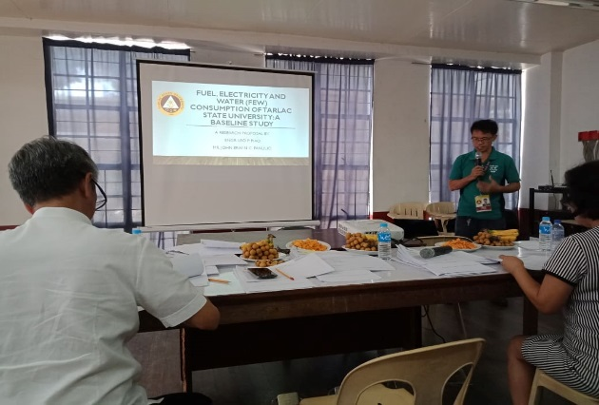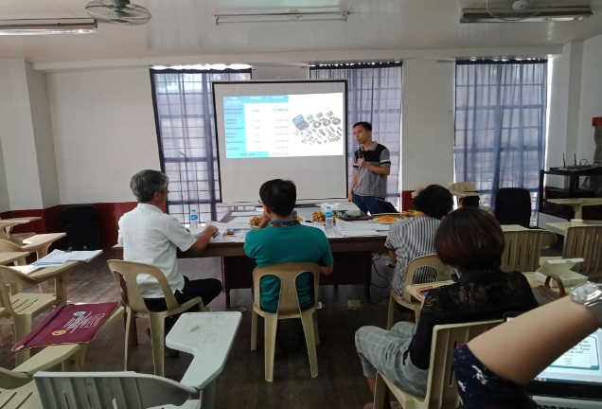
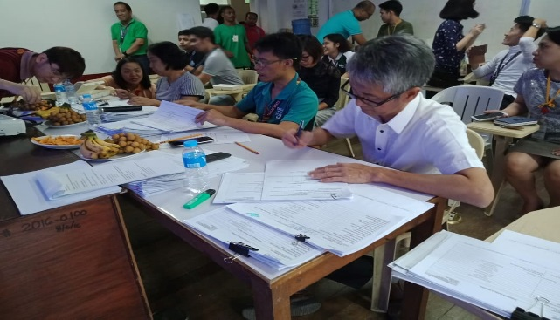
College of Public Administration and Governance and the College of Criminal Justice Education
The College of Public Administration and Governance and the College of Criminal Justice Education held their joint research colloquium on April 10, 2019 at the Dean’s Office of the CPAG wherein a total of 9 research proposals were presented.
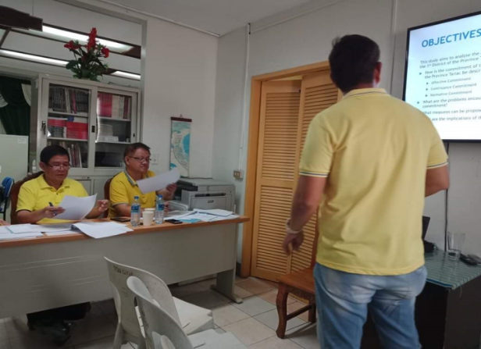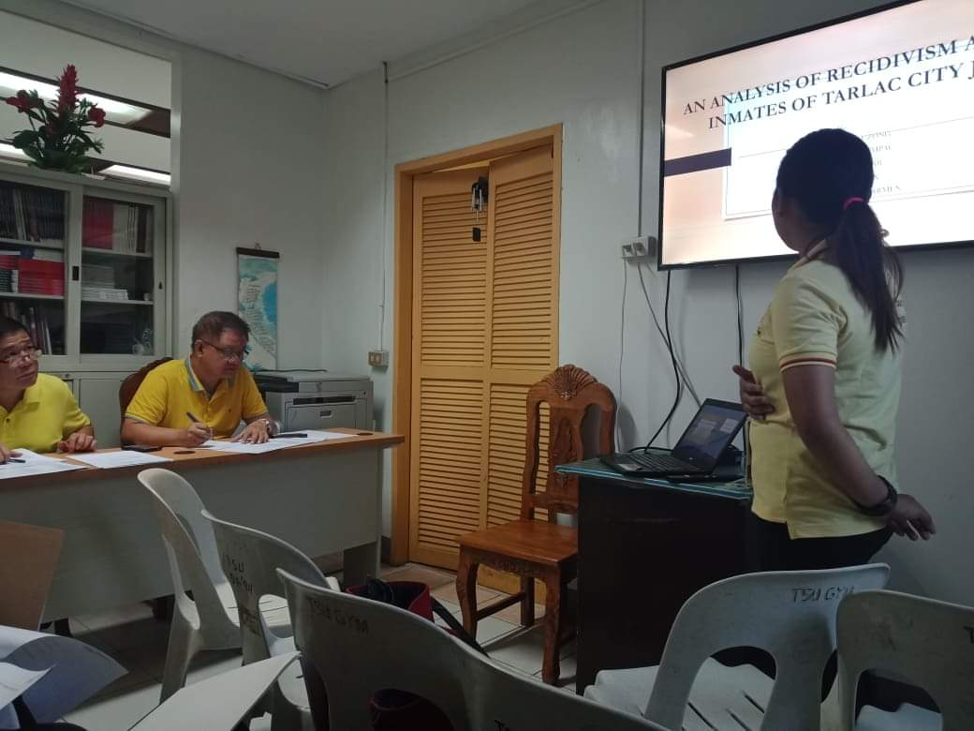
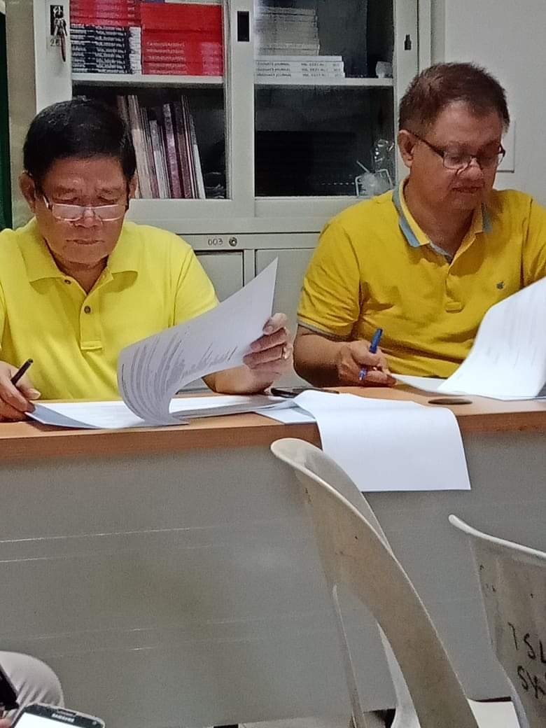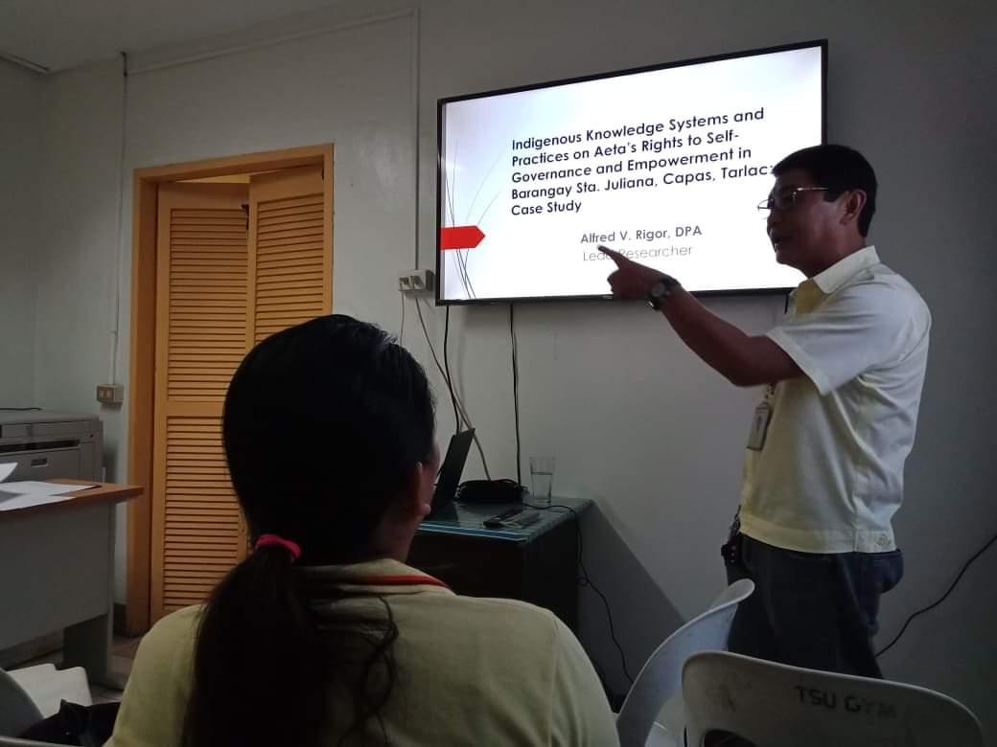
Sample Photos during the event

College of Architecture and Fine Arts
The College of Architecture and Fine Arts successfully conducted its research colloquium on April 16, 2019 wherein a total of 3 research proposals were presented.
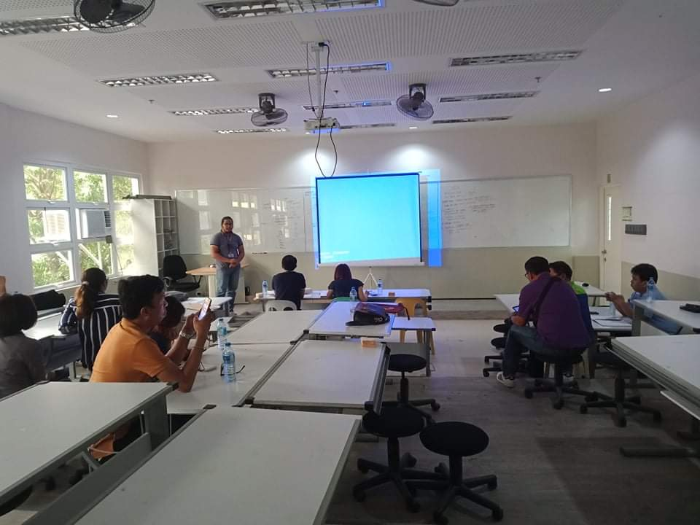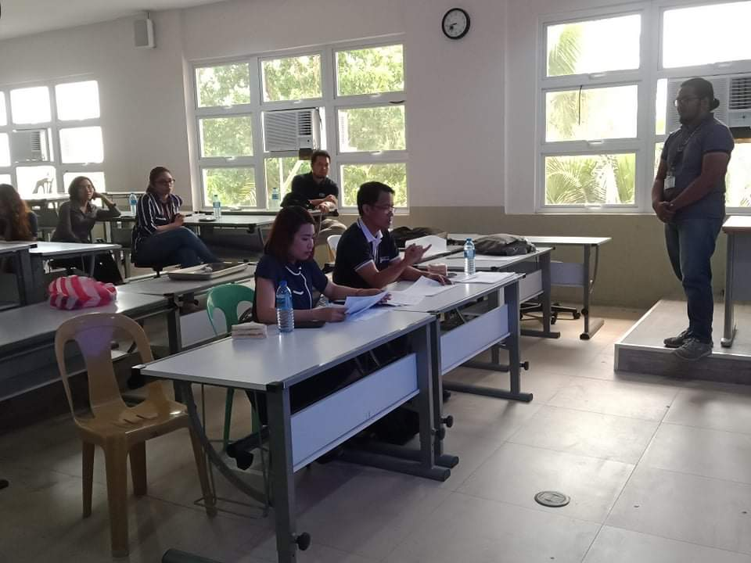
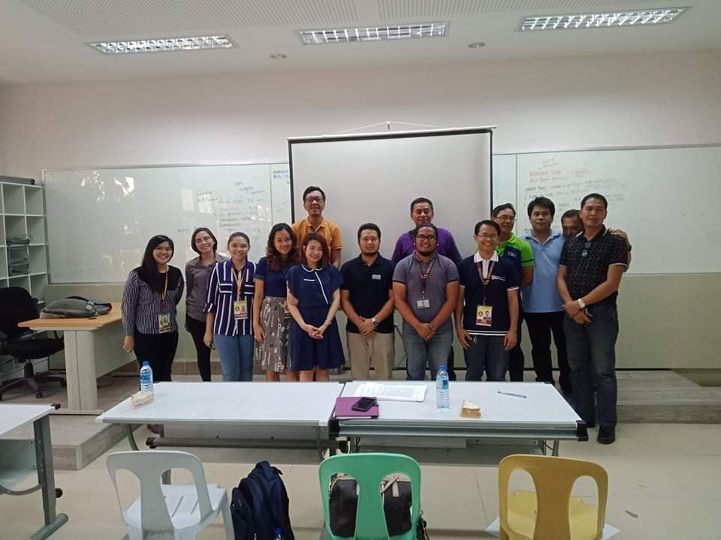
Sample Photos during the event

