URO Annual Report
The University Research Office (URO) highlights of accomplishments for 2017 involves the creation of the Food Innovation Center, University Statistical Research Center, also, researches on Solar-Powered Generator passed the pilot testing of DOST as it produced enough power to run common household appliances simultaneously. The successful International Research Conference held at the Princesa Garden Resort, Palawan on December 18-20 was also one of the major achievement of the University Research Office.
With respect of its core function which is to oversee the conduct of research activities as to consolidate, coordinate and operationalize research activities, the URO was able to obtain 34 completed researches; 14 published researches internationally, 7 published researches in CHED accredited journals; and 6 externally funded researches. Moreover, 22 researches were presented 26 international. In addition, the Office conducted 2 In-House Reviews for Completed Researches and 5 Capability Building Seminars.
Completed Researches
The table below shows the distribution of the completed researches in 2017 as to Information Dissemination - 22 researches; Social Sciences, (SOCSCI) - 9 researches and Technology Generated – 3 researches:
Name of Faculty | Title
Henry D. Rufino, Rhene G. Payabyab  Grace T. Lim | Competency Requirements for Professional Accountants: Basis for Accounting Curriculum Enhancement
Ninez B. Tulo, Nancy L. Mati | Neuroelt Strategies and TBLT for College Integrated Language Skills
Criselda Alamo-Tonelada, Ferdinand Y. Silaran, Maria Cristina A. Bildan | Sanitary Conditions of Food Vending Sites and Food Handling Practices of Street FoodVendors along the Peripheral Area of Tarlac State University, Main Campus:  Implication for Food Hygiene and Safety
Ma. June S. Carlos, Edwin T. Caoleng &  Alfred V. Rigor | Evaluation of the Disaster Risk Reduction and Management Offices of Local Government Units in the Province of Tarlac
Niño B. Corpuz, Sheila Marie O. David, Jeanette P. Mendoza, Jayson Y. Punzalan | Validation of the General and Professional Education Areas of the College of Education Retention Examinaton: Inputs to Assessment of Learning
Dr. Elizabeth A. Amurao, Renato T. Mercado, Jhonel C. Panlilio | Work Values of Young Professionals in the City of Tarlac
Limuel P. Pavico , Elvira B. Mercado, Fabian P. Seguira | Entrepreneurial Landscape of Tarlac City
Erwin P. Lacanlale | Research Writing- Related Problems of Selected Graduating Students in Tertiary Level
Elvira B. Mercado , Limuel P. Pavico , Jose T. Geaga | Utilization of Taro for Innovative Flavored Chips Product
Rowena C. Ramos, Remedios A. Tamina, Grace T. Lim | PERFORMANCE OF MULTI-PURPOSE COOPERATIVES  in the City of Tarlac
Sheila Marie O. David | Oral Corrective Feedback in a Tertiary L2 Classroom: a Metalinguistic Analysis
Jeanette P. Mendoza | Inter-Ethnolinguistic Group Stereotypes in the Tarlac State University
Erwin Lacanlale | Teaching and Age-Related Problems of Senior Faculty Members in Higher Educational Institutions in Tarlac
Rita Pulmano  Suzanne Cruz  Michelle Rivera | Status of Offenders in Tarlac Provincial Jail
Cynthia G. Quiambao, Alma M. Corpuz & Maria Agnes P. Ladia | Impact Evaluation of the Community Extension in Laungcupang, La Paz, Tarlac, Central Luzon, Philippines
Marie Paz H. Angeles & Geraldine Ann R. Lenon | An Assessment of the Intrapersonal and Interpersonal Skills of TSU Non-teaching Employees: Towards an Effective Wellness Program
Joseph M. Melegrito, Jeremy R. Canlas & Julieta M. Lagasca | The Entrepreneurs in Tarlac Province: An Analysis
Rita E. Pulmano, Suzanne P. Cruz, Jeah N. Melocotones & Alfred V. Rigor | An Assessment on the Functionality of VAW Desks in Tarlac Province
Lolita V. Sicat & Rodrigo M. Sicat | Indigenous Students’ School Engagement: Basis for Multi-Sectoral Intervention
Maan B. Florendo, Enalyn T. Domingo & Miriam S. Galvez | Load Forecasting Analysis for Tarlac Electric Incorporated
Angelo Garcia & Carlos P. Flores Jr. | An Integrated System for Red Cross: Donors’ Profiling
Julieta M. Lagasca & Felicitas Quilondrino | Acceptability of Horse Radish “Malunggay” Food Wrapper
Heidilyn V. Gamido & Marlon V. Gamido | Comparative Review of the Features of Automated Sotware Testing Tools
Brendalyn A. Manzano | Researcher and Non-researcher Teachers’ Evaluation of ELT Materials: Converging or Diverging
Raffy S. Aganon | Kahandaan ng mga Propesor sa Filipino sa Pagtuturo ng Bagong Pangkalahatang Edukasyon: Batayang Pag-aaral Tungo sa Pagpaplanong Pangwika ng mga SUC III
Marilou P. Agustin | Komprehensyon sa Pagbasa sa Filipino ng mga Mag-aaral sa Antas Tersarya
Marie Paz H. Angeles | The Teaching Efficacy of State Universities and Colleges Psychology Professors: Implication to the Teaching-Learning Process
Leo P. Piao | Computing and Interpreting Reliability Indices of an Electric Distribution Circuit
Wilmark J. Ramos | Organizational Change and Dimensions of Learning in Manufacturing Firms
Jayson Y. Punzalan & Cynthia G. Quiambao | Development and Validation of Infographics Based on the Least Mastered Competencies in Physics
Cecilia L. Calub, Rosalina Garcia, Leodivina P. Tagama, Ma. Shinette P. Morales & Francelle L. Calub | Listening Comprehension Difficulties of College Students: Basis for Remediation Strategies in the Classroom
Nelvin Nool & Maria Agnes P. Ladia | Performance in the Licensure Examination of Teacher Education Institutions in Central Luzon
Nelvin Nool, Maria Agnes P. Ladia, Niño B. Corpuz & Socrates A. Embesan | Exploring the Validity of TSU College Admission Test in Predicting Graduates LET Performance
Ma. Susan Z. Maglaqui | Implementation of DOTS in Rural Health Units of Tarlac City: An Assessment

Published Researches
The table below shows the list of 21 internationally-published researches
Journal Title | Project/Study Title | Author(s)
Conference of the International Journal of Arts & Sciences | Antibacterial Activity of Some Medicinal Plants Using Paper Disk Marine Bioluminescent Bacteria | Louella Ona
The International Medical Journal of Malaysia | Ethno botanical Survey of Plants Commonly Used for Diabetes | Erwin Mina
Upland Farm Journal -Ifugao State University | Classroom Learning Environment at Tarlac State University College of Education | Norbina Genever M. Castro
Upland Farm Journal -Ifugao State University | State of the Art of Technical Education and Skills (TESDA)Programs of State Universities and Colleges in Region 3 | Felicitas A. Quilondrino
Upland Farm Journal -Ifugao State University | The Extension Program of the Teacher Education Institutions Among State Universities in Region 3: An Evaluation | Ma. Theresa Acosta
Upland Farm Journal -Ifugao State University | Effect of inorganic Nitrogen and Liquid Fertilizer with Micronutrient Suppliments with Rice Straw on the Growth and Yield of Oyster Mushroom (Pleurotus sp.) | Rodel T. Botio, Dr. Ma. Socorro D. Valdez, Prof. Antonio C. Rosel, Prof. Estrella B. Pagco
Upland Farm Journal -Ifugao State University | The Effect of Remediation on the Performance in Retention Examination of Underachieving Prospective Secondary Teachers | Maria Agnes P. Ladia, Elizabeth P. Balanquit, Socrates A. Embessan, Yyette S. Legaspi
Upland Farm Journal -Ifugao State University | Development of an Energy-Efficient Cook Stove | Enalyn T. Domingo, Miriam S. Galvez, Crispin I. Flora
Upland Farm Journal -Ifugao State University | Development and Validation of Gabay Sourcebook | Niño B. Corpuz, EdD, RGC
Upland Farm Journal -Ifugao State University | Predicting Student Performance Using Data Mining Methods | Jo Anne G. Cura
Upland Farm Journal -Ifugao State University | Cases of Violence Against Women: Towards a Proposed Plan of Action | Rita E. Pulmano and Murphy P. Mohammed
Upland Farm Journal -Ifugao State University | Performance of Students in College Retention Examination Vis-à-vis General Weighted Averages | Ma. Theresa A. Acosta, Alma M. Corpuz, Lourdes S. Briones
Upland Farm Journal -Ifugao State University | Business Permits and Licensing System (BPLS) in the Municipality of Paniqui: An Evaluation | Edwin T. Caoleng, Ma. June S. Carlos, Alfred Nonnatus V. Rigor
Upland Farm Journal -Ifugao State University | 2016 Citizens Satisfaction Index System Pilot Testing in the Municipality of Victoria | Edwin T. Caoleng, Ma. June S. Carlos, Alfred Nonnatus V. Rigor
Upland Farm Journal -Ifugao State University | Evaluation of the Local Disaster Risk Reduction and Management Offices of the Local Government Units in the Province of Tarlac | Edwin T. Caoleng, Ma. June S. Carlos, Alfred Nonnatus V. Rigor
Upland Farm Journal -Ifugao State University | Thinking Styles of BSED COED Students and Their Academic Performance | Leodivina P. Tagama
Upland Farm Journal -Ifugao State University | Classroom Learning Environment at Tarlac State University | Dr. Norbina Genever M. Castro
Upland Farm Journal -Ifugao State University | An Analysis on the Heforshe Campaign Speech of Emma Watson in Correcting Misconceptions on Feminism and Gender Equality Using Feminist Rhetorical Criticism and Speech Act Theory | Jazzel Llaneli E. Manalo
Upland Farm Journal -Ifugao State University | The Professional Competencies of College Teachers of Higher Education Institutions in Tarlac Province: An Analysis | Julieta M. Lagasca & Ma. Theresa A. Acosta
Upland Farm Journal -Ifugao State University | Cases of HIV/ AIDS in Tarlac Province, Central Luzon, Philippines from 1984 to 2016 and the Knowledge and Risky Behaviors of Various Gender Groups | Alma M. Corpuz, Lucila O. Sunga, Ph.D. , Rita E. Pulmano, Ed.D., Jeanette A. Lazatin , MD MPM
Upland Farm Journal -Ifugao State University | Short Circuit Analysis For Amacalan Distribution Circuit of TARELCO: Basis for an Intervention Program | Leo P. Piao

Presented Researches

The table below shows the distribution of 22 presented researches in local, regional, national and international conferences.

Title of Research Paper | Presenter(s) | Type of Conference
Classroom Learning Environment at Tarlac State University College of Education | Norbina Genever M. Castro | ISERD-106th International Conference on Education and E-Learning
The Extension Program of the Teacher Education Institutions Among State Universities in Region 3: An Evaluation | Ma. Theresa A. Acosta | ISERD-106th International Conference on Education and E-Learning
Cases of HIV/AIDS in Tarlac Province, Central Luzon, Philippines from 1984-2016 and the Knowledge and Risk Behaviors of Various Gender Groups | Alma Corpuz | 1st Central Luzon Health Research Forum
Classroom Learning Environment at Tarlac State University College of Education | Norbina Genever M. Castro | International Research Conference  Puerto Princesa  May 18-20, 2017
State of the Art of Technical Education and Skills (TESDA)Programs of State Universities and Colleges in Region 3 | Felicitas A. Quilondrino | International Research Conference  Puerto Princesa  May 18-20, 2017
The Extension Program of the Teacher Education Institutions Among State Universities in Region 3: An Evaluation | Ma. Theresa Acosta | International Research Conference  Puerto Princesa  May 18-20, 2017
Effect of inorganic Nitrogen and Liquid Fertilizer with Micronutrient Suppliments with Rice Straw on the Growth and Yield of Oyster Mushroom (Pleurotus sp.) | Rodel T. Botio, Dr. Ma. Socorro D. Valdez, Prof. Antonio C. Rosel, Prof. Estrella B. Pagco | International Research Conference  Puerto Princesa  May 18-20, 2017
The Effect of Remediation on the Performance in Retention Examination of Underachieving Prospective Secondary Teachers | Maria Agnes P. Ladia, Elizabeth P. Balanquit, Socrates A. Embessan, Yyette S. Legaspi | International Research Conference  Puerto Princesa  May 18-20, 2017
Development of an Energy-Efficient Cook Stove | Enalyn T. Domingo, Miriam S. Galvez, Crispin I. Flora | International Research Conference  Puerto Princesa  May 18-20, 2017
Development and Validation of Gabay Sourcebook | Niño B. Corpuz, EdD, RGC | International Research Conference  Puerto Princesa  May 18-20, 2017
Predicting Student Performance Using Data Mining Methods | Jo Anne G. Cura | International Research Conference  Puerto Princesa  May 18-20, 2017
Cases of Violence Against Women: Towards a Proposed Plan of Action | Rita E. Pulmano and Murphy P. Mohammed | International Research Conference  Puerto Princesa  May 18-20, 2017
Performance of Students in College Retention Examination Vis-à-vis General Weighted Averages | Ma. Theresa A. Acosta, Alma M. Corpuz, Lourdes S. Briones | International Research Conference  Puerto Princesa  May 18-20, 2017
Business Permits and Licensing System (BPLS) in the Municipality of Paniqui: An Evaluation | Edwin T. Caoleng, Ma. June S. Carlos, Alfred Nonnatus V. Rigor | International Research Conference  Puerto Princesa  May 18-20, 2017
2016 Citizens Satisfaction Index System Pilot Testing in the Municipality of Victoria | Edwin T. Caoleng, Ma. June S. Carlos, Alfred Nonnatus V. Rigor | International Research Conference  Puerto Princesa  May 18-20, 2017
Evaluation of the Local Disaster Risk Reduction and Management Offices of the Local Government Units in the Province of Tarlac | Edwin T. Caoleng, Ma. June S. Carlos, Alfred Nonnatus V. Rigor | International Research Conference  Puerto Princesa  May 18-20, 2017
Thinking Styles of BSED COED Students and Their Academic Performance | Leodivina P. Tagama | International Research Conference  Puerto Princesa  May 18-20, 2017
Classroom Learning Environment at Tarlac State University | Dr. Norbina Genever M. Castro | International Research Conference  Puerto Princesa  May 18-20, 2017
An Analysis on the Heforshe Campaign Speech of Emma Watson in Correcting Misconceptions on Feminism and Gender Equality Using Feminist Rhetorical Criticism and Speech Act Theory | Jazzel Llaneli E. Manalo | International Research Conference  Puerto Princesa  May 18-20, 2017
The Professional Competencies of College Teachers of Higher Education Institutions in Tarlac Province: An Analysis | Julieta M. Lagasca & Ma. Theresa A. Acosta | International Research Conference  Puerto Princesa  May 18-20, 2017
Cases of HIV/ AIDS in Tarlac Province, Central Luzon, Philippines from 1984 to 2016 and the Knowledge and Risky Behaviors of Various Gender Groups | Alma M. Corpuz, Lucila O. Sunga, Ph.D. , Rita E. Pulmano, Ed.D., Jeanette A. Lazatin , MD MPM | International Research Conference  Puerto Princesa  May 18-20, 2017
Short Circuit Analysis For Amacalan Distribution Circuit of TARELCO: Basis for an Intervention Program | Leo P. Piao | International Research Conference  Puerto Princesa  May 18-20, 2017

Externally-Funded Researches
Below is the table of researches conducted in the university that were funded by external agencies in 2017:
Faculty Researcher/s | Research Titles | Collaborating Schools, Institutions and Agencies | Amount of Grants | Year
Prof. Rodel Botio | Development, Fabrication and Performance Evaluation of an Innovative Multi-Voltage, System Solar Power Generator | Department of Science & Technology-3 | 446,330.00
Prof. Rodel Botio | Development, Fabrication and Performance Evaluation of an Integrated Solar Power Generator and Water/Irrigation Pump | Department of Agriculture Region III | 345, 130.000
Prof. Rodel Botio | Fabrication and installation of integrated solar powered generator and multi-purpose drip irrigation pump for upland indigenous farmers of capas,tarlac | Department of Agriculture Region III | 446, 320.00
Dr. Lea B. Milan | Application of Thermal Processing to Native Rice Cake Products for Adaption in Tarlac Province | Department of Science and Technology | 1,207,050
Abegail F. Feliciano | Product Development of Calamansi and Sugarcane Products with Application of Spray Drying and Carbonation for Adaption in Tarlac Province | Department of Science and Technology | 1,940,900
Prof. Leah T. Matias | Product Development of Sweet Potato Products with Application of Freeze Drying and Vacuum Frying for Adaption in Tarlac Province | Department of Science and Technology | 1,672,050

Capacity Building
Below is the table showing the seminars/trainings conducted by the University Research Office in 2016
TITLE | DATE | NUMBER OF PARTICIPANTS
Training on Anti-Plagiarism (Turnitin) Software | July 13, 2017 | 66
Research writing and Formatting Seminar | February 8, 2017  February 9, 2017 | 72  72

IN-HOUSE REVIEWS OF COMPLETED RESEARCHES

The Midyear In-House review was held at the Training Room RED Building, TSU Lucinda Campus on June 23, 2017 and the upcoming Yearend In-House review of completed researches will be conducted on December 13, 2017 with 13 research entries as of December 1, 2017.

2017 Mid-Year In-House Review of Completed Researches
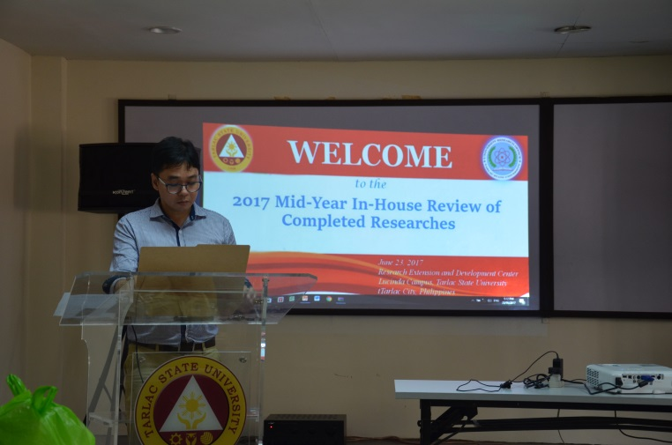
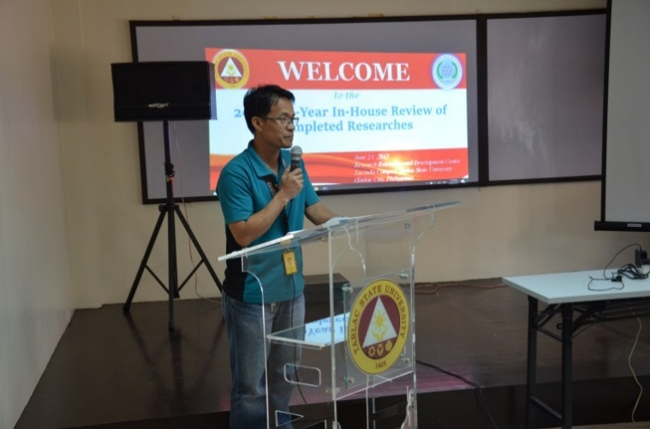

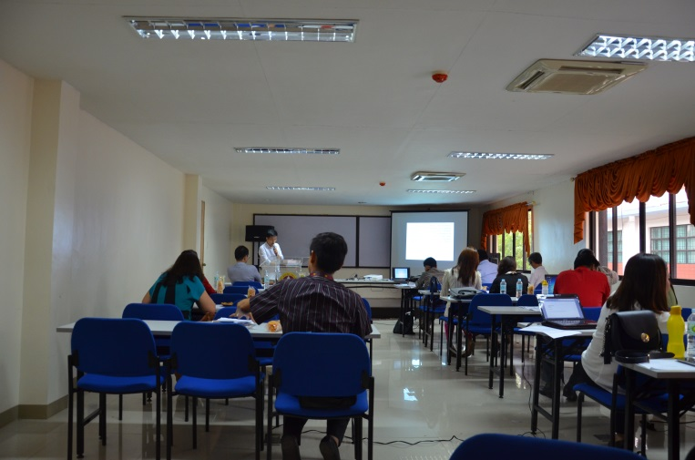

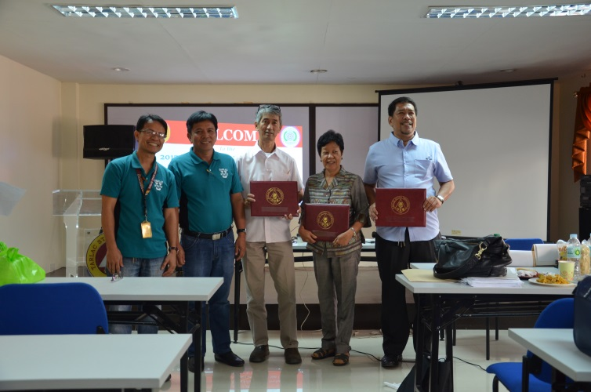
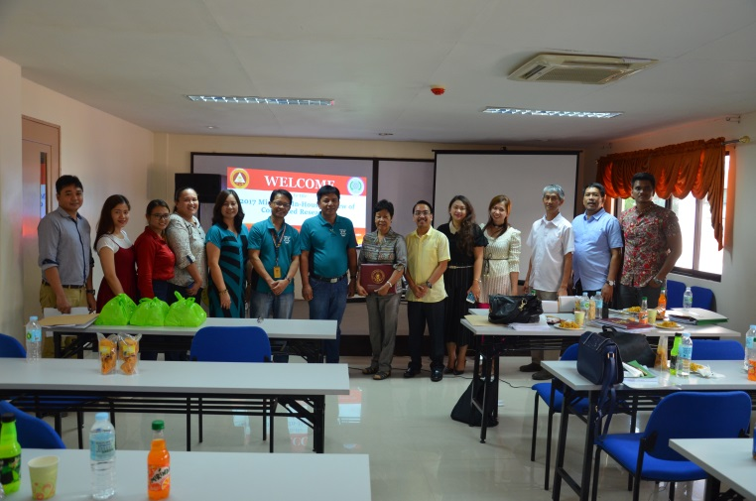

CAPABILITY BUILDING

Research writing and Formatting Seminar
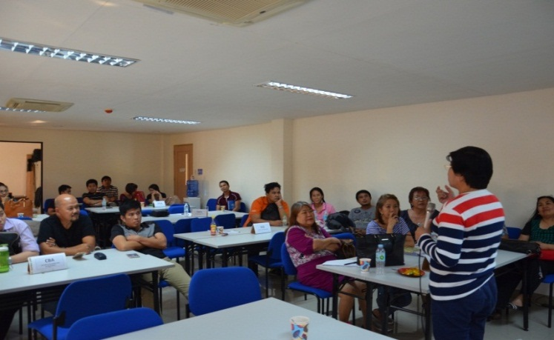
(February 9-10, 2017)
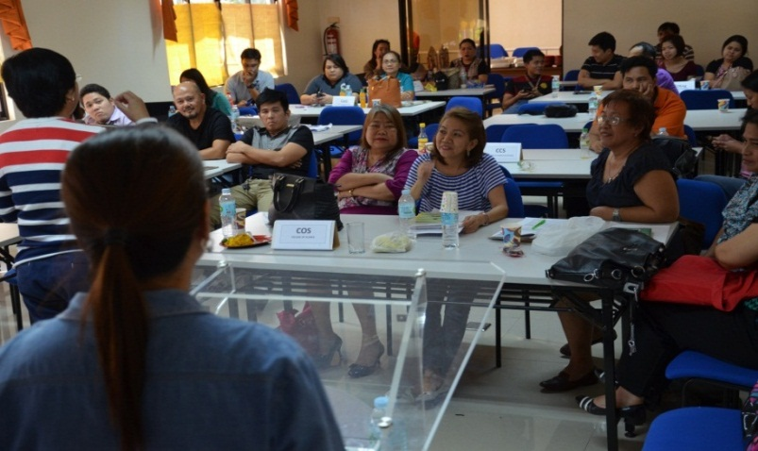

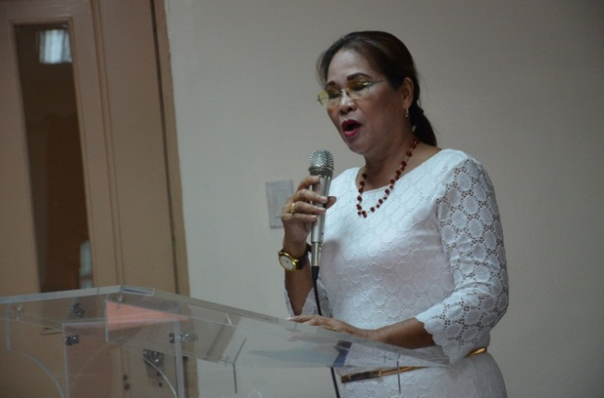
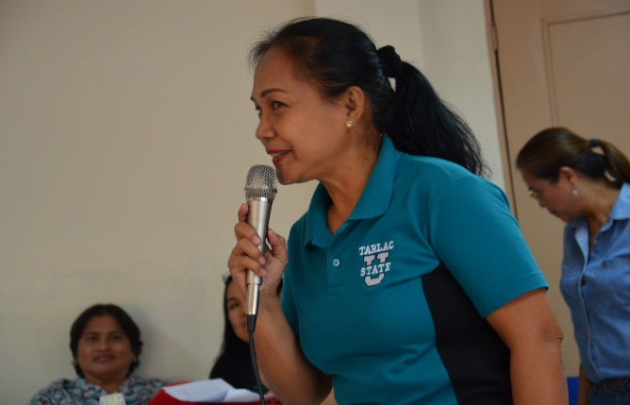

Turnitin Software Training
July 13, 2017

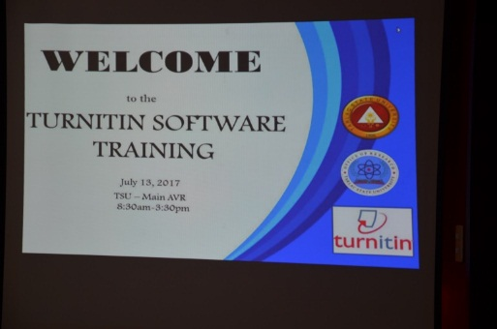
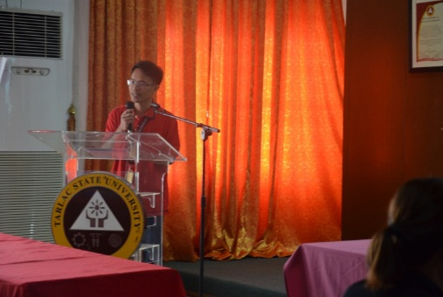

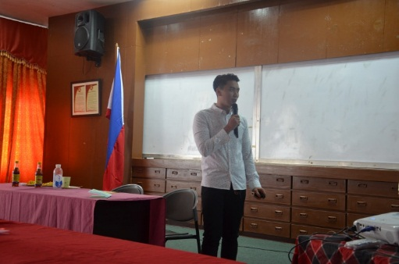

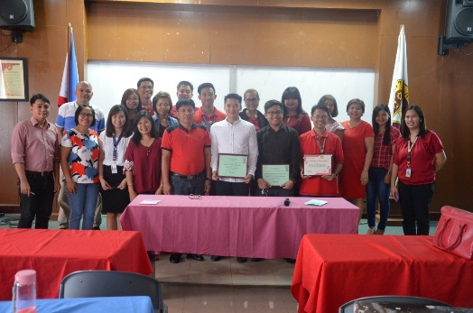
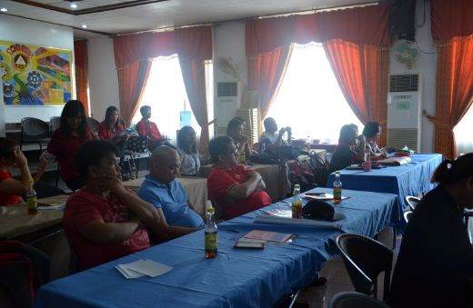

OTHER ACTIVITIES
2nd International Research Conference
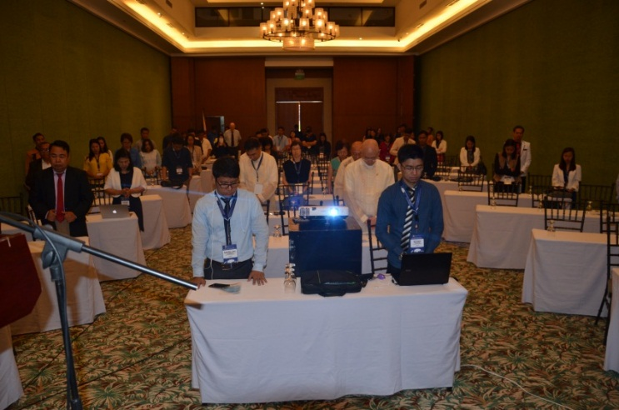
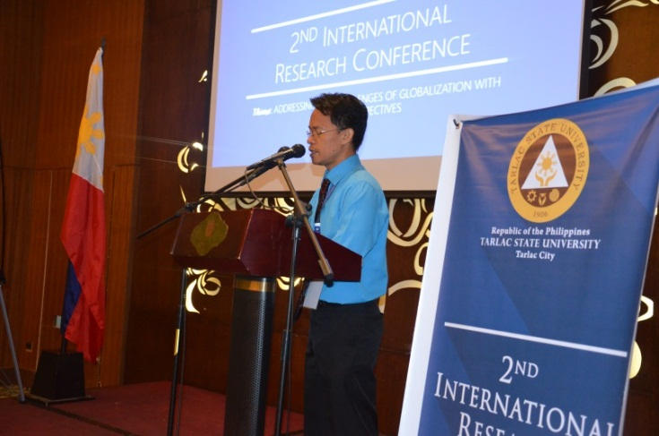

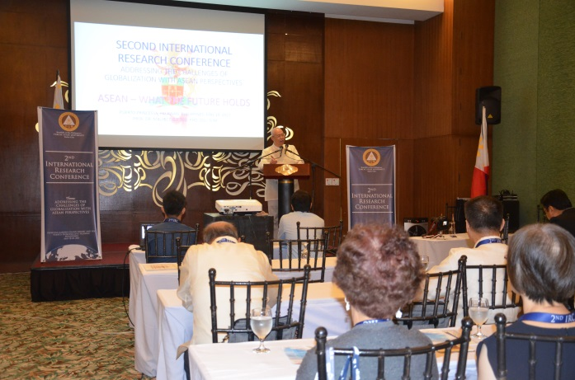

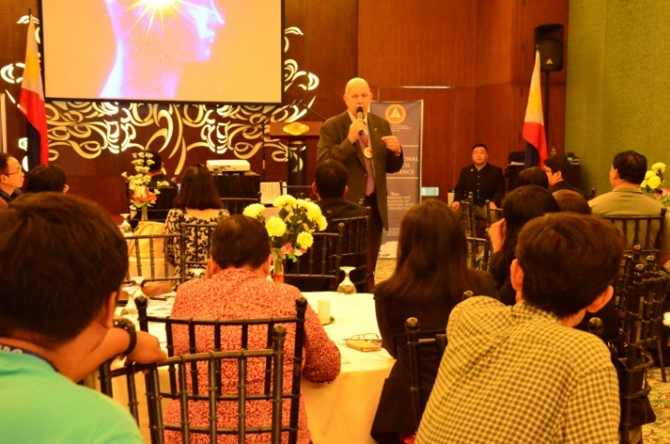
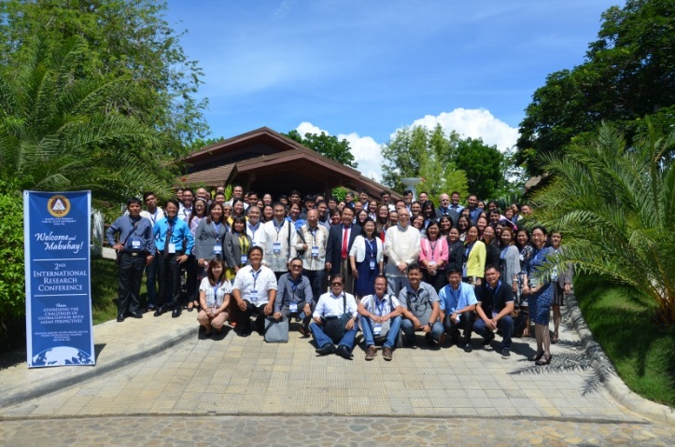

Photos of Research Proposal Colloquim

COLLEGE OF ENGINEERING
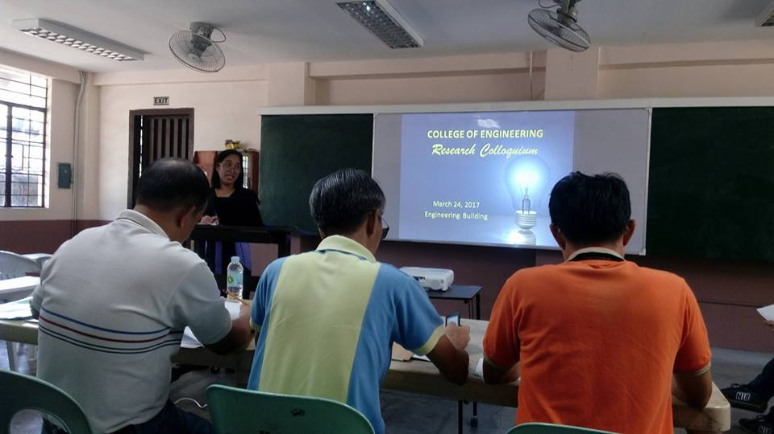

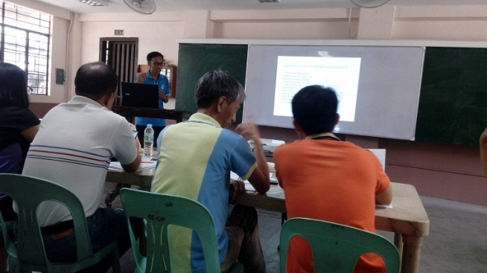
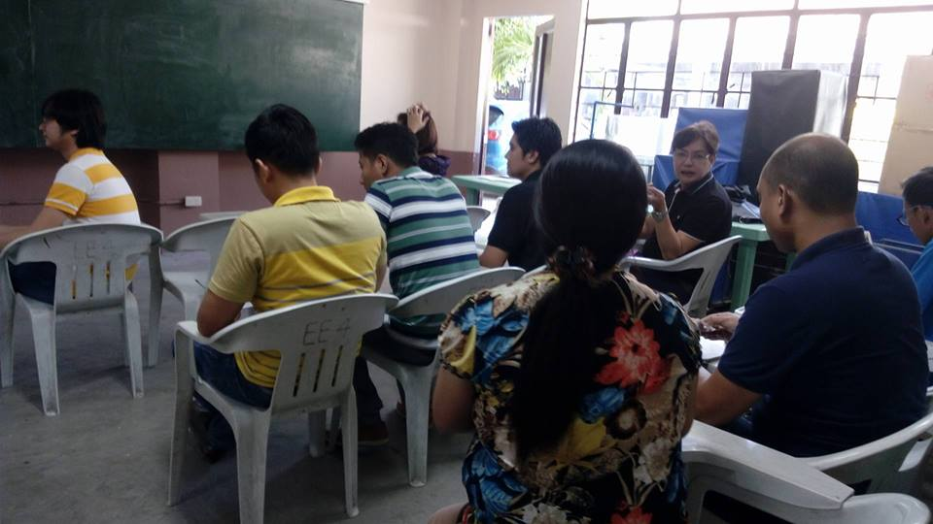

COLLEGE OF SCIENCE
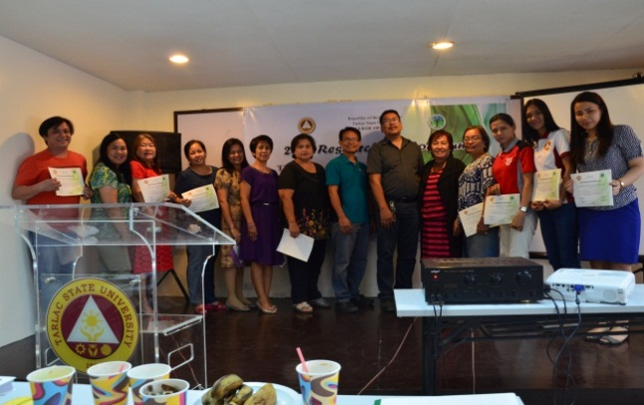
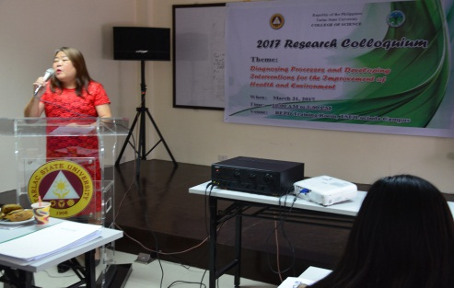

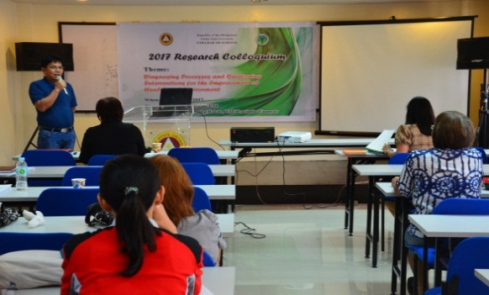

COLLEGE OF COMPUTER STUDIES
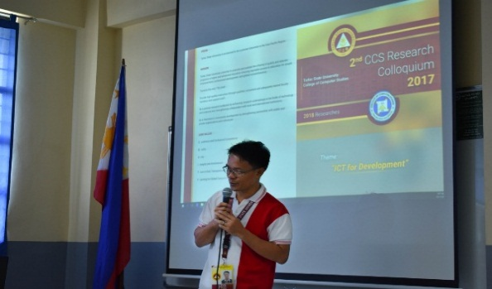
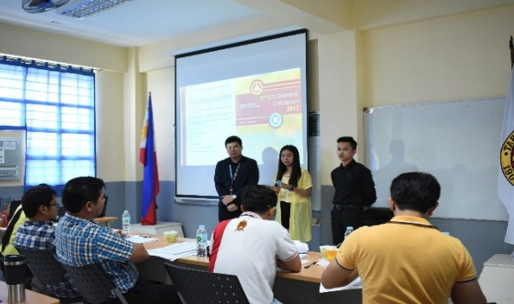
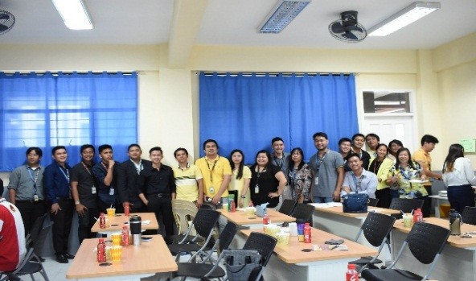

COLLEGE OF BUSINESS AND ACCUNTANCY
