1. **YOUTH AND DRUG EDUCATION**

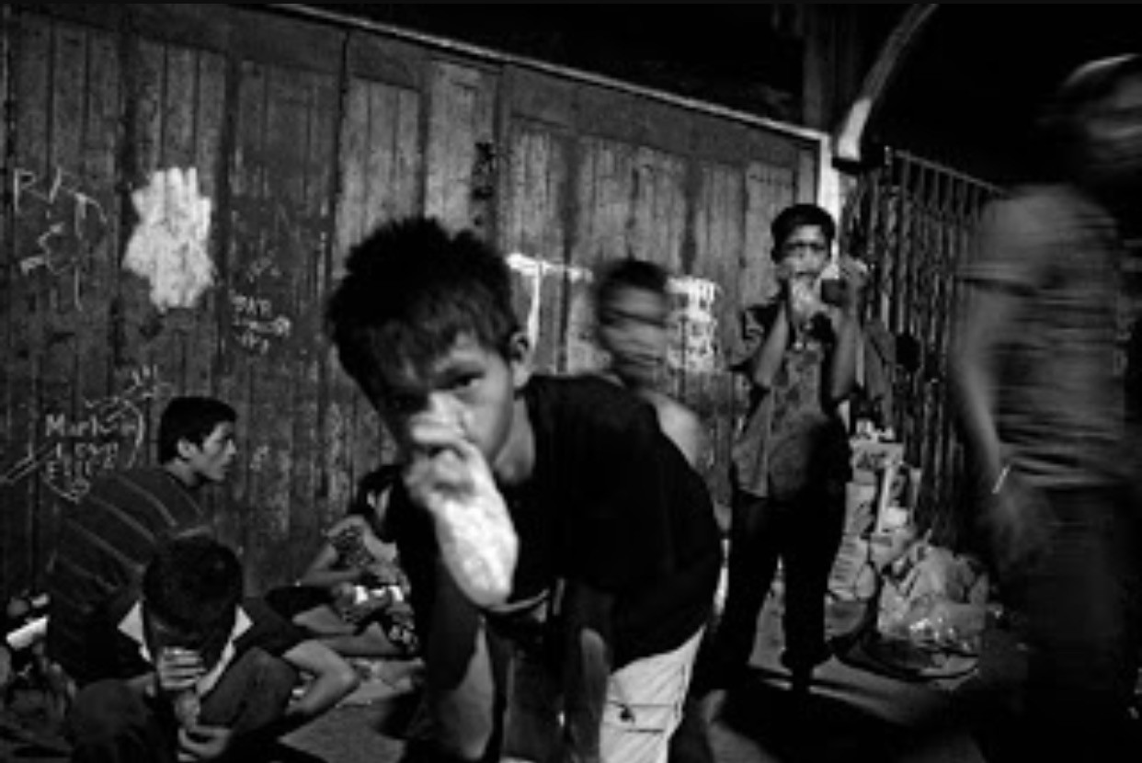The drug problem in the Philippines is multidimensional in nature and deeply rooted in the systemic roots of deprivation, injustice, and impotence of the Filipino people. In contrast to the government's position to treat issues as a crime and lawlessness issue, the drug problem must be addressed through a holistic and rights-based approach requiring the mobilization and involvement of all stakeholders. We must all work together to protect and promote the health and well-being of all peoples in our country. It is necessary to equip our young people with knowledge of why drug addiction occurs and how to prevent drug dependence.

1. **YOUTH, DISASTER AND SAFETY**

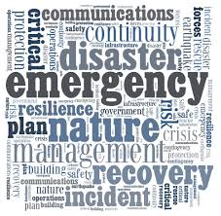

Crises and disasters cannot be avoided, but planning, training and preparedness can mitigate their consequences. While significant incidents influence culture, they have a greater influence on disadvantaged communities. Children and young adults are in this category and special planning and education needs to be considered. Numerous studies have shown the importance of young people's early involvement in disaster planning and preparedness. However, most of the emergency assessment and crisis prevention studies for young people are descriptive and end up in handbooks, suggestions and case-by - case lectures.

Given the recent tragedies involving school children around the world alongside other natural and man-made disasters, the current approach to education seems to be inadequate, and additional emergency and disaster management training is unquestionably needed. Young people need to understand not only the nature of the response to disasters and terrorist attacks in society, but also how to respond to the risk of a catastrophic event. Theoretical awareness is not adequate in this regard and a realistic solution should always be considered.

Young people should be trained to adjust their knowledge, develop crisis management and preparedness skills, and ensure that they are prepared for future emergencies. Even though young people are considered a risk group in a disaster because they cannot manage it, an educational initiative can make it an important resource to help them prepare for future emergencies.

1. **YOUTH AND ENVIRONMENT**

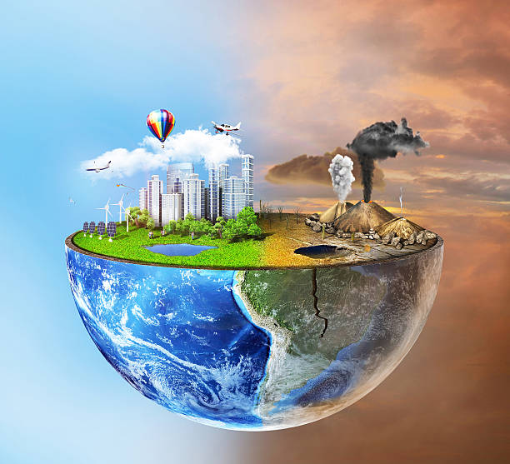Like we have noted in the past, there are even other environmental conservation guidelines, regulations, and treaties, but there is little meaningful enforcement. Young people have a crucial part to play.

Young people make up a large part of the world's population, and young people will have to live longer than their elders with the consequences of current environmental decisions. Such policies would also impact future generations and tackle concerns such as resource degradation, habitat destruction and long-lived toxic material.

Young people should take an important role in the safety and development of the community. Adjust the way of life and the way it impacts the climate. By adopting environmentally friendly practices, recycling various materials, and preserving resources such as water and electricity, they can build their homes, schools, and young organizations. Engaging young people in environmental conservation not only has a significant effect on the evolving attitudes of young adults, it may also affect their parents and their friends.

1. **YOUTH AND HEALTH**

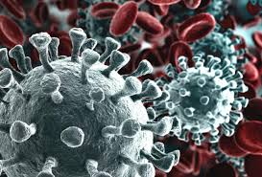

The World Program of Action for Youth (WPAY) calls on governments to ensure that their services meet the needs of young people. In the current conditions, it is especially critical for young people to be identified alongside other collective interests in the development of health and non-health initiatives in response to COVID-19.

Building on the ability of young people to make their own decisions and to take responsibility for their own health is a key element of WPAY. Health education, public health promotion and evidence-based information are critical in the fight against the spread and effects of COVID-19. The role of governments, youth organizations and community groups will be crucial in challenging the spread of disinformation online and ensuring that reliable public health information is disseminated.

Young innovators are already responding to the pandemic through social impact projects. Governments and the corporate sector are working with young people around the globe to implement programs that harness young people 's engagement to improve their neighborhoods. Through voluntary initiatives, many young people have also supported vulnerable members of their communities, for example in the distribution of food and medicines.

Youth-driven innovation hubs around the world are supporting start-ups to develop technological solutions to address COVID-19, as the pandemic is shifting more and more online. Policies that enable partnerships with young people in this area can deliver future economic dividends and provide an opportunity for young people to contribute and show solidarity in a time of crisis.

As the crisis unfolds, there will be a wide range of youth policy responses tailored to specific contexts and needs. Countries should invest in protecting all human rights, going beyond the right to health, in building a more resilient society, including for young people. Policies, those involving coercive measures or subjecting certain persons to high risks, should be evidence-based, proportionate and non-discriminatory. Decisions concerning children under the age of 18 should always be made in the best interests of the child in accordance with the Convention on the Rights of the Child.

1. 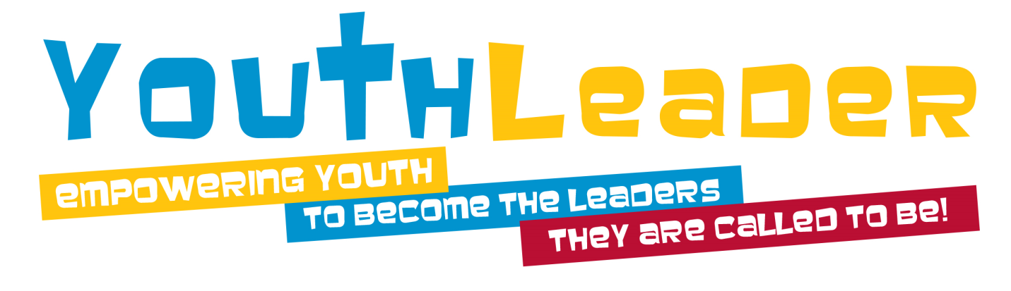**YOUTH, VALUES AND LEADERSHIP**

Values are the guiding principles of our lives. Leadership takes place within the framework of core principles. Leaders guide and facilitate others to make a positive difference in their own lives and to contribute to a greater good. Values inform the application of leadership qualities as the leadership skills – learned, developed, and practiced – are activated within the core values set. By focusing on what people believe and value, and then building positively on that understanding, we have a far wider impact potential than if we approach leadership development as a problem-solving activity.

Character education means creating a culture that requires everyone in the school community to be the best people they can be. Character education systems that succeed are a massive mechanism of collective change involving pupils, instructors, staff, parents, and other stakeholders.

1. 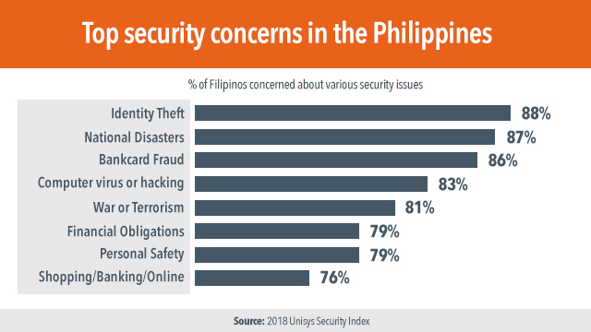**YOUTH & NATIONAL SECURITY**

Today, the Philippines is tormented by numerous social afflictions – misery, violence, abuse, and indifference. Just as Jose Rizal and others like him exclaimed, young people are burdened with the task of cultivating the motherland. So how can we deal with these social ills that plague the Philippine Society? What role do young people play in addressing these social ills?

Youth, who, by legal definition, includes those between 15 and 30 years of age, make up nearly one-third of the country 's population. With a significant proportion of the Filipino community, young people are rapidly playing a major role in the growth of the Filipino society. Their attitudes, values, attitudes, and priorities will determine the future development of the country. With the crucial role that society has played for young people, it is imperative that the young people of today have a positive outlook that will guide them towards development. With that in mind, how does the youth see and react to this challenge?

According to the Social Weather Station (SWS) report, young people consider structural challenges, violence, and politics as the country's biggest problems. However, even though they recognized the severity of these problems, most of them respond with either helplessness or apathy when asked what they can do to help solve them. This is reflected in the behavior of young people towards involvement and participation in organizations and activities. Furthermore, the Filipino youth was found to have unexpectedly high incidences of involvement in illegal activities such as illegal drug use, criminality, and illicit sex. Given these disturbing facts about Filipino youth, will they address the various social ills of the country?

The Global Partnership for Youth Development suggested that one way to overcome and better equip young people to develop society is through empowerment of young people. Empowerment could be manifested through greater opportunities for young people. Youth must be granted the chance to engage in civic life and capacity building. The leadership needs to be harnessed.

Young people may, thus, encourage both optimism and fear in community. Fear in the form of apathy, crime, and immorality. Hope in the form of participation, concern, and voluntary action. Solving the social problems of the country is therefore a challenge for young people to bring hope rather than fear into our society.

Youth have a key role to play in shaping the future of our country, about which there is little doubt. They have demonstrated that they can be powerful agents of change. The question is, are they up to the challenge?

1. **YOUTH ENTREP**

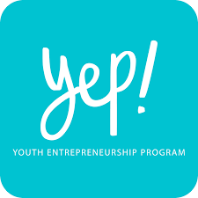Youth is the hope of any country and the descendants of the world tomorrow. This argument is valid in every way. When a country has a healthy youth population, you will find a country that is making progress in terms of overall development and progress. A country with a high aging population and a lower youth population has a lot of problems that can slow down its growth.

Today, the world has moved into the 'Technology Era.' Technology has made advances in many areas and in all cultures. The technology transition has transformed the course of people's lives taking health services, education, and communication to perhaps the most distant and disconnected regions.

Globalization has put nations together and developed the global economy. We have witnessed several shifts in the world's foreign security diagram. Countries are beginning to show determination to move from old-age monarchies and dictatorial regimes to democracy.

Global youth unemployment could boom to become a global crisis that would have a social and economic impact on all countries, as well as pushing economies back and making progress backwards. Although each government, as well as the World Organizations, is implementing policies and promoting schemes as well as funds to support youth employment programs, the amount of such efforts is negligible compared to the vast numbers.

Youth entrepreneurship has an impact on the social, cultural, and economic progress of society. Building an environment that promotes creativity and provides opportunities for entrepreneurship calls for multi-pronged strategies to be implemented and implemented at all levels, including the government, industry, political, social, and educational sectors.

Working towards Youth Entrepreneurship programs can help to solve and avoid many of the problems currently facing countries and pave the way for a better future and a more progressive society in the world.

1. **YOUTH AND EDUCATION**

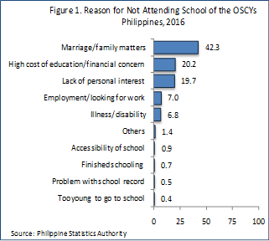Education policies, curricula and training programs need to be aligned in a people-centric manner with national development priorities and needs, international development strategies and labor market requirements. This will promote the situation of young people, combat extreme poverty, and maximize the benefits of globalization for young people.

The persistent gender gap in education hinders the development of young people. Gender inequity in education is distinguished, among other issues, by a lack of exposure to and provision of gender-sensitive educational services, facilities, and training programs, as well as a high drop-out rate for secondary school-aged students.

Awareness and knowledge are essential drivers for the complete and successful involvement of young people in social, economic, and political growth systems. More attention needs to be paid to improving the participation rate of young people , particularly marginalized young people, in order to ensure that they acquire the knowledge , skills, skills and ethical values needed to fulfill their role as agents of development , good governance , social inclusion, tolerance and peace.

A greater focus on universal access to education, quality education, human rights education and learning, as well as increased access to the complementary nature of vocational, formal, informal and non-formal education practices in a non-discriminatory manner-especially for young women-is crucial for young people to be able to respond to their aspirations and challenges, to realize their potential and opportunities.

**FINAL REMARKS:**

All young people are called to be **One** ... to serve as One, to Heal as One, to Pray as One, and to SAVE as One. The NATIONAL SERVICE TRAINING PROGRAM (NSTP) is an avenue in which young leaders will be formed and developed to show a sense of patriotism, nationalism, service, and love of the country. Each of the three (3) components shall provide the following services:

1. **RESERVE OFFICERS’ TRAINING CORPS (ROTC)**
2. Military Training - The students undergo military training, defense preparedness, basic life support and search and rescue operation under the Armed Forces of the Philippines. Each cadet shall become military reservist after the training.
3. **LITERACY TRAINING SERVICE (LTS)**
4. School-based Tutorial Learning Program -The students aid public pre-elementary and elementary pupils who have difficulties in reading, writing, listening, speaking and arithmetic and computer. The tutorial activities are conducted in the elementary schools or Day Care Centers.
5. Community-Based/Home-based Tutorial Learning Program - The students aid children in the communities who have difficulties in in reading, writing, listening, speaking and arithmetic and computer. Tutorial activities are conducted in barangay halls, covered courts, multi-purpose halls or at the houses of these children.
6. **CIVIC WELFARE TRAINING SERVICE (CWTS)**
7. Information, Education, Campaign on Disaster Risk Reduction Management - The students pursuant RA 10121 conduct surveys/conversations with the residents of selected barangays on their disaster experience. They help the community understand and prepare for disasters. CWTS graduates shall be part of the Barangay Disaster Risk Reduction and Management committee (BDRRMC) or the Municipal Disaster Risk Reduction and Management council (MDRRMC) and shall be engaged during calamities or emergency response.