**WAIVER AND TRANSFER OF COPYRIGHT OWNERSHIP**

The Tarlac State University, through the Technology Development, Transfer and Commercialization Office (TDTCO), requires a formal written waiver and transfer of copyright ownership from the author(s) of institutional works that fall under one of the categories enumerated below. You are hereby requested to complete this form and return to the office for notarization. Your cooperation is essential and appreciated.

TITLE OF WORK: _____________________________________________________________________

____________________________________________________________________________________

____________________________________________________________________________________

NAME OF AUTHOR : _______________________ NAME OF AUTHOR : _______________________ ADDRESS : _______________________ ADDRESS : _______________________

_______________________ _______________________

NAME OF AUTHOR : _______________________ NAME OF AUTHOR : _______________________ ADDRESS : _______________________ ADDRESS : _______________________

_______________________ _______________________

NAME OF AUTHOR : _______________________ NAME OF AUTHOR : _________________________ ADDRESS : _______________________ ADDRESS : _________________________

_______________________ _________________________

*(An additional sheet may be used, if necessary)*

WHEREAS, the author(s) whose name/s appear/s above has/have created an original work of authorship fixed in a tangible medium of expression mentioned in the title of work above;

WHEREAS, the created original work specified above falls under one of the categories of exclusive ownership of the university over institutional works such as:

1. Works that are supported by a specific allocation of university funds or other resources other than the usual salary and resources made available to every faculty member, personnel, staff, visiting professors, and students;
2. Works created at the direction and control of the university through officials or designates for the purpose of a specific project or purpose;
3. Works whose authorship cannot be attributed to one or a discreet number of authors, despite the application of process prescribed under the rules;
4. Works whose authorship cannot be attributed to one or a discreet number of authors because it is the result of simultaneous or sequential contributions by multiple authors;
5. Works created by the faculty members, personnel, staff, visiting professors, and students of the university beyond or not part of their regular functions and duties which uses the facilities, materials and resources of the university;
6. Works created through substantial use of university resources, such as libraries, research facilities, buildings, utilities, equipment, tools and apparatus, including services of its employees working within the scope of their activities, duties, or functions which are not for university purposes, but for the personal gain or advantage of the faculty member, personnel, staff, visiting professors, and students of the university. There is a presumption of substantial use of university resources if the work has in any way been done during official time or within the premises of the university and is related to unauthorized outside teaching or practice of profession without requisite permission.

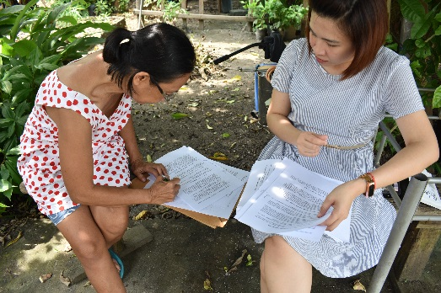

NOW, THEREFORE,

1. the Author(s) do hereby assign, transfer and convey unto Tarlac State University, the entire right, title and interest in and to said works and in and to any and all copyrights on said work that may arise and/or granted in the Philippines and any foreign country, and including each and every derivative work arising from the said work.
2. The author(s) shall fully cooperate in the prompt execution of all papers which are deemed necessary or desirable to perfect in it the right, title, and interest herein conveyed;
3. The author(s) shall fully cooperate in the prompt execution of all petitions, oaths, specification, declarations or other papers which are deemed necessary or desirable by Tarlac State University for obtaining copyright registration in the Philippines and/or foreign countries covering said works or works derived from said works.
4. The author(s) warrant/s and represent/s that he/she has not entered into any assignment, contract, or understanding in conflict herewith.
5. The author(s) acknowledge/s that the terms, covenants, and provision of this assignment shall inure to the benefit of Tarlac State University, its successors, assigns and/or other legal representatives, and shall be binding upon said author(s), his respective heirs, legal representatives, and assigns.
6. The author(s) is/are entitled to whatever royalties that may be derived from the copyrighted work in accordance with the guidelines specified in the manual of operations of TDTCO.

IN WITNESS WHEREOF, the AUTHOR(S) has executed and delivered this WAIVER AND TRANSFER OF COPYRIGHT OWNERSHIP this _________ day of _______________, 201_ at Tarlac City.

_______________________________ _______________________________

Author Author

(Signature over printed name) (Signature over printed name)

_______________________________ _______________________________

Author Author

(Signature over printed name) (Signature over printed name)

_______________________________ _______________________________

Author Author

(Signature over printed name) (Signature over printed name)

Signed in the presence of:

_______________________________ _______________________________

Signature over printed name Signature over printed name

*Remainder of page intentionally left blank. Acknowledgement page follows.*

**A C K N O W L E D G E M E N T**

REPUBLIC OF THE PHILIPPINES )

CITY OF TARLAC ) S.S.

On ___________________, 201_ before me the undersigned, a Notary Public in and for the city and Province of Tarlac personally appeared:

NAME ID PRESENTED DATE AND PLACE ISSUED



5.

6.

All known to me and to me known to be the same persons who executed the Waiver and Transfer of Copyright Ownership and they acknowledged to me that the same is their free and voluntary act and deed.

IN WITNESS WHEREOF, I have hereinto set my hand and affixed my notarial seal on the date and at the place first above written.

______________________________

**NOTARY PUBLIC**

Doc. No. ______________

Page No. _____________

Book No. _____________

Series of 201_