**ACCOMPLISHMENT REPORT MARCH**

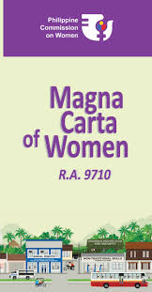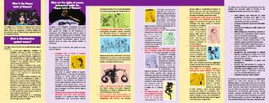

200 copies of IEC Materials on the Rights of Women were distributed to TSU Women Employees in the University on March 1-3, 2017. Tarpaulins on Magna Carta of Women were also posted the whole month in the three campuses of the University.

March 2 and 3 Resource Speaker Dr. RITA E. Pulmano GPB 2018

To officially launch the 2017 Women’s Month Celebration, a Flag-Raising Ceremony were conducted on February 27 and the whole month of March in San Isidro, Lucinda, and Main Campus.

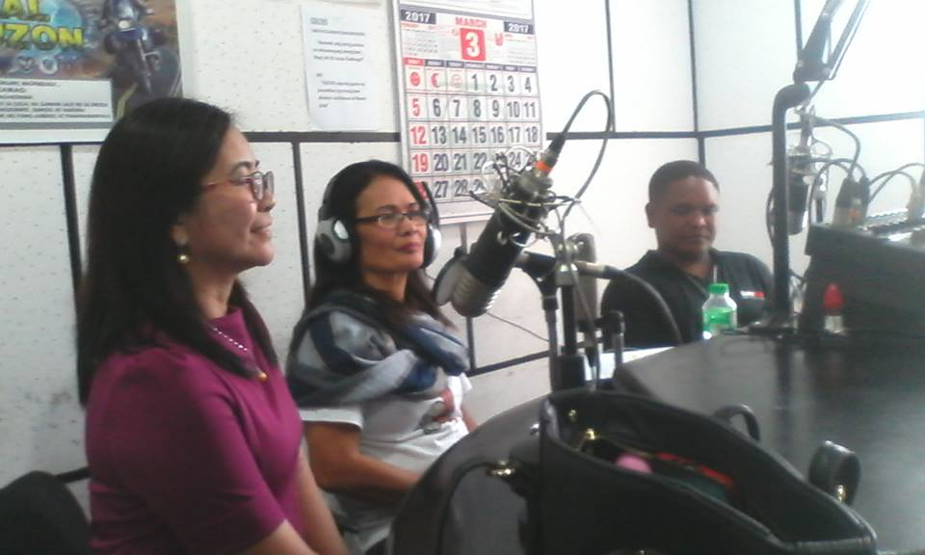

Dr. Rita E. Pulmano talked about the importance of Women’s Month Celebration and issues concerning women at the present during the Radio Guesting with the DZTC Tarlac on March 9, 2017.

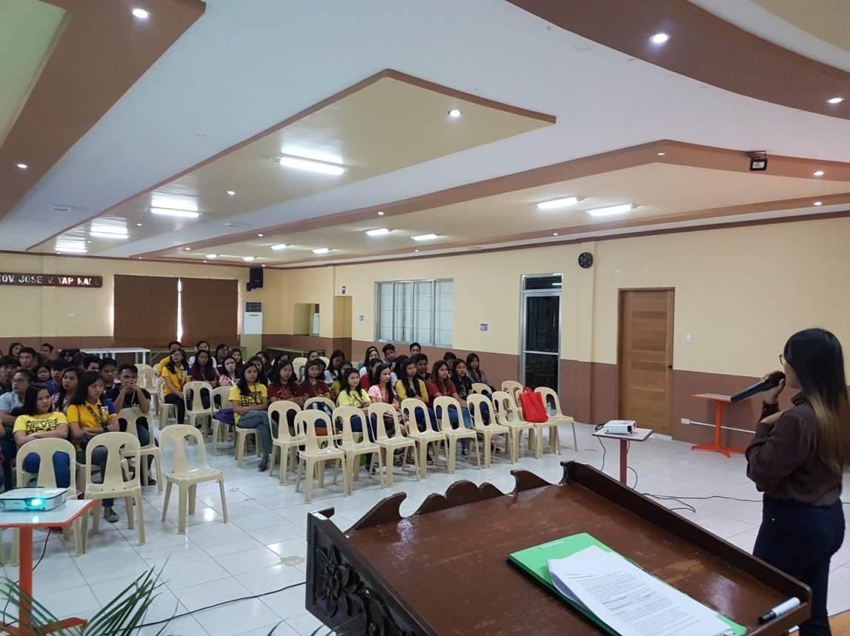

In line with the Women’s Month Celebration, Suzanne Cruz, CGAD Staff conducted a Seminar on Young Adult Fertility and Sexuality Seminar attended by COED students in Alumni Center Lucinda Campus on March 11, 2017.

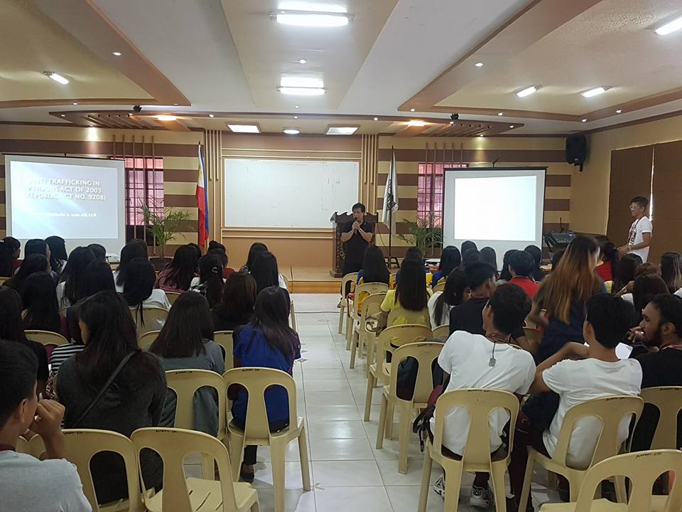

Increasing the awareness of students in their rights, the CGAD invited Prof. Winifredo Luis to be the Resource Speaker on the Seminar on

LAW ON RAPE on March 13, 2017held at the Alumni Center Lucinda Campus.

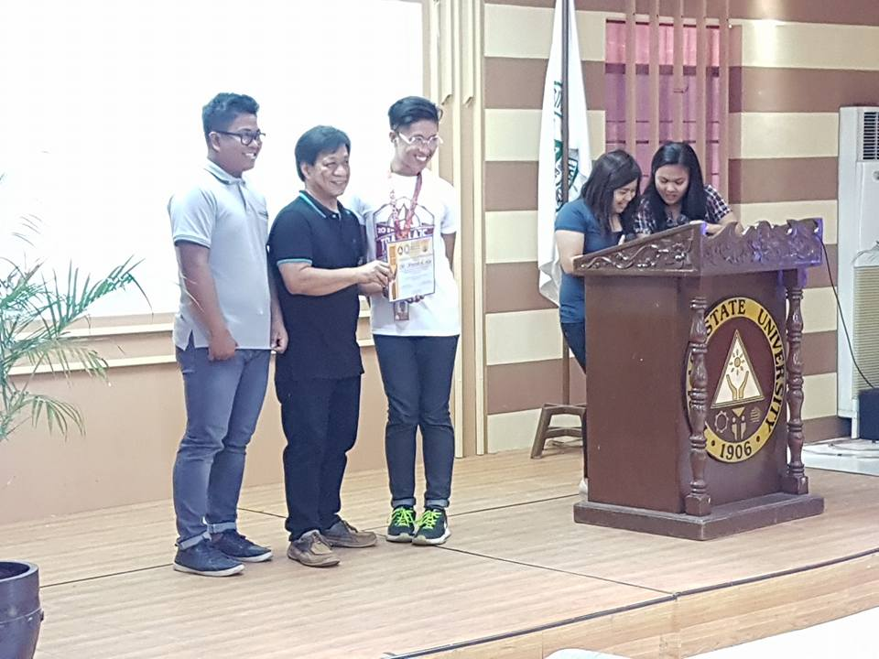

On March 13, 2017, CGAD conducted a Seminar on RA 10364 ortherwise known as Expanded Anti-Trafficking in Persons Act of 2012″ to COED students heled at the Alumni Center, Lucinda Campus.

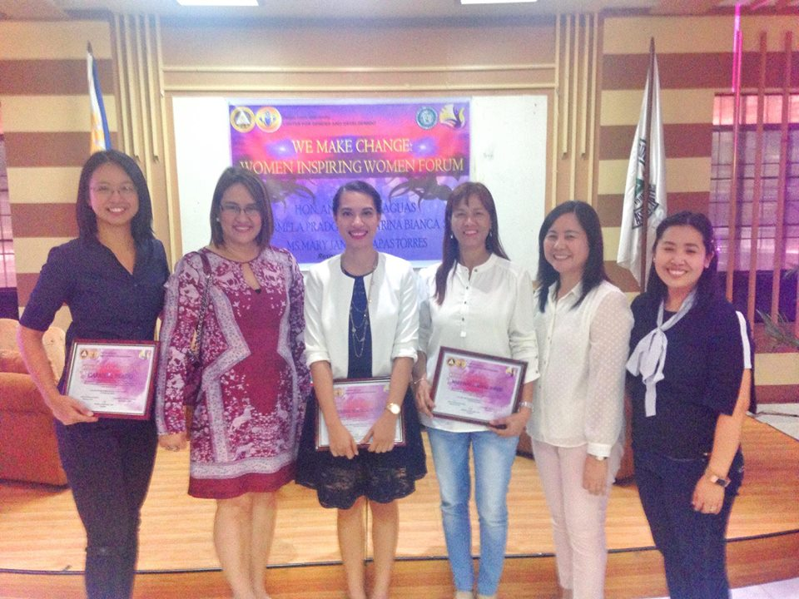

The CGAD Staff and Director Organize and facilitated the 2017 National Women’s Month Women Inspiring Women Forum on March 18, 2017 at the Alumni Center with Hon. Ana Aguas, Ms. Katrina Bianca Sicat, Ms. Carmela Prado, and Ms. Mary Jane L. Torres as the Resource Speakers.

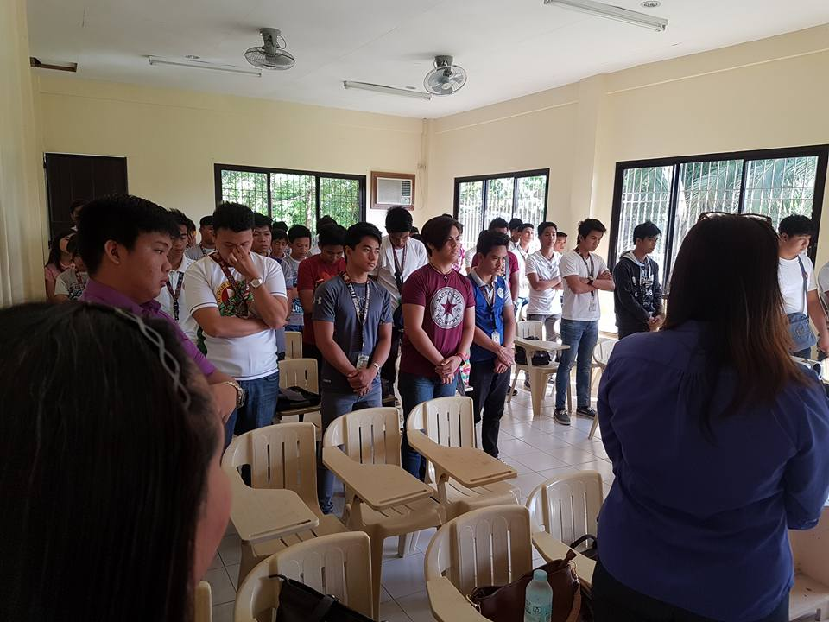

The College of Technology students had their Gender Sensitivity Orientation and Magna Carta of Women on **20 March 2017 (8am-5pm)** (*Monday* ) at the CT Conference Room, San Isidro Campus

March 22 Meeting in Capitol about GAD Code

March 24 Moving Up Child Care and Communication guild Seminar How to Protect your Self

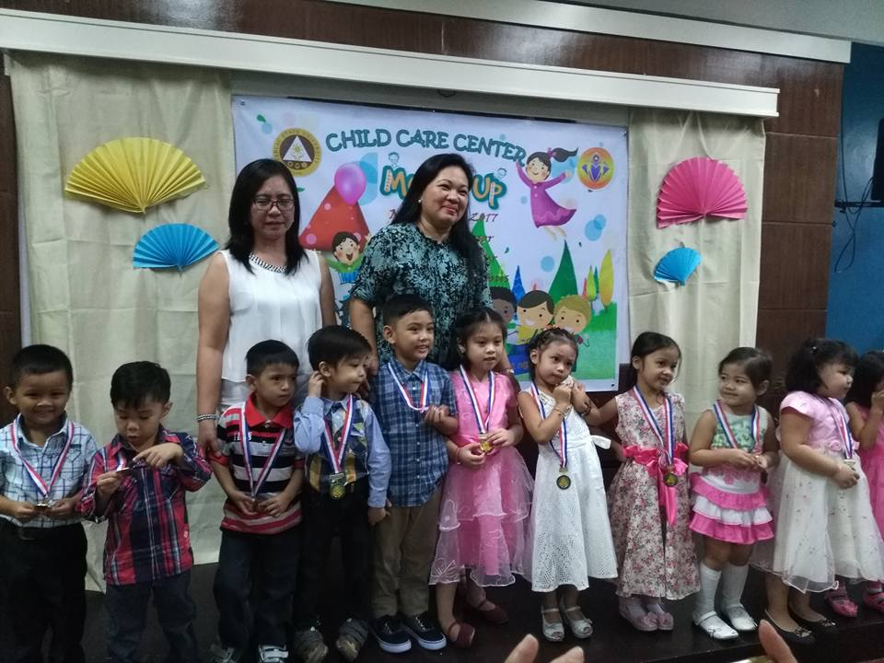

12 pupils completed the Child-Care Program of the CGAD with a Moving-Up Ceremony on March 24, 2017 at the AVR of Business Center, Main Campus.

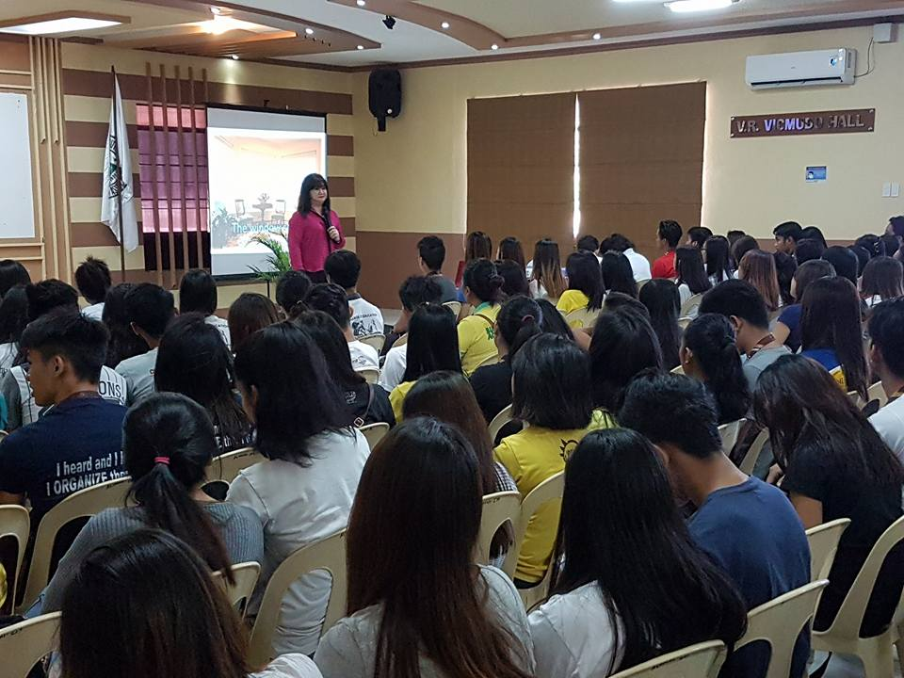

A University-wide seminar on Adolescent Reproductive Health for student scholars was held on March 27, 2017 at the Alumni Center with Dr. Lucilla Sunga as the Resource Speaker.

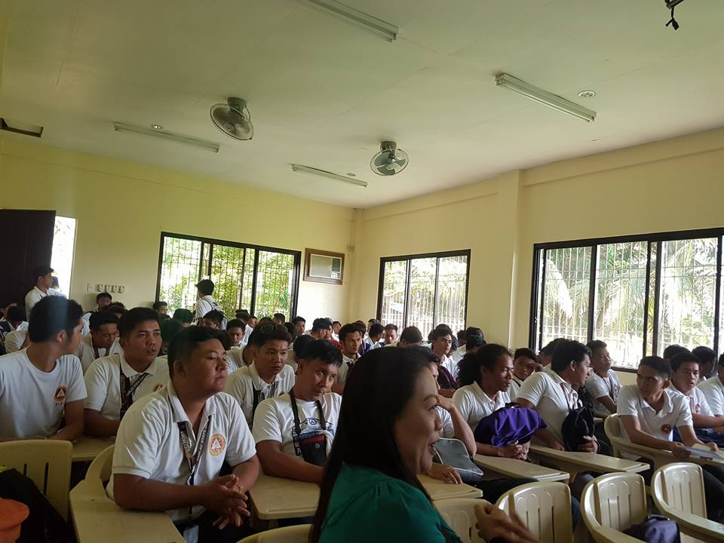

An Anti-Sexual Harassment Seminar was held in the College of Technology on March 27, 2016 with OJT students as the participants and Prof. Winifredo Luis as the Resource speaker.

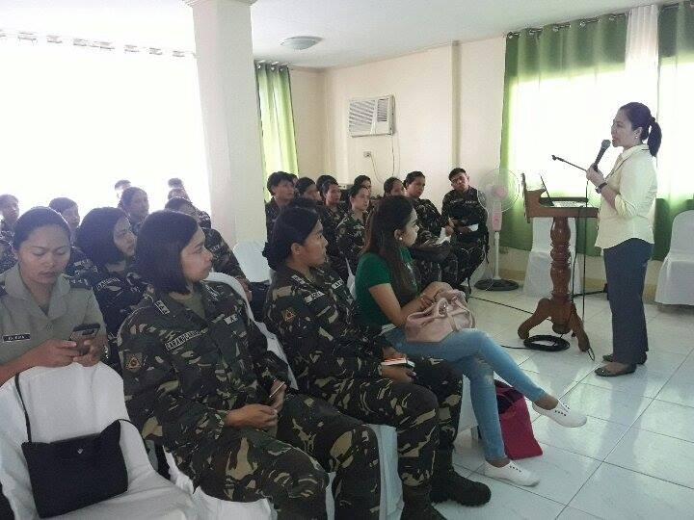

As per request of the 3rd Mechanized Infantry Division of the Philippine Army, CGAD Director Dr. Rita E. Pulmano served as the Resource Speaker in the GAD Concepts Gender Sensitivity Gender Roles and Stereotyping and Understanding Gender Roles and its Interplay in Times of Conflict and other Crisis Situation at Camp O’Donnel, Capas Tarlac.

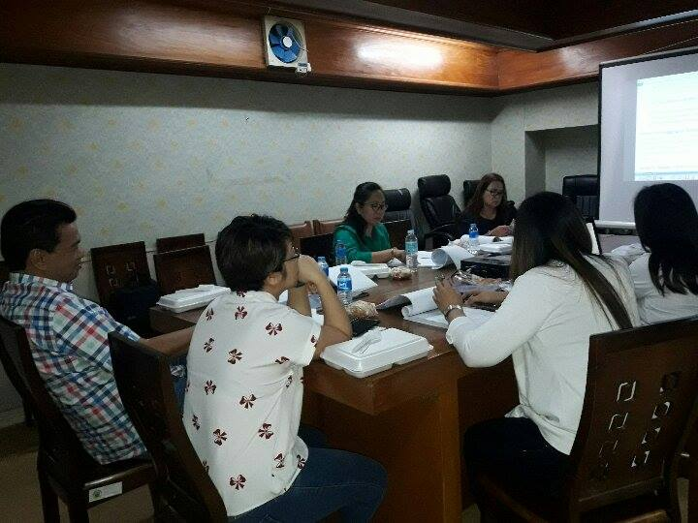

The Drafted GAD CODE of Tarlac Province was initially Reviewed by CGAD director Dr. Rita E. Pulmano, Suzanne Cruz, Provincial GAD Staff, Legal Staff of Provincial Capitol, and Hon. Board Member Antonio Cervantes on March 31, 2017.

26 Women Head of the Family Employees served as beneficiaries in the “Alalay Para Kay Juana” Programof the Center for Gender and Development. The freebees were given from March 28 to March 31, 2017.