ACCOMPLISHMENT REPORT
JANUARY 2017

- UPDATING OF INTERNATIONAL RESEARCH CONFERENCE
As a member of the IRC Committee, Dr. Rita Pulmano facilitated in the preparation for the 2017 International Research Conference in Palawan. Dr. Pulmano, together with the team, has been accepting required documents from foreign and local researchers. Updates and plans were discussed during the meeting on January 11 at the TSU Planning Office.

- REVIEW OF THE FORMULATED GAD CODE OF TARLAC PROVINCE
The crafted GAD Code of Tarlac Province was presented before the Technical Working Group, representing offices and units of Tarlac Provincial Government on January 17 at the Tarlac Museum. The members of the TWG were given a copy of the GAD Code, and reviewed the document wherein they provided inputs during the said meeting. At the present, the GAD Code is being reviewed by the legal Office of the Tarlac Provincial Government.
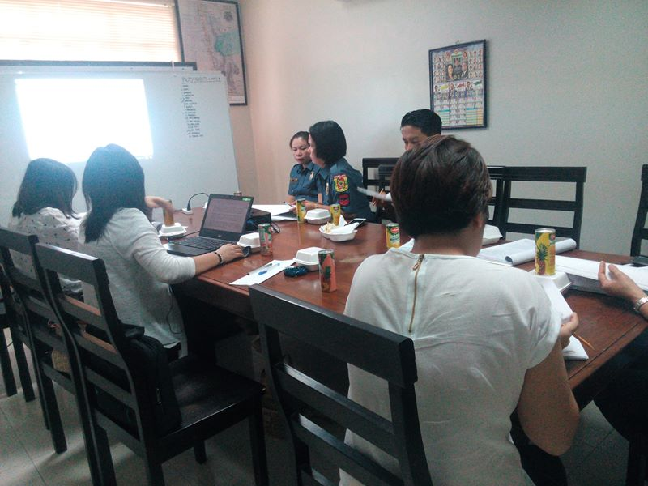
- SUBMISSION OF DPCR
The DPCR of the Center for Gender and Development was completed by Dr. Pulmano and was submitted on January 20, 2016.

- GAD SEMINAR FOR THE 552ND ENGINEER BATTALION
Dr. Rita Pulmano served as the Resource Speaker for the Gender Sensitivity Orientation for the wives of the 55nd Engineer Battalion of the Philippine Army on January 26, 2017 at the Camp Servillano Aquino.

