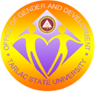
CENTER FOR GENDER
AND DEVELOPMENT
ACCOMPLISHMENT REPORT

The Center for Gender and Development augmented its undertakings in advocacy programs of strengthening, empowering, different sectors of society towards an equitable, sustainable, free from violence, and respectful of human rights community and University. The number of capability building seminars and trainings conducted this year reflect the intensification of commitment of the Office to educate and inform students, employees, and partner agencies in Gender and Development concepts and Human Rights. We have played a key role to mechanize gender mainstreaming efforts of different government agencies in the Province such as the Provincial Government of Tarlac, Municipality of Gerona, PNP, NFA, DepED, and Women’s Group such as Soroptimist International Tarlac Chapter among others. With the establishment of Center for Gender Studies in 2015, we were able to conduct our first Research Agenda Setting and First Research Colloquium in the latter part of 2016, where 17 research proposals were presented. At the end of 2016, the Office was tapped to craft the Gender and Development Code of Tarlac Province, where the Office provided the Resource Persons to discuss the Guidelines of the Philippine Commission on Women, Provide substantive inputs, and craft the code, which will serve as the basis for all the Gender and Development Codes of 18 municipalities in the Province. The Center was also able to produce its operational manual, and is among the Offices initiating Environmental Health and Safety practices.

I– CAPACITY BUILDING
Center for Gender and Development

Figure 1. Seminars Conducted in 2016

Participants | Number
Students | 1,125
Faculty and Personnel | 555
Participants from Partner Agencies | 680
Total | 2,360
Table 1. Number of Participants in Seminars Conducted by GAD in 2016
The Center for Gender and Development conducted a total of 29 seminars, 14 of which are capability building seminars on Gender Sensitivity Orientation, Magna Carta of Women, and Violence Against Women for students. Twenty four percent (24%) or 7 are seminars and trainings for faculty and personnel, and the rest (8 seminars), are conducted as per request of different government agencies and units in the Province of Tarlac comprising 28% of the conducted seminars. Altogether, 2,360 participants benefitted from the capacity building program of the Center for Gender and Development.

SEMINARS CONDUCTED WITHIN THE UNIVERSITY (IN-HOUSE)
TITLE OF ACTIVITY | DATE | PARTICIPANTS | # |  | VENUE | SPEAKER |  | AMOUNT
JANUARY TO JUNE
Gender Sensitivity Orientation | 01-18-16 | NSTP Faculty | 35 |  | COENG Library | Dr. Rita E. Pulmano
HIV AIDS Awareness Seminar | 01-29-16 | COS Students | 129 |  | Amphiteather | Dr. Rommel Hernandez |  | 5,520
Gender Sensitivity Orientation | 02-13-16 | COED Students | 304 |  | Alumni Center | Dr. Rita E. Pulmano/Engr. Michelle Rivera |  | 7,329
Gender Sensitivity Orientation | 02-15-16 | CT Students | 132 |  | Open hall San Isidro Campus | Engr. Michelle Rivera |  | 6,800
Gender Sensitivity Orientation | 03-05-16 | NSTP Students | 201 |  | EB5 Eng. Building | Engr. Michelle Rivera |  | 3,760
Gender Sensitivity Orientation | 03-07-16 | NSTP Students | 200 |  | EB5 Eng. Building | Engr. Michelle Rivera |  | 3,760
Teenage Reproductive Health | 03-07-16 | CBA,CASS,CPA Students | 217 |  | Alumni Center | Prof. Lucila Sunga |  | 4,715
Anti-Sexual Harassment | 03-11-16 | COS Students | 93 |  | Alumni Center | Prof. Winifredo Luis |  | 4,400
Anti-Sexual Harassment | 03-22-16 | Students Leaders | 108 |  | Alumni Center | Prof. Winifredo Luis |  | 4,400
HIV AIDS Awareness Seminar | 03-28-16 | COE Students | 110 |  | EB8 Eng. Building | Dr. Rommel Hernandez |  | 4,400
Gender Sensitivity Orientation | 04-25-16 | Security Guard | 48 |  | Main AVR | Dr. Rita E. Pulmano
Anti-Sexual Harassment | 05-16-16 | COENG Students | 85 |  | EB 7 Eng. Building | Atty. Marlon Baldovino |  | 4,919
Gender Sensitivity Orientation | 05-16-16 | NSTP Students | 85 |  | CBA room 216 | Engr Michelle Rivera |  | 2,960
MAG NA CARTA | 05-27-29-16 | TSUFPU | 133 |  | LAGUNA | Dr. Rita E. Pulmano |  | 524,600
Gender Sensitivity Orientation | 06-12-13-16 | NASA | 127 |  | BATAAN | Dr. Rita E. Pulmano |  | 325,200
SALAMAT DOC | 06-17-16 | TSU Employees | 52 |  | AVR | Dr. June Masagca |  | 4,915
JULY TO DECEMBER
Anti-Violence Against Women | 07-09-16 | COED Students | 136 | Alumni Center |  |  | Prof. Winifredo Luis | 7,200
Gender Sensitivity Orientation | 10-12-16 | COED STUDENTS | 110 | Amphiteather |  |  | Engr. Michelle Rivera | 7,200
MAG NA CARTA of Women | 10-12-16 | COED STUDENTS | 110 | Amphiteather |  |  | Ms. Suzanne Cruz
Incorporating Gender Message to Curriculum: Faculty Team Building | 09-10-17 | COED  Faculty | 50 | Grand Harbour Hotel, Subic |  |  | Dr. RITA E. PULMANO | 37, 000
Violence Against Women and Children | 11-29-16 | CT CCS Students | 144 | CT San Isidro |  |  | BONG | 4,000
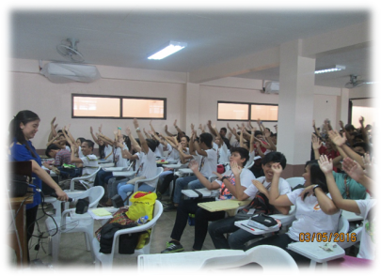
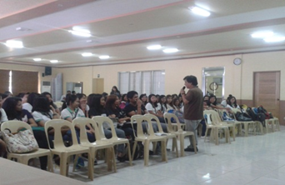
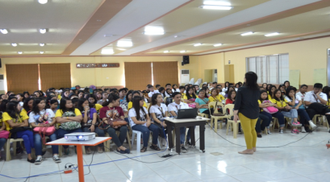
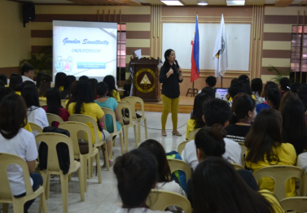
SEMINARS FOR STUDENTS

Gender Sensitivity Orientation (GSO) on 13 February 2016 (

Gender Sensitivity Orientation on 07 March 2016

Anti-Sexual Harassment Seminar for the College of Science (COS) students held on 11 March 2016

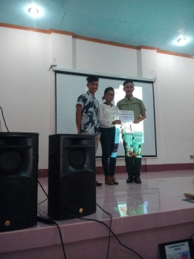
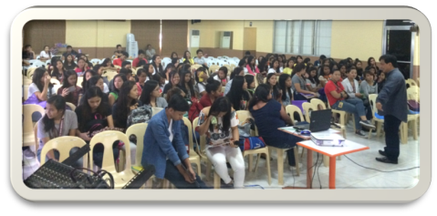
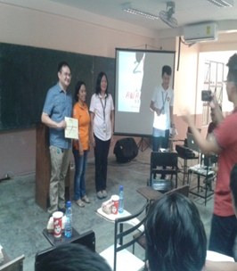
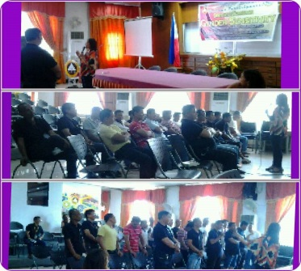
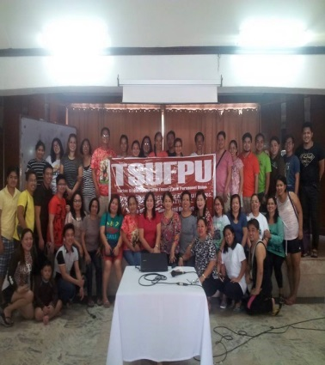
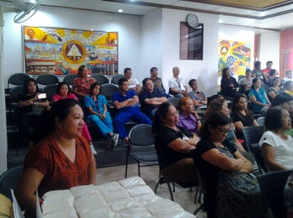
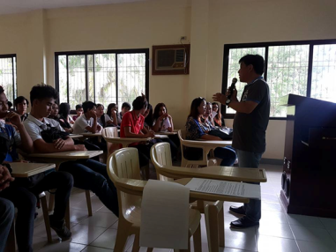
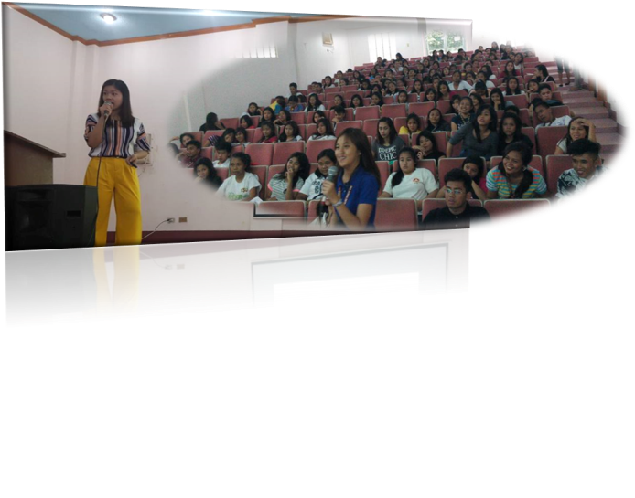
-
Gender Sensitivity Orientation for TSU Civil Security Unit
Magna Carta of Women Seminar during the TSUFPU Teambuilding
Salamat Dok: Seminar on Naturopathic Medicine
SEMINARS FOR FACULTY AND PERSONNEL
Seminar on RA 9262 on Nov 25, 2016
Gender Sensitivity Seminar October 12, 2016
Magna Carta of Women Seminar October 12, 2016
Anti- Violence Against Women and Children of the COED BEED (Generalist) students on 9 July 2016

AIDS Awareness Seminar on 28 March 2016

II– RESEARCH (CENTER FOR GENDER STUDIES)
Center for Gender and Development
Research Proposals

At the present all the research proposals falls under the Social Sciences, Business and Education (SSBEd) category, where a total of 17 proposals were presented and reviewed during the Research Colloquium of Center for Gender Studies in October of 2016. Proposals under the Science Technology and Mathematics were not approved due to lack of gender perspective. Provided on Table 2 are the list of research proposals presented in the Reseach Colloquium.

TITLE OF RESEARCH | AUTHOR
1.Development and Validation of a Gender-Fair Test in Fundamentals of Mathematics | Nelvin R. Nool (BEEd)  Socrates A. Embesan (BSED)
2. Impact of the Skills and Knowledge Development of the Unemployed Women in Dumarais Lapaz Tarlac | Dr. Felicitas A. Quilondrino (BTTE)  Dr. Jessica dela Pena (BTTE)
3. Gender Preference of the South Korean Students in the English Language Proficiency Program | Ninez B. Tulo  Nicanor C. Caingat
4. A Study on the Gender Friendliness of Elementary Schools in Tarlac City | Laarni Capinding  Dr. Rodrigo Sicat
5. First Job of Bachelor of Science in Industrial Engineering Graduates of Tarlac State University | Victoria C. Antallan
6. Retirement: Expectation and Reality | Alma M. Corpuz  Dr. Rita E. Pulmano
7.Math Intervention in Elementary Learners with Learning Difficulties | Estrella B. Pagco
8. Child Rearing Practices of Teenage Mothers Among Tarlac State University Students | Prof. Lorna C. Gamis  Prof. Maria Susan Maglaqui  Prof. Adora N. Obregon  Prof. Mary Jane N. Rigor
9.Shatterring the Glass Ceiling: A Comparative Study on the Employment Status of Male and Female graduates of Tarlac State University College of Technology | Christine Janelle S. Matias  Jovy P. Tomas  Federico Estrada Jr.
10. Risk Assessment of the TSU Employees with Job Order status | Engr. Michelle Rivera  Suzanne P. Cruz
11. The Status of Women Offenders in Tarlac Provincial Jail: Towards the Development of an Intervention Program | Dr. Rita E. Pulmano  Suzanne P. Cruz  Engr. Michelle D. Rivera  Dr. Alma Corpuz
12. Prevalence and Factors Related to Teenage Pregnancies: Basis for Strengthening the Reproductive Health Program of the Province of Tarlac | Dr. Rita E. Pulmano  Suzanne P. Cruz
13. Gender Differences in Mathematics Test Taking of Engineering Students | Emy-Lumba Vasquez  Leo P. Piao
14.Employability Study of Graduates of Male-Dominated Courses of College of Technology | Jovy P. Tomas  Christine Janelle M. Santiago  Federico M. Estrada Jr.
15. Analysis of Engineering Course Preference of Female Grade Eleven Students Enrolled in STEM | Emir Lenard Sicangco  Laarni T. Capinding
16. Gender-Responsiveness of Extension Projects of Tarlac State University | Lea B. Milan  Emir Lenard Sicangco  Redemptor Toledano/Glenard Madriaga
17.Prospective English Teachers’ Conceptions on English Language and Language Learning | Dr. Agnes Ladia
Table 2. Research Titles and Authors of Research Proposals Presented during the 2016 Research Colloquium
Gender Analysis
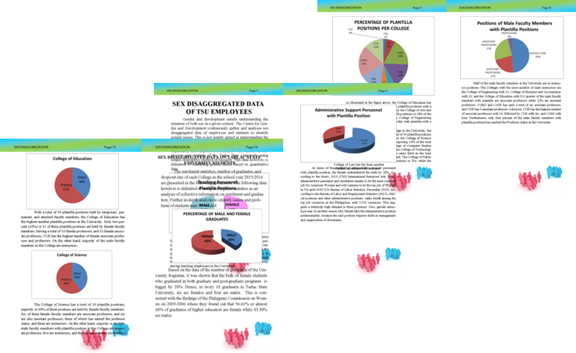
The Office was able to come up with an analysis of sex disaggregated data of TSU employees and students, presented during the ore-planning of the VPRES. Twenty copies of the said reference material is reproduced and disseminated among Colleges and Units in the University. The said material now serves as a basis for the Gender and Development Plan and Budget of CGAD, and used to being utilized by the Provincial Government of Tarlac for identifying Gender Issues in higher education in the province, towards their implementation of policies and programs.

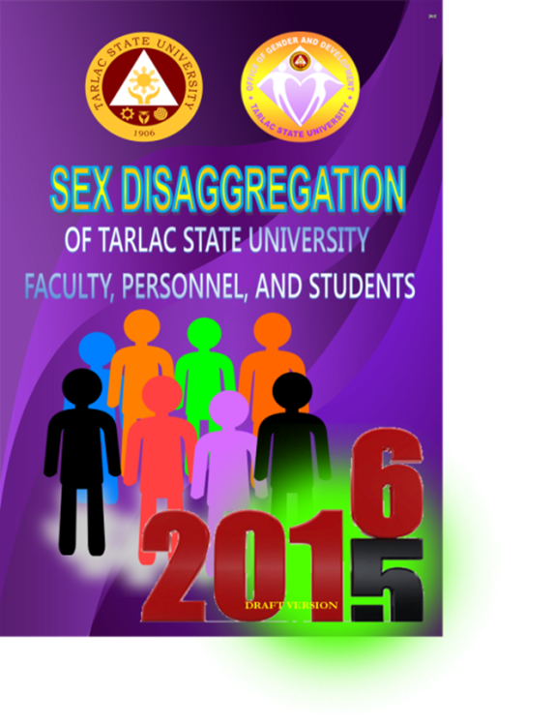

Figure 2. Sex-Disaggregated Date of TSU Faculty Personnel and Student
III– EXTENSION
Center for Gender and Development
Office | Number of Seminars Conducted | Participants
Provincial Government of Tarlac | 4 | 469
National Food Authority | 2 | 134
Municipality of Gerona | 1 | 47
DepEd camiling West Central Elementary School | 1 | 30
Total | 8 | 680
Table 3. Summary of Seminars Conducted as Extension Project of CGAD in 2016
The Center for Gender and Development provides extension programs as per request of the partner agencies and community. The Office was able to provide eight (8) seminars and trainings as part of its extension programs, with a total of 680 participants.
SEMINARS CONDUCTED OUTSIDE THE UNIVERSITY (EXTENSION)
Title of Seminar | Date | Participants | Number of Participants | Venue | Speaker
GAD Plan and Budgeting | 03-29-30-2016 | Provincial Planning and Development Office  Provincial Government of Tarlac | 40 | La Maja Rica Hotel | Dr. Rita Pulmano
Gender Sensitivity Orientation | 09-26-2016 | Provincial Government of Tarlac Employees | 130 | Session Room, Tarlac Capitol | Dr. Rita E. Pulmano
GAD key Concepts and Gender Sensitivity Seminar/Workshop | 09-28-2016 | NFA Employees | 72 | NFA Office, Aguso | Dr. Rita E. Pulmano
Gender Sensitivity Orientation of the Provincial Government of Tarlac | 10-18-19-2016 | Provincial Government of Tarlac  Employees  Social Worker | 224 | Session Room, Tarlac Capitol | Dr. Rita E. Pulmano
RA 9262: Violence Against Women and Children | 11-28-2016 | National Food Authority Employees | 62 | NFA Office, Aguso Tarlac | Dr. Rita E. Pulmano
GAD Code of Tarlac Province Review and Overview of New Guidelines | 12-12-2016 | Provincial Government of Tarlac Officials and Employees | 75 | Session Hall, tarlac Capitol | Dr. Rita E. Pulmano
Gender Sensitivity Orientation and GAD Concepts | 12-21-2016 | DepEd Teachers Camiling West Central Elem. School | 30 | Fisherman’s Diner Function Room | Suzanne P. Cruz
GAD Mainstreaming and Gender Sensitivity Orientation  Table 4. List of Seminars Conducted as Extension Programs | 12-27-2016 | Municipality of Gernona Officials | 47 | Municipal Hall  Gernona | Dr. Rita E. Pulmano
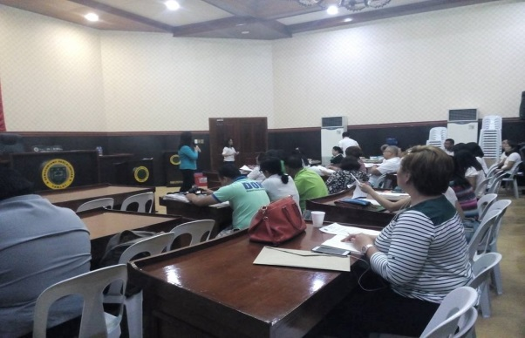
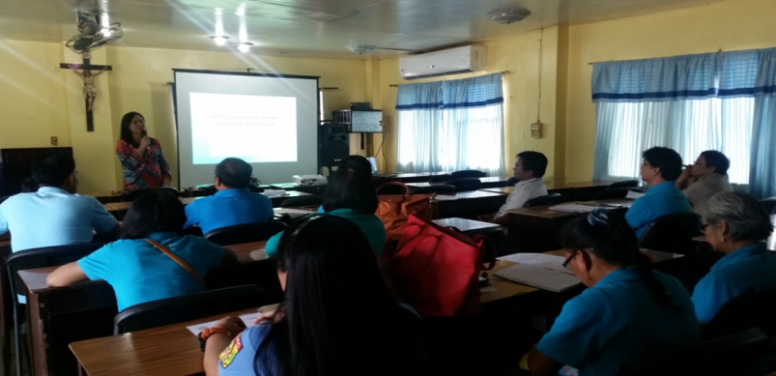
SEMINARS FOR GOVERNMENT AGENCIES AND UNITS

SEMINAR FOR THE UPDATING OF GAD CODE FOR THE PROVINCIAL GOVERNMENT OF TARLAC
GENDER SENSITIVITY ORIENTATION AND GAD MAINSTREAMING FOR THE MUNICIPALITY OF GERONA

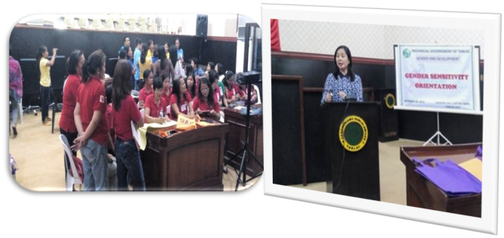
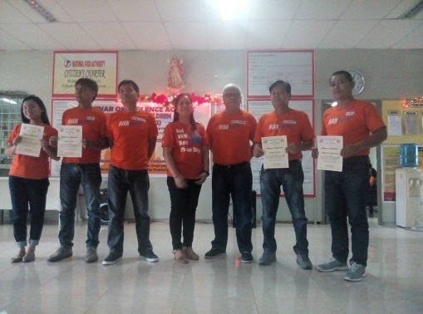
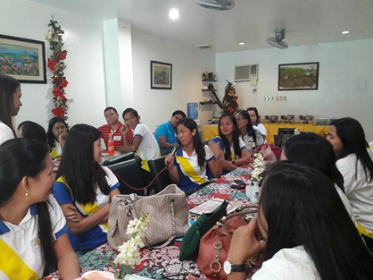

GENDER SENSITIVITY ORIENTATION FOR DEP-ED TEACHERS
GENDER SENSITIVITY ORIENTATION FOR THE PROVINCIAL GOVERNMENT OF TARLAC
VAWC SEMINAR FOR NFA

OTHER EXTENSION ACTIVITIES
The Provincial Government of Tarlac requested for the updating and crafting of the GAD Code of Tarlac Province. Dr. Rita Pulmano served as the Resource Person during the Review of existing GAD Code and Overview of New Guidelines set by the Philippine Commission on Women on December 12. The said meeting was represented by the Provincial Offices, Units, and Organizations of Tarlac Province. The Provincial Government of Tarlac further requested the Office serve as author for the GAD Code.

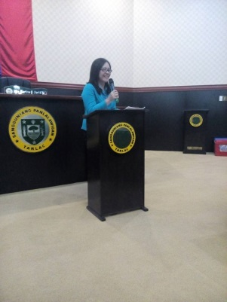
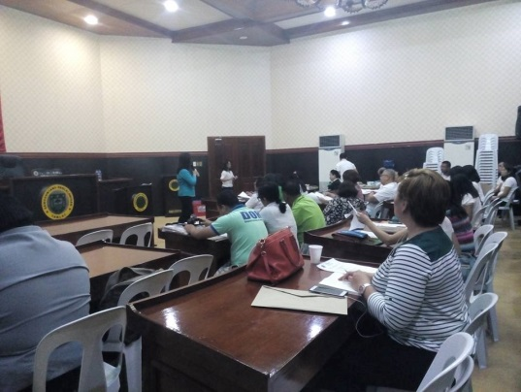
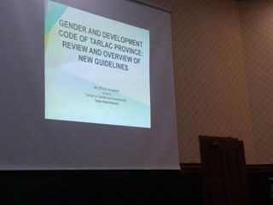
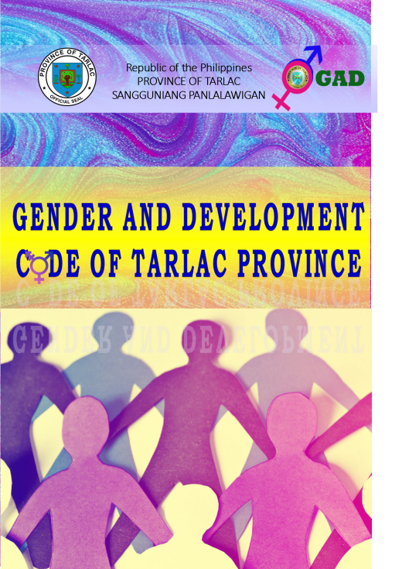
Suzanne Cruz served as the evaluator for the “Live Your Dream” Education and Training Awards for Women
Of the Soroptimist International on December 27, 2016. The Soroptimist Live Your Dream Awards (formerly the Women’s Opportunity Awards) assists women who provide the primary source of financial support for their families by giving them the resources they need to improve their education, skills and employment prospects.

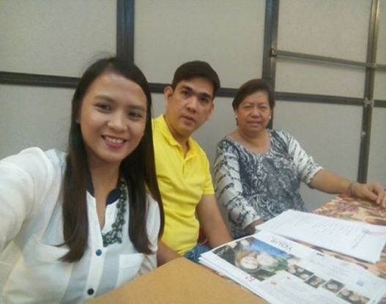
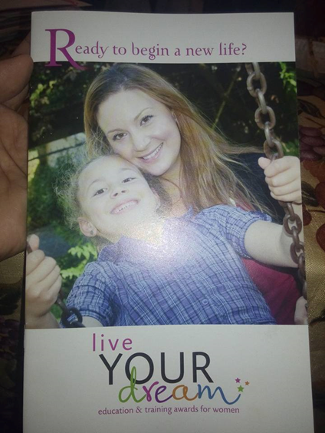

III– ADVOCACY
Center for Gender and Development
The Center for Gender and Development successfully initiated activities for the two National Celebrations namely: 18 Day Campaign on Violence Against Women and Women’s Month.
NATIONAL CELEBRATIONS
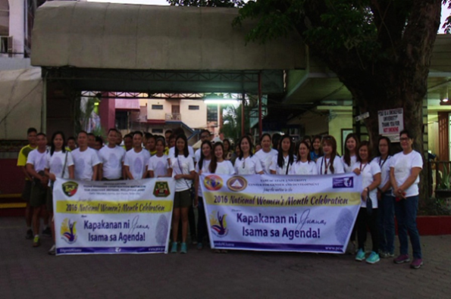
Activities for Women’s Month
Juana Walk
Seminar on HIV Awareness
Seminar on Gender Sensitivity Orientation
Seminar on Anti-violence Against Women
Seminar on Sexual Harassment
Zumba
Literary Contest
Flag Raising Ceremony
Boodle Fight
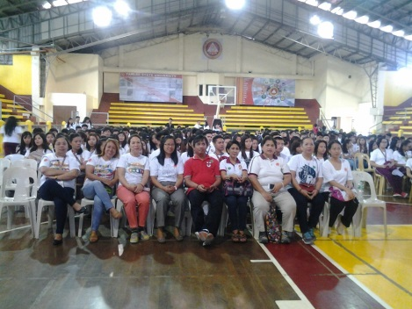
Table 5. List of Activities during the Women’s Month Celebration
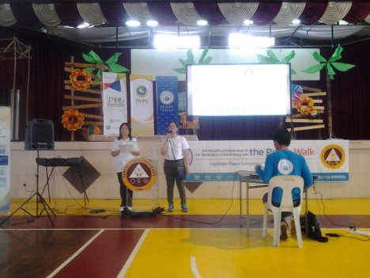

Activities for 18 Day Campaign to End Violence Against Women
Activities | Participants | Date | Venue
Kick-off Activity During Flag Ceremony | All Faculty Personnel and Students of TSU | November 29, 2016 | Main: The Campus, San Isidro Campus, and Lucinda Campus
Orange Your Icon | All Faculty Personnel and Students of TSU | November 29 to December 12
Post Your Campaign: Photo Competition for Faculty and Students | All Faculty Personnel and Students of TSU | November 22 to 29, 2016 | Main Campus, San Isidro Campus, and Lucinda Campus
Painting and Photo Competition/Exhibit | Students | November 24, 2016 | San Isidro Campus
Short Film Viewing | All Faculty Personnel and Students of TSU | November 29 to December 12 | Main Campus, San Isidro Campus, and Lucinda Campus
Student Seminars  RA 7877 | Students | San Isidro Campus—Nov.24  Main Campus-- | Main and San Isidro Campus
Voices Against Violence: Storytelling for Girls and Boys | Child Care Pupils | December 7 to 9, 2016 | Child Care Room, GAD Building
Table 6. List of Activities during the 18 Day Campaign on VAWC
HIGHLIGHTS OF ACTIVITIES FOR THE 18 DAY CAMPAIGN TO END VAWC

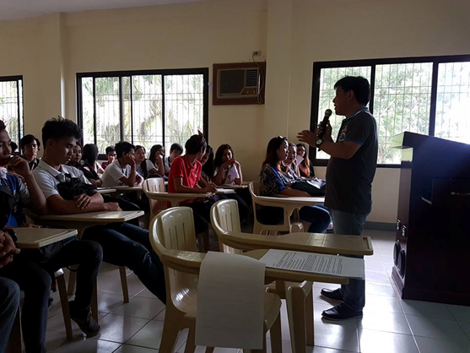
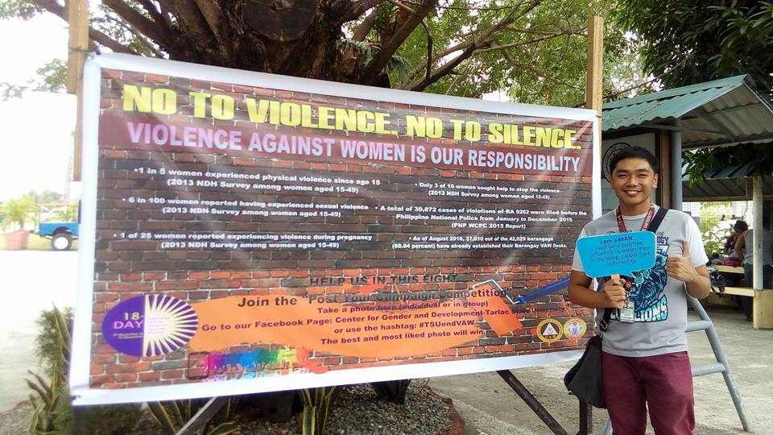

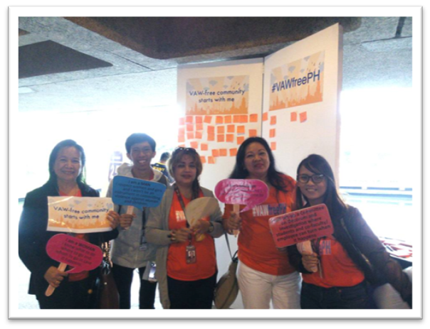
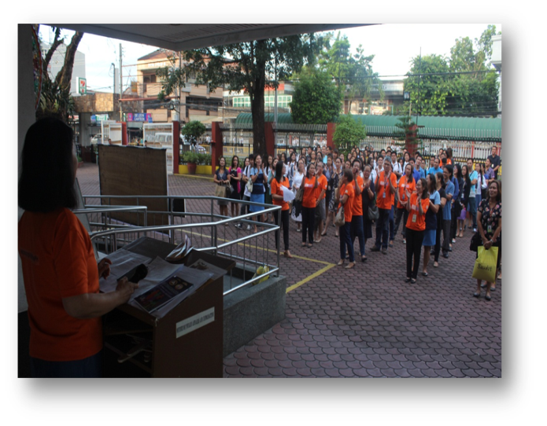

ADVOCACY MATERIALS
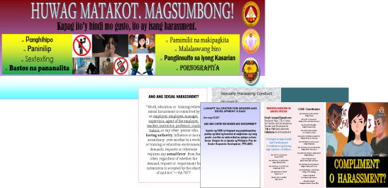
The Office developed two IEC materials on Sexual Harassment disseminated to students. Another IEC material containing information about the CGAD, its function, and offered services were also printed and given to students, faculty, and government offices. Advocacy materials from PCW are also printed and distributed among GAD Coordinators, while copies of Harmonized Gender and development Guidelines Handbooks are also disseminated.

PEACE ADVOCACY
The Center for Gender and Development spearheaded activities on Peace Advocacy in partnership with the Heavenly Culture, World Peace, Restoration of Light (HWPL). The activities are as follows:
Activities | Date and Venue | Number of Participants
CGAD spearheaded the University-wide program concerning the institutional linkage with HWPL on for the orientation about its subsidiaries – the International Women Peace Group (IWPG) and International Youth Peace Group (IYPG). The HWPL guests also discussed the implementation of Signature Campaign and other related activities in support of the Declaration of Peace and Termination of War. | May 13, 2016 | Faculty and Non-teaching personnel
Peace Walk | May 26, 2016 | TSU Main
CGAD-Director Dr. Rita E. Pulmano, TSU-SSC-President Christopher Aaron Bondoc and the undersigned met with the International Peace Women Group (IPYG) Philippines – Miss Gihan and Miss Luna for the launching of Peace Academy in the University. Said intra-curricular activity is a three (3) months-course which aims to contribute to the training of student leaders who will be tasked to disseminate about Peace programs in the University and around the province. | September 1, 2016 | CGAD Office
Annual Commemoration of September 18th World Alliance of Religious’ Peace (WARP) Summit | September 18-21, 2016 | Seoul, Korea.
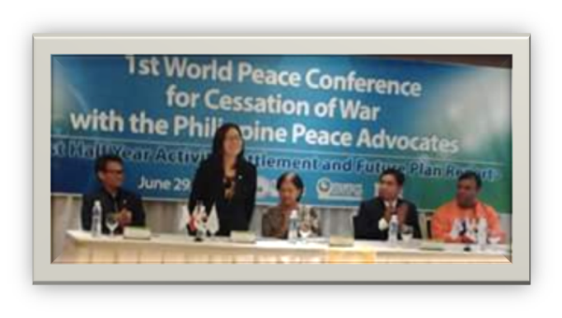
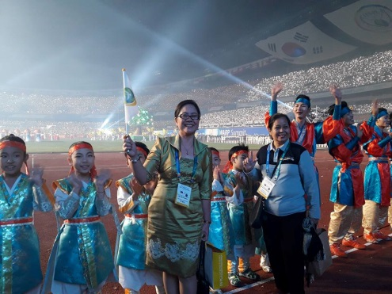
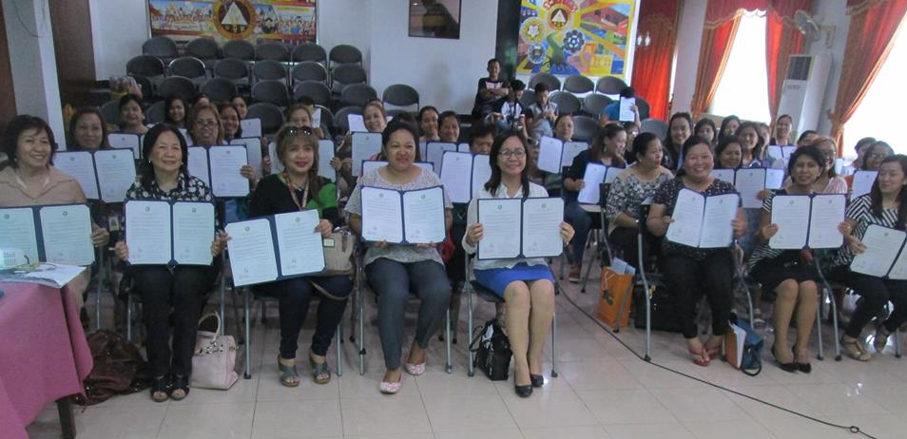

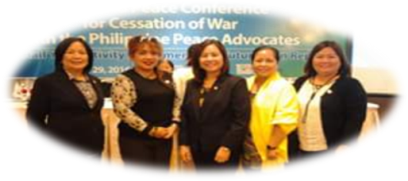

III– AUXILLARY SERVICES
Center for Gender and Development
A total of 12 students are enrolled under the child care program of Gender and Development. The following faculty and personnel benefits from the said Program of GAD:
NAME | OFFICE
Oliver Cura | Guidance and Counselling Unit
Arlyn Cura | COED
Nicolas Z. Diaz | CCS
Earl Alexander V. Dizon | Business Center
Arra T. Evidante | Admin Office
Rosita M. Ferrer | Admin Office
Winniefe F. Guttierrez | Admin Office
Erwin P. Lacanlale | CASS
Claire Lagrana | COS
Jerome Legaspi | CCS
Yvette Legaspi | CBA
Michelle D. Rivera | IMO
Irene Ugay | CBA

